Fire Risk Assessment

1. | Premises Particulars

PREMISES NAME: |  | USE OF PREMISES:
A1 Group Wokingham Site |  | Scrap Metal/Metal Recycling/Wet Waste
ADDRESS: |  | OWNER/EMPLOYER/PERSON IN CONTROL OF WORKPLACE:
Highland Avenue |  | Clive Owen
Silver Birches |  | TELEPHONE NUMBER:
Wokingham RG41 4SP |  | 0118 989 4652

DATE OF RISK ASSESSMENT: |  | DATE OF REVIEW:
10th November 2015 |  | 10th May 2016

NAME AND RELEVANT DETAILS OF THE PERSON WHO CARRIED OUT THE FIRE RISK ASSESSMENT:
Sean Whittle, FCIPD H&S Consultant
HR & Business Solutions Limited
6 Tamar Drive, Keynsham, Bristol, BS31 1PP

2. | General Statement of Policy

STATEMENT:
It is the policy of the A1 Group to protect all persons including employees, customers, contractors and members of the public from potential injury and damage to their health which might arise from work activities.

The company will provide and maintain a safe and healthy working environment, equipment, and systems of work for all employees, and to provide such information, training and supervision as they need for this purpose. The company will give a high level of commitment to health and safety and will comply with all statutory requirements.

3. | Management Systems

COMMENTARY:
The Fire Safety Management plan is contained within the Health & Safety file and is kept in the General Office on the Wokingham Highland Avenue site and copies are also held by the General Manager and the Health & Safety Representative and contained in the H&S folder on the “Back Office”. The H&S consultant also retains a copy.

It confirms that a fire risk assessment will be completed and reviewed periodically every 6 months to ensure adequate fire safety. The fire risk assessment will follow the 5- step narrative method as advocated by the Employers Guide. The significant findings will be recorded and any deficiencies identified by the fire risk assessment process will be prioritised and rectified accordingly.

Although having overall responsibility for fire safety matters the A1 Group has made the Health & Safety Representatives responsible for fire safety matters at the Wokingham Highland Avenue site and is supported by the H&S Consultant for the Group which includes the fire risk assessment and all matters appertaining to it.

This person will be responsible for:-

• Deciding the fire safety protective and preventative measures
• Informing other responsible persons what they are
• Ensuring they are implemented and communicated to other employees
• Ensuring co-ordination between other responsible persons

Fire Safety will be an agenda item for the monthly H&S meeting.

The other responsible persons are shown on the schematic (attached). They will be responsible for the fire safety measures as shown. The Health & Safety Consultant will be responsible for monitoring the effectiveness of the fire risk assessment process and its implementation.

4. | General Description of Premises

DESCRIPTION:
Large open operational site with a medium size open plan brick built general office with flat felt roof. Internally there is a kitchen area and a reception area, two medium offices and two smaller offices there are external toilet facilities. There is a canteen with kitchen facilities and training office housed within two porta cabins near the main entrance to the site.

There is another reception/office area housed within the car spares area. There are various working workshops around the site which care used to decontaminate the scrap cars/fit tyres to customer vehicles and fitting area for A1 vehicles. There are also various storage buildings around the site including 2 large containers. All site building have a fire certificate. The premises are considered to be of low risk in the office areas and medium risk in the workshop areas (however in the event of fire there is a low chance of anyone being placed at risk due to the fire safety measures in place and that the building have large front open areas).

There is a training office above a staff canteen by the main entrance to the site. The is a static kitchen that supply’s food and beverages to staff and customers. This is housed by the main entrance to the site.

There is a car park for customers which, is adjacent to the general office with specific walkway to the main reception and Car Spares reception. There are two main evacuation areas, 1. Outside the tyre fitting area this is in case of emergencies in the lower yard. A total site evacuation muster station is located by the main entrance to the site. There are ample fire extinguishers located at numerous locations (see map)

The is a bungalow on site for which provides employee accommodation with three exits routes in case of emergency.

OCCUPANCY |  | SIZE
TIMES THE PREMISES ARE IN USE: |  | BUILDING FOOTPRINT (METERS X METERS):
7am – 6pm |  | Loo Hire - 3760.03 m2  Loo Storage - 1464.76 m2  Metal Recycling and Depollution - 8458.07m2  Car Spares - 8484.14m2  Skip Storage - 1986.8m2
TOTAL NUMBER OF PERSONS EMPLOYED WITHIN THE PREMISES AT ANY ONE TIME: |  | NUMBER OF FLOORS:
54 |  | 2 (Porta Cabins Only)
TOTAL NUMBER OF PERSONS WHO MAY RESORT TO THE PREMISES AT ANY ONE TIME: |  | NUMBER OF STAIRS:
120 |  | 15 (Access to and from 2nd floor of Porta Cabin)

5. | Fire Safety Systems within the Premises

FIRE WARNING SYSTEM: (i.e. AUTOMATIC FIRE DETECTION, BREAK-GLASS SYSTEM TO BS 5839, OTHER)
Manual Alarm system located on outside of General office and also in workshop complying with British safety standards BS5839. Smoke detectors fitted in general office.

EMERGENCY LIGHTING: (i.e. MAINTAINED/NON-MAINTAINED, 1HR/3HR DURATION TO BS 5266)
Emergency Lighting System. There are Green Illuminated LED exit lights above the door in the corridor from the rear offices and also above the Main Reception entrance door. Yard area well-lit with manual lighting on all building and on perimeter fencing in various locations. Internal illumination emergency lighting at exits.

OTHER: (i.e. SPRINKLER SYSTEM TO LPC RULES BS 5306)
No sprinkler system present on site. There is a hose system in yard area if required and numerous foam Fire Extinguishers.

6. | Plan Drawing
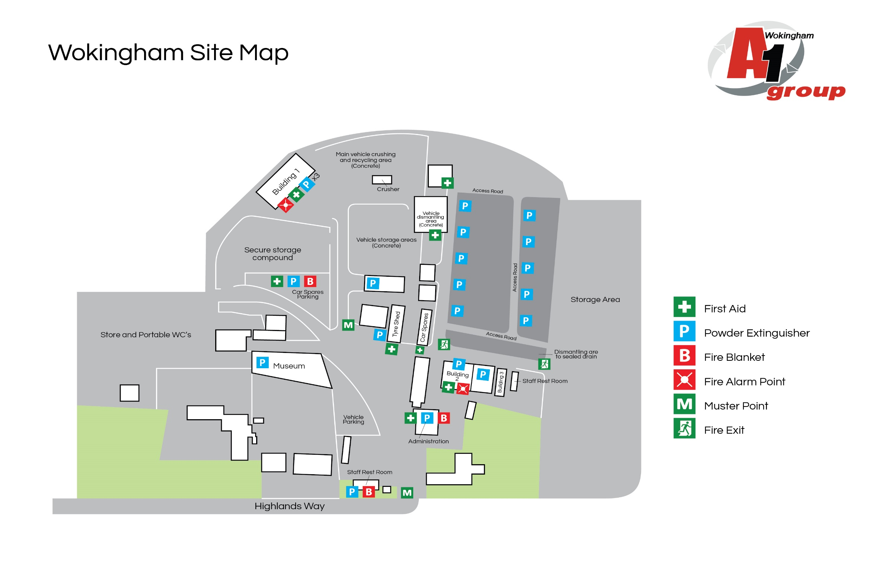

7. | Indentify Fire Hazards

SOURCES OF IGNITION:
The following ignition sources are those commensurate with office premises. Kitchen area in general office – microwave/kettle/toaster
- Paper is stored in cupboards in office area
- Smoking is not allowed in the building
- Waste bins – emptied weekly

Canteen area – kitchen with microwave/kettle/toaster

The following ignition sources are those commensurate with yard / workshops
- Oxyacetylene
- Air Conditioning Systems
- Compressors

The sources of fuel commensurate within office premises are as follows:
- The majority of the work is completed on computers so there are not vast amounts of paper. Paper for printers etc. is stored away in stationary cupboard which is kept locked. Waste paper bins are emptied weekly and the waste is removed from site.

The sources of fuel commensurate within the Yard Area are as follows:
- Oxyacetylene
- Butane Gas for heaters in workshop
- Oil for vehicles
- Combustible materials in workshops
  - Fuel – diesel
  - Fuel – Leaded Petrol
- Anti-Freeze

WORK PROCESSES:
The work processes are commensurate within the office and workshop premises. There are no processes
that pose a significant fire hazard in the office. In the workshop use of Oxyacetylene, compressor guns, grinders are limited to workbenches which are clear of combustible material.

A competent electrician maintains all the electrical equipment. There is a service level agreement with an outside contractor to service all IT equipment. The company policy is to close/shutdown down all electrical equipment at night.

STRUCTURAL FEATURES THAT COULD PROMOTE THE SPREAD OF FIRE:
The office premises is an old building built around 1950. All services and compartments are adequately fire stopped and there are no voids or false ceilings.

8. | Fire Safety Signs and Notices

COMMENTARY:
There are adequate fire safety signs and notices on the premise. All exit routes and fire safety equipment are adequately signposted.

9. | Fire Warning System

COMMENTARY:
There are two manual fire warning systems on site comprising of a switch system to activate alarm. They will warn persons on site including visitors to evacuate the building and locate at the fire evacuation point at the front of the building

10. | Emergeny Lighting System

COMMENTARY:
Emergency Lighting System. There are Green Illuminated LED exit lights above the door in the corridor from the rear offices and also above the Main Reception entrance door.

11. | Fire Fighting Equipment

COMMENTARY:
There is sufficient number of correct type of extinguishers located throughout the general office /canteen/yard area /workshop and storage areas (numerous foam extinguishers These are serviced annually and staff are trained in their use.

12. | Management – Mantenance

IS THERE A MAINTENANCE PROGRAMME FOR THE FIRE SAFETY PROVISIONS IN THE PREMISES? | YES | NO
COMMENTARY:
All fire equipment is serviced annually by RES Group based in Reading | 

ARE REGULAR CHECKS OF FIRE RESISTING DOORS, WALLS AND PARTIONS CARRIED OUT? | YES | NO
COMMENTARY:
Carried out by H&S Representative | 

ARE REGULAR CHECKS OF ESCAPE ROUTES AND EXIT DOORS CARRIED OUT? | YES | NO
COMMENTARY:
Yes a weekly check is conducted by the H&S Representative | 

ARE REGULAR CHECKS OF FIRE SAFETY SIGNS CARRIED OUT? | YES | NO
COMMENTARY:
Yes a weekly check is conducted by the H&S Representative | 

IS THERE A MAINTENANCE REGIME FOR THE FIRE WARNING SYSTEM? |  | YES | NO
COMMENTARY:
Yes a weekly check is conducted by the H&S Representative | WEEKLY: | 
 | ANNUALLY: | 

IS THERE A MAINTENANCE REGIME FOR THE EMERGENCY LIGHTING SYSTEM? |  | YES | NO
COMMENTARY:
The lighting in the yard area is tested weekly | WEEKLY: |  | 
 | MONTHLY: |  | 
 | ANNULALLY: |  | 

IS THERE MAINTENANCE OF THE FIREFIGHTING EQUIPMENT (BY COMPETENT PERSON?) |  | YES | NO
COMMENTARY:
All fire equipment is serviced by RES Group based in Reading | WEEKLY: |  | 
 | ANNUALLY: | 

ARE RECORDS KEPT AND THEIR LOCATION IDENTIFIED? | YES | NO
COMMENTARY:
The records for all aspects relating to maintenance issues are kept in general office by the H&S Representative | 

13. | Method for calling the Fire Service

SPECIFY:
Dial 999 from any telephone

14. | Emergency Action Plan (EAP)

COMMENTARY:
There is a sufficient Emergency Action Plan attached to this record.

15. | Training

COMMENTARY:
Training is provided by the H&S Representative. An annual refresher training is conducted to remind staff of what to do in the event of fire. Also included – How to call the Fire Service, and How to operate the fire alarm system. All personnel including the Managing Director undertake this Training.

16. | Fire Safety Deficiencies to be rectified

DEFICIENCY/RECTIFICATION: | PRIORTY: | DATE TO BE RECTIFIED: | DATE RECTIFIED:
No Fire Exit in main office | 1 | January 2016 | 14/12/2015
Signage needs to be reviewed around the site | 1 | January 2016 | 14/12/2015

17. | Significant findings

SIGNIFICANT FINDING: | CONTROL MEASURE/ACTION:
No record of last fire drill conducted | Action by H&S Representative
No training records to support refresher fire safety training is conducted annually | Action by H&S Representative
Fire Procedure missing from notice boards in general office/canteen/workshop | Action by H&S Representative
Smoke detector fitted in employee canteen | Action by qualified electrician

18. | Additional Hazards

SPECIFY:
None present at time of assessment
NEED TO CONSULT FIRE SERVICE? (Please circle) | YES | NO

A1 GROUP FIRE SAFETY MANAGEMENT PLAN

FIRE SAFETY PLAN: |  | RESPONSIBLE PERSON:
Person with overall responsibility for Fire Safety. |  | Clive Owen
 |  | POSITION:
 |  | General Manager

FIRE RISK ASSESSMENT: |  | RESPONSIBLE PERSON:
Person responsible for carrying out and review. |  | Sean Whittle, FCIPD
 |  | POSITION:
 |  | H&S Consultant

MAINTENANCE PROGRAMME: |  | RESPONSIBLE PERSON:
Person responsible for:  - Maintenance of Fire Safety provisions  - Fire Alarm  - Emergency Lighting  - Fire Fighting Equipment  - Escape routes  - Fire Safety signs and notices |  | Alan McGregor
 |  | POSITION:
 |  | H&S Representative and Transport Manager

EMERGENY ACTION PLAN: |  | RESPONSIBLE PERSON:
Person responsible for production and review |  | Clive Owen
 |  | POSITION:
 |  | General Manager

STAFF TRAINING: |  | RESPONSIBLE PERSON:
Person responsible:  - Fire Safety Training of all staff  - Implementing Fire Drills |  | Various Managers/Alan McGregor
 |  | POSITION:
 |  | Transport Manager

A1 GROUP EMERGENCY ACTION PLAN

ASSEMBLY POINT:
Next to the main entrance to the site

ACTION ON DISCOVERY OF FIRE:
- Sound the alarm using the nearest fire alarm call point
- Leave the building work area by the nearest fire exit
- Do not re-enter the building / work area
- Report to the assembly points either by main gate or by the tyre workshop
- Call the fire brigade by mobile phone (after leaving the building/ working area)
- Liaise with the fire brigade on their arrival
- Only attempt to tackle small fires if confident to do so using the correct extinguisher
- Do not put yourself at risk at any time

ACTION ON HEARING ALARM:
- Leave the building / work area by the nearest fire exit
- Do not re-enter the building / work area
- Report to the assembly point by the main gate or outside the tyre bay workshop
- Call the fire brigade by mobile phone (after leaving the building / work area)
- Liaise with the fire brigade on their arrival

VISITORS:
- Ensure all visitors and contractors are taken to the assembly point
- Assist any disabled persons with their evacuation as necessary

