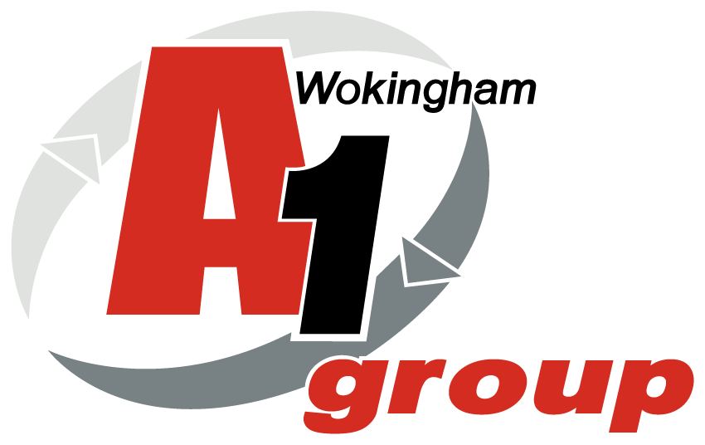

Health and Safety Audit

A1 Loo Hire & A1 Wet Waste
Bennett’s Yard - Wokingham

16th December 2021

Approvals and Amendments

Rev # | Date | Amended by | Approved by | Details
01 | 16/12/2021 | Sean Whittle | Paul / Laura | Site audit and creation of draft
02 | 17/1/2022 | Sean Whittle |  | Report sent to client
03 | Ongoing |  |  | Meeting to review actions
04 | H&S Meeting  February |  |  | Feedback to H&S Reps
05 | 14/1/2022 |  |  | Action Plans Devised
06 | H&S Meetings |  |  | Action Plans to be reviewed

Report completed by:
Sean Whittle FCIPD
HR Advisor
HR & Business Solutions Ltd

Report completed for:
Paul James Wet Waste Manager / Laura White Loo Hire Manager
Bennetts Yard,
Longacres,
Waterloo,
Wokingham,
RG40 3DA

This risk assessment is limited to the risks and findings identified on the day of the assessment and the recommendations contained in this report are based upon information provided by others and the assumption that all relevant information has been provided by those bodies from whom it has been requested.

This document is solely for the use and benefit of the Client. This document shall not be distributed, republished, uploaded, referred to, displayed, posted, edited, modified, re-written, copied in whole or part in any form (including but not limited to electronic, mechanical, printing, photocopying), by any other corporate entity, individual persons, or for any other purpose by the Client without the prior written permission of HR & Business Solutions Limited.

Table of Contents

Approvals and Amendments 2
1. Introduction 4
2. Scope 4
3. Aims and Objectives 5
4. Meeting the Objective 5
5. Background Information 5
6. Significant and Moderate Risks 6
Umbrella Risk Assessment Report 8
Substantial Risks 8
Moderate Risks 8
Moderate and Low Priority Risks 13
Next Steps 13
Appendix 1 - Prioritised Risk and Hazard Table 14
General Site - Risk Assessment Table 16
Driving at Work - Risk Assessment Table 17
Occupational Health - Risk Assessment Table 18
Manual Handling - Risk Assessment Table 19
Workshop Noise - Risk Assessment Table 20
Training and Induction - Risk Assessment Table 21
Offices and DSE Work Stations - Risk Assessment Table 22
Contractors - Risk Assessment Table 23
Site Electrical Equipment - Risk Assessment Table 24
Delivery Drivers Lifting Equipment - Risk Assessment Table 25
Water Systems and Shower - Risk Assessment Table 26
Site Fire - Risk Assessment Table 27
Work at Height - Risk Assessment Table 28
Falling Objects - Risk Assessment Table 29
Pressure Vessels and Gas Supplies - Risk Assessment Table 30
Handling Waste for Disposal - Risk Assessment Table 31
Machinery and Work Equipment - Risk Assessment Table 32
External Area and Site Access - Risk Assessment Table 33
First Aid and Accident Reporting - Risk Assessment Table 34
Hazard and Near Miss Reporting - Risk Assessment Table 35
Health & Safety Communication - Risk Assessment Table 36
Outdoor Work - Risk Assessment Table 37
Asbestos - Risk Assessment Table 38
Kitchen Area / Rest room - Risk Assessment Table 39
Pregnant Workers and Young Persons - Risk Assessment Table 40
Appendix 2 - Risk Assessment Scoring 41
Severity Score Table 42

1. Introduction

Clive Owen, Director A1 Group commissioned HR & Business Solutions Ltd to

- Audit the occupational health and safety status of their site in Bennetts Yard, Longacres, Waterloo, Wokingham, RG40 3DA
- HR & Business Solutions used an umbrella risk assessment to achieve this requirement

A1 Group Ltd is a well-established company with three separate Divisions namely Car Spares / metal recycling / Wet Waste and Loo Hire from its five depots in Wokingham, Longacres (Bennetts Yard), Bridgend, Coventry, Oxford and Portsmouth. The Bennetts Yard depot comprises of a ground floor reception area, general office which has a separate toilet facility. There is another building adjacent to this building which houses 2 offices separate kitchen / toilet facilities. There is also a flat above the Wet Waste employee canteen/office area. There is a large external workshop building which comprises of 6 individual units which are used for vehicle repair / spray garage and equipment/product storage. The large yard area is used mainly for storage of vehicles and some equipment and fuel refilling and cleaning area. There is a large portable building opposite the to the general office which is planned for office use in the coming months – this was not audited at time of visit as not in used. At the time of the visit approximately 155 people were employed within the A1 Group business, with around 50 based out of Bennett’s (Wet Waste and Loo Hire) with at least 10 on the Bennetts site at any time serving the operational needs of the business.

Risk assessment is a legal requirement and is the starting point for all Occupational Health and Safety (OH&S); HR & Business Solutions risk assessment approach is an umbrella over the top of A1 Wet Waste / A1 Loo Hire (Bennetts Yard) ensuring all risks are captured. By assessing the risks of injury and ill health, identifying what is in place to control these risks and then determining further controls necessary, sets the boundaries on OH&S. The resulting risk control measures determine the effort, time and financial commitment that need to be applied to training, writing procedures, on-going support etc. The H&S system can then be proportionate to the risks; because it is derived from A1 Wet Waste (Bennetts Yard) relevant risks, it will have value and purpose for your business. The umbrella risk assessment is a functional business tool, which should be used by the Board as part of their commitment to managing and monitoring OH&S risks.

By reviewing its operations and identifying key risks A1 Wet Waste / A1 Loo Hire (Bennetts Yard) will be able to manage its OH&S issues. By establishing risks, A1 Wet Waste / A1 Loo Hire (Bennetts Yard) can plan and implement relevant safe working procedures to ensure, so far as is reasonably practicable, the health, safety and welfare of those affected by its undertaking.

2. Scope

Carry out an ‘Umbrella Risk Assessment’ A1 Wet Waste / A1 Loo Hire (Bennetts Yard).

3. Aims and Objectives

The aim is to identify and provide A1 Wet Waste / A1 Loo Hire (Bennetts Yard) with an overview of their key health and safety hazards and risks within their operations.

The main objective is to identify significant hazards and risks for A1 Wet Waste / A1 Loo Hire (Bennetts Yard) and make recommendations in line with legislative requirements.

4. Meeting the Objective

To meet the objectives the following activities will be undertaken:

Umbrella Risk Assessment of Bristol Site

- Visit each key area in the Bennetts Yard facility
- Meet and talk to management, H&S representative and employees, as appropriate
- Record relevant risks/hazards, current controls and recommendations
- Include hazard/risk table in appendix 1
- Outline significant and moderate risks in main body
- Make recommendations in line with legislative requirements

5. Background Information

HSE Poster
Displayed around the depot – on Loo Hire H&S Board / Employee noticeboard in canteen in Wet Waste.

H&S Policy
This was in date and displayed correctly.

Employers Liability Insurance
In date and signed copy displayed.

Accidents and Incidents
Reported, recorded and reviewed. No significant incidents in the last 12 months.

Additional current H&S Documentation
- H&S Policy written, signed and displayed on Back Office
- Risk Assessments / Method Statements for items of work equipment, tasks and areas completed and reviewed in January of each year by the H&S Advisor. New RA’s are completed when required.
- Risk Assessments / method statement are contained on the Back
- Risk Assessments reviewed annually by the responsible person for H&S at the depot

6. Significant and Moderate Risks

Understanding the Hazard and Risk Table (Appendix 1)
The columns in the Umbrella Risk Assessment Table are as follows:

No.
The hazard numbers.

Hazard
A description of the common hazard identified.

S
This is the severity of the hazard (see Appendix 2 for Severity Scoring).
Person Affected
This column identifies the persons most likely to be affected by the hazard.

Existing Control Measures and Common Theme
These are the existing controls in place to reduce the likelihood of the hazard reaching full potential and any common themes seen at the depots.

L
This is the likelihood, taking account of the persons affected and the existing controls, of the hazard occurring (see Appendix 2 for Likelihood Scoring).

RPN
This is the Risk Priority Number = Severity x Likelihood.

Recommendations
These are recommendations of how to lower the risk.

Relevant Legislation
Applicable legislation for the risk identified.

Risk Priority Number is kept simple and scoring is summarised in the following table and in Appendix 2 - Risk Assessment Scoring.

Risk Priority Number | Action and Timescale
Intolerable:  RPN = 9 | Stop activity immediately or do not start until action has been taken to reduce the level of risk. (Enforcement risk - possible HSE Prohibition Notice).
Substantial:  RPN = 6 | Take action to reduce the risk level within 1 month. (Enforcement risk - possible HSE Improvement Notice).
Moderate:  RPN = 3 or 4 | Take action to reduce the risk level within 3 - 6 months.
Trivial/Low:  RPN = 1 or 2 | No further action required.

The Risk and Hazard Table is prioritised with the high RPN’s listed first, these are discussed next.

Umbrella Risk Assessment Report

On the day of the risk assessment, and in the opinion of the assessor there were 0 Substantial Risks and 5 Moderate Risks scoring a four; these are outlined below.

Substantial Risks

There were no substantial risks at the time of the audit

Moderate Risks

1. Emergency Lighting

Emergency lighting on site no record of last check

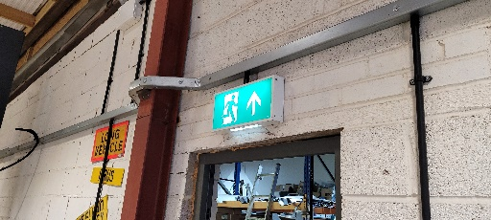

Specific Risks
In event of emergency if lights are not working then Employees find difficult to exit building. The yard area is well lit and no issues

Relevant Legislation

- Management of Health and Safety at Work Regulations 1999

Recommendations

- Ensure emergency lighting is checking annually by qualified A1 Group Electrician

2. Noticeboards

There were two noticeboards on site (Loo Hire office entrance and Wet Waste employee canteen)

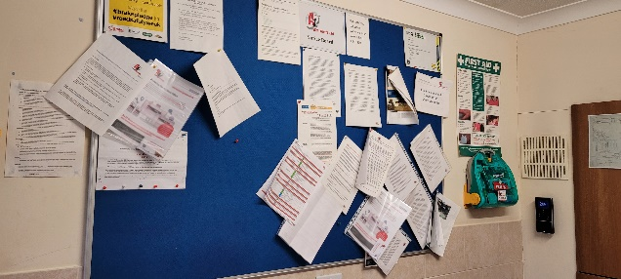
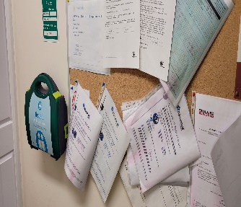

Specific Risks
Employees could receive the wrong information

Relevant Legislation

- Management of Health and Safety at Work Regulations 1999

Recommendations

- Ensure all documents are reviewed and replaced regularly and make check they are in date as part of the fortnightly IAuditor walkaround

3. Fire Extinguishers

There were two fire extinguishers where on the floor and not secured.
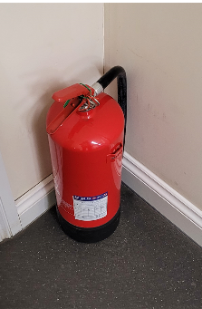
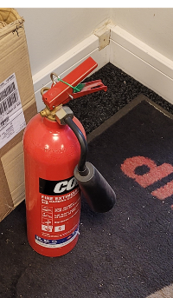

Specific Risks
The fire extinguishers could fall over, and the labels can become worn. The fire extinguishers can get moved and not where in right place when needed in the event of emergency and also at time of annual service. The fire extinguishers can activate accidently if knocked over

Relevant Legislation

- Management of Health and Safety at Work Regulations 1999

Recommendations

- Ensure all fire extinguishers are placed on hooks on walls or on special storage trays and ensure that the correct usage labels are close by so if required the correct extinguishers is used to treat a fire

4. Hoses / Ladders / Oxyacetylene

General housekeeping around the site was good and both office areas were clean and tidy and well organised. Both had adequate ventilation and no tripping hazards.

There were various items of equipment and rubbish left around the site which could be considered trip hazards. There were various hoses left on the floor and ladders were not secured and left against racking. The oxyacetylene bottle was also not secured

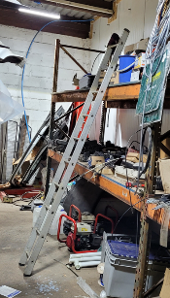
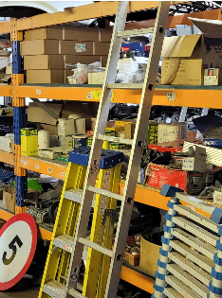
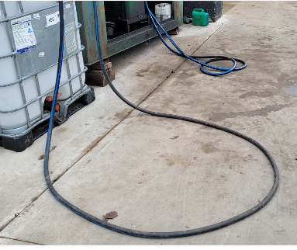
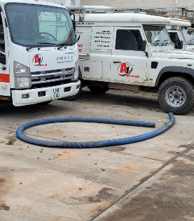
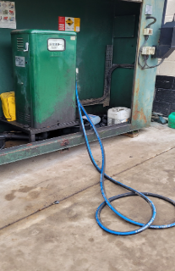

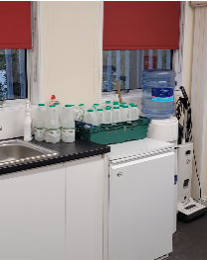
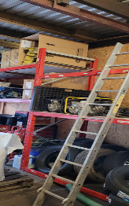
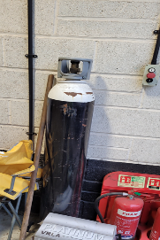
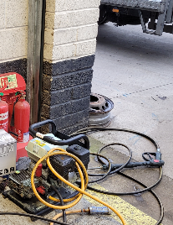

Specific Risks
Trips and falls on unmarked hosed or leads and on unprotected floor areas in wintery conditions. Ladders if not secured can fall and also need to be checked regularly to ensure fit for purpose. If oxyacetylene bottles fall over they can cause crush injury if they land on persons foot

Relevant Legislation

- Management of Health and Safety at Work Regulations 1999

Recommendations

- Ensure rubbish bins / recycling are regularly emptied/collected
- Ensure all hoses/cables are tided away after use to prevent becoming trip hazards
- Ensure ladders are secured when not in use and introduce regular checks to ensure all fit for purpose
- Secure the oxyacetylene bottles to wall or unit to prevent falling over

5. Occupational Health

Work activities can impact on employee’s heath as well as their safety. A proactive occupational health program can assist with the monitoring of adverse health effects and also maintain a healthy and productive workforce.

Specific Risks
Some occupational health is required under certain regulations for managing specific risks. For A1 Loo Hire these include:

- Skin sensitising chemicals - currently undertaking
- Manual Handling - review required
- Noise - currently undertaking

Additional Considerations

- Sickness absence management, Fitness for work assessment
- Wellbeing and stress management, Drug and alcohol

Relevant Legislation

- Management of Health and Safety at Work Regulations 1999
- Noise at Work Regulations 2005
- Control of Substances Hazardous to Health Regulations 2002
- Working Time Regulations 1998

Recommendations

Audiometry
Introduce audiometry for those exposed to noise above the 1st and 2nd action levels.

COSHH Heath Surveillance
Review following outcome of COSHH Assessments (separate recommendation).

MSD Report
Introduce reporting system for MSD. Train employees on what to look out for and report issues to line managers.

- Train line managers on completing MSD form, restricting duties and referral procedure to OH

Moderate and Low Priority Risks

There are a number of remaining Moderate and Low Priority risks that are included in the Hazard and Risk Table but not discussed in this section of the report.

Next Steps

This risk assessment is a live working document and a tool for the business.

Read the recommendations in point 6 above. These are the top priority recommendations based on the RPN.

Further recommendations are outlined in the risk assessment table (Appendix 1).

Documented Action Plan
Document an Action Plan and assign responsibility with timescales for completing the recommendations in the report.

- Monitor and review the Action Plan on a regular basis, recording when the actions are completed. Note down any relevant evidence against the completed actions i.e. training records, new work instructions etc.
- Some examples of how to record the evidence: on the action plan, hand written notes in this report, or separate documents attached or referenced to the report/Action Plan

Consultation and Training
There is a legal requirement to consult employees on risk control measures that relate to, or affect them and to provide any related training. Where either result from this risk assessment, ensure the communications and training occur. Document when and how consultation was achieved, and document employee training records.

Risk Assessment Review
There is no legally set review period for a risk assessment, but there needs to be a mechanism for reviewing when necessary.

As a framework, a risk assessment should be reviewed:

- At least every 1-5 years; the Health and Safety Executive recommend annual review
- If the business expands, takes on more staff or moves premises
- If there is a significant change to the work activities, process or task
- If the type or no. of persons exposed changes
- If there is a related accident, ill-health or incident reported
- If there is a change in technology or information that could affect the risk
- For any other reason if the assessment is no longer valid

Appendix 1 - Prioritised Risk and Hazard Table

Hazards considered during this Risk Assessment:

Work At Height | X |  | Manual Handling | X |  | Slips, Trips & Housekeeping | X
Lighting, Heating & Ventilation Levels | X |  | Falling Objects | X |  | Display Screen Equipment | X
Layout/Storage/Space/Obstructions | X |  | Workplace Transport / Pedestrians | X |  | Driving At Work | X
Welfare Facilities | X |  | Pregnant Workers / Young Persons | X |  | DDA
Outdoor Work/Extreme Temperature | X |  | Off Site/Home/Peripatetic Working |  |  | Occupational Pressure
Violence To Staff / Verbal Assault |  |  | Contractors | X |  | Visitors / Trespassers | X
Lifting Equipment | X |  | Work Equipment (Fixed / Portable) | X |  | Electrical Equipment | X
Lone Working/Out Of Hours/Security | X |  | Pressure Vessels / Gas Supplies | X |  | Hazardous Substances | X
Noise | X |  | Vibration | X |  | Biological Agents
Legionella or Lead | X |  | Asbestos | X |  | Flammable Substances (F, F+) | X
Dangerous Substances (O, E, DSEAR) | X |  | Radiation Sources I.E. Lasers, UV |  |  | Confined Space/Asphyxiation
Environmental Risks | X |  | Food Preparation |  |  | Fire | X

X = Relevant at the time of the visit, if there is no X the hazard was considered not relevant or insignificant.

General Site - Risk Assessment Table

# | Hazard | S | Persons Affected | Existing Control Measures and Common Theme | Risk |  | Recommendations | Relevant Legislation
 |  |  |  |  | L | RPN
1 | Hazardous/Flammables Substances – gas bottles  Only diesel stored on site/ propane or butane stored on site at time of audit | 1 | Employees | There is lockable gas gage | 2 | 2 | No actions required at time of audit | Control of Substances Hazardous to Health Regulations 2002

Driving at Work - Risk Assessment Table

# | Hazard | S | Persons Affected | Existing Control Measures and Common Theme | Risk |  | Recommendations | Relevant Legislation
 |  |  |  |  | L | RPN
2 | Driving At Work - Delivery and tanker drivers are the main drivers for A1 Group but other employees may drive on company business.  Hazard: road traffic accident.  Vehicles used are both company and privately owned. | 2 | Employees | A Driving at work procedures manual is in place. | 1 | 2 | Driver risk assessments were viewed on the day of the visit. | Management of Health and Safety at Work Regulations 1999

Occupational Health - Risk Assessment Table

# | Hazard | S | Persons Affected | Existing Control Measures and Common Theme | Risk |  | Recommendations | Relevant Legislation
 |  |  |  |  | L | RPN
3 | Occupational Health - Work activities can impact on employee’s heath as well as their safety. A proactive occupational health program can assist with the monitoring of adverse health effects and also maintain a healthy and productive workforce.  Specific Risks - Some occupational health is required under certain regulations for managing specific risks: For IOS these include Skin and respirator sensitising chemicals, Noise and Task Repetition.  Additional Considerations  - Sickness absence management  - Fitness for work assessment  - Wellbeing and stress management  - Drugs and alcohol | 2 | Employees | MSD Reporting (musculoskeletal disorder) - Repetitive tasks have ben risk assessed Use of HSE guidance in HSG60 is recommended but not recorded at time of assessment. MSD reporting is currently verbal and too Depot managers. If further medical advice is required the employee is referred to the OH.  Audiometry - No audiometry is carried out currently.  COSHH Heath Surveillance - Currently, nothing is carried out.  Stress/Wellbeing - Employees reporting stress are currently referred to the OH.  Drugs & Alcohol - Zero tolerance, procedure in place. Facility to random test in place. | 2 | 4 | Audiometry - Introduce audiometry for those exposed to noise above the 1st and 2nd action levels.  MSD Report - Introduce reporting system for MSD. Train employees on what to look out for and report issues to line managers.  Train line managers on completing MSD form, restricting duties and referral procedure to OH. | Management of Health and Safety at Work Regulations 1999  Noise at Work Regulations 2005  Control of Substances Hazardous to Health Regulations 2002  Working Time Regulations 1998

Manual Handling - Risk Assessment Table

# | Hazard | S | Persons Affected | Existing Control Measures and Common Theme | Risk |  | Recommendations | Relevant Legislation
 |  |  |  |  | L | RPN
4 | Manual Handling - Handling of incoming/outgoing equipment. | 2 | Employees | Risk Assessments include manual handling activities; these are housed on the Back Office.  Safety shoes worn by all employees handling equipment.  Manual Handling training recorded in training files soon to be via Human Focus which will be accessible via the HUB. | 1 | 2 | In addition to training on manual handling at induction provide practical manual handling training to all employees who are required to carry out MH operations such as lifting, pulling, pushing, bending and twisting as part of their role. | Manual Handling Operations Regulations 1992  Lifting Operations and Lifting Equipment Regulations 1998  Provision and Use of Work Equipment Regulations 1998

Workshop Noise - Risk Assessment Table

# | Hazard | S | Persons Affected | Existing Control Measures and Common Theme | Risk |  | Recommendations | Relevant Legislation
 |  |  |  |  | L | RPN
5 | Noise: Equipment and vehicles being serviced - Exposure to noise above statutory action levels of 80dBA and 85dBA can lead to hearing loss. | 2 | Employees | No existing controls in place | 1 | 2 | No actions required at time of audit | Noise at Work Regulations 2005

Training and Induction - Risk Assessment Table

# | Hazard | S | Persons Affected | Existing Control Measures and Common Theme | Risk |  | Recommendations | Relevant Legislation
 |  |  |  |  | L | RPN
6 | Training and Induction - Without a clear and relevant induction and training programme, new starters and employees are more likely to have accidents and/or suffer from work related ill health.  A1 Group Training Includes:  - Manual Handling - Induction and annually  - DSE training online  - Role specific training  - Equipment specific training  - Managers H&S responsibilities - | 2 | Employees | Training arrangements in place and recorded on SAGE HR.  All employees’ are trained against defined skills and subjects, which are recorded in personal file,  H&S training is captured either as a specific role H&S module or as part of other training i.e. equipment operation.  A lot of the H&S related training is managed and delivered in house. | 1 | 2 | Review other specific H&S training delivered internally to ensure the key points of the training are documented.  All employees should receive practical manual handling training as well as the on line training. This should be documented and refreshed regularly i.e. 1-2 yearly.  General H&S awareness training should be considered for all employees yearly.  Introduce training for MSD and issues related to repetitive roles.  Introduce Health Surveillance training in relation to skin issues.  Introduce regular H&S training for members of H&S committee. | Management of Health and Safety at Work Regulations 1999

Offices and DSE Work Stations - Risk Assessment Table

# | Hazard | S | Persons Affected | Existing Control Measures and Common Theme | Risk |  | Recommendations | Relevant Legislation
 |  |  |  |  | L | RPN
7 | Display Screen Equipment - Use of desktop PCs at workstations in various locations at Bennetts Yard site. | 2 | Employees | Employees made aware of DSE during Induction.  Annual DSE Assessments have been completed | 1 | 2 | No actions required at time of audit | Display Screen Equipment Regulations 1992

Contractors - Risk Assessment Table

# | Hazard | S | Persons Affected | Existing Control Measures and Common Theme | Risk |  | Recommendations | Relevant Legislation
 |  |  |  |  | L | RPN
8 | Contractors - Uncontrolled contractor activities can lead to incidents both to themselves on company premises or which could affect company employees.  Hazards include: falling objects, electrical damage, fires etc. | 2 | Employees and Contractors | There is mention of contractor management in the H&S Manual. | 1 | 2 | Risk assessments and method statements prior to contractors working on site were not available at time of visit. Prior to starting work contractors must receive a contractor’s safety induction.  H&S procedures required to manage risks while working at an A1 Group depot, including preparation of risk assessments, method statements and assessing competence. | Management of Health and Safety at Work Regulations 1999

Site Electrical Equipment - Risk Assessment Table

# | Hazard | S | Persons Affected | Existing Control Measures and Common Theme | Risk |  | Recommendations | Relevant Legislation
 |  |  |  |  | L | RPN
9 | Electrical Equipment - Failure of electrical equipment through poor maintenance or damage can lead to electrocutions. | 2 | Employees and Third Parties | PAT Testing completed | 2 | 4 | Emergency lighting needs to have annual inspection  No actions required at time of audit | Electricity at Work Regulations 1989

Delivery Drivers Lifting Equipment - Risk Assessment Table

# | Hazard | S | Persons Affected | Existing Control Measures and Common Theme | Risk |  | Recommendations | Relevant Legislation
 |  |  |  |  | L | RPN
10 | Lifting Equipment - Failure of lifting equipment can result in a serious incident and would be a RIDDOR reportable incident.  Lifting equipment identified:  - Workshop hoist equipment  - Roller Shutter Doors  - Tailgates on vehicles | 2 | Employees | Statutory inspections for lifting equipment and accessories are completed.  Maintenance in place for all lifting equipment.  Workshop/delivery drivers wear safety shoes and high visibility clothing.  Risk Assessments are completed and reviewed regularly | 1 | 2 | No further recommendations | Lifting Operations and Lifting Equipment Regulations 1998  Provision and Use of Work Equipment Regulations 1998

Water Systems and Shower - Risk Assessment Table

# | Hazard | S | Persons Affected | Existing Control Measures and Common Theme | Risk |  | Recommendations | Relevant Legislation
 |  |  |  |  | L | RPN
11 | Legionella - Hazards: Legionella bacterial inhalable through water mist from a shower or developing in hot and cold water systems. | 2 | Employees | Legionella risk assessment report has been completed in July 2018 and recommendations implemented. | 1 | 3 | No actions required at time of audit | Control of Substances Hazardous to Health Regulations 2002

Site Fire - Risk Assessment Table

# | Hazard | S | Persons Affected | Existing Control Measures and Common Theme | Risk |  | Recommendations | Relevant Legislation
 |  |  |  |  | L | RPN
12 | Fire - Fire risks from ignition source finding a fuel source. Fuel sources include stock, cardboard/paper/waste materials in outside bins. | 2 | Employees, Third Parties, Vulnerable Persons and Contractors | Fire alarm installed and working  There are 2 Fire Marshals for the site and there has been and emergency evacuation  Fire evacuation signage is placed around site i.e. general office, canteen and workshop. – need more Fire signage in new Workshop | 1 | 2 | No actions required at time of audit | Regulatory Reform (Fire Safety) Order 2005

Work at Height - Risk Assessment Table

# | Hazard | S | Persons Affected | Existing Control Measures and Common Theme | Risk |  | Recommendations | Relevant Legislation
 |  |  |  |  | L | RPN
13 | Work at Height - Limited work at height for A1 Group employees.  No work at height for Office workers.  Contractors carry out work at height. | 2 | Employees | No working at height activity at Depot therefore not risk assessed. | 2 | 4 | Need to remove all ladders than have no identification on – thy must be checked a and safe for purpose and if not then destroy on remove from site.  No actions required at time of audit | Work at Height Regulations 2005

Falling Objects - Risk Assessment Table

# | Hazard | S | Persons Affected | Existing Control Measures and Common Theme | Risk |  | Recommendations | Relevant Legislation
 |  |  |  |  | L | RPN
14 | Falling Objects - Hazards: items falling on persons around the site. | 3 | Employees | Items are stored on secure shelving and all items over 20kg are stored at lowest point and form part of IAuditor weekly inspections | 1 | 3 | All Items over 20kgs were stored below head height in various areas around the depot  - Workshop store room  - Canteen items on cupboards  No actions required at time of audit | Management of Health and Safety at Work Regulations 1999

Pressure Vessels and Gas Supplies - Risk Assessment Table

# | Hazard | S | Persons Affected | Existing Control Measures and Common Theme | Risk |  | Recommendations | Relevant Legislation
 |  |  |  |  | L | RPN
15 | Pressure Vessels and Gas Supplies - For A1 Group these are:  - Gas Storage bottles  - Gas boiler  - Compressor for machine air lines  - Pressure Washer  Failure of pressure vessels or poorly maintained gas supplies can lead to serious incidents.  Hazard: uncontrolled release of pressurised material, failure of pressure vessel, release of gas, explosion or fire. | 2 | Employees and Third Parties in the areas | No gas boiler on site  Pressure washer in use on site | 1 | 2 | Compressor had been serviced  No further recommendations. | Gas Safety (Installation and Use) Regulations 1998  Pressure Systems Safety Regulations 2000

Handling Waste for Disposal - Risk Assessment Table

# | Hazard | S | Persons Affected | Existing Control Measures and Common Theme | Risk |  | Recommendations | Relevant Legislation
 |  |  |  |  | L | RPN
16 | Handling Waste for Disposal - Use of bins at the back of the site.  Hazard: manual handling. | 3 | Employees | Waste is stored bins around the site. All materials are disposed of correctly.  Waste is disposed of correctly | 1 | 3 | Consider introducing a waste management system for different types of waste.  No further recommendations. | Management of Health and Safety at Work Regulations 1999  Manual Handling Operations Regulations 1992

Machinery and Work Equipment - Risk Assessment Table

# | Hazard | S | Persons Affected | Existing Control Measures and Common Theme | Risk |  | Recommendations | Relevant Legislation
 |  |  |  |  | L | RPN
17 | Machinery and Work Equipment - Use of work equipment by untrained persons or work equipment that is poorly guarded and maintained is more likely to lead to incidents.  Work equipment includes:  Lifting equipment  Hire Equipment. | 2 | Employees | Risk Assessment - The use of each item of work equipment is risk assessed.  New equipment is captured when purchased and training on use delivered by supplier.  . | 1 | 2 | Provide a hard copy of risk assessments on certain equipment in various areas on site.  Maintenance – Ensure all work equipment is maintained regularly.  Training – Ensure training is completed and recorded for all users of equipment  No further recommendations | Provision and Use of Work Equipment Regulations 1998

External Area and Site Access - Risk Assessment Table

# | Hazard | S | Persons Affected | Existing Control Measures and Common Theme | Risk |  | Recommendations | Relevant Legislation
 |  |  |  |  | L | RPN
18 | Visitors/Trespassers - Unaccompanied visitors may be more likely to have an accident due to less knowledge about the site layout and operation.  Foreseeable hazards to trespassers should be avoided. | 3 | Employees, Visitors, Contractors and  Trespassers | Visitors/Contractors are required to sign consider issuing identification badge  Signage around site  Site fencing is adequate | 1 | 3 | No further recommendations | Management of Health and Safety at Work Regulations 1999  Occupiers Liability Act 1947/1984

First Aid and Accident Reporting - Risk Assessment Table

# | Hazard | S | Persons Affected | Existing Control Measures and Common Theme | Risk |  | Recommendations | Relevant Legislation
 |  |  |  |  | L | RPN
19 | First Aid and Accident Reporting - If an incident occurs, slow first aid response can increase the severity of the injury. | 2 | Employees and Third Parties | Accident reporting procedure in place although not available at time of audit. | 1 | 2 | No further recommendations | First Aid Regulations 1981

Hazard and Near Miss Reporting - Risk Assessment Table

# | Hazard | S | Persons Affected | Existing Control Measures and Common Theme | Risk |  | Recommendations | Relevant Legislation
 |  |  |  |  | L | RPN
20 | Hazard and Near Miss Reporting - Reported incidents (Hazards and Near Misses) are indicators of potential accidents waiting to happen. | 2 | Employees and Third Parties | Controls process is in place | 1 | 1 | No further recommendations | Management of Health and Safety at Work Regulations 1999

Health & Safety Communication - Risk Assessment Table

# | Hazard | S | Persons Affected | Existing Control Measures and Common Theme | Risk |  | Recommendations | Relevant Legislation
 |  |  |  |  | L | RPN
21 | H&S Communication - Clear methods of H&S communication.  A written H&S policy signed and displayed.  H&S procedures for controlling workplace risks in place and available to employees.  H&S Committee. | 2 | Employees | Notice board has various information but H&S notices mixed in with other Company information and some was out of date  Weekly H&S inspections carried out by the reps and issues discussed at H&S committee meeting. Corrective actions are implemented immediately. | 2 | 4 | Ensure all information on notice boards in Loo Hire Entrance and Wet Waste Canteen are in date and relevant  No further recommendations. | Health and Safety at Work Act etc. 1974  Management of Health and Safety at Work Regulations 1999  The Health and Safety (Consultation with Employees) Regulations 1996

Outdoor Work - Risk Assessment Table

# | Hazard | S | Persons Affected | Existing Control Measures and Common Theme | Risk |  | Recommendations | Relevant Legislation
 |  |  |  |  | L | RPN
22 | Outdoor Work - Some employees have a need to work outside during the winter but they are not based outside continuously. | 2 | Employees | All employees are provided with high visibility jackets/fleeces gloves for wearing in all areas apart from offices on site.  All affected employees can move into the warmth as required.  Heaters provided in rest area and general offices | 1 | 2 | No further recommendations | Management of Health and Safety at Work Regulations 1999

Asbestos - Risk Assessment Table

# | Hazard | S | Persons Affected | Existing Control Measures and Common Theme | Risk |  | Recommendations | Relevant Legislation
 |  |  |  |  | L | RPN
23 | Asbestos - If asbestos is present in the building, disturbance of the fibres can lead to personal exposure. | 1 | Employees and Contractors | Asbestos not present on site. | 1 | 1 | No further recommendations | Control of Asbestos at Work Regulations 2006

Kitchen Area / Rest room - Risk Assessment Table

# | Hazard | S | Persons Affected | Existing Control Measures and Common Theme | Risk |  | Recommendations | Relevant Legislation
 |  |  |  |  | L | RPN
24 | Food Hygiene - risk of bacterial cross contamination with out of date food.  Slips Trips and falls - bags / clothing and rubbish across floor | 2 | All employees | Fridge provided to place food into to keep at adequate temperature.  Bins are provided but were full at time of audit and could consider rota to ensure bin / fridge are emptied regularly as part of weekly audit.  Signage was good in canteens | 1 | 2 | No further recommendations | Food Hygiene Regulations 2006  Management of Health and Safety at Work Regulations 1999

Pregnant Workers and Young Persons - Risk Assessment Table

# | Hazard | S | Persons Affected | Existing Control Measures and Common Theme | Risk |  | Recommendations | Relevant Legislation
 |  |  |  |  | L | RPN
25 | Pregnant Workers and Young Persons - Higher risk groups more susceptible to workplace risks. | - | Pregnant Employees and Young Persons | Pregnancy Risk Assessment is a HR procedure and is in place.  No young persons employed at the time of the visit. Risk Assessments are completed for any work experience visitors. | - | - | No further recommendations at this time. | Management of Health and Safety at Work Regulations 1999

Appendix 2 - Risk Assessment Scoring

Risk Management and Compliance Audit Scoring
Severity Hazard (S) | Severity Hazard (S) |  | Likelihood of Occurrence (L)
 | Compliance | Harm or Ill Health | Low | Medium | High
 | 3 - None | 3 - High | 1 | 2 | 3
 | 2 - Partial | 2 - Medium
 | 1 - Satisfactory | 1 - Low

Risk Priority Number | Action and Timescale
Intolerable:  RPN = 9 | Stop activity immediately or do not start until action has been taken to reduce the level of risk. (Enforcement risk - possible HSE Prohibition Notice).
Substantial:  RPN = 6 | Take action to reduce the risk level within 1 month. (Enforcement risk - possible HSE Improvement Notice).
Moderate:  RPN = 3 or 4 | Take action to reduce the risk level within 3 - 6 months.
Trivial/Low:  RPN = 1 or 2 | No further action required.

See next page for Severity and Likelihood descriptions.

Severity Score Table

# | Description
3 | High Hazard - extremely harmful consequences  Major notifiable RIDDOR injury or fatality. Permanent disability. Severe life threatening RIDDOR Reportable diseases and illnesses i.e. cancer, asbestosis  Extensive loss of plant, or major damage to equipment, property or the environment. RIDDOR Dangerous Occurrence.  Would attract a prohibition notice from the HSE.  None Compliance  Breach of a relevant statutory provision with potential for harm.  No evidence of compliance to the relevant statutory provisions.
2 | Medium Hazard - harmful consequences  7 Day RIDDOR Reportable Lost time incident. Temporary disability, lacerations, serious cuts and bruises, burns, concussion, serious sprains and strains, minor fractures (fingers and toes).  RIDDOR Reportable Diseases i.e. occupational deafness, dermatitis, allergy, repetitive strain injury. Serious damage to equipment, property or the environment disrupting normal activities would attract an improvement notice from the HSE.  Partial Compliance  Minor or technical Breach possible. Some evidence of compliance to the relevant statutory provision i.e. hazards and risks identified some supporting documentation & training records.
1 | Low Hazard Severity - slightly harmful consequences  Minor Injuries & ill health i.e. minor sprains and strains, cuts and bruises, eye irritation, nuisance (e.g. headaches), minor skin irritation.  Minor damage to equipment, property or the environment.  Satisfactory  At the time of the audit or risk assessment and in the opinion of the assessor, compliance to the relevant statutory provisions is considered to be adequate i.e. hazards and risks identified by competent persons, full documentation supporting a system of managing the relevant risk and hazards identified, training in place and recorded, communication of risk control measures to employees in place.  Achieving this standard does not absolve the company of its duty to continuously monitor compliance to the relevant statutory provisions review risk on a regular basis.
Likelihood of Occurrence Table
3 | High (highly likely) | Daily or weekly opportunities for the hazard to be realised.  Continuous or almost continuous presence of the hazard.
2 | Medium (likely) | Opportunities for hazard to be realised are possible i.e. within the next 6-12 month period.
1 | Low (unlikely) | Opportunities for hazard to be realised are Infrequent and possible, but not expected in the next 12 month period.

