Fire Risk Assessment

1. | Premises Particulars

PREMISES NAME: |  | USE OF PREMISES:
A1 Loo Hire Oakley Depot |  | Toilet / Welfare Unit storage, workshop and offices
ADDRESS: |  | OWNER/EMPLOYER/PERSON IN CONTROL OF WORKPLACE:
Thame Road |  | Ivor Swatton – Events Manager
Oakley, HP18 9DQ |  | TELEPHONE NUMBER:
 |  | 07919 287352

DATE OF RISK ASSESSMENT: |  | DATE OF REVIEW:
13th November 2018 |  | November 2019

NAME AND RELEVANT DETAILS OF THE PERSON WHO CARRIED OUT THE FIRE RISK ASSESSMENT:
Sean Whittle, FCIPD H&S Advisor
HR & Business Solutions Limited
6 Tamar Drive, Keynsham, Bristol, BS31 1PP

2. | General Statement of Policy

STATEMENT:
It is the policy of the A1 Group to protect all persons including employees, customers, contractors and members of the public from potential injury and damage to their health which might arise from work activities.

The company will provide and maintain a safe and healthy working environment, equipment, and systems of work for all employees, and to provide such information, training and supervision as they need for this purpose. The company will give a high level of commitment to health and safety and will comply with all statutory requirements.

3. | Management Systems

COMMENTARY:
The Fire Safety Management plan is contained within the Health & Safety file and is kept in the General Office on the Oakley Depot and copies are also held by the Office Manager, the Health & Safety Representative and H&S Consultant as well as the Staff and Client Back Office system.

It confirms that a fire risk assessment will be completed and reviewed periodically every 6 months to ensure adequate fire safety. The fire risk assessment will follow the 5- step narrative method as advocated by the Employers Guide. The significant findings will be recorded and any deficiencies identified by the fire risk assessment process will be prioritised and rectified accordingly.

Although having overall responsibility for fire safety matters the A1 Group has made the Health & Safety Representative responsible for fire safety matters at the Oakley Depot and is supported by the H&S Consultant for the Group which includes the fire risk assessment and all matters appertaining to it.

This person will be responsible for:-

• Deciding the fire safety protective and preventative measures
• Informing other responsible persons what they are
• Ensuring they are implemented and communicated to other employees
• Ensuring co-ordination between other responsible persons

Fire Safety will be an agenda item for the monthly H&S meeting.

The other responsible persons are shown on the schematic (attached). They will be responsible for the fire safety measures as shown. The Health & Safety Consultant will be responsible for monitoring the effectiveness of the fire risk assessment process and its implementation.

4. | General Description of Premises

DESCRIPTION:
The Oakley depot comprises of a large industrial unit housing ground floor general office with separate kitchen/toilet facilities and Workshop / Warehouse. There is also a small mezzanine floor above the office area with access gained through stairs in the Workshop.

There is a separate kitchen / rest room and shower / toilet facility to the rear of this unit. The large workshop (which houses spares materials / vehicles in for repair and a spares area for the toilets and welfare units).

The large yard area in front of the main unit is used for employee parking / trailer toilet storage and plastic toilet storage there is also a wash down cleaning area.

The perimeters of the yard are protected with steel fencing and CCTV and is well lit.

At the time of the visit approximately 145 people (4 based at Oakley) were employed within the A1 Group business, with around 4 on the Oakley site at any time serving the operational needs of the business.

OCCUPANCY |  | SIZE
TIMES THE PREMISES ARE IN USE: |  | BUILDING FOOTPRINT (METERS X METERS):
8am – 5pm Monday to Friday |  | Yard = 1922.22 m²  Offices/canteen/workshop =294.91 m²  Total Site = 2217.13 m²
TOTAL NUMBER OF PERSONS EMPLOYED WITHIN THE PREMISES AT ANY ONE TIME: |  | NUMBER OF FLOORS:
4 |  | 2 one in workshop above workshop/warehouse
TOTAL NUMBER OF PERSONS WHO MAY RESORT TO THE PREMISES AT ANY ONE TIME: |  | NUMBER OF STAIRS:
6 |  | 1 - in workshop/warehouse leading to mezzanine floor area which is used as a storage area

5. | Fire Safety Systems within the Premises

FIRE WARNING SYSTEM: (i.e. AUTOMATIC FIRE DETECTION, BREAK-GLASS SYSTEM TO BS 5839, OTHER)
No Alarm system present on site Smoke detector fitted in general office and kitchen / canteen

EMERGENCY LIGHTING: (i.e. MAINTAINED/NON-MAINTAINED, 1HR/3HR DURATION TO BS 5266)
Emergency exits visible – with emergency lighting. Yard area well lit with manual lighting on all building and on perimeter fencing in various locations

OTHER: (i.e. SPRINKLER SYSTEM TO LPC RULES BS 5306)
No sprinkler system present on site. There is a hose system in yard area if required

6. | Plan Drawing

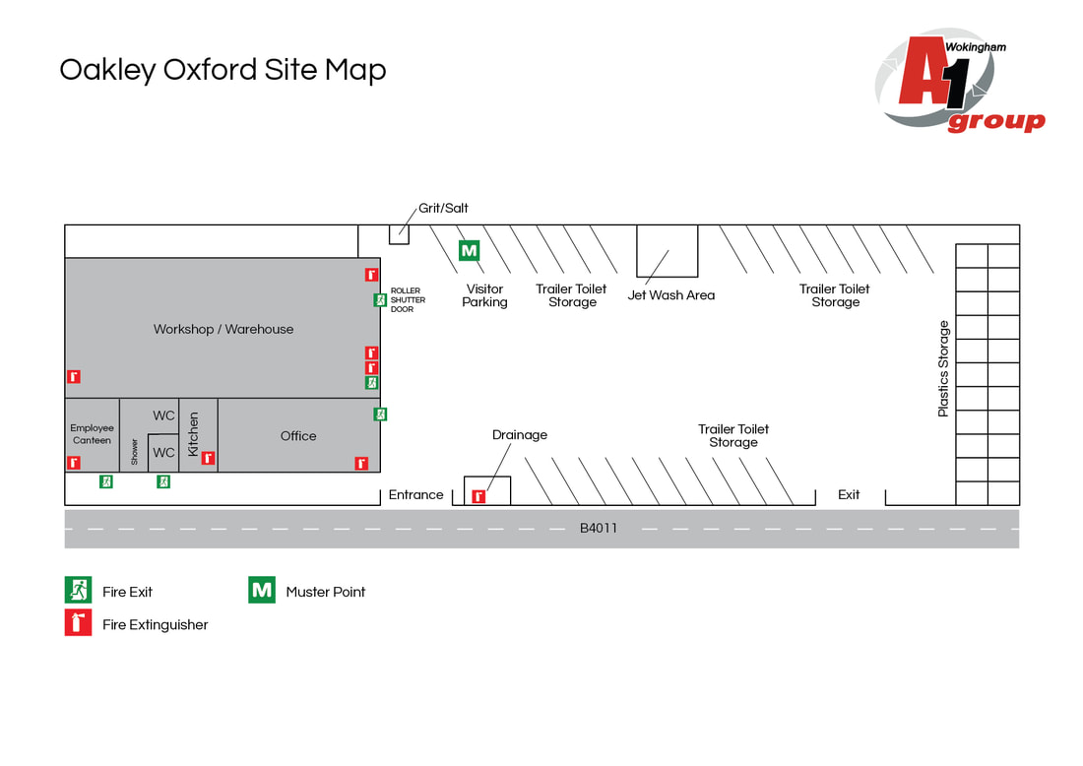

7. | Indentify Fire Hazards

SOURCES OF IGNITION:
The following ignition sources are those commensurate with office premises. Kitchen area in general office – microwave/kettle/toaster
- Paper is stored in cupboards in office area
- Smoking is not allowed in the building and is at least 4mtrs away from entrance
- Waste bins – emptied weekly

The following ignition sources are those commensurate with workshop
- Combustible materials in workshop – solvents / fuel / cleaning materials

Canteen area – kitchen with microwave/kettle/toaster

Yard area – there are no combustible materials or ignition sources in the yard and therefore should be considered low risk

SOURCES OF FUEL:
The sources of fuel commensurate with office premises are as follows:
- Office - the majority of the work is completed on computers so there are not vast amounts of paper. Paper for printers etc. is stored away in stationary cupboard which is kept locked. Waste paper bins are emptied weekly and the waste is removed from site.

The sources of fuel commensurate with workshop premises are as follows:
- Oil for vehicles / cleaning materials / butane and oxyacetylene
- No petrol stored on site

WORK PROCESSES:
The work processes are commensurate with office and workshop premises. There are no processes
that pose a significant fire hazard in the office. In the workshop grinding and use of Oxyacetylene
are limited to workbenches which are clear of combustible material.

A competent electrician maintains all the electrical equipment. There is a service level agreement with an outside contractor to service all IT equipment. The company policy is the close down all electrical equipment at night.

STRUCTURAL FEATURES THAT COULD PROMOTE THE SPREAD OF FIRE:
The office premises were built around 90’s. All services and compartments are adequately fire stopped and there are no voids or false ceilings. The workshop and Warehouse are large open spaces with numerous fire exits

8. | Fire Safety Signs and Notices

COMMENTARY:
There are adequate fire safety signs and notices on the premise. All exit routes and fire safety equipment are adequately signposted.

9. | Fire Warning System

COMMENTARY:
There was no fire warning systems on site. A Manual Alarm bell need to be installed immediately on site and test evacuation needs to be conducted. There is a fire evacuation point at the front of yard area

10. | Emergency Lighting System

COMMENTARY:
There is emergency lighting system in the general office / canteen. The Workshop/Warehouse as a number of fire exits with warning signs above the appropriate fire doors – which do not have emergency lightening. There are two fire exits in the general office. The yard area has adequate emergency lighting which can be activated manually if required.

11. | Fire Fighting Equipment

COMMENTARY:
There is sufficient number of correct type of extinguishers located throughout the general office /canteen/yard area/workshop and warehouse area. These are serviced annually and staff are trained in their use.

12. | Management - Mantenance

IS THERE A MAINTENANCE PROGRAMME FOR THE FIRE SAFETY PROVISIONS IN THE PREMISES? | YES | NO
COMMENTARY:
All fire equipment is serviced annually by RES Group of 14 Cremyll Road, Reading, RG1 8NQ | 

ARE REGULAR CHECKS OF FIRE RESISTING DOORS, WALLS AND PARTIONS CARRIED OUT? | YES | NO
COMMENTARY:
Carried out by Depot Manager | 

ARE REGULAR CHECKS OF ESCAPE ROUTES AND EXIT DOORS CARRIED OUT? | YES | NO
COMMENTARY:
Yes a weekly check is conducted by the Depot Manager | 

ARE REGULAR CHECKS OF FIRE SAFETY SIGNS CARRIED OUT? | YES | NO
COMMENTARY:
Yes a weekly check is conducted by the Depot Manager | 

IS THERE A MAINTENANCE REGIME FOR THE FIRE WARNING SYSTEM? |  | YES | NO
COMMENTARY:
Yes a weekly check is conducted by the H&S Representative | WEEKLY: | 
 | ANNUALLY: | 

IS THERE A MAINTENANCE REGIME FOR THE EMERGENCY LIGHTING SYSTEM? |  | YES | NO
COMMENTARY:
The lighting in the yard area is tested weekly | WEEKLY: |  | 
 | MONTHLY: |  | 
 | ANNULALLY: |  | 

IS THERE MAINTENANCE OF THE FIREFIGHTING EQUIPMENT (BY COMPETENT PERSON?) |  | YES | NO
COMMENTARY:
 | WEEKLY: |  | 
All fire equipment is serviced annually by RES Group of 14 Cremyll Road, Reading, RG1 8NQ | ANNUALLY: | 

ARE RECORDS KEPT AND THEIR LOCATION IDENTIFIED? | YES | NO
COMMENTARY:
The records for all aspects relating to maintenance issues are kept in general office by the Depot Manager | 

13. | Method for calling the Fire Service

SPECIFY:
Dial 999 from any telephone

14. | Emergency Action Plan (EAP)

COMMENTARY:
There is a sufficient Emergency Action Plan attached to this record.

15. | Training

COMMENTARY:
Training is provided by the Depot Manager. An annual refresher training is conducted to remind staff of what to do in the event of fire. Also included – How to call the Fire Service, and How to operate the fire alarm system. All personnel including the Managing Director undertake this Training.

16. | Fire Safety Deficiencies to be rectified

DEFICIENCY/RECTIFICATION: | PRIORTY: | DATE TO BE RECTIFIED: | DATE RECTIFIED:
Fire/Evacuation procedures need to be displayed around the depot | 1 | Immediate
Site map needs to be displayed around depot | 2 | Immediate
General housekeeping in Workshop/Warehouse needs to be improved | 1 | Immediate
Lockable cabinet required for all flammable aerosols and cleaning products on site. | 1 | Immediate

17. | Significant findings

SIGNIFICANT FINDING: | CONTROL MEASURE/ACTION:
No Fire Alarm Operational on site or record of last fire drill conducted | Action by H&S Representative
Fire Procedure missing from all notice boards | Action by H&S Representative
Flammable aerosols/cleaning products which are used on site to be stored in lockable cabinet when not in use | Action by H&S Representative
Create a smoking area which is at least 4 meters from building | Action by H&S Representative

18. | Additional Hazards

SPECIFY:
None present at time of assessment
NEED TO CONSULT FIRE SERVICE? (Please circle) | YES | NO

A1 GROUP FIRE SAFETY MANAGEMENT PLAN

FIRE SAFETY PLAN: |  | RESPONSIBLE PERSON:
Person with overall responsibility for Fire Safety. |  | Ivor Swatton
 |  | POSITION:
 |  | Depot Manager

FIRE RISK ASSESSMENT: |  | RESPONSIBLE PERSON:
Person responsible for carrying out and review. |  | Sean Whittle, FCIPD
 |  | POSITION:
 |  | H&S Consultant

MAINTENANCE PROGRAMME: |  | RESPONSIBLE PERSON:
Person responsible for:  - Maintenance of Fire Safety provisions  - Fire Alarm  - Emergency Lighting  - Fire Fighting Equipment  - Escape routes  - Fire Safety signs and notices |  | Ivor Swatton
 |  | POSITION:
 |  | Depot Manager

EMERGENY ACTION PLAN: |  | RESPONSIBLE PERSON:
Person responsible for production and review |  | Clive Owen
 |  | POSITION:
 |  | General Manager

STAFF TRAINING: |  | RESPONSIBLE PERSON:
Person responsible:  - Fire Safety Training of all staff  - Implementing Fire Drills |  | Ivor Swatton
 |  | POSITION:
 |  | Depot Manager

A1 GROUP EMERGENCY ACTION PLAN

ASSEMBLY POINT:
Away from the main building in the employee parking area

ACTION ON DISCOVERY OF FIRE:
- Sound the alarm using the nearest fire alarm call point
- Leave the building by the nearest fire exit
- Do not re-enter the building
- Report to the assembly point
- Call the fire brigade by mobile phone (after leaving the building)
- Liaise with the fire brigade on their arrival
- Only attempt to tackle small fires if confident to do so using the correct firefighting equipment
- Do not put yourself at risk

ACTION ON HEARING ALARM:
- Leave the building by the nearest fire exit
- Do not re-enter the building
- Report to the assembly point
- Call the fire brigade by mobile phone (after leaving the building)
- Liaise with the fire brigade on their arrival

VISITORS:
- Ensure all visitors and contractors are taken to the assembly point
- Assist any disabled persons with their evacuation as necessary

