Fire Emergency Evacuation Plan and the Fire Procedure

The A1 Group fire emergency evacuation plan (FEEP) is a document which includes the action to be taken by all staff in the event of fire and the arrangements for calling the fire brigade. It includes all relevant information in relation to the FEEP.
General Fire Notice - a fire action sign posted in positions where staff and relevant persons can read it and become familiar with its contents.
Staff Fire Notice - this is a detailed emergency evacuation plan which takes account of the findings of the risk assessment, e.g. the staff significantly at risk and their location. In addition, it contains notices giving clear and concise instructions of the routine to be followed in case of fire.
Responsible Persons
These are employees responsible for implementing the A1 Group fire action plan and they have received adequate training in firefighting and evacuation procedures.
In producing this document, the following items have been considered where appropriate:
- Fire evacuation strategy
- Action on discovering a fire
- Action on hearing the fire alarm
- Calling the fire brigade
- Power/process isolation
- Identification of key escape routes
- Fire wardens/marshals
- Places of assembly and roll call
- Firefighting equipment provided
- Training required
- Personal Emergence Evacuation Plan
- Liaison with emergency services

Fire evacuation strategy
At the A1 Group we have a simultaneous Evacuation in place which is where everyone will react to the warning signal given when a fire is discovered, then making their way, by the means of escape, to a place of safety away from the premises which is located by the main entrance to the site.
Defend in Place
This allows the employees to stay put and allow the internal fire service to extinguish the fire. If the fire spreads and it cannot be controlled, then they will initiate a full evacuation.

Action on discovering a fire:
On discovering a fire, it is the duty of every person to sound the nearest fire alarm immediately.
Action on hearing the fire alarm
All employees of the A1 Group upon on hearing the fire alarm to act in accordance with the agreed FEEP strategy and the responsibility of the fire warden’s on hearing the alarm. All employees and visitors should proceed to muster station located by the main entrance via the nearest safe route.
Lifts and escalators – N/A
Building control - Employees should not re-enter any building with the possible exception of the Fire Team.
Calling the fire brigade
The Fire Service should also be informed immediately, either by a Fire Warden once they have assessed the conditions.
Work Time – all Fire Wardens are conversant with the emergency evacuation plan during work hours. .
Other Times – to be discussed
Power/process isolation
Close Down Procedure – The A1 Group ‘ Close Down’ procedure is as follows:
Identification of key escape routes
At the Wokingham site where members of the public or persons unfamiliar with layout of the premises will follow a Fire Warden who will direct them to the muster station via pre-designated escape route. Fire maps are displayed throughout the site in each zoned area
Fire Wardens/Marshals
The Fire Marshals where necessary safeguard the safety of employees and are responsible for the implementation of certain fire safety measures which will include the fire evacuation.
The A1 Group have in place a Fire Marshal for each identified zone and they are responsible for liaising with the chief fire warden to ensure all persons are accounted for in the event of a fire. They have all received special training above the needs of the normal employee, this training was conducted by an external fire training organisation. They are competent in the use of fire extinguishers and be capable of extinguishing small fires. They should have some knowledge of fire prevention and are able to identify possible fire hazards to prevent fire from occurring.
The senior Fire Marshal has the responsibility of maintaining a high standard of fire precautions and the overall responsibility for the action in the event of fire. There is a nominated deputy.
Evacuation fire wardens are appointed for each zone on site and each warden should has a nominated deputy.

Fire Marshals are responsible for
- Fire routine and evacuation drill procedure
- Ensuring personnel know location of fire alarm points.
- Ensuring regular use of primary and secondary escape routes.
- The close down procedure
- Procedure for nominated staff to assist employees and members of the public to nearest exits.
- The Senior Fire Marshall is responsible for ensuring that notices are correctly sited the fire emergency evacuation plan is distributed and under stood by all employees and visitors
Places of assembly and roll call
All employees and visitors should assemble at the muster station located by the main entrance to site but in in the way to prevent the Fire Brigade entering site in an emergency.
A roll call of all employees is taken by the Fire Marshal who is in charge of the assemble point and should report to the Senior Fire Marshal indicating all persons accounted for or whose missing and where they were last seen.
The assemble point is deemed far enough away from the site not to employees in danger of radiated heat and falling debris and not to interfere with firefighting operations and not to jeopardise the actions of the fire service.
Appropriate signage is located around the site directing all employees and visitors to the muster station
Firefighting equipment provided
The A1 Group has a nominated fire team and they are trained and considered competent in attacking fire with appropriate equipment however firefighting is always secondary to life safety.
DO NOT PUT ANY PERSONS AT RISK.
A1 Group firefighting equipment
- Fire Engine
- Fire Extinguishers
- Fire Blankets
Training required
The A1 Group emergency evacuation plan is part of the A1 Group induction and subject to annual refresher training and all employees are familiar with its contents and the A1 Group also conduct regular evacuation drills. All emergency evacuation training is recorded on employee files
The A1 Group fire emergency evacuation plan includes instructions and training for all employees

Fire drills:
- Regular intervals
- Records kept
- There should be drills completed at least once a year, from sounding of alarm to roll call procedure
- Fire Alarms and Fire Fighting Equipment should be tested at weekly intervals and records kept
- Fire equipment regularly serviced
Personal Emergency Evacuation Plan (PEEP)
In order to assist ANY disabled or sensory-impaired people to escape from fire on the Wokingham site Fire Marshals are trained in the correct procedures to deal with this eventuality.
Liaison with emergency services
All Fire Marshals are aware of the necessary contacts with external emergency services. It is the duty of the Senior Fire Marshal to meet the fire and rescue service when they arrived to provide them with any information they require. They are deemed to have an intimate knowledge of the premises and be in contact with the person conducting the roll call at the assemble point.

A1 GROUP EMERGENCY ACTION PLAN

ASSEMBLY POINT:
There are two muster stations on site
- If fire in bottom yard (metal crushing and recycling area) then muster station at top of the slope next to tyre bay

- Total site / office evacuation is outside main gates to the site

ACTION ON DISCOVERY OF FIRE:
- Sound the alarm using the nearest fire alarm call point
- Leave the building by the nearest fire exit
- Do not re-enter the building
- Report to the assembly point
- Call the fire brigade by mobile phone (after leaving the building)
- Liaise with the fire brigade on their arrival
- Only attempt to tackle small fires if confident to do so
- Do not put yourself at risk

ACTION ON HEARING ALARM:
- Leave the building by the nearest fire exit
- Do not re-enter the building
- Report to the assembly point
- Call the fire brigade by mobile phone (after leaving the building)
- Liaise with the fire brigade on their arrival

VISITORS:
- Ensure all visitors and contractors are taken to the assembly point
- Assist any disabled persons with their evacuation as necessary

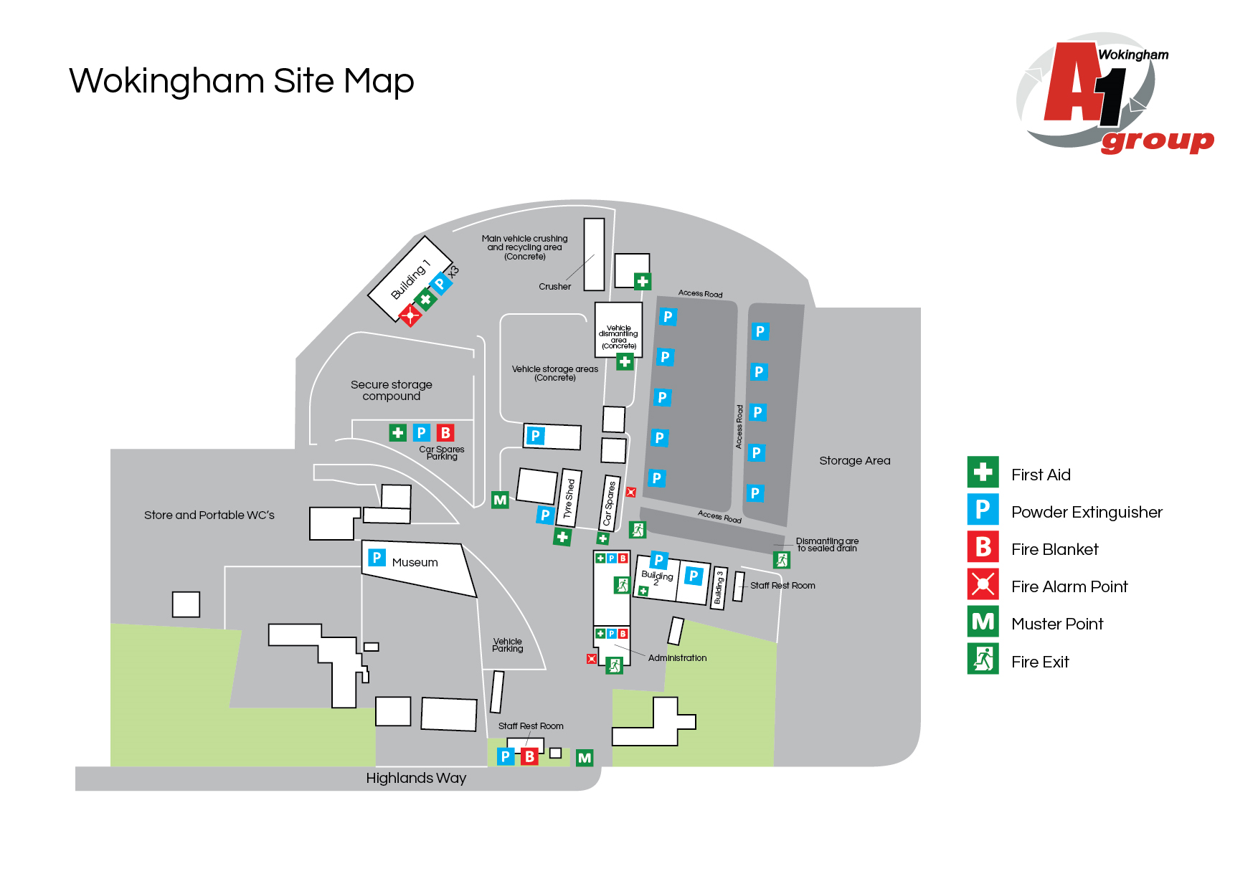

ZONE 1 – SCRAP SIDE

