BASIC DELIVERY / COLLECTION OF ACCOMODATION UNITS
Section | Title | Page
0.0 | Index | 1
1.0 | Document control | 1
2.0 | Site location and contact details | 1
3.0 | Scope | 1
4.0 | Document compiled and issued by | 1
6.0 | Clients responsibility | 2
5.0 | Description of works | 2
7.0 | Operational hazards | 2
8.0 | Site emergency procedures | 3
9.0 | Environmental  protection | 3
10.0 | Plant and equipment | 3
11.0 | Safety equipment and PPE | 3
12.0 | Procedure details | 4-8
13.0 | Lorry loader operation pre-start check | 9
14.0 | Risk Assessment | 10-14
Appendices | A: Double stacking B: Linking  C: Waste tanks and steps D: Contacts  E: Rescue plan F: Wind speeds G: Lone working  H: Cabin weights

0.0 Index |  | 1.0 Document Control
 |  | Version  1.0 | Comments  First issue | Approved by  Spencer Morgan |  | Date  March 21 | Review  Jan 2021
 |  | 2.0 Site Location and Contact Details
 |  | This section may be completed by the supplying branch, and is the only amendable section of this document:
 |  | Customer:
 |  | Contact Details:
 |  | Date of Operation:
3.0 Scope
This document sets out the A1 Group Transport method of delivery and collection of temporary accommodation hire items using lorry loader cranes. It has been produced in accordance with LOLER 1998; PUWER 1998; the RHA conditions of carriage 2009; the A1 Group Transport (UK) Ltd terms and conditions of hire; BS7121 Part 4 2010; CPA-ALLMI Best Practice Guide 2010; and the MPBA ACOP 2009.

This document has been produced without an advance survey by A1 Group Transport and is intended for the basic category of lift as defined in BS7121 Part 4:2010 and is not intended as a site-specific lift plan. It is the responsibility of the hirer to ensure that any site hazards present are notified to A1 Group Transport at the point of order.

If further information or a site-specific lift plan is required please ensure sufficient notice is provided to A1 Group Transport, in writing, to allow a site survey to be carried out and documentation produced. There may be an additional charge for this service.

Subcontractors: This document has been produced for use by A1 Group Transport lorry loader operators and vehicles only. Should you decide to adopt this document for your own use this does not alter the contractual position that all bookings made by A1 Group Transport are de-facto contract lifts (unless agreed otherwise) and the adequate planning and responsibility for all lifts remains your own.
4.0 Document compiled and issued by:
Spencer Morgan – Director A1 Group Transport |  |  |  |  | 15/03/2021

5.0 Description of Works
To deliver and collect site accommodation units of all sizes, from single units at ground level to linked and stacked complexes, using the ‘top’; ‘four corners’; or ‘bottom’ lift methods; using lorry mounted loader cranes.
6.0 Clients Responsibility
It is the client’s responsibility to ensure that the following site hazards have been controlled prior to A1 Group Transport Ltd entering site where applicable.

  - Site access must not be restricted for a loaded delivery lorry including lorries with trailers, and articulated vehicles – unless previously notified to the supplying branch.

  - Provide a work area and site access route clear of obstruction with adequate hard standing, free from underground services, manhole covers, excavations, and backfilled areas. Note: A1 Group Transport vehicles will not drive over or set up on grass or muddy areas.

  - Ensure no unauthorised persons, including the public; pedestrians; and site operatives are in the vicinity of the lift area, and provide barriers if necessary.

  - Site supervision, including: site inductions; welfare facilities; first aider; and banksman as required.

  - Ground conditions must be of sufficient strength to withstand lorry loader stabiliser pressure, and of suitable strength to accommodate the weight of the cabins being supplied.

  - Provide a work and lift area free of overhead obstructions (overhanging trees, power cables, telephone cables etc.) and any other height or width restrictions that could prevent vehicle manoeuvring or lorry loader set up for lifting (including stabilisers).

  - Clear access and egress to the area of installation, including parked cars.

  - For units being collected, all services shall be disconnected prior to A1 Group Transport arriving on site; including the flushing through of all effluent pipe work, and emptying of waste tanks, electrical supplies and cabling, ensuring no items are stored on unit roofs; and water supplies and pipework.
7.0 Operational Hazards
  - Vehicle movements.
  - Other site operatives.
  - Use of access equipment.
  - Working at Height.
  - Manual handling.
  - Use of lorry loader crane and associated lifting equipment.
  - Movement of suspended loads.
  - Locating of unit(s).
  - Lone working

8.0 Site Emergency Procedures
  - If an emergency arises all Operators will be moved to a designated place of safety, which will be briefed by the hirer during induction prior to work commencing.
  - A qualified First Aider should be on site, supplied by the hirer during the operation that this Method Statement and Risk Assessment covers.
9.0 Environmental Protection
  - Waste materials will be disposed of in the appropriate waste skips supplied on site, although it is anticipated that there will be no waste generated from this operation.
  - Any spillages of materials or liquids hazardous to the environment will be contained and reported to the site supervisor immediately. Spill kits are on all A1 Group Transport vehicles.
10.0 Plant and Equipment
  - Lorry loader crane, associated lifting accessories and associated certification to comply with LOLER 1998: Annual thorough examination of loader crane; 6 monthly thorough examination of lifting equipment.
  - Class 1 industrial ladder - of suitable length to allow 3 rungs / 1 metre extension above cabin roof line.
  - Small tools to secure / dismantle staircase and landing, and secure jacklegs as required; including bolts, washers, and nuts to suit.
  - Twist locks if stacking containerised units.
  - Wooden and / or metal packing and shims as required.
11.0 Safety Equipment and PPE
PPE is the last line of defence against the hazards identified. The following items should be used during all lorry loader operations as a minimum, in addition to any site specified items:

  - Safety helmet
  - Safety boots
  - Hi-visibility clothing
  - Safety harness/Fall arrester block (when top lifting / working at height)
  - Safety gloves
  - Safety glasses
  - Ladder stabilising device – ladders must be adequately stabilised with a ladder stabilising device; or fully footed by a second operative
  - Spill Kit
  - Fire Extinguisher

12.0 Procedure Details
The operator of the lorry mounted loader crane is given authority to STOP the lifting operation if it is considered that a dangerous situation is likely to arise if the operation were to continue.
  - Lorry loader vehicles will arrive to site having completed pre-operational inspections at the start of the day or shift; the drivers will sign in and complete any site induction as required. Responsible person on site will provide site-specific safety information.

  - Driver will provide all necessary certification for the Lorry Loader and lifting accessories to be utilised, and competency cards.

  - Responsible person on site will give instructions on the positioning of the units and loading / unloading point, and the suitability of ground. Client will provide a banksman to assist in positioning of lorry (if required, such as when reversing).

  - Lorry loader operator will proceed to and assess the suitability of the loading / unloading point and completes the on-site Lorry Loader Pre-Start Check. The Duty Chart will be checked to ensure the lift radius required does not exceed the loader cranes capacity. All concerns are reported to the responsible person and / or the Appointed Person who will assist with resolution.

  - The lifting zone is adequately identified by appropriate measures, such as site supplied barrier, cones, barrier tape etc. It is the sole responsibility of the operator to ensure the lift zone is free from all personnel.

  - The remote control is taken from its dedicated storage point and worn via its belt or neck strap at all times, and isolated apart from when operating from a standing position.

  - Operator will fully extend stabiliser legs of lorry loader and place spreader pads under feet before lowering hydraulic legs, checking firmness of ground. Stabiliser locking mechanisms must be operated and checked if fitted. Lorry loaders fitted with a Stability Monitoring Device may operate without the full deployment of all stabiliser legs, because they automatically de- rate the capacity of the crane.

  - Operator will unfold lorry loader arm and attach lifting equipment. If roof access is required an Auto-descender fall arrest block is attached using the hook which is used as an anchor point. Tag line is attached to the snap hook for retrieval from ground level once the hook is at height.

  - Operator positions the hook over the unit centre of gravity. Remote control is isolated. If delivering, load restraints are removed.

  - The bottom lift method will be used by default providing the unit has appropriate lifting points; suitable lifting accessories are available on the vehicle; and environmental conditions allow it (for example unit cannot be flush to a wall / other item which would prevent the removal of the lifting accessories).

Notes:
Bottom lifting is not achievable when linking units as the lifting accessories become trapped and irretrievable. If collecting via a bottom lifting method, the roof must be checked for materials prior to any lifting.
A1 Group Transport units should not be lifted using jacklegs.

Procedure details continue on next page:

Ref. | Bottom Lifting Method: Containers and Containerised Accommodation units
12.11A | Operator attaches 4 x cam locks (Preston Shoes) into the four bottom ISO castings along with shackles, checking the ISO casting for any visual defects. The chain hooks are then connected to the shackles.
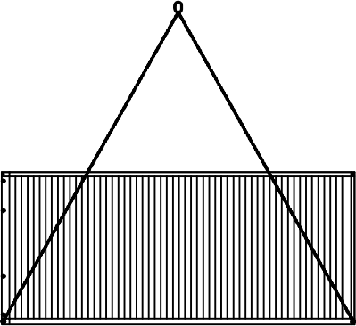
Figure 1: Container slung for ‘Bottom Lifting’ eliminating Working at Height.

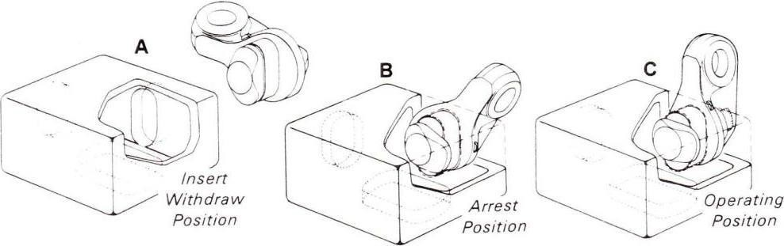
Figure 2: Operation of Preston Shoe ‘Bottom Lifting’ cam lock.
Ref. | Bottom Lifting Method: Accommodation units
12.11B | Bottom lifting method for accommodation units is for the operator to position and secure the chain hook directly on to the lifting lug situated on the bottom corner of the unit, with the safety catch of all brother chain hooks positioned facing away from the units centre of gravity, checking the lifting point for any visual defects.  Note: A1 Group Transport units have two types of bottom lifting points. The type shown in Figure 5 require the use of 1 No. 3.0te ‘D’ shackle connected to each lifting point, to hand-tightness, and the chain hook connected to the shackle.
Figure 3: Accommodation unit slung for ‘Bottom Lifting’ eliminating Working at Height.
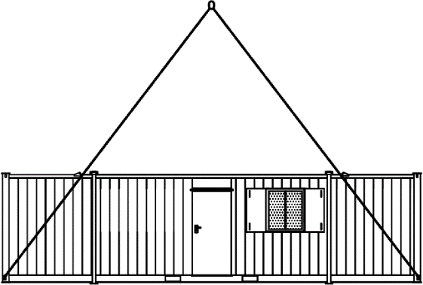
Figure 4: Typical bottom lifting point
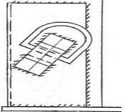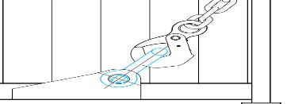
Figure 5: Bottom lifting point requiring 3.0te SWL ‘D’ shackle.

Ref. | Four Corner Method
12.11 | For all lifting methods using units dedicated lifting points at roof level the safety catch of all brother chain hooks should be positioned facing away from the units centre of gravity.  Figure 5: Safety catch position ISO point units  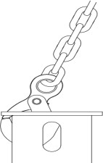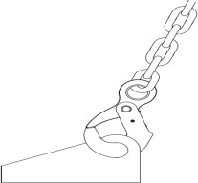  Figure 6: Safety catch position lifting point units
12.11C | The Four Corner method of lifting is for the operator to connect the lifting chains to the four lifting points via a fully stabilised ladder; angled 4 to 1 against the cabin avoiding the need to access the unit roof; checking the lifting point for any visual defects. Ladder MUST be stabilised and 3 points of contact MUST be achievable when connecting the lifting chains.
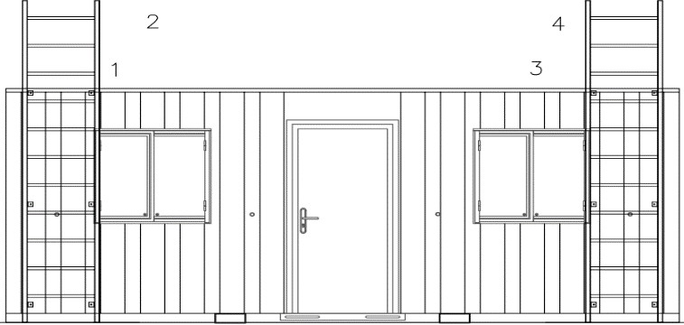
Figure 7: Four Corner Method
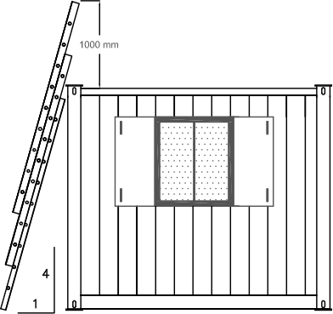
Figure 8: Ladder Angle

Ref. | Top Lifting Method.
12.11 | For all lifting methods using units dedicated lifting points at roof level the safety catch of all brother chain hooks should be positioned facing away from the units centre of gravity.  Figure 9: Safety catch position ISO point units  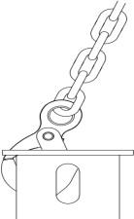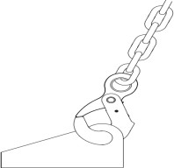  Figure 10: Safety catch position lifting point units
12.11D | i. With the fall arrest block connected to the crane hook as an anchor point, the Operator retrieves snap hook via a tagline and attaches to safety harness at ground level. Operative must be attached at all times during all working at height tasks.
 | ii. The anchor point must be held as high as possible above the working area. Additionally, the angle of the cable line should not exceed 45 degrees, to limit swing effect in the event of a fall.
 | ii. Access to the unit is made from a fully stabilised ladder placed centrally to the unit, allowing for the ladder to extend 3 rungs / 1 metre above the roofline.
 | iv. Operator takes one chain leg at a time and connects to the units lifting points until all chains are connected, checking the lifting point for any visual defects.
 | v. Operator descends ladder and disconnects from fall arrest system. Ladder is stowed away.
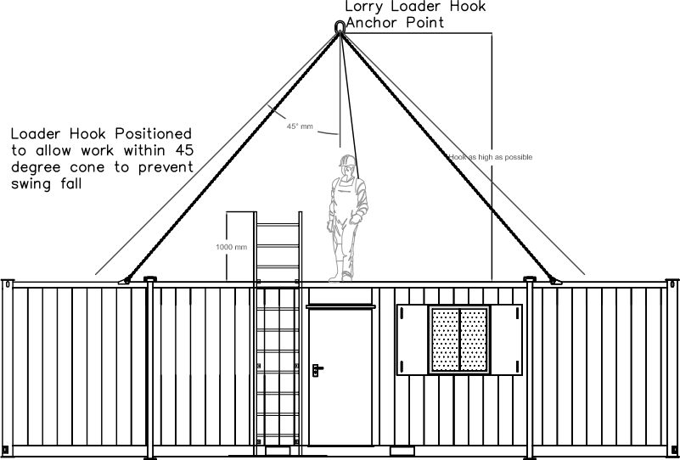
Figure 11: Top Lifting Method.

12.0 Procedure Details Continued:
  - Dependent upon the weather conditions, and height of lift, the Operator will attach guide ropes to assist stability during lifting and may request assistance in holding guide ropes if necessary.

  - The remote control is made live. Operator carefully operates lorry loader to tension the lifting tackle and ensure the alignment of the crane hook is over centre of load, repositioning and adjusting the lifting accessories if required.

  - Before lifting commences Operator ensures there are no unauthorised personnel are in or around the lifting zone, and authorised personnel are clear of the lifting route.

  - Operator lifts load slightly and conducts a test lift to determine the load is level and stable, and the lifting accessories are correctly attached. Final inspection of lifting points is made under tension.

  - When satisfied that load is stable the Operator manoeuvres and lowers unit to the offloading point, or the lorry bed if collecting. The load should be kept as low to the ground as reasonably practicable, with the remote-control levers operated progressively and gently.

  - Operator must select a standing position with a clear view of the vehicle, load, and its intended path at all times; and ensure re they are not in such a place where an incorrect or unintended movement of the lorry loader can trap or crush the operative or any other personnel. If unachievable a signaller should be used, or further persons to ensure the working area is not breached. No operatives may walk or place any body part including hands under a suspended load.

  - When delivering units, the Operator / Installation operatives will ensure they are level using a spirit level and packing, shims, or sleepers as required under the corners or jacklegs of the units, checking the doors open and close. If positioning a unit over a waste tank, jacklegs are extended to required height. Packing and jacklegs are only to be used to level over small slopes, and not to build up or bridge large gaps.

Use of Jacklegs
    - Jacklegs are only to be used to level units to a maximum gradient of 150mm (except 2+1, 2+1+Shower and 3+1 toilet blocks).
    - Jacklegs on any unit apart from the above exemptions must not be installed whilst extended beyond 150mm under any circumstances.
    - Effluent tanks cannot be placed under 4+1, 6+1 or 6+1+showers unless the customer has built a 4x corner foundation to allow the space underneath.

  - When the Operator is satisfied the unit is level and in the correct position the loader arm is lowered slightly to release the tension on the lifting accessories. Remote control is isolated. The cabin stability is checked.

  - Operator then disconnects lifting chains by using the method used to sling the unit originally.

  - The remote control is made live and the loader arm is manoeuvred away from load.

  - For double stacked units refer to Appendix A. For linked units refer to Appendix B. For units being positioned over waste tanks, refer to Appendix C.

  - When (un)loading is complete, all lifting accessories are removed from the hook and stored, loader arm is folded away, stabiliser legs retracted, stabiliser locking mechanisms checked, and spreader pads are stored away.

  - If collecting load is adequately secured using appropriate restraints. All window shutters, doors, and unit contents are secured for transportation.

  - Operator tidies lifting area, paper work is signed, checks the remote-control handset is in its storage place, lorry leaves site under guidance of Banksman where necessary.

13.0 Lorry Loader Operation Pre- Start Check
IF ANY OF THE ANSWERS BELOW ARE ‘NO’ LIST FURTHER CONTROL MEASURES UNTIL THE PROCESS  IS SUITABLY CONTROLLED IN CONSULTATION WITH RESPONSIBLE PERSON ON SITE AND / OR APPOINTED PERSON ACCORDING TO THE KEY BELOW:  GREEN: Proceed with the lift  AMBER: Consult with responsible person on site until resolved, or contact Appointed Person RED: Stop work immediately and contact the Appointed Person | SATISFACTORY?
Have the vehicle daily walk around checks; loader crane and lifting accessory; and Safety Equipment / PPE pre-  use checks been completed and documented? | Yes | No
Has a site induction been conducted, and the client confirmed they have seen and approved these documents? | Yes | No
If on a public road are the emergency services able to pass whilst you are working? | Yes | No
Is the work area clear with adequate hard standing? Free from slip, trip and fall hazards, and with sufficient space  available for the lorry loader vehicles to set up for lifting, including vehicle stabilisers? | Yes | No
Are adequate controls in place to prevent ingress of others, including children/public? | Yes | No
Clear overhead - electricity (min distance to cables is 9m wooden poles and 15m steel structures, PLUS full length  of boom PLUS any protruding load)? | Yes | No
Clear overhead – other (telephone cables, canopies, trees, bridges)? | Yes | No
Is the ground condition around the working area free from underground services, manhole covers, and backfilled?  areas? Can you set up 1m away for every 1m deep from any excavations? | Yes | No
Are the lifting points visually sound? Note: A1 Group Transport units are not suitable for lifting using the jacklegs | Yes | No
For deliveries, is the ground condition where the unit(s) will be positioned level and of suitable strength to  accommodate the weight of the unit, and without requiring excess packing? | Yes | No
Are the weather conditions satisfactory to conduct a safe lift? | Yes | No
Is the site adjacent to any railway lines, either within a Network Rail boundary fence or in such proximity that an  emergency situation may affect the safety of the lines? | Yes | No
If Lifting forward of the front outriggers, is there adequate space to work? (tag lines to be used) | Yes | No
If lifting forward of the front outriggers, has the capacity de-rate of the lorry loader been considered? | Yes | No
State which safe method of lift is being used (tick box):
Further Comments / Control Measures:
If the delivery location is going to substantially change prior to the unit’s eventual collection, such as new buildings or access routes, or any further information that the branch should be made aware of, please note here:
I confirm that on completion of this checklist all areas are satisfactory, and the lifting operation can commence according to the contents of this
method statement and risk assessment:
Lorry Loader Operator:
Name (printed):…………………………… Name (Signed):………………………………… Date:……………………………….
Eliminate Roof Access |  | Mitigate Effects of Roof Access |  | Other
Bottom Lift containerised unit |  | Top lift with inertia block & harness |  | Webbing sling (refer to Appointed Person)
Bottom lift accommodation unit
Four corner method

Additional Operatives Role | Name (printed) | Name (Signed) | Date

Appendix A: Double Stacking
A1. Operator/Installation operatives will ensure that the base unit is levelled prior to the second unit being lifted into position.

A2. The same procedure as outlined for a single unit is followed for the lifting and positioning of the double-stacked unit. For containerised units being stacked, twist lock intermediaries are placed in the base units ISO castings ready to secure the double stacked unit.

A3. The second unit is then manoeuvred by use of taglines and positioned directly above the base unit so that the adjoining jacklegs or Twist locks are aligned.

A4. Operative secures and stabilises ladder prior to bolting and securing together adjoining jacklegs or to secure twist locks.
No operatives may place any body part including hands between cabins during the stacking procedure.

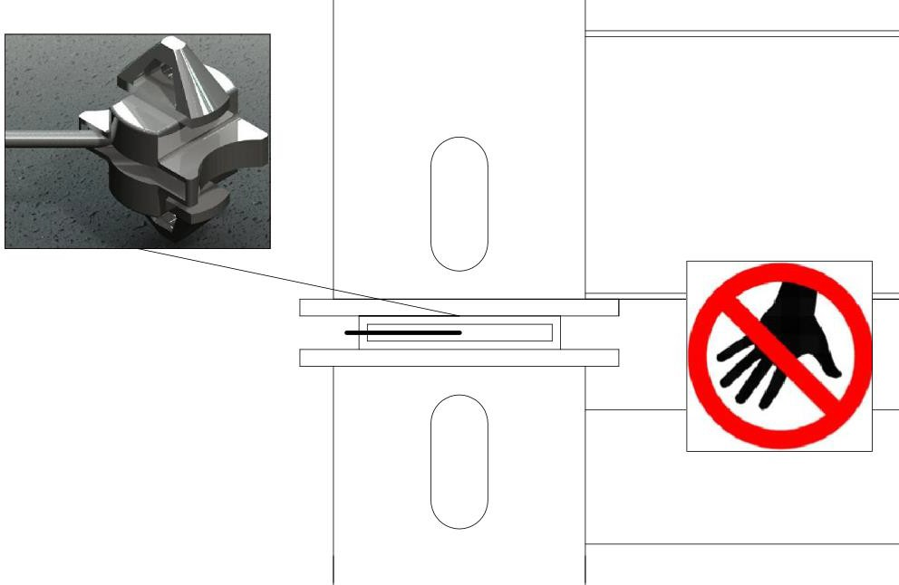
Figure 12: Securing of stacked units using twist lock intermediaries

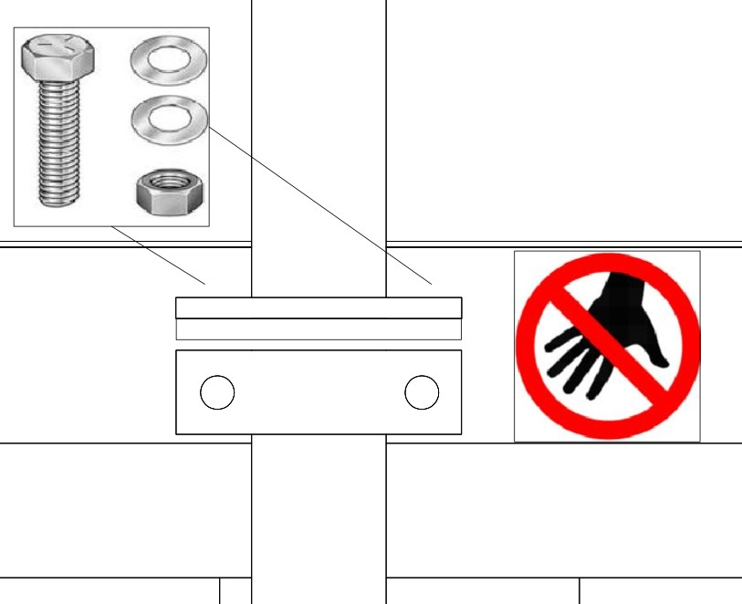
Figure 13: Securing of stacked units using bolts in jacklegs
- 4x corner twist lock stacking is our default method.
- When a jackleg stack is installed, it must be fully bolted with adequate washers (2x bolts and 4x washers per leg) and the nuts securely tightened.
- Never twist lock units together then use the jacklegs on the bottom unit to level.
- Jackleg stacks can never be more than 2x units high and the bottom unit’s legs must not be extended beyond 150mm (preferably less)
- Jackleg stacks can only be carried out on units not containing toilets.

Ref. | Staircase Installation | 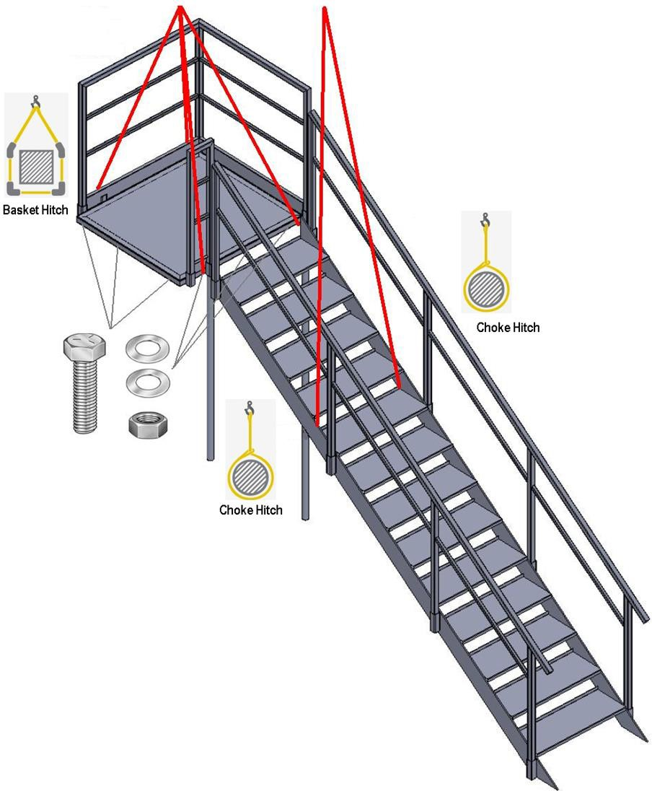  Figure 14: Slinging and securing of steel staircase and landing
A5. | i. Landing is slung using basket hitch sling method; test lift is conducted; and landing is lifted into position at doorway(s) of first floor unit. Second Operative places and secures/stabilises ladder; ascends and places bolts into position at the upper unit doorway(s) that can be achieved without over-reaching. Descends ladder, repositions and ascends again to place remaining bolts. All bolts are tightened from appropriate positions. Operative descends and retracts ladder.
 | ii. Operative raises and positions landing support legs, raises and stabilises ladder, ascends and secures support legs, ensures landing is level; removes slings.
 | iii. Handrail is fitted to stairs at ground level; appropriate slings are attached by choke hitch sling method to enable stairs to be lifted at approximately correct angle as they need to be installed at.
 | iv. Lorry loader Operator conducts test lift. Second Operative secures and ascends ladder under platform at upper unit doorway.
 | v. Stairs are lifted into position under guidance of second Operative to line up boltholes with the landing platform. Operative fits and secures bolts.
 | vi. Operative removes slings from stairs.
 | vii. Operatives to ensure stairs are installed correctly and level, obtaining clients satisfaction.
Ref. | Staircase DE installation
A6. | i. Lorry loader is manoeuvred over stairs and slings attached by choke hitch sling method to 4th/5th step down from top to allow lifting at correct angle. Lorry loader tensions slings.
 | ii. A fully restrained ladder is placed underneath the landing, providing stabilised access for an operator to unbolt stairs from landing. When stairs are unbolted they are lifted away from landing and placed upon ground, where handrail may be unbolted and removed. Stairs may be lifted onto lorry, along with handrail.
 | iii. Lorry loader is manoeuvred over landing; ladder is placed alongside and fully restrained. Landing is slung by basket hitch sling method, tension is taken up.
 | iv. Operative repositions and restrains ladder to unbolt uprights and remove from landing.
 | v. Ladder is repositioned and restrained to unbolt landing from the unit. When all bolts are removed, operative descends and retracts ladder, removing from under landing.
 | vi. Lorry loader manoeuvres landing down to ground, where handrail may be unbolted and removed. Landing and handrail may then be lifted onto bed of lorry. Note: A1 Group Transport do not permit the transport of staircases, or any ancillary items on cabin roofs, or inside units / containers.

Appendix B: Linking of units using butt- link or tunnel link system
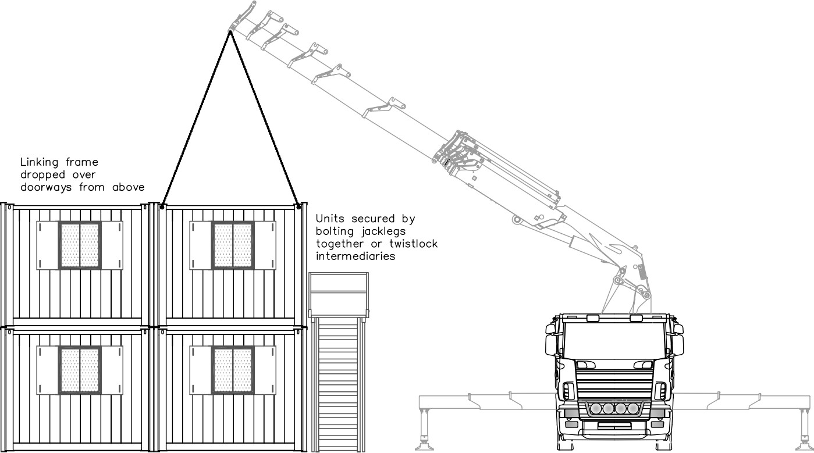

Figure 15: Linking frames

Ref. | Linking of units
B1. | i. Operative wearing full body safety harness attaches to elevated fall arrest system at ground level
 | ii. Ascends secured ladder and accesses the unit roof
 | iii. Links are positioned between the two units either by loader crane or manually, depending on size and weight.
 | iv. Descends ladder
 | v. Disconnects from fall arrest system
Ref. | DE installation of links
B2. | i. Operative wearing full body safety harness attaches to elevated fall arrest system on ground level. Ascends secured ladder and accesses the unit roof.
 | ii. Lifts the link out of position manually (with additional assistance from inside the unit from a second operative if required).
 | iii. Some heavier links, including ones with lifting points or tunnel links may be slung and lifted out by lorry loader crane.
 | iv. If De installing from a single stack, link is manually lowered to the ground to second operative.
 | v. If De installing from a double stack, link is left on the cabin roof until cabin is at ground level; or if link has dedicated lifting point, is lowered to the ground after operative is at ground level.
 | vi. Descends ladder, disconnects from fall arrest system.

Ref. | Delivery of units over 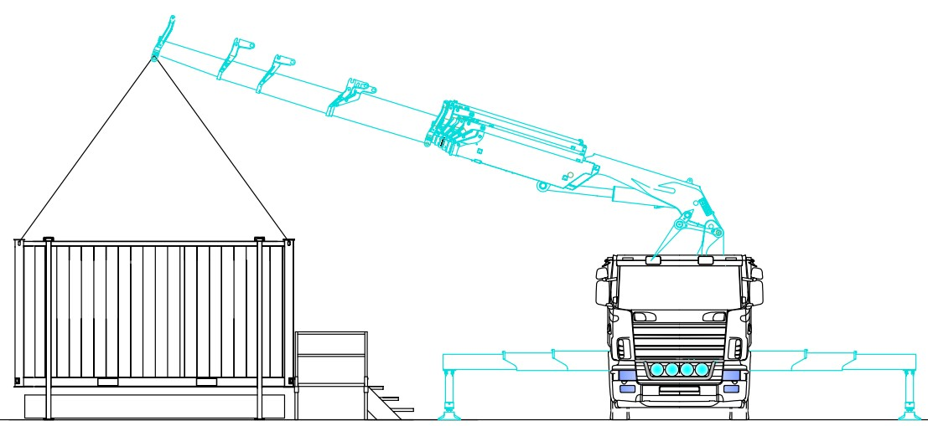waste tanks, with WC steps  Jacklegs extended to allow unit to sit just above waste tank, with waste pipe and waste hatch aligned  Appendix C: Positioning of WC units over waste tanks, and WC steps installation
C1. | i. Waste tank is lifted into position onto level ground, slung by the dedicated lifting points on all four corners.
 | ii. WC unit is lifted into position as per the procedures detailed in section 12 of this document.
 | iii. Jacklegs are extended to allow the WC unit to straddle the waste tank. Jackleg length kept to a minimum, with only enough height so as allow for connection and disconnection of plumbing and waste, and to ensure WC steps will be level with door threshold.
 | iv. WC steps are lifted into position, slung in a basket hitch, and aligned with the WC doors.
Ref. | Collection of units over waste tanks, with WC steps
C2. | i. Operative confirms with responsible person on site that the WC tank has been pumped dry (‘final pump out’). If not, the waste tank must not be collected until this has been completed.
 | ii. WC steps are lifting onto lorry bed, slung in a basket hitch.
 | iii. WC unit is lifted into onto lorry bed as per the procedures detailed in section 12 of this document.
 | iv. Waste tank is lifted onto lorry bed, slung by the dedicated lifting points on all four corners. A1 Group Transport do not permit the transport of waste tanks, or any ancillary items on cabin roofs, or inside units / containers.

Appendix D: Contacts
A1 Group Transport Contacts: Spencer Morgan or Clive Owen

A1 Group Transport Ltd
Bridgend

Clive@A1groupuk.com
Tel: 07712 556825
Spencer@A1groupuk.com
Tel: 07810 897047

