A1 Wokingham Car Spares

Continuously look for pedestrians, forklifts and hazards.
Spillage Procedure
Ensure
all necessary
PPE
is worn at all times

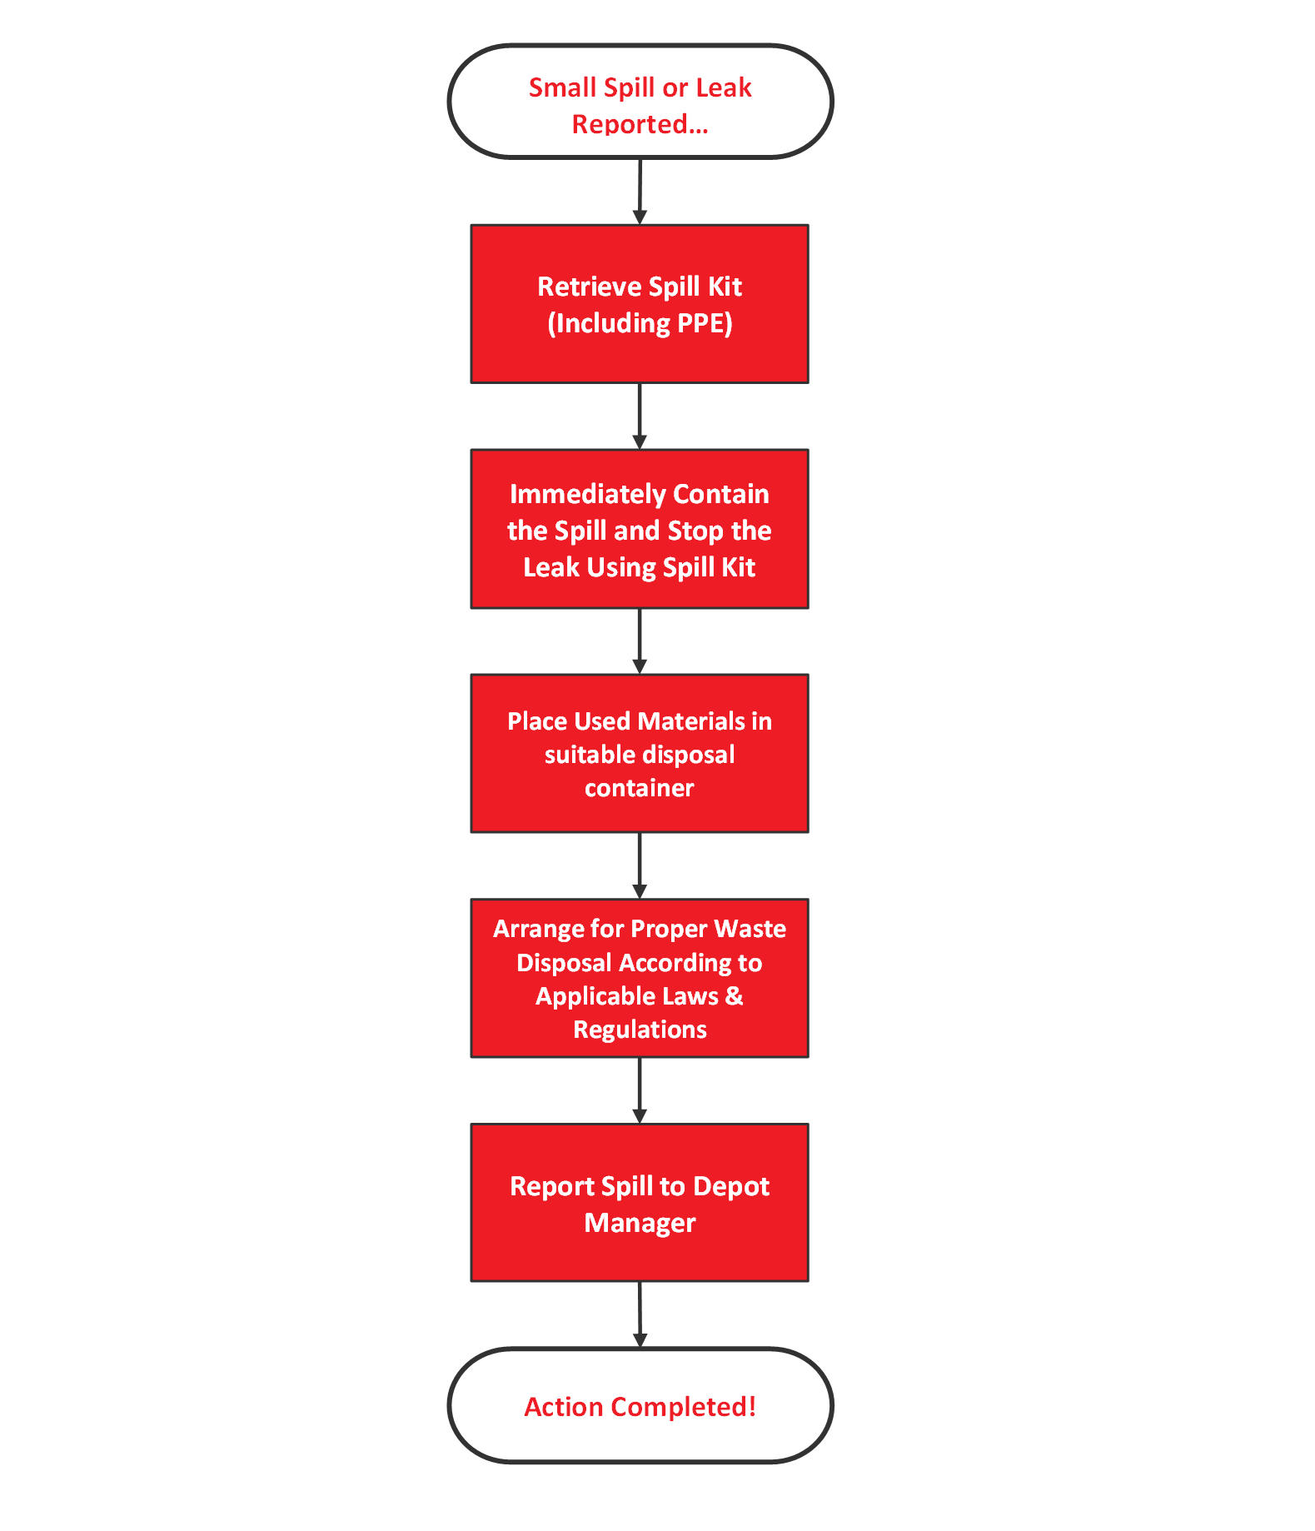

No
Yes

