Method Statement – Pipe Jetting of Existing pipe work and CCTV Surveying (non-man entry)

Thursday 12th September 2019

- Intent and Introduction

The method statement is for the proposed works by the A1 Group which is to undertake, supply materials, equipment and labour to clean by pipe jetting an existing pipe and to conduct a CCTV Survey and report findings once complete. This is method statement is not a risk assessment, please see attached risk assessment for associated related hazards and controls. Please note it is the responsibility of the proprietor / person responsible for works to ensure that there are no other hazards introduced from their own acts or omissions, or some others instructed by them. It is the responsibility of the supervisor to ensure that this method statement is adhered to and works must be halted if any hazards or risks occur but have not been suitably controlled.

- Location

Houses of Parliament, Elizabeth Tower Lift Shaft, Westminster, SW1A.

- Description of Work

To undertake and supply materials, equipment and labour to clean by pipe jetting an existing pipe and to conduct a CCTV Survey once complete.

- On arrival to site, all A1 Wet Waste Ltd employees must report to the prearranged meeting point (Site Office) wearing correct PPE – hi viz jacket / steel toe capped boots / gloves and have eye protection with them
- All A1 Wet Waste Ltd employees will undergo a site induction at 08:00am. All site rules will be understood adhered to
- A1 Wet Waste Ltd employees are reminded of the dangers of work on site.
- Site will be under the control of the appointed SRM Managers whose instructions will be obeyed at all times
- An on-site risk assessment will be carried out by the site supervisor and an SRM Manager . Any changes from the site risk assessment will be noted and appropriate measures taken to control risks identified. If site safe with all control measures in place work may commence. If site unsafe with all control measures in place work must be abandoned until risks assessed an additional control measures put in place
- Work will not commence until procedure 5 is completed. If risks cannot be controlled works must be abandoned until appropriate control measures in place and works safe to continue
- Safer access will be made to the point of works. All site safety rules will be followed throughout the operations including access and egress to a point of works

- Locate area of work unload the equipment following the correct Manual handling procedure
- Operations may now start
- Cover any equipment with tarpaulin to ensure doesn’t become contaminated with any possible debris
- Locate and remove rodding eye from pipework
- Insert jetter into pipework and remove blockage (if there is one)
- CCTV equipment will be set up and inserted in to entry point, the CCTV survey will then take place.
- Once blockage removed/problem is identified and resolved reinstate rodding eye and rubber seal and ensure tight
- On completion of the works ensure all equipment is checked, cleaned and stowed away
- When safe to do so ensure covers, pipes are replaced, barriers removed, the work area cleaned and disinfected, and the site is left in a safe condition
- Report any defects, faults or operational problems immediately to your supervisor

- Plant and Equipment

- Operations equipment (Electric Jetting unit – 240v ) Extension lead if required
- All equipment MUST be tethered all times when in use using a typical tool tethering system this will have three parts: the tether point on the tool itself, a tool lanyard, and an anchor point – this is a preventative control and will stop the tool from falling or being dropped in the first place
- A1 Wet Waste vehicle
- Potable First aid kit
- Portable exterior lighting (if required)
- Appropriate lighting (intrinsically safe head/hand lamps when required)
- PPE – hard hat / hi viz jacket / gloves / safety boots / eye protection

- Related Documentation and Assessments

- Site specific Risk Assessment
- All generic Risk Assessments
- Safety at street works and road works Code of Practice
- Health and Safety and Environmental Policy

- Location and Protection of any Services/Facilities Affected by Works

- Liaison with SRM over specifics to be determined prior to commencement of works

- Foreseeable Adverse Effects and their Control

- No issues with people as area is closed to public, office staff, other works personnel - Control measures ensure no one working in adjacent/above or below during works
- No weather conditions as work to be carried out inside building

- Safety Precautions

- First aid kit
- PPE to be worn at all times
- All equipment MUST be tethered all times when in use using a typical tool tethering system this will have three parts: the tether point on the tool itself, a tool lanyard, and an anchor point – this is a preventative control and will stop the tool from falling or being dropped in the first place

- Monitoring Systems

Supervisor or Team Leader (Kyle Styles – 07774 251238 / Steven Cummings – 07824 600382) to oversee complete operations.

- Further Information / Observations

A1 Wet Waste Ltd supervisors or managers take over all responsibility of operations and retain the right to cancel or halt any operations as they deemed necessary.

Works may need to be rescheduled if initial assessment of site deems this method statement as unviable. Please attached site specific risk assessment.

- Emergencies

First Aid Equipment is provided by the A1 Group and will be available at the location of the work

Emergency Services: 999

- Call 999 in the event of an emergency and state the incident location as [site address]
- Follow the instructions of the 999-call handler/emergency medical dispatcher until help arrives
- Call x3333 to ensure Parliament guide in emergency services
- Ensure that access for emergency vehicles is maintained throughout the site operations

Nearest Hospital:
St Thomas’
Address: Westminster Bridge Road, London, SE1 7EH.
Tel: 020 7188 7188

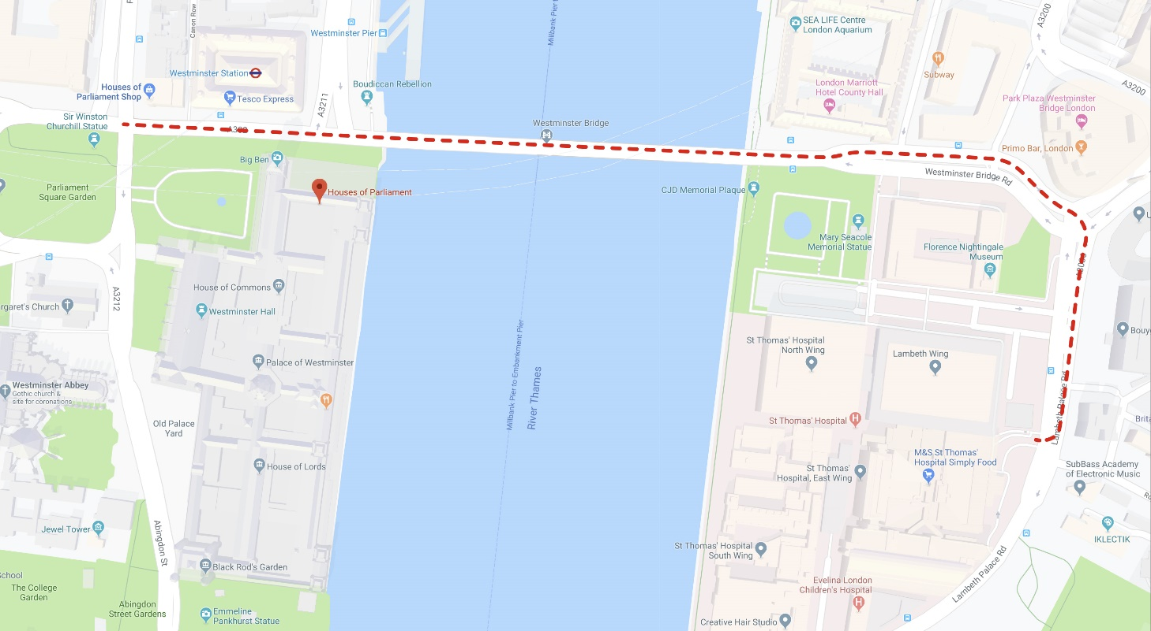

Method Statement prepared by: |  | Name: | Steve Cummings
Signed: |  | Date:

Engineer:  (When on site to confirm you have read and understood the content of this Method Statement) |  | Name:
Signed: |  | Date:

