Method Statement - Existing Pipe Replacement, Old for New

- Intent and Introduction

The method statement is for proposed works. This is purely a method statement for works and is not a risk assessment, please see attached and risk assessment for related hazards and controls. Please note it is the responsibility of the proprietor / person responsible for works to ensure that there are no other hazards introduced from their own acts or omissions, or some others instructed by them. It is the responsibility of the supervisor to ensure that this method statement is adhered to and works must be halted if any hazards or risks occur but have not been suitably controlled.

- Location

Houses of Parliament, Elizabeth Tower Lift Shaft, Westminster, SW1A.

- Description of Work

To undertake and supply materials, equipment and labour to connect 1 x existing 100mm cast iron pipe to 1 x existing 255mm pipe. All works may be weather reliant. Forecast reports shall be obtained and no works shall commence if weather causes uncontrollable hazards.

- On arrival to site, all A1 Wet Waste Ltd employees must report to the prearranged meeting point (Site Office)
- All A1 Wet Waste Ltd employees will undergo a site induction at 08:00am. All site rules will be understood adhered to
- A1 Wet Waste Ltd employees are reminded of the dangers of work on site. See generate risk assessment “Working on Site”
- Site will be under the control of the appointed site supervisor (Interserve: David Nash – 07553 376112) whose instructions will be obeyed at all times
- An on-site risk assessment will be carried out by the site supervisor and a representative for the Houses of Parliament. Any changes from the site risk assessment will be noted and appropriate measures taken to control risks identified. If site safe with all control measures in place work may commence. If site unsafe with all control measures in place work must be abandoned until risks assessed an additional control measures put in place
- Work will not commence until procedure 5 is completed. If risks cannot be controlled works must be abandoned until appropriate control measures in place and works safe to continue
- Safer access will be made to the point of works. All site safety rules will be followed throughout the operations including access and egress to a point of works
- Locate area of work unload the equipment following the correct Manual handling procedureOperations may now start
- Existing pipe removal will be undertaken, and equipment will be set up and/or lowered to the ground. Replacement pipe installation will then take place
- Or equipment used for operations will be lowered or raised, not carried down
- On completion of the works
- Ensure all equipment is checked, cleaned and stowed away
- When safe to do so ensure covers, pipes are replaced, barriers removed, the work area cleaned and disinfected, and the site is left in a safe condition
- Report any defects, faults or operational problems immediately to your supervisor

- Plant and Equipment

- Gas detectors
- Operations equipment (110V Electric Saw)
- A1 Wet Waste vehicle
- First aid kit
- Portable exterior lighting (if required)
- Appropriate lighting (intrinsically safe head/hand lamps when required)
- PPE

- Related Documentation and Assessments

- Site specific Risk Assessment
- All generic Risk Assessments
- Safety at street works and road works Code of Practice
- Health and Safety and Environmental Policy

- Location and Protection of any Services/Facilities Affected by Works

- Customer to advise prior to work commencing

- Foreseeable Adverse Effects and their Control

- Member of the public, shop and office staff, other works personnel
- Weather conditions: control weather forecast must be obtained before any works commences

- Safety Precautions

- Gas detectors
- First aid kit
- Constant atmosphere testing throughout operations
- Safety Barrier

- Monitoring Systems

Supervisor or Team Leader (Kyle Styles – 07774 251238 / Steven Cummings – 07824 600382) to oversee complete operations.

Gas monitoring to consistently monitor atmosphere.

- Further Information / Observations

A1 Wet Waste Ltd supervisors or managers take over all responsibility of operations and retain the right to cancel or halt any operations as they deemed necessary.

Works may need to be rescheduled if initial assessment of site deems this method statement as unviable. Please attached site specific risk assessment.

- Emergencies

First Aid Equipment is provided on each vehicle

Emergency Services: 999

- Call 999 in the event of an emergency and state the incident location as [site address]
- Follow the instructions of the 999 call handler/emergency medical dispatcher until help arrives
- Care must be taken to ensure that access for emergency vehicles is maintained throughout the site operations

Nearest Hospital: St Thomas’
Tel: 020 7188 7188
Address: Westminster Bridge Road, London, SE1 7EH.

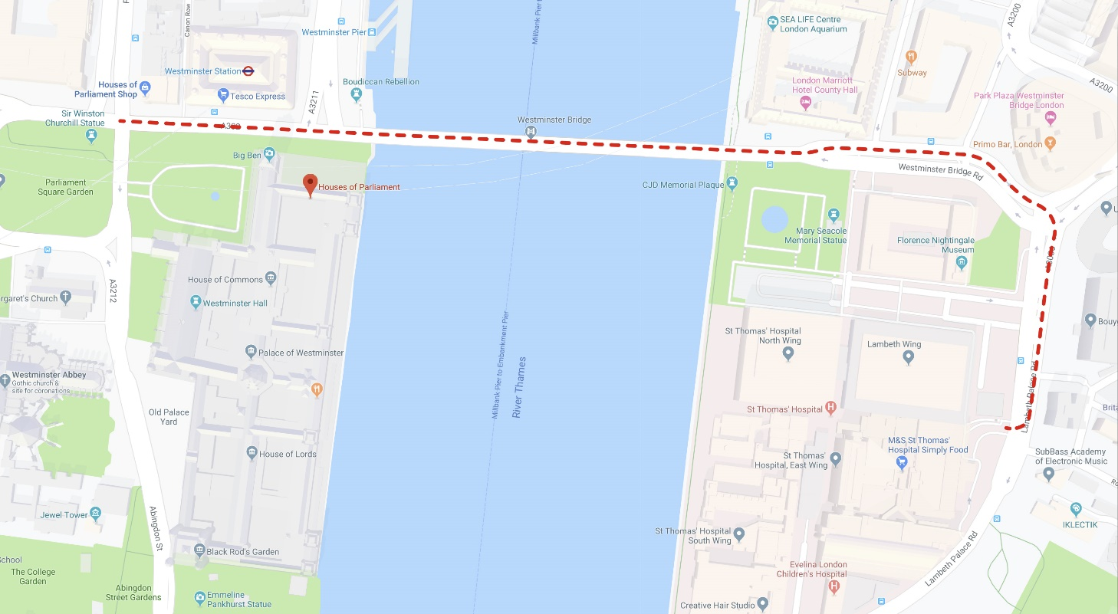

Method Statement prepared by: |  | Name: | Steve Cummings
Signed: |  | Date:

Engineer:  (When on site to confirm you have read and understood the content of this Method Statement) |  | Name:
Signed: |  | Date:

