Managing staff competence and training records
A1 Car Spares and Metal Recycling

Management Structure

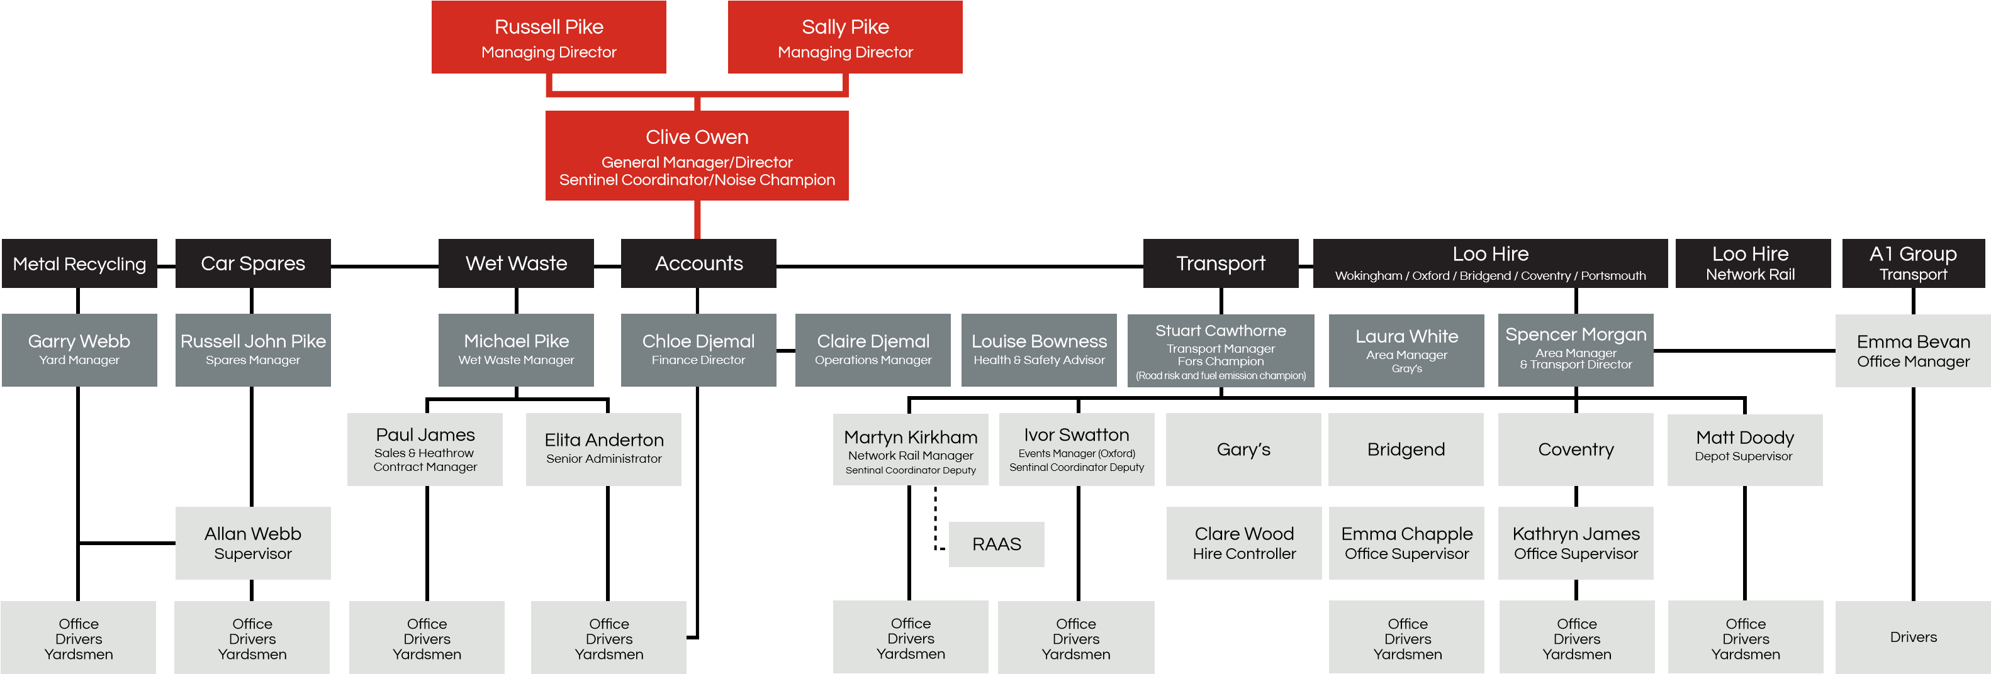

Our A1 Structure Chart outlines the roles and responsibilities of the Management team. This is given to all new starters and is available on our back office for both employees and clients to view.
Both Clive Owen (Director) and Claire Djemal (Operations Manager) are the companies Technically Competent Managers. Both have successfully completed the WAMITAB qualification. Clive Owen has also completed the NEBOSH qualification and oversees the Health and Safety aspect of the A1 Group.
Garry Webb is the Metal Recycling Manager and oversees the day to day running of the scrap yard. He recruits his own employees, conducts inductions, delivers relevant role specific training, manages performance and conducts appraisals.
Russell John Pike is the Car Spares Manager and oversees the day to day running of the Car Spares department. He recruits his own employees, conducts inductions, delivers relevant role specific training, manages performance and conducts appraisals.

Louise Bowness is the companies Health and Safety Advisor and reports to Clive and Claire. Her role is to support and guide the managers with training and working safely. Louise has completed IOSH and is currently completing NEBOSH General Certificate.

Inductions
All new employees are required to complete an induction on their first day of work. This is conducted by the relevant manager or Emily Russell who supports with completion and filing of data protected documentation.
Employees are given a copy of their job description and this is discussed with their Manger.
House Rules are also discussed at this point. Both are available for employees to review on back office.
Induction includes a checklist, review of structure chart, tour of the premises, fire and evacuation procedure and an indepth health and safety video. The video which is available on our back office includes safe working practices, for manual handling, fire and evacuation, accident and incident reporting, correct use of PPE, forklift safety etc.

Training
All new employees are required to complete the relevant role specific training prior to work commencing. This will include working alongside a competent person until they are confident to carry out tasks themselves and the manager has observed them carrying out tasks correctly.
Regular on the spot feedback is given regarding performance and annual appraisals are completed by manager to discuss progress, wellbeing and to identify if there are any training needs.
Health and Safety refresher training is completed yearly for all members of staff. This takes place in the conference room at HO. This is delivered by Sean Whittle and Louise Bowness. This includes , discussion, presentation and various videos to view. This is also available on back office for review.

Risk Assessments and Method Statements
These are available to both employees and clients on our back office. These have been written by Sean Whittle our external Health and Safety Consultant, and are reviewed yearly.
Employees are reminded of these on a regular basis via tool box talks or when training or refresher training is being conducted.

Training Matrix
Louise Bowness, Health and Safety advisor has created a training matrix, which identifies what training is required for each role, when the training was completed and when refresher training is due.
Louise will liaise with managers and book in training with relevant trainer.
We use a company called BAM to deliver dangerous machinery training for new starters and refresher training. Most dangerous machinery is completed every 1-3 years dependant on legal requirements and manufacturers suggestions.
Certificates are kept in employees personal files.

Health and Safety Meetings
These are conducted monthly with Sean Whittle who is our Health and Safety Consultant. Clive Owen, Claire Djemal, Louise Bowness and all managers are in attendance via zoom. This is an opportunity to discuss recruitment, new starters, training requirements etc. The minutes are available on back office for employees to review.

Job Roles Car Spares and Metal Recycling
Administration Assistant
The Administration Assistant provides both clerical and administrative support to the business. The Administration Assistant plays a vital part in the administration and smooth-running of businesses and involves the coordination and implementation of office procedures and frequently has the responsibility for specific projects and tasks.
Cleaner
The role of a cleaner is to ensure the facilities are clean and tidy to the frequency and standards set out.
Car Spares Manager
Reporting to the Directors / General Manager, the Car Spares Manager will supervise and communicate daily with the yard foreman and administrate all related documentation and communications to ensure sufficient smooth operation of the car spares area. They are also responsible for making sure all car spares machinery is functioning correctly and for reporting issues whenever there is a problem. The Car Spares Manager is responsible for overseeing yard cleanliness and safety and will work in conjunction with other managers to assist with various managerial duties such as hiring, induction and training. Whenever there is a customer service issue, the Car Spares Manager answers all customer questions.
Baler Operator
The role of a Baler Operator is to operate and maintain the scrap metal baler /shearer on site. Depresses buttons, lifts levers, and ensures load is safely loaded, compacted and discharged from the machine.
Crane Operator
The role of a Crane Grab Operator is to operate and maintain the crane on site. The Crane Grab Operator is responsible for operating a stationary crane to position, and reposition loads. Depresses buttons, lifts levers, and ensures load is safely attached to crane before bringing it down
HGV Driver
The HGV drivers responsible for the safe delivery of ELV’s and processed metal locally and nationally. They are responsible for the safe upkeep of their vehicles alongside the transport manager.
Metal Recycling Manager
Reporting to the Directors / General Manager, the Metal Recycling Manager will supervise the yard foreman and administration staff and administrate all related documentation and communications to ensure sufficient smooth operation of Metal Recycling area. They are also responsible for making sure all yard machinery is functioning correctly and all company vehicles are in line with VOSA regulations and requirements and for reporting issues whenever there is a problem. The Metal Recycling Manager is responsible for overseeing yard cleanliness and safety and will work in conjunction with other managers to assist with various managerial duties such as hiring, training, evaluating, assigning duties. Whenever there is a customer service issue, the Metal Recycling Manager answers all customer questions.
Mechanic
Communicating daily with all drivers and providing assistance where The Maintenance Fitter is required to maintain, service and repair all A1 Group fleet of vehicles including Lorries, trucks, vans and cars. They will diagnose a wide variety of technical issues then fix those problems by repairing or replacing some parts for these vehicles. They perform restorative and preventative work on gears, brakes, engine, air conditioning, security features, fuel pump, etc. The Maintenance Fitter uses their advanced knowledge about functioning of many vehicle systems to ensure that the fleet of Company vehicles are roadworthy and repair time required is minimal.
Non Ferrous Foreman
Reporting to the Metal Recycling Manager, the Non Ferrous Foreman will supervise the non-ferrous department and administrate all related documentation and communications to ensure sufficient smooth operation of non-ferrous operations. The Non Ferrous Foreman also is responsible for overseeing cleanliness and safety of the non-ferrous area and will assist with various managerial activities such as hiring, induction and training. Whenever there is a customer service issue, the Non-Ferrous Foreman answers all customer questions.
Recovery Driver
The Recovery driver is responsible for the safe collections of vehicles locally and nationally.
Transport Manager
The Transport Manager organises and supervises all the vehicle activities on behalf of the Group working closely with all Departmental Managers and Supervisors. Liaising with Managers to resolve all concerns relating to driver/vehicle issues to ensure the smooth running of Group Operations at its various locations. The Transport Manager carries out a wide range of operational and administrative related tasks.
Yard Operative
To provide an efficient yard service for the A1 Group which includes ensuring the yard area is clean and tidy and in line with Company H&S requirements reporting directly to the Area Manager. As a yard operative, duties include movement and preparation of equipment ready for dispatch, general yard clean up duties, basic paperwork and admin duties as required.

