**RAMS for**

**Gully Cleaning and CCTV Survey**

**Bam Nuttall Limited**

Cargo Tunnel Air Side – London Heathrow Airport

Prepared by: A1 Group

Date: 12th November 2015

Reviewed: 1st January 2023

Table of Contents

Summary 1

Nature of Work 1

Specific Work Method Statements 2

CCTV Survey - Risk Assessment Appendices 1 2

Jet Blasting/Vacuum Pumping - Risk Assessment Appendices 2 3

Site specific scope of work for A1 Employee 4

Housekeeping 4

Access and egress to authorised personnel 4

Work permits and licences 4

Labour force 4

Training 4

Personal protective equipment 5

Transportation 5

Lifting equipment 5

Portable tools 5

Mechanical plant 5

Track mounted vehicles and plant 5

Temporary lighting and power 5

Signs and notices 5

Safety Barriers 6

Traffic management 6

Temporary structures/ false work 6

Working at heights 6

Emergency Procedures 6

First aid 6

Accidents, incidents and reporting of injuries, diseases and dangerous occurrences (RIDDOR 1995). 7

Statutory records 7

Fire 7

Excavation 7

Materials 7

Control of work with Hazardous substances and processes 7

Storage and handling of hazardous substances and materials 7

System/codes of practice 8

Inspection and Environmental auditing 8

Noise and vibration 8

Air quality and dust 8

Waste management 8

Protection of assets 8

Protection of water quality 8

Management of pest and weeds 8

Nature protection 9

Contaminated Land 9

Archaeology 9

Records and documentation 9

Potential Hazards to A1 Group employees 10

APPENDICES 1&2 11

Appendices 1 – CCTV Survey Risk Assessment 12

Appendices 2 – Drain Jetting/Emptying drain or Gully Risk Assessment 14

# Summary

This Health and Safety Method Statement has been prepared by A1 Group and concerns cleaning / jetting and CCTV Surveys of the drainage and sewerage systems and their associated assets as requested by the client **Bam Nuttall Limited**.

Please find below details of the work to be carried out and any perceived hazards associated to the work involved and should be read in conjunction with quotation provided.

Nature of Work

Cleaning / jetting and CCTV Surveys of the gully drainage in the **Cargo Tunnel at London Heathrow Airport.**



**Gully**

1. Two A1 Group employees will exit their vehicle wearing Hi visibility jackets which will be worn at all times whilst working in the area.
2. Two A1 Group employees will then erect barrier system around the manhole on the in the working area.
3. Both employees will then use manhole lifting keys to remove the manhole using the correct manual handling lifting techniques. The manhole cover will be placed away from the drain area to avoid tripping over it whilst obtaining the sample
4. Assess depth of drain and distance from tank opening to vehicle to determine hose requirements.
5. Unload required length or quantity of hoses.
6. Connect hoses together and connect one end to inlet valve on vacuum tanker vehicle.
7. Place lose end of hose into manhole.
8. Engage jetter on tanker.
9. Open out valve on jetter.
10. Proceed to jet drain making any necessary adjustments to the positioning of the hose at the bottom of the drain to ensure that it is totally clean or empty.
11. When the task is complete, close the jetter valve.
12. Switch off the jetter and remove the hose from the drain.
13. Lower in controlled manner CCTV equipment into pipe in the drain (refer to CCTV RAMS).
14. The manhole cover will then be replaced by two A1 Group employees using the manhole lift keys and the correct manual handling techniques.
15. Disconnect the hoses and place them back in or on the A1 vehicle using correct manual handling techniques.
16. Remove barriers and store correctly.
17. Move onto next gully approx. 20 metres along the tunnel and repeat the above process.

# Specific Work Method Statements

CCTV Survey - Risk Assessment Appendices 1

1. A1 use a flexible CCTV camera, which allow us to perform close and thorough inspections of every drain we encounter.
2. A1 Group only uses the latest technology to conduct effective inspections of both new and old drains.
3. An A1 technician will have a mobile CCTV camera which they insert into the gully manually by lying down and placing in the pipe.
4. Once inside, the camera's operator will investigate and highlight any structural faults or defects, both on the footage and in their notes.
5. A1 record the total survey onto DVD, which is included in a computer-generated report sent directly to the client.
6. After the survey has been reviewed A1 can assist in drawing up plans for whatever future work on the drain and pipework is required.
7. State-of-the-Art Drain Cameras
8. Every CCTV camera comes with its own power unit and either a mini-cam rover pan or tilt colour tractor, so that we can remotely navigate the device through a drain of any size.

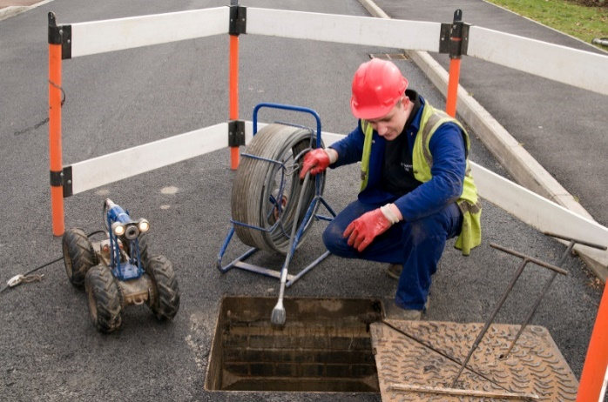

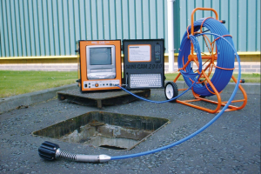

Jet Blasting/Vacuum Pumping - Risk Assessment Appendices 2

1. Assess depth of gully and distance from tank opening to vehicle to determine hose requirements.
2. Unload required length or quantity of hoses.
3. Connect hoses together and connect one end to inlet valve on vacuum tanker vehicle.
4. Place lose end of hose into manhole.
5. Engage small bore sprung nozzle jetter into the gully.
6. Open outlet valve on jet.
7. Proceed to jet contents of drain making any necessary adjustments to the positioning of the hose at the bottom of the drain to ensure that it is totally clean or empty and stop when the et reaches the main line (main drain).
8. When the task is complete, close the jet valve.
9. Switch off the jet.
10. Remove the hose from the drain.
11. Replace the cover to the drain.
12. Disconnect the hoses and place them back in or on the vehicle.

[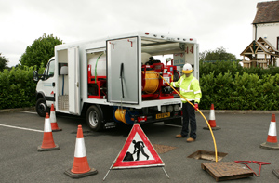](https://www.google.co.uk/url?sa=i&rct=j&q=&esrc=s&source=images&cd=&cad=rja&uact=8&ved=0CAcQjRxqFQoTCLi8r72y_MgCFcgEGgodXmULtg&url=http://whale.co.uk/sp-holding-invests-in-more-whales/&psig=AFQjCNHtcnedzjKrdONsUyORsSz9VcHe3Q&ust=1446919718862722)

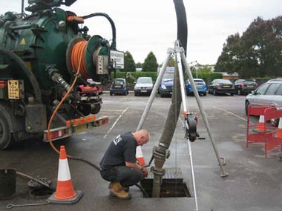

# Site specific scope of work for A1 Employee

* On arrival at site at **Entrance Control post 24**, contact the Client’s responsible person and obtain necessary permits and note any special precautions required including a full site induction at 8pm at Lands Compound which will include a drug and alcohol tests
* All staff employed by A1 Wokingham Wet Waste Limited carrying out protection duties will have been through approved training.
* Two trained and competent A1 Employees will control the work for the duration of the job.
* All A1 operators will wear issued PPE. All engineers must wear PPE provided.
* Carry out protection procedures as required by site and location in accordance with client’s procedures.
* Provide signing, lighting and guarding to isolate working areas, taking into consideration the protection of any adjacent properties.

Housekeeping

* All working area on site will be left clean, tidy, clear of any obstruction and safe on completion of works.
* All waste will be removed from site and disposed of to a licensed waste transfer station.

Access and egress to authorised personnel

* Via approved exits and entrances and other safe areas, this will be ascertained from the Client.

Work permits and licences

* As the work to be completed will involve A1 employees entering an area which is considered to be sufficiently hazardous as to give rise to specific risks a permit to work system will be used and a site specific risk and method statement have been completed in this document.
* Where necessary the appropriate client protection will be arranged.
* All employees will book in as appropriate on arrival and when leaving the client’s site, to comply with the client’s regulations.

Labour force

Each Drain cleaning/CCTV surveying team will consist of:

* 2 x Suitably qualified and experienced person

Training

The teams will be trained in:

* CITB working safely
* OS20 x pipe condition surveying
* High pressure water jetting techniques
* Emergency first aid
* NRASWA- signing, lighting and guarding
* Working in confined spaces
* Tool box talks as appropriate at the start of each shift

Personal protective equipment

All operators will be issued with, and trained in the use of the following PPE:

* General - Overalls, gloves, hard hats, safety boots. Hi visibility jackets, safety glasses.
* Specific- Full face visor, ear defender, wetsuit, safety Wellington boots and an intrinsically safe torch.
* Detailed records of monitoring, servicing and calibration of all equipment are available for inspection, along with issue and use of PPE.

Transportation

* All operators use A1 vans or lorries for transport to and from the work site.

Lifting equipment

* All manhole covers where required will be lifted using manual manhole lifting equipment.

Portable tools

* No portable tools required for this work.

Mechanical plant

* All plant brought onto site will be regularly maintained and tagged for identification purposes. The CCTV surveying unit will be located as close as possible to the work area as is permitted.

Track mounted vehicles and plant

N/A

Temporary lighting and power

Temporary lighting will be provided by:

* Tunnel has adequate lighting
* Lighting from A1 Vehicles will also be used.
* Hand held intrinsically safe battery powered torches.
* All A1 Operators will wear head torches whilst in the tunnel.
* Self-powered flashing lights/beacons will be used around barriers.

Signs and notices

* The working will be isolated using signing, lighting and guarding in accordance with chapter 8 of the NRASWA 1991.
* Notices of warning of HPWJ and CCTV survey activities are erected in prominent positions for the protection of employees and general public.

[](https://www.google.co.uk/url?sa=i&rct=j&q=&esrc=s&source=images&cd=&cad=rja&uact=8&ved=0CAcQjRxqFQoTCJyt8bnL_MgCFcbsFAodWPcHuA&url=http://www.protectsigns.uk/750mm-traffic-lights-ahead.html&psig=AFQjCNFDoEDknlwSEE0A4RauSd95jxV-5A&ust=1446926513953910)

**Work being undertaken Ahead**

[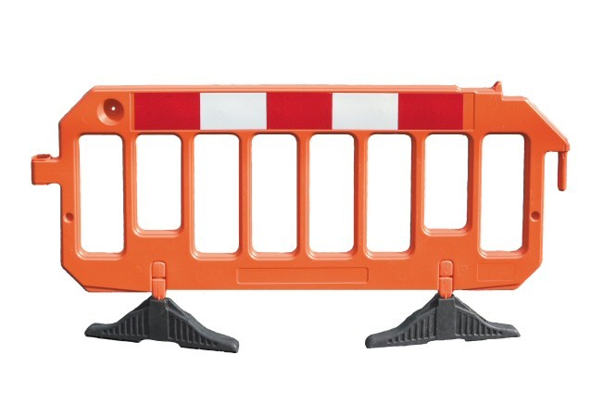](https://www.google.co.uk/url?sa=i&rct=j&q=&esrc=s&source=images&cd=&cad=rja&uact=8&ved=&url=http://www.grade1online.com/fencing/4544487958&psig=AFQjCNE9re6MqSLcMwDiTBwsam5ml5AzmA&ust=1446920048340842)Safety Barriers

* Compliant with BS 7818 for pedestrian restraint systems and Chapter 8 Street works A1 Group use Avalon plastic barriers with locking system which creates secure joints on uneven ground, up slopes, over kerbs and across rough terrain. Either unlocked or in locked mode, configurations are made to prevent unauthorised dismantling.

Traffic management

* No access to pedestrians or vehicles are present in the tunnel. However all signage, lighting and guarding of works in accordance with the requirements of NRASWA 1991 will be employed.

Temporary structures/ false work

N/A

Working at heights

N/A

Emergency Procedures

A1 Wokingham Wet Waste Limited 24-hour emergency service number is:

**Tel: 07831 507 920**

**Fax: 0118 989 4652**

**Safety Officer: 07712 556 825**

First aid

* All vehicles will carry an accident book and are equipped with a suitable first aid kit.
* A nominated first aider is available at each depot together with the necessary first aid equipment.
* All operators will carry Weils disease and HPWJ cards at all times.

The Health and Safety manager for A1 Wokingham Wet Waste Limited is Mr Clive Owen.

**24-hour contact numbers: 07712 556 825 / 07831 507 920.**

Accidents, incidents and reporting of injuries, diseases and dangerous occurrences (RIDDOR 1995).

* All accidents will be recorded in the accident book and reported to the client. Incidents that are reportable, under RIDDOR 95 will be reported to the HSE using forms F2506, F2508A etc. Copies will be sent to the DER.
* The company’s safety manager, Mr Clive Owen will investigate all reportable incidents.
* The site safety file will contain a site specific accident book, although all information entered will be recorded in the depot accident book.

Statutory records

* All accidents will be recorded in the site accident book and the client notified immediately. A1 Wokingham Wet Waste Limited head office will handle all reportable incidents in association with the Head office of other contractors, so that the HSE can be notified.
* The site safety file will have an individual accident book, and all information held will be recorded in the head office accident book. This office safety file will be the responsibility of the Operations manager at each depot.

Fire

All the client’s fire evacuation procedures will be carried out as per site instructions. All operators will be trained in Fire awareness.

All Working operations will have present on site for use:

* 1 no.9 litre Triple F aqueous foam extinguishers
* 1 no.2.5 kg CO2 extinguisher

Excavation

N/A

Materials

* Manufacturers’ safety data sheets for any hazardous substances will be supplied in accordance with COSHH regulations 1999 should the requirement become necessary.

Control of work with Hazardous substances and processes

* Details of any applicable COSHH assessments will be kept on file and all team members will be required to read and understand this file.
* If asbestos is found to be present in any working area, the client will be notified and further instructions obtained.
* All team members will be trained in the use of the HPWJ equipment.

Storage and handling of hazardous substances and materials

* Care will be taken to ensure that all hazardous substances will be stored and handled in accordance with the manufactures safety data sheets and COSHH assessments.

System/codes of practice

* A schedule of documents and references will be provided by the A1 Group. This list is not exhaustive and check should be made for any revisions. If in doubt refer to quality/safety department at head office.

Inspection and Environmental auditing

* The Operations manager at each depot is the person responsible for environmental surveillance on a client site.
* The Team Leader on each job is the person responsible for environmental surveillance on site, as work progresses.

Noise and vibration

* The system of dealing with noise and vibration assessments and preventative action is contained within the project plan.
* If the Team Leader is concerned regarding noise and vibration levels of an activity or an item of plant he will refer back to A1 Management, who will plan the necessary course of action.
* If noise or vibration assessments and specialized prevention measures are required, a specific risk assessment and method statement will be prepared.

Air quality and dust

* All equipment will be regularly maintained with specific attention being given to the control of exhaust emissions.
* Inspect area of work before work starts to establish if dust may be a problem and be prepared to damp down, especially in windy conditions.

Waste management

* Any materials or debris arising from the CCTV operations will be placed in double bags, removed from site and taken to a licensed waste transfer station.
* All such activities are carried out in accordance with the requirements of the “Code of practice. A duty of care” under the provisions of the Environment Protection Act 1990.
* A1 Wokingham Wet Waste Limited is a licensed waste carrier and its registration no. is TSE/388156.

Protection of assets

* The client’s assets will be protected during the course of all work. The method for this will be detailed in a detailed site-specific method statement.

Protection of water quality

* The teams carrying out the CCTV surveying work will ensure that no materials or debris are allowed to enter any watercourse or drainage outlets or channels.

Management of pest and weeds

* Should any special measures be required these will be the subject of a separate instruction from the client and a specific method statement raised by A1 Wokingham Wet Waste Limited and agreed with the client, before work commences.

Nature protection

* Should any special measures be required these will be the subject of a separate instruction from the client and a specific method statement raised by A1 Wokingham Wet Waste Limited and agreed with the client, before work commences.

Contaminated Land

* Should any special measures be required these will be the subject of a separate instruction from the client and a specific method statement raised by A1 Wokingham Wet Waste Limited and agreed with the client, before work commences.

Archaeology

* Where it is suspected that archaeology finds may be made a separate method statement will be raised for the works involved.
* Should any archaeological finds be made during the works the charge hand will cease working in the areas affected and alert the client and A1 Wokingham Wet Waste Limited head office immediately.
* The area (s) affected will be left in a safe condition and as undisturbed as that will allow. A1 Wokingham Wet Waste Limited will agree and obtain written instructions from the client as what works are to proceed. A new programme/method statement for the works will be raised by A1 Wokingham Wet Waste Limited and accepted by the client, in writing, prior to works recommencing.

Records and documentation

* All consents, environmental check lists and audit results are kept at our head office at each appropriate depot. These are the responsibility of the operations manager at each depot who can be contacted.

# Potential Hazards to A1 Group employees

The potential hazards and risks to which the teams may be exposed are:

* Splashing from debris: Control Measure: Ensure correct PPE is work at all times.
* Fumes from chemicals: Control Measure: Ensure correct PPE is work at all times.
* Noise/Ambience: Control Measure: Ensure correct PPE is work at all times.
* Weils disease: Control Measure: Ensure correct PPE is work at all times.
* Lifting operations (Manual handling): Control Measure: Ensure correct manual handling procedures are followed at all times and where necessary using hydraulic machinery to lift heavy objects.
* Tripping: Control Measure: Ensure all potential trip hazards are removed before during and after work completed.

The work by its very nature is varied and consequently will need to be risk assessed on a task specific basis.

|  |
| --- |
| **Confirmation** |

I confirm that I have read, acknowledge and will adhere to the contents of this document at all times whilst working at a client’s premises on behalf of the A1 Group.

|  |
| --- |
| Print Name: |

|  |  |  |
| --- | --- | --- |
| Signature: |  | Date: |

# APPENDICES 1&2

Appendices 1 – CCTV Survey Risk Assessment



Appendices 2 – Drain Jetting/Emptying drain or Gully Risk Assessment

