ISOQAR CLIENT COMPANY DETAILS BS OHSAS 18001 2007 SSIP, ISO 9001:2008 and ISO 14001:2004FOR SURVEILLANCE VISITS at A1 Group

Certificate No: 7366 Expiry date: 30 April 2018 Visit No/Follow up: 4

Accredited: Yes Guidelines Ref: EAC Code(s): 24a 24b 35f 39a

Visits/Year: 2x2 Months: October, April

Standard: BS OHSAS 18001 2007 SSIP, ISO 9001:2008 and ISO 14001:2004

Company Scope: Provision of waste management incorporating metal recycling, vehicle de-pollution, loo hire and wet waste removal.

Schedule for Wayne Bennett

01 Feb 2017 09:00 to 18:00 (Lead Auditor)
Head Office; Contact: Phone: 0118 989 4652

Other Auditor Appointments for this Standard

01 Feb 2017 09:00 to 18:00 Tanya Richardson ()
Head Office; Contact: Phone: 0118 989 4652

HEAD OFFICE DETAILS
A1 Group
Incorporating: A1 Wokingham Wet Waste Limited, A1 Loo Hire Limited, Metal Recycling - Partnership R Pike and S Pike and A1 Wokingham Car Spares - Partnership R Pike and S Pike
Silver Birches
Highland Avenue
Wokingham
Berkshire
RG41 4SP

Contact Name: Mr Clive Owen Position: Director & General Manager
Phone: 0118 989 4652 Fax: 0118 979 4328

Appointments for other Standards & History

01 Feb 2017 Surveillance Wayne Bennett (Lead Auditor) Head Office Tanya Richardson () Head Office
01 Feb 2017 ISO 14001: 2004 Surveillance Wayne Bennett (Lead Auditor) Head Office Tanya Richardson ()
18 Jul 2016 BS OHSAS 18001 2007 SSIP Surveillance Maj: 0 Min: 0 Bob Sillence (Lead Auditor) Head Office
18 Jul 2016 ISO 9001: 2008 Surveillance Maj: 0 Min: 0 Bob Sillence (Lead Auditor) Head Office Wayne
18 Jul 2016 ISO 14001: 2004 Surveillance Maj: 0 Min: 0 Bob Sillence (Lead Auditor) Head Office
25 Jan 2016 BS OHSAS 18001 2007 SSIP Surveillance Maj: 0 Min: 0 Bob Sillence (Lead Auditor) Head
25 Jan 2016 ISO 9001: 2008 Surveillance Maj: 0 Min: 0 Bob Sillence (Lead Auditor) Head Office Nick Morice
25 Jan 2016 ISO 14001: 2004 Surveillance Maj: 0 Min: 0 Bob Sillence (Lead Auditor) Head Office
29 Jul 2015 BS OHSAS 18001 2007 SSIP Surveillance Maj: 0 Min: 0 Bob Sillence (Lead Auditor) Head Office
29 Jul 2015 ISO 9001: 2008 Surveillance Maj: 0 Min: 0 Bob Sillence (Lead Auditor) Head Office

Justified exclusions: ISO 9001 clause 7.3 and 7.5.2 are formally excluded

Protective Equipment: MAF on file for WB by RS KJW 25/07/2016



MANAGEMENT SYSTEM AUDIT REPORT

Cert Ref Number: | 7366 | Audit Date(s): | Wednesday, 1 February 2017 |  | Visit Num: | 4
Standard(s) audited: | BS OHSAS 18001 2007 SSIP, ISO 9001:2008 and ISO 14001:2004 |  |  | Type of audit | SURVEILLANCE

Organisation: |  | A1 Group
Address: |  | Incorporating: A1 Wokingham Wet Waste Limited, A1 Loo Hire Limited, Metal Recycling - Partnership R Pike and S Pike and A1 Wokingham Car Spares - Partnership R Pike and S Pike  Silver Birches  Highland Avenue  Wokingham  Berkshire  RG41 4SP
Tel: | 0118 989 4652 | E Mail: | clive@a1groupuk.com |  |  | Web:
Representative(s): |  | Mr Clive Owen |  |  |  | Staff: |  | FT | 120 | PT
Locations & Site(s) visited: |  |  | SEE SECTIONS 9 & 10 |  | EAC Code(s): |  | 24a 24b 35f 39a
Lead Auditor: |  | Wayne Bennett |  | Additional Team Member(s): |  |  | Tanya Richardson
Legal Status of Organisation i.e. Ltd company, Partnership etc
NB if partnership - names of partners required

Scope as it will appear on certificate: | Provision of waste management incorporating metal recycling, vehicle de-pollution, loo hire and wet waste removal.

The objectives of the audit:
- To confirm that the management system conforms with the requirements of the audit standard and also any statutory, regulatory and contractual requirements that are applicable;
- To confirm that the organisation has effectively implemented the planned management system;
- To confirm that the management system is meeting its specified objectives

Audit scope:
- The audit will evaluate the effectiveness of the processes identified within the visit plan and in line with the 3 year plan. The audit will be conducted at the location(s) specified within the visit plan.

Time the audit commenced: | 9am | Time the audit was completed: | 15:05

Report submitted to and accepted by: | Clive Owen | Position in Organisation: | Director

Report prepared by: | Wayne Bennett | Lead Auditor

Date(s) of Next Visit: | 2/8/17 | Start Time: | 9am

Surveillance visits set at: | 2 | Per year of: | 2 | Days per visit

NB If the next visit is a Recertification Visit additional days over and above the surveillance days may be required.

The Organisation agrees to comply with ISOQAR’s Rules of Registration

* Please see Audit Plan for details of the next visit ** Enter details in section 2 if days or pattern of days has changed

This report is confidential and its distribution will be limited to the audit team, client representative and ISOQAR office



Attendees

Opening Meeting |  |  | Closing Meeting
Name | Position |  | Name |  | Position
Clive Owen | Director |  | Clive Owen |  | Director
Wayne Bennett | ISOQAR Lead Auditor |  | Wayne Bennett |  | ISOQAR Lead Auditor
Tanya Richardson | ISOQAR Lead Auditor |  | Tanya Richardson |  | ISOQAR Lead Auditor
 |  |  | Nicola Hull |  | Consultant

1 Audit Conclusion

The audit team concludes that the organisation HAS/HAS NOT established and maintained its management system in line with the requirements of the standard(s) and demonstrated to the audit team that it has the ability to systematically achieve the requirements for products and or services within the scope of its activities and in accordance with its policy and objectives.

The audit team recommends that based on the evidence obtained during this audit that Certification should be:

Recommended |  | Continued | X | Deferred (until satisfactory corrections/corrective action has been completed)

--------------------------------------------------------------------------

Non-conformances

Number of Non-conformances raised |  | Major |  | Minor | 3

NB Where Non-conformances are Raised

- For Initial Audits, Extensions to Scope and Recertification Audits; all Non-conformances must be closed out before a Certificate is authorised for issue and can only be closed out either by submission of evidence to ISOQAR or a re-visit to audit the corrections/corrective action
(see Non-conformance section of this report).

- For Surveillance Audits any Non-conformance classified as Major can also only be closed out either by submission of evidence to ISOQAR or a re-visit to audit the corrections/corrective action (see Non-conformance section of this report).

NB All Non-conformances must be actioned within the agreed timescales.

Please Note the audit conclusion is provisional and subject to review by ISOQAR’s Certification Review Team.

--------------------------------------------------------------------------

2 Significant Organisational Changes (also include any changes to surveillance visit patterns e.g. if additional standards have been added) and any additional information.
Significant changes to the plan for stage 2 or planned arrangements (produced at stage 1)

Do the justified exclusions remain valid YES/NO/N/A (If no please give details) | Yes

7.3 and 7.5.2 remain justified exclusions to the QMS.

--------------------------------------------------------------------------

3 Audit Summary (Observations, Non-conformance, Opportunities for Improvement, Good Practice etc)

OBS – The organisation does not formally document any site inspections or audits, these should be formally recorded and added to the audit schedule going forward.

OFI - It may be beneficial for the organisation to include a column or table at the bottom of the minutes to identify actions and responsibilities

OFI – The organisation may wish to consider adding monitoring and measurement information into their objectives plan

OFI – It may be beneficial for the organisation to consider Scenario training for their emergency procedures.

--------------------------------------------------------------------------
Auditor to complete
Non-conformances

 | Details of Non-conformances Raised |  |  | Standard/  Clause No | Major/  Minor | Completion  Date
1 | The organisation should ensure that they are recording the results of actions taken to prevent the reoccurrence of actions raised on their improvement log as currently there is no formal record of these.  ISO 9001:2008, 8.5.3 - The organisation shall determine action to eliminate the causes of potential nonconformities in order to prevent their occurrence. Preventive actions shall be appropriate to the effects of the potential problems. |  |  | 8.5.3 (9001, 14001, 18001) | Minor | 1/5/17
 |  |  |  | Standard/  Clause No | Major/  Minor | Completion  Date
2 | Fire extinguishers in the non-ferrous stores had not been serviced in line with the planed schedule.  BS OHSAS 18001:2007, 4.4.7 - The organisation shall periodically review and, where necessary, revise its emergency preparedness and response procedure(s), in particular, after periodical testing and after the occurrence of emergency situations. |  |  | 4.4.7 (18001) | Minor | 1/5/17
 |  |  |  | Standard/  Clause No | Major/  Minor | Completion  Date
3 | The following COSHH related items were not referenced on the current COSHH listings  Safeshield 50 5L (located in the stores area – Not on COSHH listings/Register  Unibond sealant (in use in workshop)– anti mould 300ml – Not on COSHH listings/Register  Adblue to also be added to the COSHH assessment listings as discussed.  ISO 14001:2004 - The organisation shall establish, implement and maintain a procedure(s)  a) to identify the environmental aspects of its activities, products and services within the defined scope of the environmental management system that it can control and those that it can influence taking into account planned or new developments, or new or modified activities, products and services, and  b) to determine those aspects that have or can have significant impact(s) on the environment (i.e. significant environmental aspects).  The organisation shall document this information and keep it up to date. |  |  | 4.3.1 (14001) | Minor | 1/5/17

The organisations representative understands the above Non-conformances and agrees to determine the root cause(s), and implement appropriate corrections/corrective actions.

Agreed by (organisation representative) | Clive Owen | Date | 1/2/17

Method of Close Out

Corrections/Corrective Action Evidence to be sent to ISOQAR | YES/NO
Check Corrections/Corrective action taken at next visit | YES/NO | Yes
Revisit to check Corrections/Corrective Action required | YES/NO

Note to Client: Please complete the Corrective Action Report Section of this report for any Non-conformance
raised during the audit and detailed above when evidence needs providing to ISOQAR for close out actions.

* PLEASE NOTE THAT THERE WILL BE AN ADDITIONAL CHARGE FOR ISOQAR TO CLOSE OUT
ANY MAJOR NON-CONFORMANCES AS PER THE RULES OF REGISTRATION

CLIENT to complete this section following Stage 2 audits, Recertification Audits and Majors Raised on surveillance only if evidence of corrective and preventive action is required to be submitted to ISOQAR see above.

AUDITOR to complete this section if any non-conformances are closed out prior to the end of the audit as evidence of close out.

Corrective Action Report

COMPLETE FOR NON-CONFORMANCES RAISED IN SECTION 3 Following Stage 2 audits, Recertification Audits and Majors raised on surveillance only

Client Name |  | Co Ref Number (Cert Num) |  | Audit Date(s)

Brief Details of Corrective Action, Root Cause, Action to Prevent Recurrence and Evidence.

N/Cr  No | Corrective Action Taken | Root Cause of Non Conformance | Action taken to prevent recurrence of Non Conformance | Evidence | Accepted by  (for use only when corrective action sent to ISOQAR)
1
2
3
4
5
6

This page must be completed and sent to ISOQAR (either via e-mail or post) along with any relevant documentary evidence following completion of the Non-conformances identified by the auditor(s) and detailed on above but only when requested to do so.

ISOQAR e-mail Address certdept@alcumusgroup.com
Post to FAO Cert Dept, ISOQAR Ltd. Cobra Court, 1 Blackmore Road, Stretford, Manchester M32 0QY

Completed By (Company Representative) |  | Date

Additional Information

NB Where evidence of corrective action is required to be submitted to ISOQAR. Certificates of Registration can only be issued after ISOQAR has received, reviewed and accepted the evidence supplied. Any Non-conformances not closed out within 3 months of the audit date may result in a re-audit being conducted and could also result in Certification being suspended.

-------------------------------------------------------------------------------------------------------------------

FOR ISOQAR USE ONLY WHEN EVIDENCE IS SUBMITTED TO ISOQAR

Satisfactorily closed out YES/NO |  |  | Reviewed By |  |  |  | Date
If not satisfactorily closed out next actions to be taken:

4 Management System Controls (i.e. Management Review, Internal Audits, Objectives, Complaints etc)

Also include in this section any additional requirements of the standard, sector scheme, legislation etc.

 | Auditor(s) | Wayne Bennett, Tanya Richardson | Standard(s) | ISO 9001:2008, ISO 14001:2004, BS OHSAS 18001:2007 SSIP
Evidence

Management review (TR)
The organisation last held a management review meeting on 8th July 2016. Meetings are held on an annual basis. In attendance at the meeting were CO (Director) and NH (Consultant). The following areas were reviewed during the meeting:

- Review of previous meeting minutes
- Actions outstanding – IOSH Training / site improvements / group very busy
- Overall system performance – back office is now up and running with COSHH assessments and risk assessments
- Policy Review – All reviewed and all still suitable
- Proposed changes/ suggestions – noise plan reviewed / H&S committee in place / toolbox talk programme in place
- External Communication – Environmental agency still regular visitors to site / no serious complaints
- Resources – site is undergoing changes
- Participation and Consultation – H&S committee established regular meetings
- Training – IOSH next on the list / Training matrix updated
- Emergency Procedures – New alarm system at head office / spill procedure still relevant / first aid adequate
- Company Objectives – Reviewed accident stats / training requirements / fleet expanded
- Suppliers / Rejects – all fine
- External / Internal Audits/ Corrective and Preventative actions – no issues from internal audits/ fire extinguishers serviced regularly / Improvement log in place
- Legal Compliance / Development – company are in legal compliance
- Customer complaints / feedback – none recorded / positive feedback noted
- Risk Assessments / COSHH assessment – all reviewed this year
- Accidents / Incidents – figures documented
- Any other recommendations – none
- Date for next meeting – July 2017

Any actions raised are documented in the main body of the report and responsibilities are noted.

OFI - It may be beneficial for the organisation to include a column or table at the bottom of the minutes to identify actions and responsibilities

Internal audit (TR)
Internal auditing is carried out by the external consultant. The audit plan for 2016 is in place and was reviewed during the audit. The 2017 plan is in development. Some audits from the 2016 plan had been delayed due to operational requirements but they had been planned to be completed in January 2017. No non-conformances were raised during the 2016 audit schedule. Yard inspections are also documented on a weekly basis and records of these were also seen. The following audits were reviewed;

- OP11 - 24.1.17 – Inspection and Monitoring – No issues raised – Evidence documented
- OP9 – 24.1.17 – Fire, first aid and spills etc – No issues raised – Evidence documented
- OP5 – 24.1.17 – Communication and Consultation – No issues raised – Evidence documented
- OP 1 – 24.1.17 – Risk Assessments – No issues raised – Evidence documented

- SCRAP Weekly check sheet yard – 30 Jan 17 – Replace Fire Extinguishers – all other areas compliant
- SCRAP Weekly check sheet yard – 23 Jan 17 – Repair sleeper wall – all other areas compliant

OBS – The organisation does not formally document any site inspections or audits, these should be formally recorded and added to the audit schedule going forward

Objectives and targets (TR)
The organisation has documented objectives that are reviewed as part of the management review meeting. The following objectives have been documented for 2017. These are available on the company intranet for all staff. They are communicated through various channels formal meetings, informal meetings and toolbox talks.

Objective | Completion Date | Responsibilities
Office extension – to allow for further office space. | July 2017 | Sally Pike / Russell Pike
Maintain existing client base across;  - Loo Hire  - Wet Waste  - Scrap | Ongoing | Clive Owen / Sally Pike
Maintain current accident statistics | Ongoing | All Staff
Completion of IOSH Managing Safely Courses for Management | July 2017 | Clive Owen
Continued recycling of scrap and waste products | Ongoing | Clive Owen
Continued replacement of the fleet in line with CO2 emissions | Ongoing | Clive / Russell
Relocation of Lambs Lane Site | December 2016 | Clive Owen
Implementation of retractable barriers on the car spare racks to stop access to these areas where the fork lift truck is in operation | July 2017 | Clive Owen
Update to the new standards; ISO 9001 and 14001 | July 2017 | Clive Owen / Nicola Hull

OFI – The organisation may wish to consider adding monitoring and measurement information into their objectives plan

Aspects and impacts (TR)
The organisation has an aspect assessment, currently at issue Jan 16. The register is comprehensive and includes the following details; Process / Activity. Emissions to air, release to water, release to land, use of natural resources, use of energy, energy emitted, waste by product, physical attributes. Aspects are assessed by way of a scoring system severity, amount, quantity, frequency, overall significance. Relevant legislation is also documented where applicable. The following processes have been assessed as part of the register; waste, office and yard, yard activities, travel and transport, abnormal, local area. Some of the higher rated aspects on the assessment were as follows;

- Fuel Storage – rating 60 (Control of pollution regs) – Release to water / physical attributes
- Large goods vehicles – rating 60 (end of life vehicle regs) – Emissions to air / Use of natural resources / energy emitted
- Storage of de-polluted vehicles – rating 60 (control of pollution regs) – release to land /physical attributes

Customer, stakeholder feedback including complaints (TR)
The organisation has a procedure in place for Customer complaints and feedback, OP13, Issue 1. This states that any complaints will be discussed and reviewed at the management review meeting. There have been no formal complaints since the last audit. The organisation does not actively pursue client feedback but reviews its repeat business levels as an indicator of customer satisfaction. Repeat business levels are high and new business often comes on recommendations from existing clients. Copies of feedback responses that come via email are kept and monitored via management review meetings. The flowing feedback was seen during the audit;

- KB (IOW Festival Manager) 9.12.16 - ‘So just to say thanks for you and your teams hard work on the 2016 Festival, I think it was the best so far, look forward to seeing you in 2017.’
- NBW (H Power Group) 5.12.16 - ‘I don’t know of another contractor in the UK or in Europe who could have provided the level of service and attention to detail that we received.’
- AB (Alex Burrows Events) 24.6.16 - ‘I'd like to extend a huge thanks for making Wednesday's event possible in such a very short time frame.’

The Environment Agency visits the main operational yard on a regular basis and also carries out formally recorded surveys. Copies of emails and responses are also kept and the following was reviewed during the audit;

- Email correspondence from (WE) at the Environment Agency regarding noise from reversing beepers – 16.12.16 – 18.1.16 – Closed out silencers fitted on the forklifts.

The company actively pursues a policy of co-operation with the local neighbourhood with regard to both operational and traffic noise etc.

Non-Conformance, Corrective & Preventive actions (TR)
The organisation has a procedure in place for Non-Conformance, OP12, Issue 1. There are various ways a non-conformance can be raised, customer complaints, management system failures, improvements from safety meetings, Environmental Agency Non-conformances. There is an improvement log in place on the company intranet that logs details of all the non-conformances raised. The improvement log documents the following, action number, date raised, depot, process improvement issues, corrective actions (fix at source), preventive action (prevent reoccurrence) date closed out. Currently preventive actions are being carried out in some cases but are not being formally documented. The following items were reviewed from the action log;

Action No. | Date Raised | Depot | Process improvement issue | Corrective action (fix at source) | Preventive Action (prevent re-occurrence) | Date Closed
23 | 24-Jan | All | PAT testing; has this all been completed | Completed CO to send KJ copies to place on BO | Wokingham on BO - remainder ongoing
27 | 24-Jan | All | Undertake fire evacuation form for the evacuations taken | AM to undertake | All outstanding actions completed | Jan-17
28 | 24-Jan | All | Check first aid kits and make sure all are stocked; check the eye wash in the de-pollution area | SS to audit first aid kits | All outstanding actions completed | Jan-17

Minor NC – The organisation should ensure that they are recording the results of actions taken to prevent the reoccurrence of actions raised on their improvement log as currently there is no formal record of these.

(ISO9001:2008 8.5.3)

Training and competence (TR)
The organisation has a procedure in place for Training and Competency, OP4, Issue 1. Employees undergo an induction upon joining. This is tailored to the individual employee but would include items such as policies and procedures, site walk, shadowing members of staff who are competent. Training is only formally recorded for an employee once they are deemed competent in that area. Training is discussed at the management review meeting. IOSH training is on the agenda for this year. A training matrix is also in place that documents the competencies for all staff in different areas of the business. Training such as CSCS, Induction, HGV, PPE, Manual Handling and confined space is recorded on here. A colour coded key is used green = complete, blue = in progress, black = expired, red = completed after expiry, grey = not applicable. Hard copies of all certificates are kept in individual employee files. The following training records were reviewed during the audit;

- SS (Tanker Driver – observed carrying out works at site vsit)
Induction Records – 1.6.16
Driving Licence check – 1.6.16

- TH (Front Desk)
Induction Records – pre system
Manual Handling – 7.12.09

- MP (Tanker Driver)
Induction records – pre system
Driving licence checks
General security awareness – exp 27.7.19
Confined space – exp 28.1.19
Site safety plus – H&S Awareness – exp 30.11.20

Calibration (TR)
The organisation has a procedure in place for Calibration and Equipment Maintenance, OP17, Issue 1. Calibration is managed via an online system that is sub-contracted out through Avery, they attend site on an annual basis to carry out calibration of all tools and equipment although this is limited. All records and certification are retained on line. The following records were reviewed during the audit;

- Avery weigh-tronix – 26.5.16 – E1205:135150564 – Weigh bridge – capacity 50000kg- Agreement Number 1737640101 - Next due May 2017
- Avery weigh-tronix – 1.8.16 – E1010:0636405514 – Weigh bridge – capacity 3000kg- Agreement Number 1737640101 - Next due Jul 2017

Plant and site maintenance / Equipment maintenance / PUWER (TR)
The organisation has a procedure in place for Calibration and Equipment Maintenance, OP17, Issue 1. Ongoing maintenance and repair is carried out by an onsite fitter who also has a schedule for repairs and maintenance (weekly documented) Service agreements are in place for some of the equipment. The flowing records were reviewed during the audit;

- FL13 – JCB Telehandler – JCBTLT30J01541956
Allianz - LOLER inspection 29.11.16 – Ref: E33626017539
Fork Lift Truck pre-operational daily check – 23.1.17 – Examples of items checked forks and attachments / mast / guards/ battery / lights and mirrors / seat belts

- CR3 – Caterpillar Crane M233D – CATM322DLD3X00245
Allianz – LOLER inspection 22.8.16 – Ref: E33626017042
Caterpillar Crane Daily inspection sheet – 23.1.17 – Examples of items checked – water, oil, grab, rams, mirrors, cab structure, windows, steering, brakes

- CR2 – Caterpillar Crane M325D – EDF02010
Allianz – LOLER inspection 29.11.16 – Ref: E33626017538
Caterpillar Crane Daily inspection sheet – 16.1.17 – Examples of items checked – water, oil, grab, rams, mirrors, cab structure, windows, steering, brakes

- FL14 – Toyota forklift – 52-8FDJF35
Allianz – LOLER inspection 4.5.16 – Ref: E33626016574
Fork Lift Truck pre-operational daily check – 23.1.17 – Examples of items checked forks and attachments / mast / guards/ battery / lights and mirrors / seat belts

- ESS Safeforce – Service of gas monitor – 12.12.16 – XAM2000
- ESS Safeforce – Service of escape set – 12.12.16 – SN: BRJZ-0074 / BRTE-0052

Emergency preparedness (TR)
The organisation has a procedure in place for Fire, first aid, spillage and other emergency situations, OP9, Issue 1. The following areas were reviewed during the audit;
- Fire Extinguishers – Last service carried out in Jul 16 by RES (See site walk section of the report)
- Fire Evacuations – The last evacuation took place on 15.7.16 at 08.50 – all staff and visitors evacuated
- Evacuation routes – All evacuation routes were clear
- Fire Alarm weekly check – 23.1.17 – Issue with alarm not turning off – engineer called out
- First Aid / Eye Wash – (See site walk section of the report)
- Spill procedures – Spill kits were seen during the site walk.
- COSHH – (See site walk section of the report)
- Fire Risk Assessment – In place 10.11.15 and reviewed on 10.5.16
- Fire prevention plan - Available dated July 2015, Version 1. Plan displayed in the main office

OFI – It may be beneficial for the organisation to consider Scenario training for their emergency procedures.

The audit methods used were interviews, observation of activities, review of hard copy documentation, review of documentation retained electronically and a review of records. The conclusion is based upon the evidence obtained during the audit. The auditor(s) used standard sampling techniques to obtain this evidence and no guarantee can be given that a different conclusion may have been reached had different samples been taken.

5 Significant Process Audit Trails followed (i.e. Sales, Purchasing, Design, Production, Training etc).

Also include in this section any additional requirements of the standard, sector scheme, legislation etc.

 | Auditor(s) | Wayne Bennett, Tanya Richardson | Standard(s) | ISO 9001:2008, ISO 14001:2004, BS OHSAS 18001:2007 SSIP
Evidence

Site walk (Highland Avenue, Wokingham branch)
A site walk was carried out on request. A tour of the site was given by CO (Director & General Manager). The following areas were visited:

- Non-ferrous shed
- Granulator room
- Car spares yard
- Scrap car/metals yard (de pollution rigs, crushers)
- Exports parts storage area
- Loo hire storage area
- Cleaning chemical storage area
- Diesel tank (for filling all company owned vehicles)
- Tyre replacement/scrap tyres area
- Staff canteen area

All areas visited showed appropriate H&S hazard and warning signage. Appropriate fire extinguishers were placed in strategic areas (foam, water, powder) Most extinguishers showed an inspection/service date of January 2017, carried out by a fully qualified external source, but it was noted that extinguishers in the welding shed showed last service dates of 2014 and 2015 respectively. First aid boxes and eyewash stations were located in each area (all in date with expiry of April 2017/September 2018). Spill kits were located/observed in the loo hire storage area, diesel tank and de-pollution area of the crusher area. Appropriate storage areas for batteries, tyres, steel and alloy evidenced. All staff observed around the site were wearing appropriate PPE and were following safe working practice guidelines.

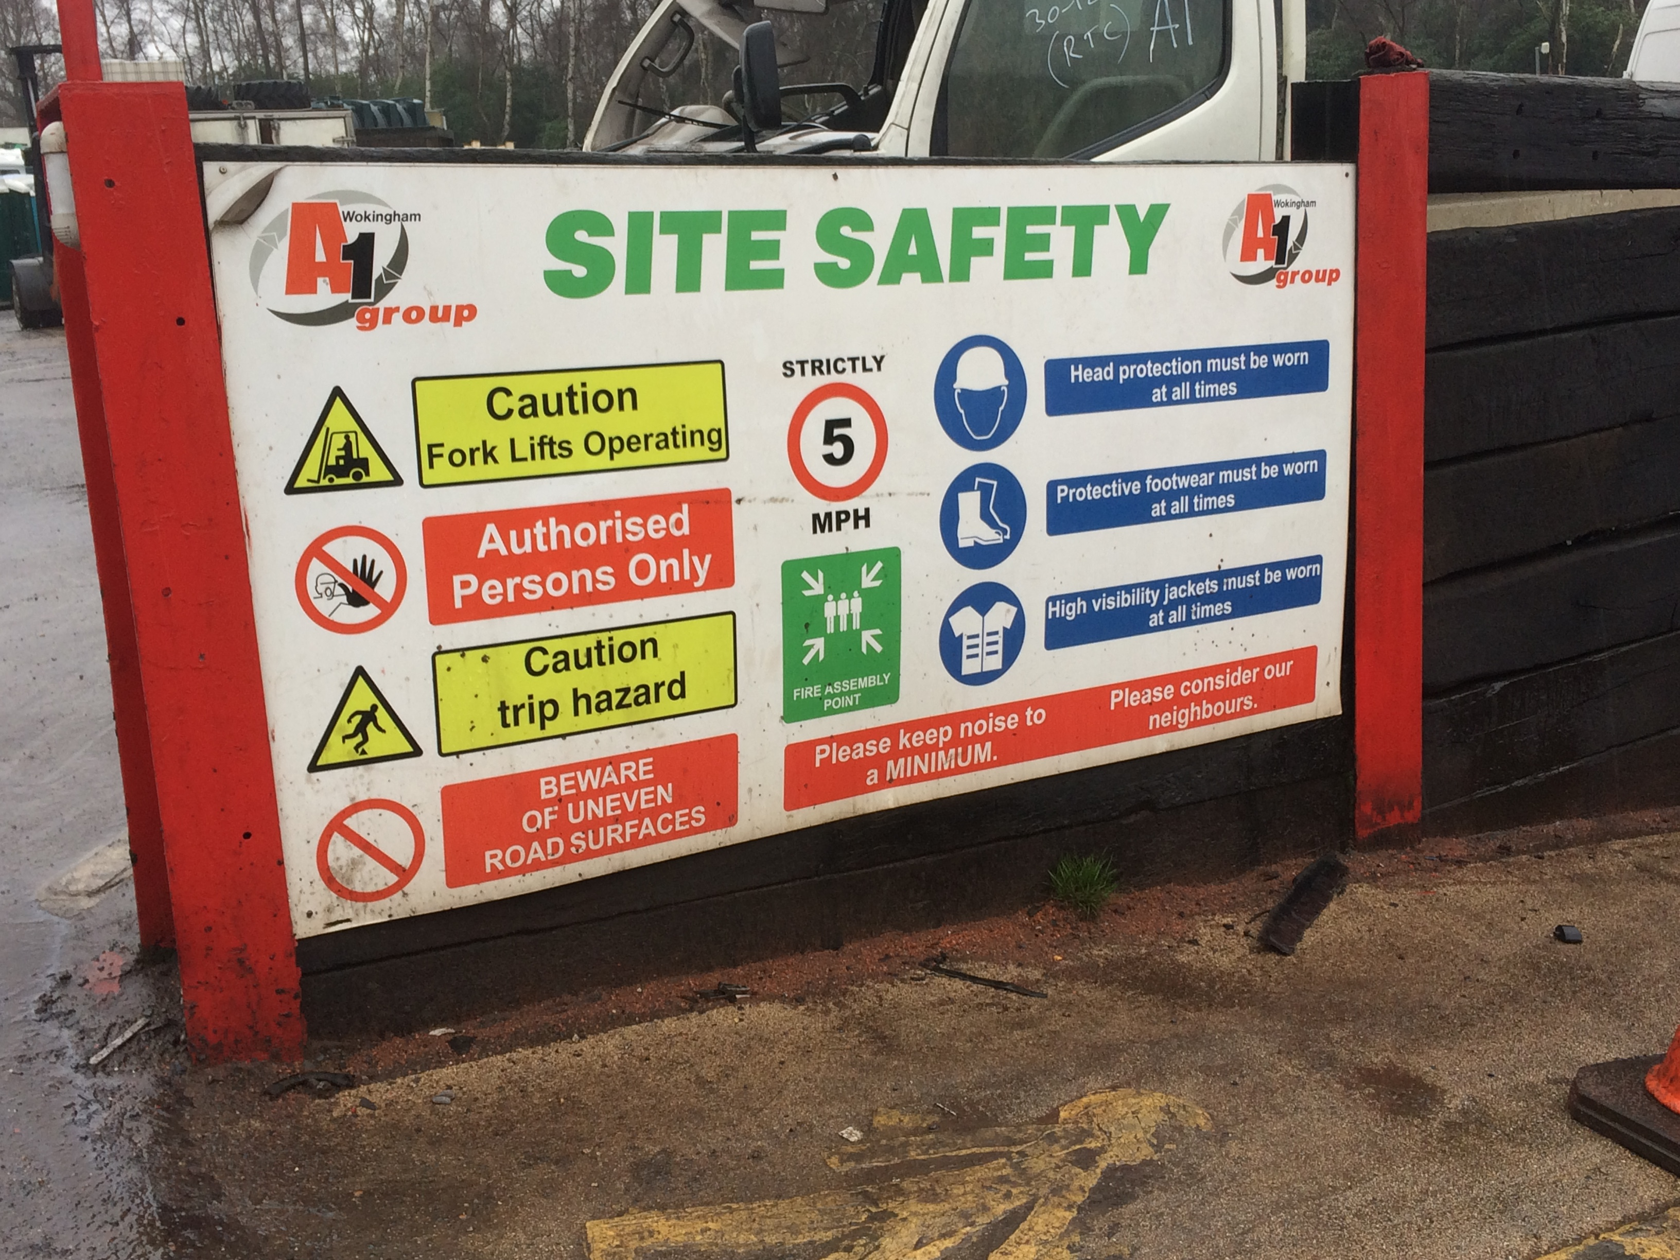

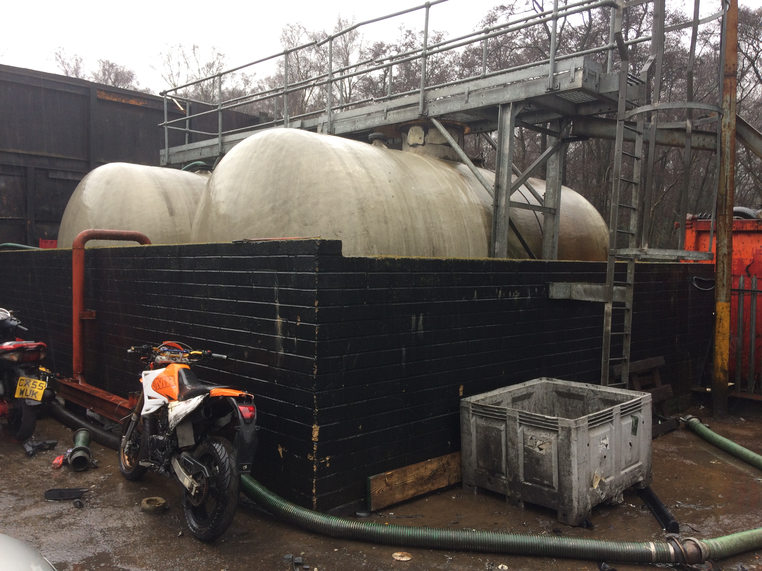

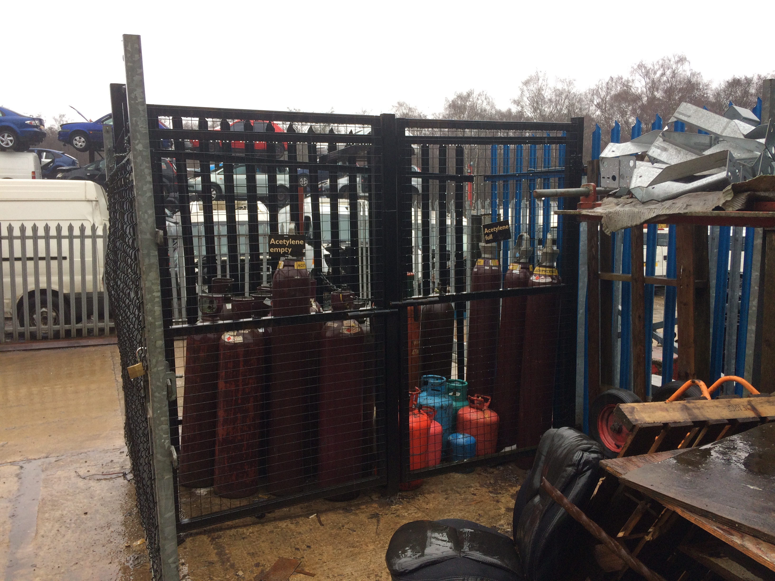

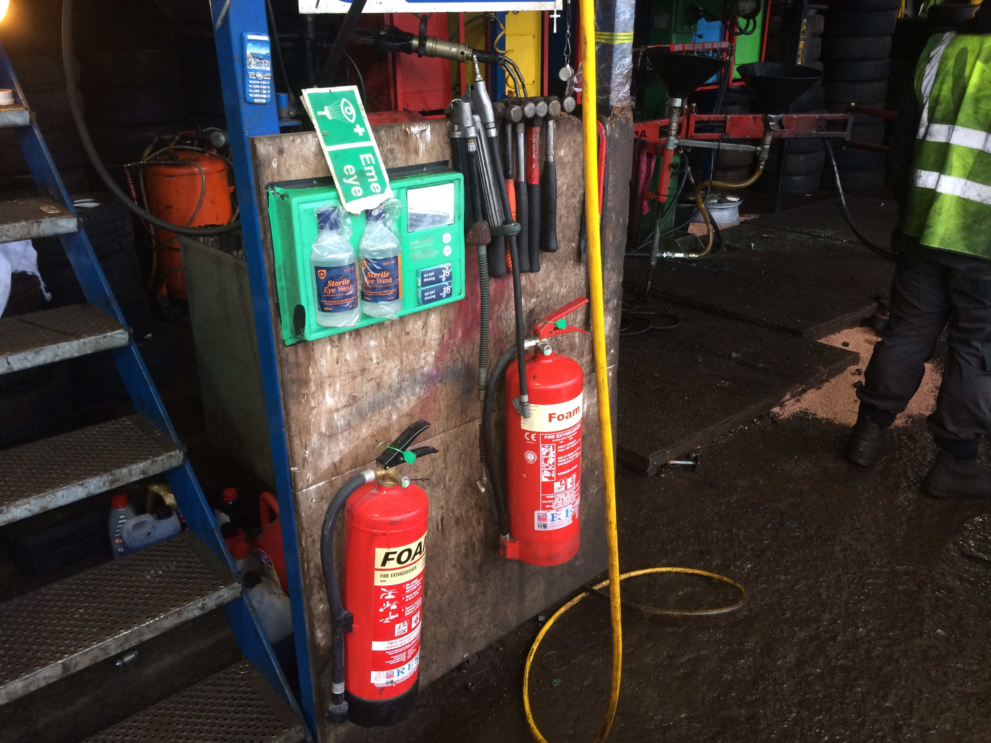

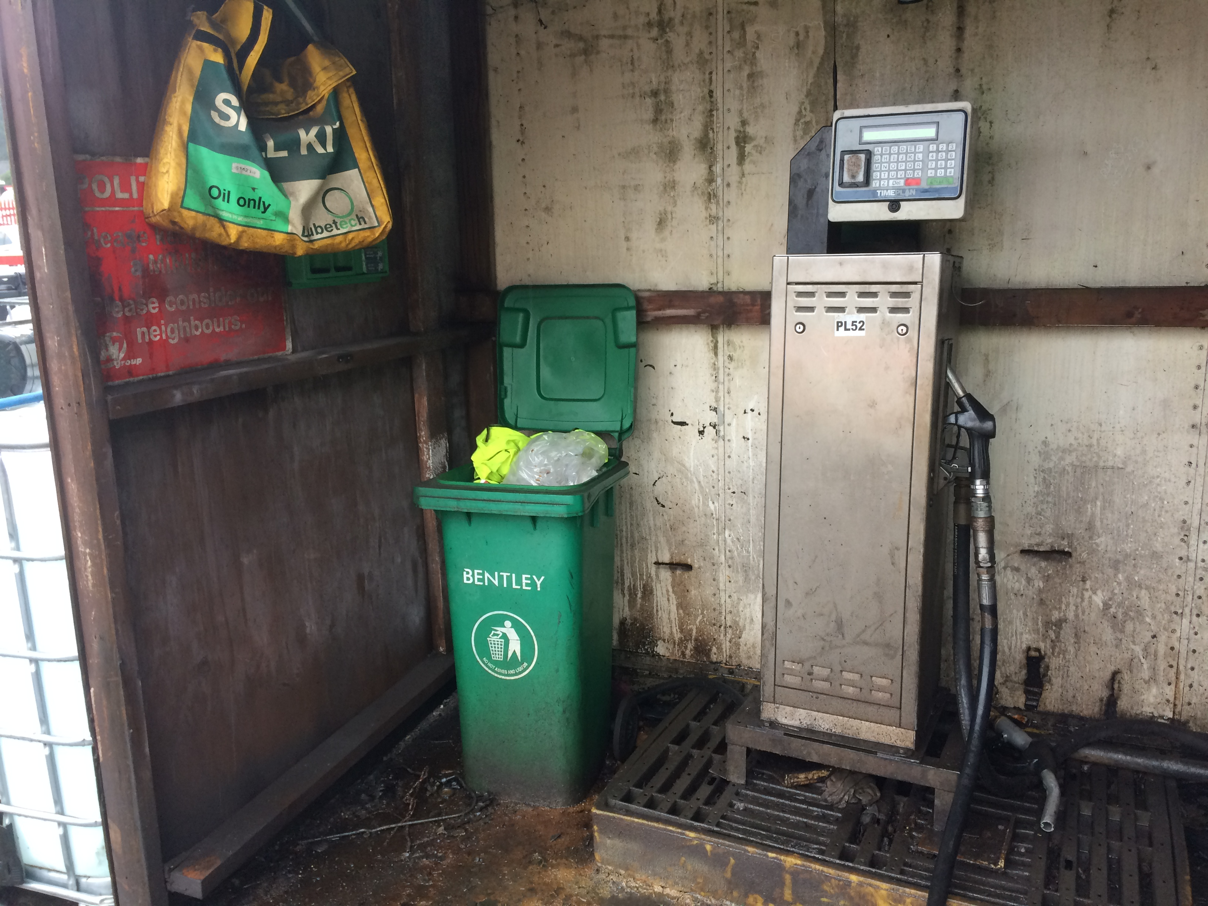
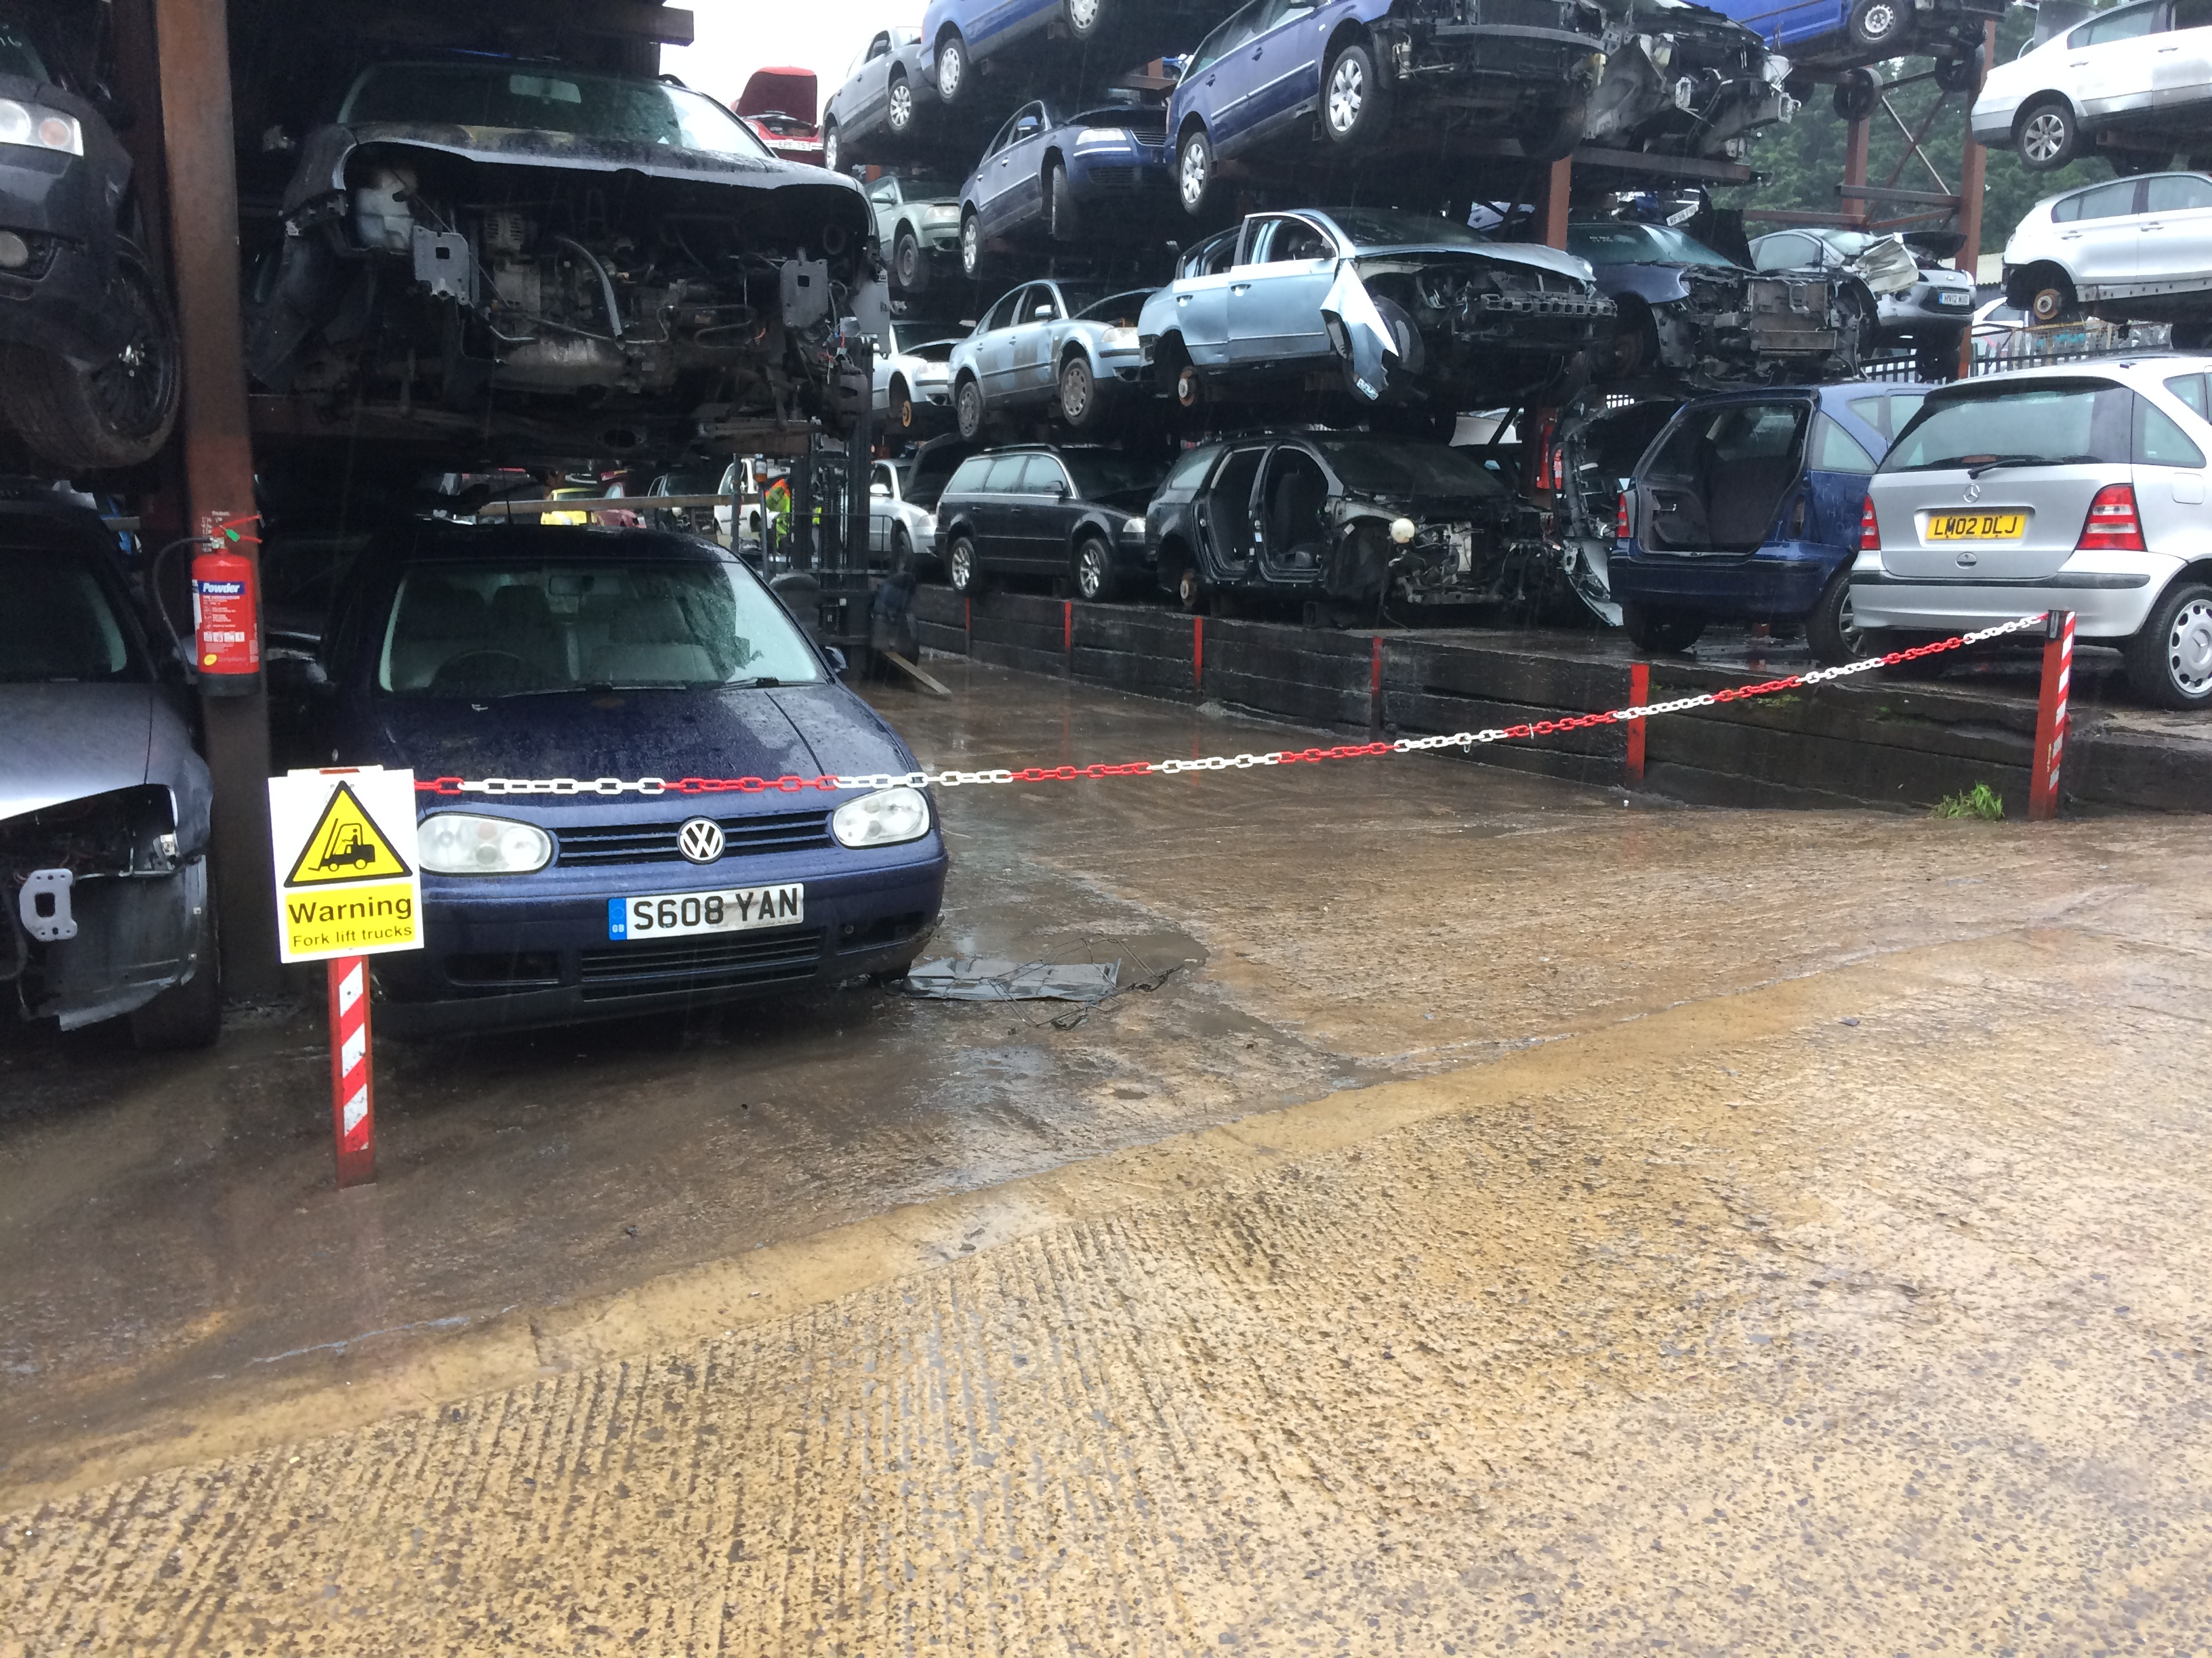

Wet Waste Operational Control – including site visit (WB)

- Wet waste continues to be either Sewage, Dirty Water or Oily Water (the latter being from gullies or interceptors).
- All work was evidenced to be controlled via the ‘Jobwatch/Inspire’ systems. These systems carried the following data:

- Customer- all client details
- Resource- driver details
- Notes- any specific contract detail
- Order Number- or description
- Load Type
- Proof of Delivery- job description
- Photographs- these can be taken and added to the job information if required
- Waste transfer instructions

- Work is allocated to specific operative’s dependent on the location (in some cases if it is a big or long term job it will have an assigned operative). Work instructions are communicated electronically direct to the Operatives smartphone.
- A job card is automatically generated and a copy forwarded to the customer, confirmed with an electronic sign-off via a phone. Specific photographs can also be added. The job card includes the EWC, List of Wastes Codes A1’s Waste Carriers registration number and the ‘Waste Hierarchy’ statement.
- When full, sewage tankers will visit the nearest treatment works to empty out, each driver has an electronic key fob that is used to record visits, Thames Water then send a monthly return listing all the visits (location, vehicle, weight taken etc.) with the invoice.
- Oily Water and Dirty Water are taken to other locations where a test is carried out of the liquid (details of contamination and levels are recorded to the Haz-Waste Consignment Notes) before it is off loaded.
- Copies of the WTN’s/job cards are passed to the office where they are matched to Customer P/O’s (note: P/O’s are not received from private customers) for invoicing, pricing for a collection is based on fixed costs of quantities collected.
- All of the above was evidenced via a site visit carried out on 1/2/17 as part of this visit as follows:

Site: Village Hall, Stratford Sage
Vehicle: GF13 JHL
Job ref: 19458
Job: Emptying 3000 gallon cesspit

- Upon arrival to site, it was evident that the area being pumped had been clearly barriered and appropriate signage was displayed.
- When unmanned, the barrier was closed and the area was closed off.
- The operative carrying out the works was wearing appropriate 5 point PPE (gloves, hard hat, safety glasses, safety boots and hi vis overalls.
- Pumping of the pit was carried out until the load was full.
- Upon completion, the hoses were removed, attachments closed/covered and barriers secured back onto the vehicle
- It was evident that a fire extinguisher was on board the vehicle (new extinguisher on board – next service date 31/12/17
- A first aid kit was not available on board the vehicle
- The operative had access to all company risk assessments and method statements via their smart phone
- The vehicle was fitted with front, side and back cameras
- Post works processes were inspected, which outlined the following information:

Name of operative carrying out the works
Load – cesspit
Status – tip
Description: sewage
Qty: 3000g
Hours taken: 1
Verification/signature of customer (electronic)

- As confirmed, the load was being taken to the nearest waste transfer centre/treatment works (Thames Water).

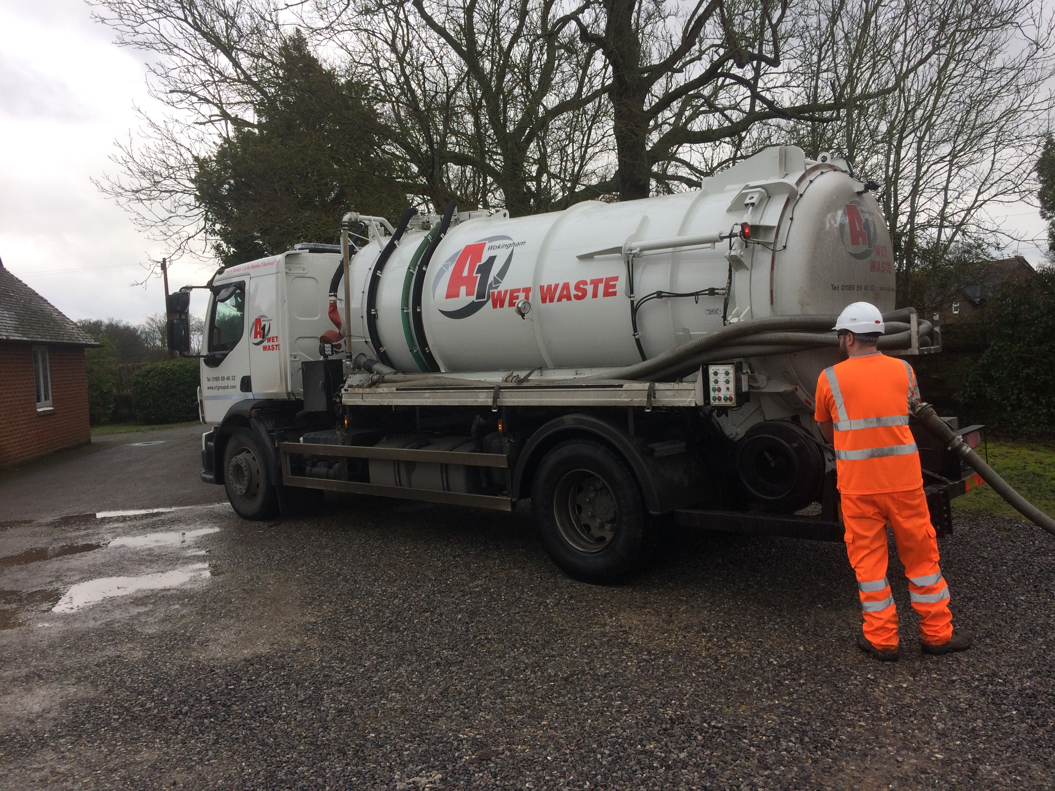

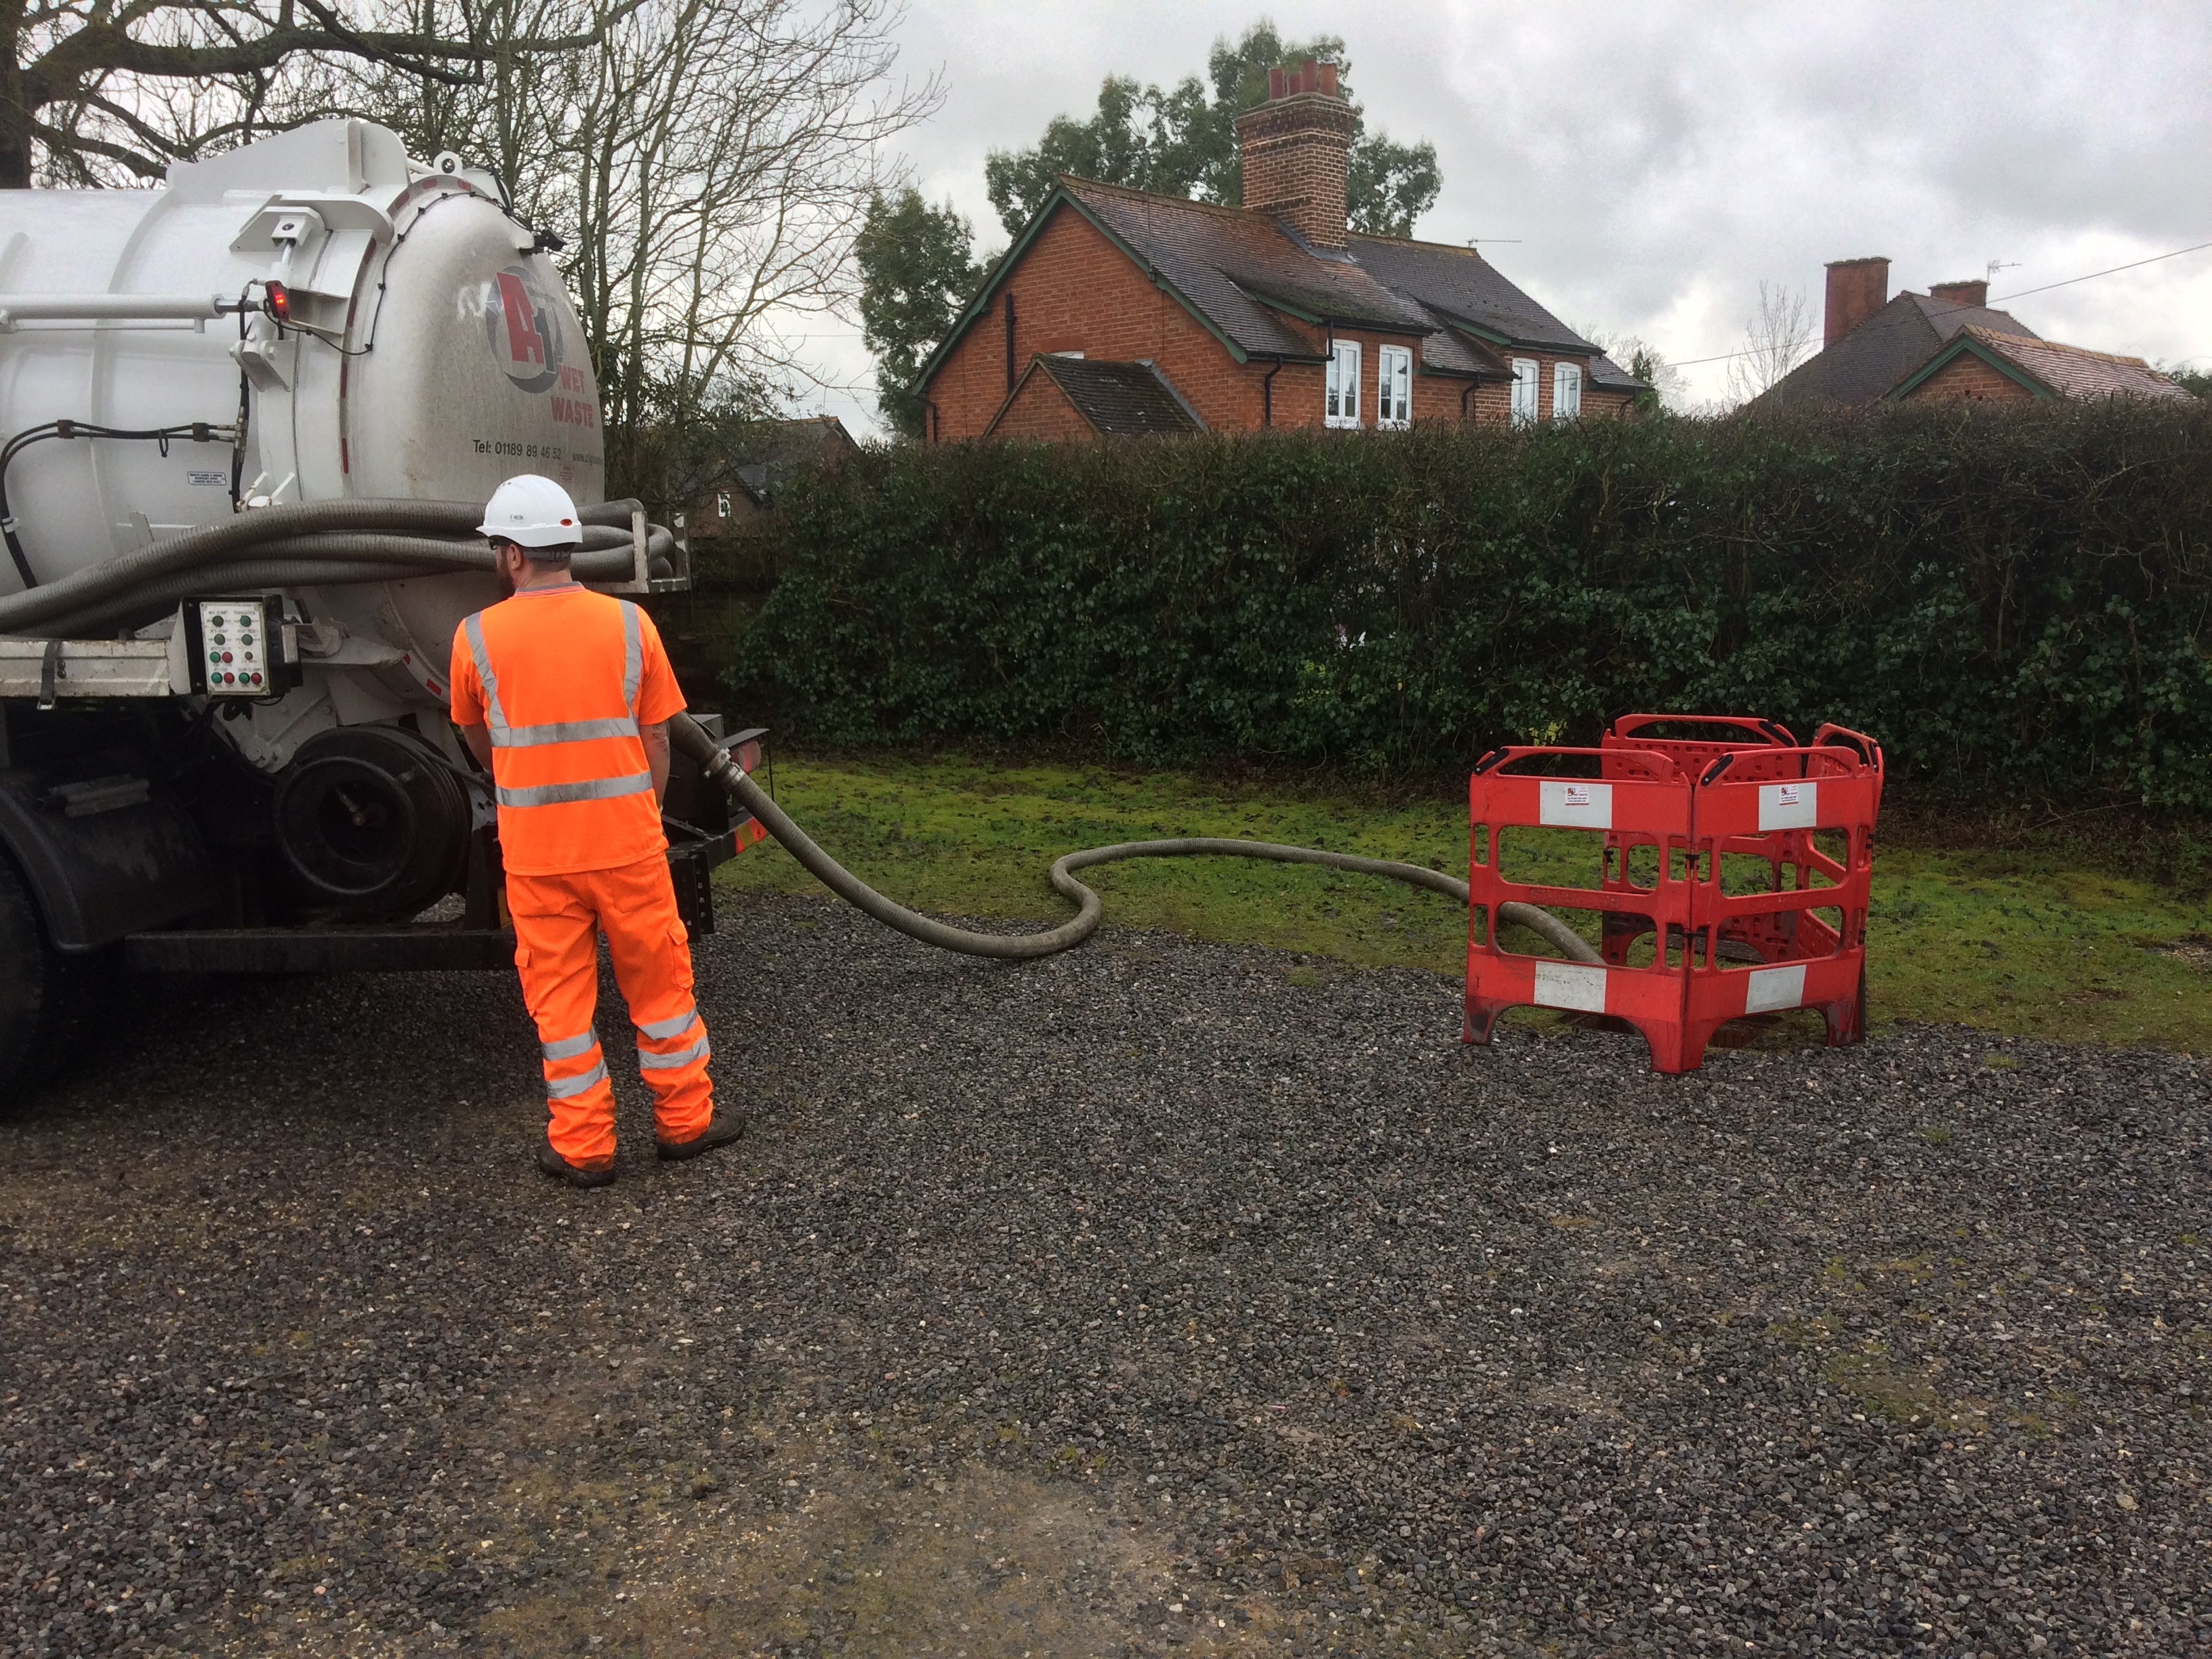

Loo Hire – Lambs Lane site visit
- As per discussions/demonstrations of the system, it was evident that all units allocated for ‘on-hire’ had been subject to a pre hire inspection before release to site (including electrics, pumps, etc) This was evidenced by pre-test certificates for units 3044 (11/11/16) 1043 (11/11/16) and 2007 (16/10/16).

The following COSHH materials were chosen at random from the storage area for inspection:
Research 50 clear – COSHH assessment evident - Next review - 15/3/16
Bac safe Gel 5l – COSHH assessment evident - Next review - 25/7/18
Safeshield 50 5L (located in the stores area – Not on COSHH listings/Register
Unibond sealant (in use in workshop)– anti mould 300ml – Not on COSHH listings/Register

The following completed job card was chosen at random for inspection, which confirmed that the above processes had been carried out/completed in line with the agreed acceptance criteria and the required records had been generated as a result. Information evidenced on these records as follows:

Customer: COSTAIN
Site: AM
Job type: WELFARE SERVICE (SMALL)
Reference: BRI/536663/D
Job duration: 00:20:00
Date: 01/02/2017
Time taken: 08:00 - 08:20
Distance travelled: 0 mi
Description of Waste: Welfare Unit
Quantity Removed: (gallons) 0 > 500
EWC: 20.03.04 – Read: Yes
Water Delivery: 0 > 1000
SIC Code: 42.11
Location: Welsh Water Gowerton
Customer Name and
Signature AM

SSIP Core Criteria Checklist – A1 Group

SSIP Requirement | Satisfied Y/N | Comment/Additional Information
H&S Policy & Organisation for H&S | Y | Policy in place. Communicated to all staff and available on the company intranet. Signed by the director on 5.1.16. Includes information on responsibilities, how these are met, employee’s responsibilities, accidents
Adequate Arrangements | Y | Discussed as part of the management review meeting.
Competent Advice | Y | External consultant – Level 3 qualified NEBOSH Diploma. Sypol system to manage COSHH
Training and Information | Y | Training procedure in place OP4. Training matrix detailing all staff members and competencies.
Individual Qualification and Experience | Y | Copies of certificates retained in employee’s personal files.
Monitoring Audit and Review | Y | Internal audits are carried out by the external consultant. These include aspects of all Health and Safety requirements. Site / Yard inspections are also documented and weekly checks are recorded.
Workforce Involvement | Y | H&S Committee has been set up involving employees from all different departments. They meet every 6 weeks. Toolbox talks are given when required.
Accident Reporting | Y | Accident stats discussed at management review meeting. Accident procedure in place, OP18.
Sub-Contracting | Y | Supplier assessment procedure in place. Approved supplier list in place reviewed at management review meeting. Procedure OP7
Risk Assessment Leading to Safe Method of Work | Y | Risk Assessments and method statements in place covering all work activities. All staff have online access to these documents. Procedure OP1
Co-Operation with and Co-Ordinating | Y | Operational planning and procedures are in place. All documents of this nature are stored on the online system.
Welfare Provision | Y | Welfare facilities for staff are good. Kitchen, break room, toilets.
Hazard Elimination & Risk Control  (Designers and Principle Designers Only) | N/A
Principle Designer Duties (Principle Designers Only) | N/A
Category Designated | *Contractor / Principle Contractor / Designer / Principle Designer

The audit methods used were interviews, observation of activities, review of hard copy documentation, review of documentation retained electronically and a review of records. The conclusion is based upon the evidence obtained during the audit. The auditor(s) used standard sampling techniques to obtain this evidence and no guarantee can be given that a different conclusion may have been reached had different samples been taken.
6 Follow Up of Previous Audit Results

Previously raised Improvement Requests/Non-Conformances have been effectively closed out, root cause determined and effective actions taken. | YES/NO/N/A | N/A

If Yes summarise the evidence seen if No what actions have you taken as a result:

7 Recertification Visits (complete only at a Recertification Visit)

Has the review of activities (in particular complaints against the client) and reports covering the certification cycle revealed any issues | YES |  | NO

If Yes please provide details

8 Activities planned but not covered on this visit and require planning for the next visit.

Date | Process/Department/Activity/Site Visit etc. | Auditor

9 Head Office/Locations/Branch Offices visited during this audit

Date | Location | Auditor
1/2/17 | Head office, Wokingham | WB/TR

10 Client/Contract Sites/Temporary Sites visited during this audit (if applicable).

Date | Location & Activity Audited | Auditor
1/2/17 | Village Hall, Stratford Sage – emptying of 3000 gallon cesspit (wet waste) | WB
1/2/17 | Lambs Lane site – general site activities (loo hire) | WB

11 Locations/Branch Offices

All permanent Locations/Branch offices for which certificates are required (Check on Business Manager) are current and correctly identified | YES/NO | Yes

If no correct details are

Location (Town/City) | Address | Standards

12 Registration Marks

Use of Registration Mark (if used) is in accordance with the Rules of Registration |  |  | YES/NO/N/A | Yes
Brief details of where the UKAS registration Mark and ISOQAR Logo is used | Used on company website and also displayed on company vehicles. New ISOQAR logo communicated to the client

13 EXTENSION TO SCOPE USE THIS SECTION ONLY IF NECESSARY

Has the wording of the scope changed | YES/NO

Has a new process(s) been added | YES/NO

Has a new permanent location(s) been added | YES/NO

Other | YES/NO

Number of certificates required i.e. Head Office plus Certificate for each Location

Details of extension to scope:

IF NEW LOCATION(S) ARE ADDED PLEASE COMPLETE FOLLOWING SECTION(S)

(Only complete the scope section if different from the Head Office Scope)

ADDRESS
SCOPE

ADDRESS
SCOPE

ADDRESS
SCOPE

14 TRANSITION REQUIREMENTS

The ISO 9001:2015 and ISO 14001 2015 standards were published on the 15th September 2015. The deadline for final transition from the existing standards to the 2015 versions is the 15th September 2018. Please indicate in the boxes below what route the client intends to take towards transition.

Please note there is a certificate reissue fee if the transition is not carried out as part of Recertification as per the rules of registration.

 | 9001:2015 | 14001:2015
Standalone Pre-assessment/Special Audit (Chargeable)
Recertification | X | X
Next surveillance visit
Not yet ready
AUDIT PLAN NEXT VISIT

Please note that changes to Auditors may be unavoidable due to operational requirements
The objectives of the audit:
- To confirm that the management system conforms with the requirements of the audit standard and also any statutory, regulatory and contractual requirements that are applicable;
- To confirm that the organisation has effectively implemented the planned management system;
- To confirm that the management system is meeting its specified objectives
Audit criteria:
- Documents, procedures and policies relevant to the standard being audited will be required.
- The audit will be performed against the scope of activities agreed at the opening meeting or as agreed at stage 1 or as detailed on the Certificate.
- The audit will be conducted at the locations identified on this audit plan.

Lead Auditor |  | Wayne Bennett |  | Additional Auditors (Expert) |  | Tanya Richardson
Standard(s) |  | ISO 9001 / ISO 14001 / OHSAS 18001 |  |  | Type of Audit (i.e. Surveillance) | Surveillance and Recertification Planning [5]
Audit Dates |  | Wednesday 2nd August 2017 |  | Location(s) | Head Office - Silver Birches, Highland Avenue, Wokingham  Berkshire, RG41 4SP
Audit Start Time |  | 09.00 |  | Does Client need to confirm site visit with ISOQAR Head Office prior to next visit YES/NO |  |  | NO
Audit Language (if not English) |  |  |  | Is Recertification Planning Required YES/NO |  |  | YES
Management Processes
Date | Time (or AM/PM) or N/A |  |  |  |  |  | Auditor
2.8.17 | AM |  | Opening Meeting |  |  |  | WB/TR
 |  |  | Review previous non-conformity |  |  |  | TR
 |  |  | Site Walk |  |  |  | WB
 |  |  | Management review |  |  |  | TR
 |  |  | Internal audit |  |  |  | TR
 |  |  | Legal Compliance and Evaluation of Compliance |  |  |  | TR
 |  |  | Non-Conformance, Corrective & Preventive actions |  |  |  | TR
 |  |  | Wet Waste operational control |  |  |  | WB
 |  |  | Access and egress from the site, control of the public |  |  |  | WB
2.8.16 | PM |  | Lifting equipment maintenance, LOLER etc |  |  |  | WB
 |  |  | Hazard identification, risk assessments and control measures |  |  |  | TR
 |  |  | Incident Investigation and Communication |  |  |  | TR
 |  |  | Purchasing including supplier evaluation and assessment |  |  |  | WB
 |  |  | Recertification Planning |  |  |  | WB/TR
 |  |  | Closing Meeting |  |  |  | WB/TR

Locations/Branch Office Visits
Date | Time (or AM/PM) | Process/Aspects/Activities etc. to be Audited | Auditor
2.8.17 | AM/PM | Head Office | WB/TR

NOTE TO CLIENT: No further confirmation or reminders will be issued. Failure to honour the date arranged may result in extra charges being incurred by your company as stated in ISOQAR Rules of Registration. Cancellation of audit or surveillance dates within 20 working days of the agreed date will result in ISOQAR claiming an extra levy from the company for each staff day cancelled.
Note to Auditor

Refer to 3 year Audit plan and last Audit plan when producing the audit plan for the next visit | Ensure that all clients’ locations/branches are visited in accordance with the 3 year audit plan
Ensure client fully understands the cancellation policy stated above. | Ensure that site activities are witnessed as appropriate and in accordance with the 3 Year Audit plan
All Management System Elements must be audited once per year as a minimum | Review the 3 year audit plan and if appropriate and necessary amend the plan

AUDIT PLAN COVERING THE 3 YEAR ASSESSMENT CYCLE

Organisation Name | A1 Group Limited

This plan commences:

- On the date of the first surveillance visit following the initial audit (stage 2) or;
- On the date of the Surveillance Audit following the Re Certification Audit;
- At the next surveillance visit if the plan requires amending or to take into account extensions to scope.

 | Visit 1 | Visit 2 | Visit 3 | Visit 4 | Visit 5 | Visit 6
Month and Year | Jul 15 | Jan 16 | Jul 16 | Jan 17 | Jul 17 | Jan 18
Number of Days | 2 | 2 | 2 | 2 | 2 | 4
Standards | 9001/14001/ 18001 | 9001/14001/ 18001 | 9001/14001/ 18001 | 9001/14001/ 18001 | 9001/14001/ 18001 | 9001/14001/ 18001
Area/Function/Process/Activity/Site Visits (temporary sites)
Recertification planning |  |  |  |  | ✓
Management review | ✓ | ✓ | ✓ | ✓ | ✓ | ✓
Internal audit | ✓ | ✓ | ✓ | ✓ | ✓ | ✓
Objectives and targets |  | ✓ |  | ✓ |  | ✓
Aspects and impacts |  | ✓ |  | ✓ |  | ✓
Legislation and evaluation of compliance | ✓ |  | ✓ |  | ✓ | ✓
Customer, stakeholder feedback including complaints |  | ✓ |  | ✓ |  | ✓
Non-Conformance, Corrective & Preventive actions | ✓ | ✓ | ✓ | ✓ | ✓ | ✓
Documentation and Records Control |  |  | ✓ |  |  | ✓
Operational control (driver hours, Waste Management etc.) | ✓ |  | ✓ |  |  | ✓
Monitoring and measuring | ✓ |  | ✓ |  |  | ✓
Loo hire operational control |  | ✓ |  | ✓ |  | ✓
Wet waste operational control |  |  | ✓ |  | ✓ | ✓
Access and egress from the site, control of the public | ✓ | ✓ | ✓ | ✓ | ✓ | ✓
Lifting equipment maintenance, LOLER etc. |  | ✓ |  | ✓ | ✓ | ✓
Hazard identification, risk assessments and control measures | ✓ | ✓ | ✓ | ✓ | ✓ | ✓
Incident investigation and communication | ✓ |  | ✓ |  | ✓ | ✓
Vehicle de pollution |  | ✓ |  | ✓ |  | ✓
Stripping of vehicles for parts resale |  | ✓ |  | ✓ |  | ✓
Spares sales and provision | ✓ |  | ✓ |  |  | ✓
Training and competence |  | ✓ |  | ✓ |  | ✓
Calibration |  | ✓ |  | ✓ |  | ✓
Purchasing (Incl. supplier evaluation/assessment) | ✓ |  | ✓ |  | ✓ | ✓
Site walk | ✓ | ✓ | ✓ | ✓ | ✓ | ✓
Plant and site maintenance / Equipment maintenance / PUWER | ✓ | ✓ |  | ✓ |  | ✓
Emergency preparedness | ✓ |  | ✓ | ✓ |  | ✓

Head Office/Locations/Branch Offices Visit Plan
 | Visit 1 | Visit 2 | Visit 3 | Visit 4 | Visit 5 | Visit 6
Head Office | ✓ | ✓ | ✓ | ✓ | ✓ | ✓
Main Office- Loo Hire; Swallowfield, Berkshire |  |  |  | ✓ |  | ✓
Loo Hire Site Visit |  | ✓ |  |  |  | ✓
Wet Waste Site Visit |  |  |  | ✓ |  | ✓

Indicate with a ✓ when audit of this function planned or when a visit is planned.

When producing this plan ensure that all clauses of the standard(s) can be attributed to Area/Function/Process/Activity/Site Visits (temporary sites) and are audited over the 3 year Recertification Cycle. The clients Locations/Branch Offices must also be appropriately sampled over the 3 Year Certification Cycle.

Plan Produced By | Bob SIllence | Date | 21/07/2014

Plan Amended By | Nick Morice-Jones | Date | 29/07/2015

For Information Only

Conducting the Opening Meeting (ISO 17021:2011 Clause 9.1.9.2)

A formal opening meeting, where attendance shall be recorded, shall be held with the client's management and, where appropriate, those responsible for the functions or processes to be audited. The purpose of the opening meeting, which shall usually be conducted by the audit team leader, is to provide a short explanation of how the audit activities will be undertaken and shall include the following elements. The degree of detail shall be consistent with the familiarity of the client with the audit process:

a) introduction of the participants, including an outline of their roles;

b) confirmation of the scope of certification;

c) confirmation of the audit plan (including type and scope of audit, objectives and criteria), any changes, and other relevant arrangements with the client, such as the date and time for the closing meeting, interim meetings between the audit team and the client's management;

d) confirmation of formal communication channels between the audit team and the client;

e) confirmation that the resources and facilities needed by the audit team are available;

f) confirmation of matters relating to confidentiality and establishing that no impartiality issues exist that would prevent the audit from continuing;

g) confirmation of relevant work safety, emergency and security procedures for the audit team;

h) confirmation of the availability, roles and identities of any guides and observers;

i) the method of reporting, including any grading of audit findings;

j) information about the conditions under which the audit may be prematurely terminated;

k) confirmation that the audit team leader and audit team representing ISOQAR are responsible for the audit and shall be in control of executing the audit plan including audit activities and audit trails;

l) confirmation of the status of findings of the previous review or audit, if applicable;

m) methods and procedures to be used to conduct the audit based on sampling;

n) confirmation of the language to be used during the audit;

o) confirmation that, during the audit, the client will be kept informed of audit progress and any concerns;

p) opportunity for the client to ask questions.

Conducting the Closing Meeting (ISO 17021:2011 Clause 9.1.9.8.1)

A formal closing meeting, where attendance shall be recorded, shall be held with the client's management and, where appropriate, those responsible for the functions or processes audited. The purpose of the closing meeting, which shall normally be conducted by the audit team leader, is to present the audit conclusions, including the recommendation regarding certification. Any nonconformities shall be presented in such a manner that they are understood, and the timeframe for responding shall be agreed. NOTE “Understood” does not necessarily mean that the nonconformities have been accepted by the client.

The closing meeting shall also include the following elements. The degree of detail shall be consistent with the familiarity of the client with the audit process:

a) advising the client that the audit evidence collected was based on a sample of the information; thereby introducing an element of uncertainty;

b) the method and timeframe of reporting, including any grading of audit findings;

c) ISOQARs process for handling nonconformities including any consequences relating to the status of the client's certification;

d) the timeframe for the client to present a plan for correction and corrective action for any nonconformities identified during the audit;

e) ISOQARs post audit activities;

f) information about the complaint handling and appeal processes.

