MANAGEMENT SYSTEM AUDIT REPORT
Executive Summary

Company Name: | A1 Group
Legal Status: | Limited
Certification Number: | 7366
Head Office Address: | Silver Birches, Highland Avenue  Wokingham  Berkshire  RG41 4SP  United Kingdom
Telephone: | 0118 989 4652
Type of Audit: | Recertification Visit 6
Visit Number: | 6
Date of Audit: | March 23rd 2021
Audit Team Leader: | Shaw Spratt, Ian Thomas
Audit Team Member(s):
Standard(s) Audited: | BS OHSAS 18001 2007 SSIP, ISO 14001: 2015, ISO 9001: 2015 45001:2018 upgrade
EAC Code(S): | 24a,24b,35f,39a
Agreed Scope:  Appropriateness of Scope:  Non-applicable clauses: | Provision of waste management incorporating metal recycling, vehicle de-pollution, toilet hire and wet waste removal.  Scope is considered to be appropriate / Scope Change Required
Main client representative: | Mr Clive Owen
Telephone: | 0118 989 4652
E-mail: | clive@a1groupuk.com
Consultant representative if used:

Staff FT: | 150 | Staff PT:

Start Time: | 09.00  09.00  09.00 | Finish Time: | 16.00 x 2 (Day 1)  16.00 x 2 Day 2)  16.00 x 2 (Day 3)

Total Hours: | 42

Justification for early finish time (less than 8 hours): | 2 hours preparation and report writing

Surveillance visits set at: | 2 | per year of | & | 2 | days per visit
Date(s) of next visit | TBC

NB If the next visit is a Recertification Visit additional days over and above the surveillance days may be required.

Alcumus ISOQAR’s Rules of Registration Apply See www.alcumusgroup.com/ISOQAR
This report is confidential and its distribution will be limited to the audit team, client representative and Alcumus ISOQAR office

- Audit Summary (Non-conformance, Opportunities for Improvement, Good Practice etc)

A good audit and the business show good working practice and good housekeeping. All staff showed great awareness and were helpful throughout the audit. Only 1 observation was raised as below..

OBS01 – The business would benefit from conducting a desktop audit on their back office system to ensure the information contained within remains up to date.

- Findings

NCR Nº | Details of Non-conformances Raised | Standard/  Clause Nº | Major/  Minor | Completion  Date
1.
2.
3.
4.
5.
The organisation’s representative understands the above Non-conformances and agrees to determine the root cause(s), and implement appropriate corrections/corrective actions.

Agreed by (organisation representative) |  | Date

Method of Close Out

Corrections/Corrective Action Evidence to be sent to ISOQAR | YES |  | NO
Check Corrections/Corrective action taken at next visit | YES |  | NO
Revisit to check Corrections/Corrective Action required | YES |  | NO

Note to Client: Please complete the Corrective Action Report Section of this report for any Non-conformance

Total Number of Non-conformances |  | Major |  | Minor

* PLEASE NOTE THAT THERE WILL BE AN ADDITIONAL CHARGE FOR ISOQAR TO CLOSE OUT
ANY MAJOR NON-CONFORMANCES AS PER THE RULES OF REGISTRATION

- Any significant Organisational Changes (also include any changes to surveillance visit patterns e.g. if additional standards have been added) and any additional information or any significant changes to the plan for stage 2 or planned arrangements (produced at stage 1)

N/A

- Audit Conclusion

The audit team concludes that the organisation HAS established and maintained its management system in conformance with the requirements of the standard(s) and demonstrated to the audit team that the management system is effective in its ability to systematically achieve the requirements for products and or services within the scope of its activities and in accordance with its policy and objectives.

The audit team concludes that the audit objectives HAVE been fulfilled. Based on the evidence obtained during this audit, the audit team recommends that Certification should be:

Recommended |  | Continued | x | Deferred (until satisfactory corrections/corrective action has been completed)

Corrective Action Report

CLIENT to complete this section following Stage 2 audits, Recertification Audits and Majors Raised on surveillance only if evidence of corrective and preventive action is required to be submitted to ISOQAR see above.

AUDITOR to complete this section if any non-conformances are closed out prior to the end of the audit as evidence of close out.

COMPLETE FOR NON-CONFORMANCES RAISED IN SECTION 2 Following Stage 2 audits, Recertification Audits and Majors raised on surveillance only

Client Name: |  | Certification Number: |  | Audit Date(s):

NCR  Nº | Corrective Action Taken | Root Cause | Action taken to prevent recurrence | Evidence | Accepted by
1
2
3
4
5
This page must be completed and sent to ISOQAR (either via e-mail or post) along with any relevant documentary evidence if instructed to do so in the Executive Summary

ISOQAR e-mail Address certdept@alcumusgroup.com
Post to FAO Cert Dept, ISOQAR Ltd. Cobra Court, 1 Blackmore Road, Stretford, Manchester M32 0QY

Completed By (Company Representative) |  | Date

Additional Information:

NB. Where evidence of corrective action is required to be submitted, Certificates of Registration can only be issued after the evidence supplied has been received, reviewed and accepted. Any Non-conformances not closed out within 3 months of the audit date may result in a re-audit being conducted and could also result in Certification being suspended.

FOR OFFICE USE ONLY WHEN EVIDENCE IS SUBMITTED TO ISOQAR

Satisfactorily closed out? | YES |  | NO |  | Reviewed By |  | Date

If not satisfactorily closed out next actions to be taken:

NB Where Non-conformances are raised
- For Initial Audits, Extensions to Scope and Recertification Audits; all Non-conformances must be closed out before a Certificate is authorised for issue and can only be closed out either by submission of evidence to ISOQAR or a re-visit to audit the corrections/corrective action
(see Non-conformance section of this report).
- For Surveillance Audits any Non-conformance classified as Major can also only be closed out either by submission of evidence to ISOQAR or a re-visit to audit the corrections/corrective action (see Non-conformance section of this report).

NB All Non-conformances must be actioned within the agreed timescales.

Please Note: The audit conclusion is provisional and subject to review by ISOQAR’s Certification Review Team.

Detailed Audit Report

The objectives of the audit:
- To confirm that the management system conforms with the requirements of the audit standard and also any statutory, regulatory and contractual requirements that are applicable;
- To confirm that the organisation has effectively implemented the planned management system;
- To confirm that the management system is meeting its specified objectives
- The auditing is based upon a sampling process of available information
- As applicable identification of areas for potential improvement of the management system.
- To identify any non-applicable clauses under the scope of certification

Audit scope:
- The audit will evaluate the effectiveness of the processes identified within the visit plan and in line with the 3 year plan. The audit will be conducted at the location(s) specified within the visit plan.

Pre- Audit Activities

- Opening Meeting Attendees:

Name | Position
Clive Owen | General Manager
Ian Wilson | Consultant
Paul Grainger | Lead Auditor
Ian Thomas | Lead Auditor
Sean Whittle | HR Consultant

- Follow up of previous audit results

Have previously raised Improvement Requests/Non-Conformances been effectively closed out? | Yes: |  | No:
Has the root cause been determined and effective actions taken | Yes: |  | No:

If Yes summarise the evidence seen if No what actions have resulted:

Nº | Previously raised IRs/NCs | Action | Closed out
1.
2.

Site Walk

Please Note – That due to the Covid 19 emergency restrictions being in place the audit was carried out remotely and some of the information contained within the audit is based on previous audit findings. Full site visits will be resumed as soon as the restrictions are lifted.
The Organisation is based on an industrial site in Wokingham Berkshire, within a gated and fenced compound which is covered by CCTV and guarded 24/7. A large car park which is situated to the front. of the reception area. When arriving at the site visitors are stopped and must report to the main reception, visitors are then directed to the relevant departments. The main office is situated within a two-floor building which is very modern and clean, the ground floor containing Administrative staff and main reception, with a large staff kitchen and toilets which provides good staff welfare. The First-floor houses management staff with offices, customer meeting rooms and a large boardroom. The building is well spaced out and contains plenty of natural lighting and emergency lighting in the event of an emergency. On the site walk of the yard it was noted that a large amount signage was visible from instruction on PPE, Hazard warnings, First Aid point of contacts, fire points, multiple first aid Kits which are in good order and had an expiry date of 2024.The Fire extinguishers were present in large numbers across the site. Starting out from the Reception area was a clearly marked walkway which lead to the main car storage and display area where visitors can inspect the cars and parts before purchasing, visitors are required to wear High Vis vest and enter the area at their own Risk. The cars are stored on large industrial Racking which is 4 levels high and well-spaced out to allow access to the viewing public and staff. The site is laid out very neat and tidy considering the nature of the business. Staff are required to were Hard Hats, Hi-Vis Vests and Protective Footwear throughout the site. To the side of the storage area again following a walkway is the breakers Yard which also has a decontamination area for removal of unused fuels, Liquids and oils. Before entering the Breakers, yard there is a PPE station with available PPE for staff and visitors which all personnel are required wear went entering this area. other notable areas in the site were:

- Health and safety Notice Board
- Defibrator located outside the Kitchen on the ground floor of the office building
- Tyre storage area
- Reception office to the Car yard
- A small Decontamination area within the car yard storage site
- 50-60 large sets of shelving for storage of cars and parts
- Spill kits
- Fire extinguishers present on every unit of shelving
- First Aid kits in every area of work
- A large metal sorting Machine within the breakers yard
- A Fire evacuation gathering point

The site was very tidy considering the nature and scale of the operations it was obvious it was very well managed.

The whole site is built on concrete and the drainage is a sealed system to ensure contamination is captured in run off. There is a large interceptor tank at the bottom of the site and this is emptied out on a regular basis by the waste carriers. There are also holding tanks further up the site to help manage the control to the interceptor. Spill kits were observed at various locations throughout the site.

The site is swept clean on a daily basis to ensure good housekeeping is maintained, when sections of concrete flooring start to break down they are repaired. The site by nature is a scrap yard and as such this was taken into account when conducting the audit.

Main Audit (ISO 9001:2015, ISO 14001:2015)

- Management System and Its processes (Including Interview with Senior Management to discuss context, interested parties, scope, any non-applicable clauses)

Detail and evidence:

Context of the Organisation (PG)
The business have identified the context of the organisation within the Systems Manual (SM1) Issue 03. Dated Mar 2020. The management system documents are all held of the online ‘Back Office’ Intranet Site. ‘The A1 Group has been established for over 15 years and has seen significant growth in recent years. This growth has led to the A1 Group achieving an unrivalled level of commitment and resource to meet client demands in the fields of wet waste disposal, metal recycling, car spares and loo hire. The Group embraces new technology and the very latest equipment to deliver real added value to their clients – aspiring to develop solutions that meet the client’s individual needs’. The organisation also have an external website that provides further details of their business. There have been no changes to the context of the organisation since the last audit.

Interested Parties and Needs & Expectations (PG)
This information is documented within the integrated systems manual. There have been no changes to the information or interested parties list since the last audit;

- Government Bodies such as HMRC, VAT, PAYE etc. ensuring that they comply with them as required.
- Local Council, Scrap Metal Dealers Act and ensuring they comply with all requirements of our license in accordance with the Act, calibration and inspection of the weighbridge and scales; ensuring they follow requirements as set for receiving any scrap waste.
- Enforcement Authorities, such as the HSE, EA, Animal and Plant Health Agency, Traffic Commissioner etc. Compliance to health and safety requirements is mandatory, the environment agency are the regulators for our licenses to allow us to deal and carry waste, and also regulate the site. Our consent to discharge and monitoring on as required. RIDDOR should they have an accident, and ensuring they collate with the HSE to investigate. Ensuring they maintain our vehicles to the standards required
- The Public, including our close neighbours and those within the surrounding areas. They shall respond to any complaints with due diligence and keep them up to date with site improvements as necessary. Ensuring their safety and well-being at all times throughout our operational activities
- Our memberships, accreditation, certifications and trade organisations, Construction Line, NOEA, BVSF, Freight Transport Association, PSE, RISQS, Achilles, ISO, MUDA and FORS.
- Suppliers and service providers, such as transport providers used by the Group for peak times. Ensuring they are aware of our polices and have their own systems in place for managing their policies and procedures and permits. Any other supplier shall comply with our requirements and any further instructions as given on an order or email.
- Customers, compliance to their requirements wherever necessary. E.g. Network Rail and their specific requirements will be catered for as necessary.
- Employees, ensuring their awareness of their roles and responsibilities within our Management system and that they report anything efficiently. Ensuring they are competent to undertake their work tasks and equipped with the tools and knowledge to undertake their work tasks.

Scope of the Management System (PG)
The scope of the management system is detailed within the Systems Manual in section 1.0. overview document. No changes have been made to the scope. The scope meets the requirements of the standards.
The work activities are still operated from the following locations;
Silver Birches,  Highland Avenue, Wokingham,  Berkshire RG41 4SP | Long acres  Waterloo Road  Wokingham  RG40 3DA

Integrated Management System (PG)
The Company operates an electronic information system known as ‘Back Office’. This system is sub-divided into two areas one for use by internal staff and one for client access. Each main screen is sub-divided into the following areas:

- Company
- H&S
- Human Resources
- Transport

The new integrated systems manual identifies the context of the organisation, interested parties, needs and expectations, interaction of processes and related processes and procedures.

Documented procedures and processes (PG)

OP 1 - Risk Assessments and Method Statements
OP 2 - Environmental Aspect Assessment
OP 3 - Compliance Obligations
OP 4 - Training and Competency
OP 5 - Communication and Consultation
OP 6 - Document Control
OP 7 - Waste Management and the environment
OP 8 - COSHH
OP 9 - Accident, Incident and near miss reporting
OP10 - Calibration and Maintenance
OP11 - Monitoring and Measurement
OP12 - Control of non-conformances
OP13 - Customer complaints and feedback
OP017 – Calibration & Maintenance

Summarise Conformity with Requirements:
The organisation has demonstrated conformity with clause 4 of the standards as per the evidence above.

- Leadership (Including interview with Senior Management to discuss commitment, customer focus, policy, organisational roles, responsibilities and authorities)

Detail and evidence:

Top Management Interview (PG/SS)
Interview/discussions: CO – General Manager, SC: Consultant and SW: HR Consultant

This interview with top management considered questions regarding the commitment of management within the organisation regarding the implementation of QMS/EMS/OH&S processes promoting continual improvement and the roles and responsibilities, including:

- Strategic goals and business continuity
- Organisation H&S Culture
- Internal/external issues relevant to the organisations purpose, environmental/OH&S strategy and goals
- Business, environmental and OH&S risks and opportunities
- legal responsibility for occupational health and safety,
- Employees' representatives with responsibility for occupational health and safety
- Regular HS meetings and interactions
- Plans to achieve set quality, environmental and OH&S objectives
- Senior management commitment and ownership of the system
- Encouragement & support of organisation members in order for them to contribute to towards the effectiveness of the system
- Organisational knowledge and QMS/EMS/OHSAS awareness
- Monitoring and measurement of the system

After these discussions, it was evident that top management were committed to the continual improvement of the IMS and planned to take an active role in driving the system forward. Constructive answers were given to confirm that Directors, other members of top management and all staff members had provided an active input to the review, identification and control of business context, risks, opportunities and quality/environmental objective setting. Clear communication channels had been established throughout the organisation, which confirmed that staff had been made aware of IMS processes and requirements.

It was evident that the strategic direction, company image, opportunities for the business and a full commitment to the continual improvement of the IMS had been considered as part of the implementation of the updated system and identification of internal/external interested parties. Top management will continue to play a key role in the monitoring, measurement and improvement of the system and will support other management/staff roles to demonstrate their leadership as it applies to their areas of responsibility. Obviously

Covid 19 has had an impact upon the business over the last year and social distancing measures have been brought into the site wherever possible in line with government guidelines.

Quality Policy (PG)
Quality policy in place – (V1) signed and approved by the Company’s Managing Director – RP on (01/01/2021). The policy was evidenced to meet requirements of ISO 9001:2015. The Quality Policy was viewed, which was:

• Appropriate to the purpose and context of the organisation and supported its strategic direction
• Provided a framework for setting quality objectives
• Included a commitment to satisfy applicable requirements
• Included a commitment to continual improvement of the quality management system.

OH&S Policy (PG)

Top management had established an OH&S policy that included a commitment to provide safe and healthy working conditions for the prevention of work related injury and ill health and is appropriate to the purpose, size and context of the organisation and was specific to the nature of its OH&S risks and OH&S opportunities. The OH&S Policy also:

- • provided a framework for setting OH&S objectives
- • included a commitment to fulfil legal and other requirements
- • included a commitment to eliminate hazards and reduce OH&S risks
- • included a commitment to continual improvement of the OH&S management system
- • included a commitment to consultation and participation of workers

The Policy had been reviewed and approved by top management (approved and signed by the Managing Director – RP, on 01/01/2021) was available as documented information and had been communicated within the organisation (displayed on H&S noticeboards/available to internal interested parties on the Organisation website). Other OH&S related policies were evidenced as follows:

- Parental Bereavement leave policy
- Drugs and Alcohol Policy
- Modern Slavery Policy
- Work Safe Policy
- Equality and Diversity Policy
- Road risk policy
- Whistleblowing Policy
- Covid 19 Policy
- Work life balance/ flexible working

All of the above were approved and signed by the Director.

Environmental Policy (PG)
It was evident that organisation had documented and established an Environmental Policy (V2 which was in line with the requirements of 5.2.1 of the 2015 standard. This policy was available as documented information. The Environmental Policy was viewed, which was:
appropriate to the purpose and context of the organisation, including the nature, scale and environmental impacts of its activities, products and services
- • provided a framework for setting environmental objectives
- • included a commitment to the protection of the environment, including prevention of pollution and other specific commitments relevant to the context of the organisation

The policy was last reviewed, approved and signed by the top management in January 2021 before release/circulation within the organisation and was available the organisation website (read only). The policy was also displayed on noticeboards on the premises and had been communicated to staff members upon update to the 2015 standard requirements/induction processes.

Roles and Responsibilities (PG)
The company has defined roles and responsibilities, including those for the Integrated management system. These are included in an organisational roles and responsibilities - Job Descriptions on the local intranet, which was at January 2021 review level, Next Review Date January 2022). A sample of the job descriptions were reviewed during this remote visit including;

Car Spares
Administrator
Cleaner
HGV Driver
Loo Hire
Administrator
Area Manager
Wet Waste
Administration Assistant
Senior Administrator

Org Chart in place, available on the intranet (back office)

The following job description example was also reviewed on the back office system;

Metal Recycling Manager – (Reporting to MD)

Key Responsibilities
Assigning the yard staff daily workloads and ensure proper start times are maintained
Ensuring all yard equipment and machinery is maintained and serviced to the necessary standard
Communicating daily with all yard foreman and providing assistance where required
Reviewing current day’s work to ensure all areas have been serviced
Ensuring that the Senior Administrator maintains the site diary
Assisting in the training of yard staff relating to policies and procedures
Working in conjunction with the car spares manager to assist with various managerial duties such as hiring, induction, training and assigning duties
Monitoring, investigate and document all yard staff / driver performance activities
Assigning daily drivers to company vehicles and ensure proper start times are maintained
Ensuring all drivers are compliant with VOSA requirements and regulations
Ensuring all vehicles are maintained and serviced to the necessary standard and where appropriate compliant with VOSA requirements and regulations
Communicating daily with all drivers and providing assistance where required
Assisting in the training of drivers relating to policies and procedures
Monitoring, investigate and document all driver performance activities
Remaining current in all health & safety legislation while participating in all health & safety training activities
Any other reasonable task required by the company

Key Skills
Good oral and written communication skills
Ability to work to a high level of accuracy with particular attention to detail
Excellent customer service skills and telephone manner
Enthusiastic, efficient, well-motivated and a positive attitude
Ability to organise and prioritise
Ability to work as part of a small team

Health & Safety
To ensure that all personnel, equipment and practices comply with Health and Safety requirements
To liaise with safety representatives and the Health and Safety department to ensure that Health and Safety initiatives are implemented
To follow all risk assessments and method statements
Report all accidents, incidents, and near misses
To ensure compliance with the full company health and safety policy

Working Environment
To maintain all areas to the highest standards of housekeeping at all times
To monitor, report and progress all damage to the fabric of the plant and equipment
To ensure that the equipment is operable and maintained according to the Preventative Maintenance Schedule
Undertake pre-checks as required for all work equipment
Deal with any spilt material and product in accordance with spill procedures.

Compliance
To follow all quality, safety and environmental policies
To ensure compliance to all objectives for continuous improvement
To complete any paperwork required, either electronically or in paper format and return it to the office.
To follow written and verbal instructions given; including any written procedures and processes as relevant to your area of operation.
To attend any training required, and read any information and newsletters issued to you.

Consultation and participation of workers: (SS)
The organisation conduct quarterly Management meetings whereby employee representative from each Depot will be in attendance to raise and discuss H&S issues. A biannual A1 Group news letter will have a specific section dedicated to H&S and employees will be encouraged to raise any H&S concerns or suggestions. The has an operating procedure OP5 Communication and Consultation currently on Issue: 3, which outlines the requirement. The organisations managers and supervisors are required to arrange when necessary, meetings for employees and any sub-contractors to inform them of:
- Ongoing system performance
- Any items of special interest
- specific achievements
- Any problems that have been encountered with the Management System

This is done so using memos, staff meetings, notices and through toolbox talks translated into differing languages where required. Where toolbox talks are held a record of the talk will be maintained. The organisation ensure that employees are consulted on all matters required e.g. new equipment, technology, PPE etc. This is done using the following methods of communication:

- Signs and notices throughout the workplace
- Emails and bulletins issued to staff in regards to accident investigation results, annual policy issue
- The use of our ‘Back office’
- Toolbox Talks
- Completion of site weekly walk arounds, where any feedback taken is recorded
- The use of our H&S meetings with minutes of these communicated to staff

All employees are also encouraged to share any concerns or raise any H&S queries to their direct line manager and actions will be taken as appropriate. All employees are consulted in respect of H&S in the following ways:

- Attendance at the Monthly H&S meeting – there are representatives from each business unit and Depot at all H&S meetings.
- All employees receive a one to one Appraisal whereby H&S issues are discussed and they have the opportunity to raise H&S concerns
- All employees receive annual H&S refresher training whereby they are given the opportunity to raise and discuss H&S issues
- All A1 Group employees receive a Monthly tool box talk in respect of a particular topic and H&S is part of this topic and employees are be encouraged to raise any H&S concerns or suggestions
- A1 Group Managers have an open-door policy where all employees are encouraged to raise any H&S concerns or suggestions

The organisation has meet the requirements of ISO45001:2018 in regards to Consultation and participation of workers.

Summarise Conformity with Requirements:

The organisation has demonstrated conformity with clause 5 of the standards as per the evidenced above.

- Planning for the Management System

Detail and evidence:

Risk and Opportunities (PG)
The business has a documented Business Risk Register in place (Dated 01/1/21) The business risk register is also reviewed at the management review meeting. This identifies the risks and opportunities under the following defined levels;

VH - Extreme Level of Risk | Not Acceptable - Immediate action required; Likely to threaten the survival of persons and or property. Must be managed by senior management.
H - Substantial Level of Risk | Generally, Not Acceptable - Activities should cease until further control measures to mitigate the risk are introduced. Management attention needed.
M - Tolerable Level of Risk | Generally Acceptable - Unlikely to cause much damage and/or threaten the person/activity; Manage by specific control measures, monitoring and procedures.
L - Low Level of Risk | Acceptable - Unlikely to require specific risk management; Manage by routine control measures and procedures; Review periodically.
VL - Negligible Level of Risk | Completely Acceptable - Doesn’t require specific risk management.

Items on the register have been identified as either a low or medium risk on the register. The Business Risk Register is reviewed on a regular basis by the Senior Management and the following risks and opportunities were viewed in the register by the auditor;

- Operations
- Infrastructure and Resource
- Services and activities
- Health and Safety
- Environmental
- Opportunities

Roles and Responsibilities as defined in the risk register
The roles and responsibilities of the various groups and individuals within the A1 Group are outlined below:

Position | Key Responsibilities
Managing Director | The Managing Director remains ultimately accountable for the organisation and its management of risk. He must:  • have a clear understanding and assessment of the risks that could prevent delivery of  objectives  • ensure that the organisation has effective risk management and control processes  • be provided with assurance that the processes and the key strategic risks are being  effectively managed
Management Board | Owners of the Corporate risk register responsible for reviewing it on a regular basis to ensure that the key risks for the A1 Group are recorded and are being effectively managed.
General Manager & Divisional Managers | Owners of Operational risk registers and project risk registers for their own Teams. Responsible for establishing Risk Management Groups for their team
Office Manager & HR Consultant, Group Accountant and Transport Manager | Responsible for ensuring that:  registers are prepared, covering the key risks that exist within the business or project;  • systems are established to regularly monitor and update the registers;  • actions identified to manage the key risks are sufficient; and  • risks that are sufficiently significant to warrant inclusion on the Business Risk register are drawn to  the attention of the Management Board.  Advising on the development and implementation of the risk management policy and guidelines and facilitating implementation.  Providing an annual opinion to the General Manager, Group Accountant, Divisional Managers on the effectiveness of risk management and internal control.
All Other Staff | Identification and management of operational and project risks. Drawing the attention of their line manager to key risks, which may be sufficiently serious to require monitoring at Managerial level.

The risk register is broken down into defined areas. These include Operational Risks, Infrastructure and Resource, Service and Activities, Health and Safety, Environmental and Opportunities. The following risks were reviewed in further detail;

INFRASTRUCTURE AND RESOURCE

RISK | Initial Risk | CONTROL MEASURES | Residual Risk | MONITORING
Resource Risk | Using sub-contractors | The A1 Group use numerous subcontractors and do not use from one source. | M | The Office Manager in conjunction with the Divisional Managers are responsible for reviewing the use of all Sub Contractors at regular intervals
Resource Risk | Using Agency staff | The A1 Group have access to temporary labour if required through a number of recruitment agencies however, it offers overtime to employees if necessary to prevent the use on agency’s | M | The Office Manager in conjunction with the Divisional Managers are responsible for ensuring each business has the required number of employees at all times to fulfil its client’s requirements
Resource Risk | Lack of robust recruitment process | The A1 Group have a robust recruitment process and all potential employees are interviewed and references taken prior to start date. All employees are reviewed during their probation period and if employee not suitable then contract can be terminated, or probation extended | M | The Office Manager in conjunction with the Divisional Managers and HR are responsible for ensuring the recruitment process meets the business needs at all times
Resource Risk | Lack of succession plan | The A1 Group have an annual Appraisal system in place whereby all employees have the opportunity to discuss goals and opportunities. All vacancies are placed on notice boards on the various sites to ensure all employees have the opportunity to apply for other roles. | M | The Office Manager in conjunction with the Divisional Managers are responsible for ensuring all roles are advertised internally
Resource Risk | Lack of training schedule | The A1 Group has an automated training system and all necessary training for employees is sourced prior to expiry and all employees hold the necessary training certification to ensure business compliance in all of its divisions | M | The Office Manager in conjunction with the Divisional Managers and HR are responsible for ensuring the training system is reviewed annually
Resource Risk | Lack of performance Management programme - appraisals | The A1 Group have an annual Appraisal system in place whereby all employees have the opportunity to discuss goals and opportunities and KPi’s are also set where appropriate | M | The Office Manager in conjunction with the Divisional Managers and HR are responsible for ensuring the Appraisal system is reviewed annually and reissued and changes communicated to all employees and Managers

HEALTH AND SAFETY

RISK | Initial Risk | CONTROL MEASURES | Residual Risk | MONITORING
Training records | Poorly trained employees | The A1 Group has an automated training system and all necessary training for employees is sourced prior to expiry and all employees hold the necessary training certification to ensure business compliance in all of its divisions | M | All Training records are held on automated system and all training requirements are flagged in advance of any training expiry
Employee Induction | Lack of H&S commitment | The A1 Group have a robust induction programme whereby all new employees watch an induction video and all aspects of the business and their role are discussed prior to starting. All necessary checks are taken before employee is allowed to undertake duties i.e. Driving licence etc. The induction covers job description, Risk Assessments, Method statements, PPE and H&S in general. | M | The Office Manager is responsible for all new employee inductions and ensuring that these are documented on employee files
Job Descriptions | Lack of understanding in role | All employees have a through ISO accredited job description, and these are reviewed on an annual basis by the Manager and employee and the employee will sign to say they understand and are happy with the requirements of their role. | M | The Office Manager in conjunction with the Divisional Managers and HR are responsible for ensuring all Job Descriptions are reviewed annually and reissued for all employees to sign and copies placed on employee files
Drug and Alcohol issues | Increase in accidents | The A1 Group conduct regular drug tests across the Group and any employee who fails the test is prevented from working and, in some cases, dismissed. The Drug Test is discussed at the monthly H&S meeting. | M | The Divisional Mangers are responsible for conducting random drug tests and liaising with the HR Consultant on failed tests
Accidents on site | HSE intervention | The A1 Group are fully compliant with H&S legislation at its HSE responsivities and where an accident becomes a RIDDOR and results in HSE visit then we are fully compliant with any investigation and will implement any necessary corrective actions immediately. All accidents are recorded and investigated at the time of the accident and also discussed at H&S meeting on a monthly basis and all Management meetings. | M | The General Manager and Office Manager will review and report accordingly to the Group Management
Tool Box talks | Lack of job knowledge in role | All employees have a thorough ISO certified job description and these are reviewed on an annual basis by the Manager and employee and the employee will sign to say they understand and are happy with the requirements of their role. The Group have a full set on SWP’s for all jobs and also the employee reviews the RAMS for the job prior to undertaking the work and if not satisfied they have a full and safe understanding of theirs and the roles responsibilities they will be prevented form undertaking the role until the Manager is satisfied this can be completed safely. | M | All employees have regular tool box talks. All jobs have a Safe Work Procedure which is given to all employee and all duties are reviewed regularly and all improvements identified are implemented and employees retrained and documentation updated to reflect changes
COVID 19 | Employees catching COVID 19 | The A1 Group has been deemed an essential business and as such will continue to operate during this CVOID 19 pandemic therefore Employees potentially catching and spreading COVID 19 in the workplace and not having enough employees to operate business. We are aware that the virus poses a greater risk in the elderly and those with underlying health conditions and we will support those employees should they need to shield.  The A1 Group has taken ALL necessary measure including providing sanitiser/ signage and PPE to protect workers their families and the general public and we continually follow GOV.UK guidelines to ensure we pass on the relevant information to ALL A1 Group employees. All face-to-face meetings will be undertaken in a controlled environment | H | The A1 Group will monitor the COVID 19 situation and report any changes to its employees.

ENVIRONMENTAL

RISK | Initial Risk | CONTROL MEASURES | Residual  Risk | MONITORING
Spillages | Damage to the Environment | The A1 Group have a robust spillage procedure and all employees are trained in its use | L | All Environmental issues are discussed at the Monthly H&S meeting and corrective actions implemented. An annual Environmental Audit is conducted by an external supplier and a report and action plan are produced.
Fire | Loss of Site | The A1 Group have a robust Fire Evacuation procedure and all employees are trained in its use and regular site evacuations take place to ensure compliance. All Fire Alarms are tested on a weekly basis. All sites have fully trained fire Marshalls and Fire Officers and at the main site in Wokingham there are 8 employees who have been fully trained in deal with fires and also have the use of a fully operational Fire Engine. All sites have an annual Fire Risk Assessment carried out by the H&S Advisor and all firefighting equipment is fully maintained and serviced on an annual basis. Fire Evacuation procedures are part of the Employee induction and Fire Evacuation procedure training also takes place annually and is recorded. Fire Evacuation Procedures are on all staff notice boards and the back office. A Fire Prevention plan is also in place to prevent Fires occurring | M | All Environmental issues are discussed at the Monthly H&S meeting and corrective actions implemented. An annual Fire Risk Audit is conducted by an external supplier and a report and action plan are produced.
Noise | Damage to employee hearing and poor relations in local community | The A1 Group conduct annual Noise assessments. Any noise complaints are addressed immediately and where necessary the Group with work with the local Environmental officer to rectify the issue | M | All Environmental issues are discussed at the Monthly H&S meeting and corrective actions implemented. An annual Environmental Audit is conducted by an external supplier and a report and action plan are produced.

Objectives and Targets - QMS, EMS & OHSMS (PG)
Objectives and Target are in place and these are reviewed annually through the organisations Management Review meetings to ensure they continue to remain / applicable. The Objectives and Targets are available to all staffs and interested parties on the organisation website/intranet. Sampled sighted during the audits (But not limited): Last reviewed on the Status at 24th February 2021.

Objective | Completion Date | Respon | Status
Maintain existing client base across;  Loo Hire  Wet Waste  Scrap | Ongoing. | Clive Owen / Sally Pike | Customer retention is excellent. New customers gained in the past 12 months.
Maintain current accident statistics | Ongoing | All Staff | Reported accidents have decreased in the past 12 months (8 to 5). Senior Management are aware of the trend. he accidents are minor and no consistent root causes have been identified. The Safety Committee meetings remain the main avenue for improvement.
Continued recycling of scrap and waste products | Ongoing | Clive Owen | On-going
Continued replacement of the fleet in line with CO2 emissions | Ongoing | Clive / Russell | On-going
Implementation of retractable barriers on the car spare racks to stop access to these areas where the forklift truck is in operation | This has been achieved but needs to be maintained. | Clive Owen | On-going

Aspects & Impacts (PG)
A detailed Aspect Assessment register is in place (Detailed in Procedure 02) the following considerations are: Waste, Office and Yard, Yard Activities, Travel / Transport, Abnormal and Local Areas, with each activity linked with respect to: Emissions to air, Release to water, Release to land, Use of natural resources, Use of energy, Energy emitted, Waste by product and Physical attributes. Aspects are then assessed by way of a scoring system severity, amount, quantity, frequency, overall significance. This register was last updated in September 2020. Review annually/MRM. Impacts include Emissions to Air, Releases to Water, Use of Natural Resources etc…

Environmental Management System - Aspect Assessment
Process/Activity | Emissions to Air | Releases to Water | Releases to Land | Use of Natural Resources | Use of Energy | Energy Emitted -vibration,heat,Radiation | Waste and By-products | Physical Attributes | Severity | Quantity | Frequency | Overall Significancy | Control Measures and Life Cycle
- General Waste |  |  |  | √ |  |  | √ | √ | 4 | 2 | 5 | 40 | General waste is placed into the general skip and removed for disposal
- Tyres |  | √ |  | √ |  |  | √ | √ | 4 | 3 | 5 | 60 | Tyres are removed from use - with tyres that are re-usable these are sold on to the general public through the tyre shed
- Ferrous Metal |  |  |  |  |  |  | √ | √ | 4 | 3 | 5 | 60 | Metals are segregated and recycled into ferrous and non-ferrous metals.
- Liquids e.g. fluids, coolants etc. |  | √ |  |  |  |  | √ | √ | 4 | 3 | 5 | 60 | Liquids and coolants are removed from vehicles and stored for disposal
- Engines |  |  |  |  |  |  | √ | √ | 4 | 3 | 5 | 60 | Engines are removed from vehicles and recycled where they can be. Scrap yard is also operational so vehicles that can be used for spare parts are stored.
- Water supply |  |  |  | √ |  |  |  |  | 4 | 2 | 5 | 40 | Water supply is minimal - we are on an interceptor, so any spillages are well contained.
- Storage of Vehicles |  | √ |  |  |  |  |  | √ | 4 | 3 | 5 | 60 | All vehicles are de-polluted before being scrapped or placed into the scrap yard.
- Light commercial vehicles | √ |  |  | √ |  | √ |  |  | 4 | 3 | 5 | 60 | Vehicles are maintained as required - according to time limits, vehicle size and legislation requirements. New Vehicles are selected based on requirements e.g. emissions as necessary
- Large goods vehicles | √ |  |  | √ |  | √ |  |  | 4 | 3 | 5 | 60

Legislation and evaluation of compliance (PG)
The Organisation have a Legal register which is managed by JR the compliance consultants seen was a register lasted updated July 19 which included Environmental, Health and Safety and Governmental Regulations. The organisation has a detailed policy on legislation compliance as seen on the Back Office online QMS. The legal Register includes the following considerations:

- Legislation
- Regulator
- Comments / means of compliance
- Method / Record maintained to ensure legal compliance

Monitoring of legal compliance is done so through various methods, sources and resources and as changes occur they are discussed, addressed and any actions or changes implemented. The monitoring of legal information is managed using the following methods.
- Internal audits of the management system on a regular basis – any changes discussed with JR Consultants as they occur.
- Information from various information sources such as HSE, Environment Agency
- Trade magazines.

Legal Register was last revised in January 2021. The following sample was viewed in the legal register;

Legislation | Regulator | Comments / means of compliance | Method / Record maintained to ensure legal compliance
Environmental Protection Act 1990 - Part 2  (Waste Duty of Care Code of Practice) | Environment Agency | Requirement to dispose of waste through proper duty of care. This applies to you if you produce, carry, keep, dispose of, treat, import or have control of waste in England or Wales.  The law requires anyone dealing with waste to keep it safe, make sure it is dealt with responsibly and only given to businesses authorized to take it. | Waste Transfer Notes  Obtainment of Waste Management / Carrier Licenses and Environmental Permits
Environmental Protection Act 1990 -Part 3 | Environment Agency | Requirement for clarifying statutory nuisance e.g. noise and odour’s from our premises | Internal audit checks
List of Waste Regulations 2005 | Environment Agency | Clarification of wastes being collected and disposed using the European Waste Catalogue | EWC Codes on the waste transfer / consignment notes
Hazardous Waste Regulations 2005 | Environment Agency | Hazardous Waste will be dealt with accordingly and appropriately with waste consignment notes maintained. | Waste Consignment Notes
The Hazardous Waste (Amendment) Regulations 2009  (as amended 2015)  (as amended 2016) | Environment Agency | All types of premises are now exempt from the Hazardous waste regulations and no longer have a requirement to register. | Waste Consignment Notes - inclusion of first letters of company name instead of the premise code
WEEE Regulations 2013  (as amended 2014)  (as amended 2015) | Environment Agency | Duty of care to dispose of any waste electrical products properly through recycling. | Waste Consignment Notes for electrical waste  Take back service to clients for old products bought after 13 August 2005.
Environmental Permitting Regulations 2010  (as amended 2011)  (as amended 2012)  (as amended 2013)  (as amended 2014)  (as amended 2015)  (as amended 2016) | Environment Agency | Requirement to pre-treat all waste, prior to it entering landfill site for disposal. | Recycling activities
Controlled Waste (Registration of Carriers & Seizures of Vehicles) 1991 | Environment Agency | Requirement to register as a carrier of waste with the Environment Agency | Carrier License  (Valid for 3 years)
Waste Batteries and Accumulators Regulations 2009  (as amended 2011)  (as amended 2015) | Environment Agency | Requirements for the safe disposal of waste batteries | Consignment notes
Water Resources Act 1991 | Environment Agency | Sets up the regime to conserve, manage and control pollution of water resources. It makes the producer of a spillage liable to prosecution | Incident Reports
Environmental Noise Regulations 2006 | Environment Agency | Noise levels within the works area to remain minimal and low as possible and in accordance with government schemes | Noise complaints (where received)  Noise plans – management plans as necessary
End of Life Vehicle Regulations 2003  (as amended 2010) | Environment Agency | Requirement to safely dispose of all vehicles | Use of competent contractor  Waste consignment note
Control of Pollution (Oil Storage) (England) Regulations 2001 | Environment Agency | Requirements for the storage of oils including requirements for secondary containment up to 110% | Secondary containment, prevention of pollution
Waste (England and Wales) Regulations 2011  (as amended 2012)  (as amended 2014) | Environment Agency | Requirement to apply the waste hierarchy when transferring waste. This is as follows;  Prevention  Preparing for re-use  Recycling  Recovery e.g. energy recovery  Disposal | Waste consignment transfer note  Recycling activities
Control of Asbestos at Work Regulations 2012 | HSE | Requirement to be aware of asbestos (ACM’S) locations where required. | Toolbox talks / Training & Awareness
Lifting Operations and Lifting Equipment Regulations 1992 | HSE | Testing and maintenance of all lifting equipment e.g. manual stacker | Maintenance records  Safe Working Load Test reports as necessary thorough reports and certificates, Training records
Smoke Free (Exemptions and Vehicles) Regulations 2007  (as amended 2015) | HSE | Provision of smoke free vehicles  Displaying of signage on vehicles. | Displaying of no smoking signage and ensuring no smoking in vehicles.
Manual Handling Operations 2002 | HSE | The transporting or supporting of loads by human effort. Includes lifting, putting down, pushing, pulling, carrying or moving. | Manual Handling Risk assessments  Training
Electricity at Work Regulations 1989 | HSE | Electrical equipment Testing, for example computers, photocopiers, kettle etc. | PA Test Records with identifiable labels
Data Protection Act  1998 | ICO | Requirement to maintain Data and records sufficiently and with due care and diligence. | As required.
Display Screen Equipment Regulations 1992  (as amended 2002)  (as amended 2007) | HSE | Minimum Health and Safety Requirements for use of Display Screen Equipment.  Every workstation will be analysed in order to assess the risks. | DSE User Risk assessments  Training where required
General Data Protection Regulations 2018 | ICO | Requirement to maintain data and records sufficiently and with due care and diligence. Staff trained to be aware of requirements and breaches. | ICO Registration  Data policies and training.
Health Protection (Coronavirus) Regulations 2020 | DoH&SE | Requirements for reporting and preventing spread of the virus | As required  Inc face masks, travel etc

Hazard identification - Risk assessments: (SS)
The Office Risk assessment was reviewed 08 Jul 20, hazards include: Slips and Trips, Manual Handling, Electricity, Fire, Working at Height, Electricity, Hand Tools, Power Tools and Ladder Use.
A COVID 19 Risk Assessment has been completed which include: Hand washing, Cleaning, Social Distancing, PPE, Symptoms and Mental Health. There is only a small number of staff working from the HO, the management and Sales staff are working from home.

The Company have carried out a Fire Plan and Risk assessment FP002 currently at Issue 4, this includes: Fire safety systems within the premises, Plan drawing, Fire hazards, Fire safety, signs & notices, Fire warning system, Emergency lighting system, Firefighting equipment, Maintenance management, Alerting the fire Service, Emergency action plan (EAP), Training and the Fire Safety Management plan.

Summarise Conformity with Requirements:
The organisation has demonstrated conformity with clause 6 of the standards as per the evidence above

- Support

Detail and evidence:

Resources (PG)
The Company has determined and provided suitable infrastructure, equipment, training and protective equipment to provide sufficient reassurance that the Integrated Management System is suitable for the purpose and will continue to improve. Processes have been established and are maintained to ensure the elimination of hazards and the reduction of health & safety risks to an acceptable level. Evidence reviewed in support throughout the audit included risk assessments, method statements, allied to appropriate well-maintained equipment, the wearing of PPE suitable for the given task, along with detailed procedures that were found to be documented, acknowledged & understood. The business are also supported by consultants who support and advise them where required.

Infrastructure & Working Environment (PG)
The Head Office facility is owned by the company and is well maintained condition. Regular cleaning of the yard area takes place to ensure housekeeping is maintained and the business are subject to random visits from the Environmental Agency. The space provided is suitable for the operation and manufacturing tasks undertaken. The area is well ventilated with and open doors, the main workshops and decontamination areas are adequate for the activities been conducted. Lighting is good throughout the site. Toilets and rest rooms are provided for employees and the facilities are cleaned daily.

Weekly Health, Safety and Environmental walkarounds are conducted on a regular basis to ensure good house keeping standards are maintained throughout the site;

- Yard & Staff Car Park – Completed on the 22/03/21 – By – CD – Score 100%
- Non-Ferrous Shed – Completed on the 19/03/21 – By – CD – Score 64% (Road marking not clear & Forklift needs Service)
- Yard & Staff Car Park – Completed on the 16/03/21 – By – CD – Score 100%
Competence, Awareness and Training (PG)
Detailed in the Training and Competency procedure OP04. Training records are held on Sage 50 system and are managed by the HR department. All new starters/induction processes include but not limited to the following: Induction video, H&S, PPE, Absence, Smoking Policy, Alcohol and Drugs Policy, Fire Evacuation, Health & Safety notice boards, Fire Assembly Points, First Aid Arrangements, Incident Reporting, Annual Performance Reviews, Back Office Document System (Management Systems Awareness), Slips, Trips and Falls, Working at Height, Manual Handling, Spillages, Sharps and Defibrillator usage.
The Training record element considerations sighted on Sage include CSCS, Induction, HGV, PPE, Manual Handling and Confined Spaces is recorded on here.

H&S Refresher Toolbox Talk (Conducted on the 21/03/21)
Completed by HR & Business Solutions Ltd – Trainer SW
Agenda included –

Introduction - why are were here?
- H&S Introduction – DVD
  - Fire Evacuation
  - Manual Handling
  - PPE
  - Slips Trips and Falls
  - COSHH
  - Typical Day at A1 Group
- H&S at the A1 Group - DVD
- Transportation
  - Daily Maintenance
- H&S Legal Requirements
  - Use of Mobiles / Drinking / Drugs
  - COVID 19
  - Housekeeping
  - Site Rules - including PPE
  - Accidents - Reporting, RIDDOR, First Aid
  - Near misses
  - Risk Assessments & Method Statements
- Summary

Signed sheets (16/03/21) were viewed for all staff and the training was done in small groups lasting approx.45 minutes

Spillage Training
Additional toolbox talk training was also viewed for Spillage Awareness, this was completed in March 2020 and signatures were viewed on the sign off sheet – HC, JH, DD, JG, AW, JP, TH, MK and GP

AC - Works Number: 108
Date Course Name Subject Duration Status Expires
05/04/17 Driver CPC Periodic Training Driver Training 1 Day No Expiry N/A
21/09/18 Industrial Forklift & Telescopic 1 ACTIVE 21/09/21
21/09/21 360 Materials Re-handler Machine Training 1 Weeks ACTIVE 12/10/21
09/04/19 Abrasive Wheels Yard Training 0 ACTIVE 09/04/2022
03/05/19 Hot Works 1 ACTIVE 03/05/2022
07/09/19 VTT Driver Legal Compliance 1 ACTIVE

JC - Works Number: 198
Date Course Name Subject Duration Status Expires
05/06/18 Materials Re-handler360 Machine Training 1 Days ACTIVE 05/06/2021
02/04/19 Fire Marshaller Fire Marshall 1 Days ACTIVE 02/04/2022

BH - Works Number: 209
Date Course Name Subject Duration Status Expires
23/11/18 Vehicle Banksman Yard Training 1 Days ACTIVE 23/11/21
25/01/19 Industrial Counterbalance Forklift Machine Training 1 Days ACTIVE 25/01/22
11/02/19 Fire Marshaller Fire Marshall 1 Days ACTIVE 11/02/22
30/09/19 Industrial Counterbalance Forklift Machine Training 1 Days ACTIVE 30/09/22
03/03/20 Handle Refrigerants Cooling 1 No Expiry

TH - Number: 144
Date Course Name Subject Duration Status Expires
31/03/16 Counterbalance Forklift Machine Training 0 ACTIVE 30/03/19
17/05/17 Level 3 Basic Mobile Air-Conditioning 0 No Expiry
23/05/18 Industrial Counterbalance Forklift Machine Training 1 Days ACTIVE 23/05/21
21/06/18 Vehicle Banksman Yard Training 1 Days ACTIVE 21/06/21
26/06/18 Level 2 Defibrillator Training Defibrillator 1 Days ACTIVE 26/06/19
03/03/20 Handle Refrigerants Cooling 1 No Expiry
05/10/20 Handle Refrigerants Cooling 1 No Expiry

First Aiders  JH – 26.6.2021  KR- 27.04.2022 | Fire Marshals  BH – 11.02.2019  JP- 02.04.2019 | Counterbalance  DN – 22.05.2021  GM – 22.05.2021  GW – 25.05.2021  HT- 21.05.2021 | Telescopic  GE – 03.05.2021  GA- 03.05.2021
Maintenance of Equipment and Calibration

- Hyvolift serial SO1138. Inspected 16th June 2020, certificated to 16th June 2021.
- FL13 Telescopic handler JCB 30D4x4 serial 1541956, Inspected 16th June 2020, certificated to 16th June 2021.
- FL18 Toyota 52-8FDJ35, serial 35060654, Inspected 16th June 2020, certificated to 16th June 2021.
- FL17 Toyota 52-8FDJ35, serial 3560451, Inspected 16th June 2020, certificated to 16th June 2021.
- FL4 Toyota 52-8FDJ35, serial 353C30188, Inspected 16th June 2020, certificated to 16th June 2021.

Plant & Equipment Lifting equipment maintenance, LOLER etc (PG)
Daily maintenance and inspection check sheets are completed on each piece of machinery. Checks include forks and lifting attachments, parking and service brakes, guards in place and free from damage, steering checks, condition of lights and mirrors, lifting and tilt mechanisms and overhead guards. Vehicle check sheets viewed for Forklift and JCB Telehandler

Vehicle Maintenance Records (PG)
An interview was held with the transport manager (SC) and the following vehicle inspection and maintenance records were viewed with the transport department manager by the Auditor;

Reg No. RP17RUS
Vehicle Type – 8 Car Transporter - Renault
Last MOT – August 2020 – Ref No. W09Q58703
Truck File Safety Inspection – Job No. R2C021309282 – Dated 25th Feb 2021
Tachograph Check – Last completed – 24/06/19 (2 yearly) – Cert No. 3090436

Reg No. AA17POO
Vehicle Type – 32 ton Tanker – Renault
Last MOT – Sept 2020 – Ref No. W12A15350
Tachograph Check – Next Cal Due – 03/09/20 – Cert No. 3099129
Vehicle Inspection - Last completed by Renault Trucks – 12/02/21 – Cert No. BR2C018079707

Reg No. RK19KRJ
Vehicle Type – 18 ton Tanker – Renault
Last MOT – New vehicle – Extended Ref No. A111111
Tachograph Check – Next Cal Due – 25/06/19 – Cert No. 0904404
Vehicle Inspection - Last completed by Renault Trucks – 02/03/21 – Cert No. 2039771

Total Number of vehicles in fleet is approximately 190

Calibration (PG)
The weighbridge - Serial No. 135150564, was inspected and calibrated by the manufacturers, Avery Weightronix, on 21st December 2020. Certificate No. 231050662/0101.
The weighbridge - Serial No. 170850445, was inspected and calibrated by the manufacturers, Avery Weightronix, on 22nd June 2020.
Certificate No. 231050662/0101.

Communication (PG)
Internal and External communication defined in the organisation Communication and Participation procedure –
OP 005 – Communication and Consultation. Sampled extracted from the procedures Internal communications were defined as:

- Signs and notices throughout the workplace
- Emails and bulletins issued to staff e.g. accident investigation results, annual policy issue etc.
- The use of our ‘Back office’
- Toolbox Talks
- One to One Meetings

Control of Documented Information (PG)
All key documents, procedures and forms are version controlled with appropriate measures to control distribution, access and security. Review and authorisation arrangements are in place to deal with changes and amendments. The Systems Manual (SM1) Issue 03. Dated Mar 2020. During the audit there appeared to be no conflict with the procedures regarding issue numbers.

A sufficient sample of a variety of documents and records demonstrated effective controls were in place. Paper documents are retained in suitable files and folders. All of which were readily available and accessible in all areas audited. Electronic records are retained on the Server with arrangements for security and back up in place. Daily off-site backups are in place.

Summarise Conformity with Requirements and any non-applicable clauses with justification:

The organisation has demonstrated conformity with clause 6 of the standards as per the evidence above

- Operation

Detail and evidence:

Life Cycle Perspective (PG)
The business recycles ferrous and no ferrous metals as well a reselling spare used car parts as their main operations. The promotion and re-use of the metals therefore has a very positive impact on the environment which is also reflected through the re-sale of their products to customers rather than disposal. The business is committed to work in partnership with local authorities and agencies and its end customers to continue to develop and improve on their recycling targets to as high as possible and ensure this continues to be achieved in the most environmentally friendly ways possible.

Site Permits
Discharge consent – NPSWQD007128 – Environmental Agency
Metal Recycling Site Disposal Licence – WML83313
Notice of Variation Application Permit No. EPR/FP3390EU/V004

Loo Hire – Work Planning and Operational Activities: (SS)
The organisation has an electronic work planning and tracking system called ‘The big change’ the new system has been live for a while now. The new system tracks the driver’s vehicle movements, sign off after each service is completed and deals with the waste transfer notes which it emails directly to the customer upon completion. New sales enquiries are dealt with through Inspire system which also manages all new contracts, accounting and the sales order generation which includes the creation of the delivery and despatch notes. The accounts mainly fall into two types of customer – Account Customers (Multiple toilets on sites) and Cash Customers (Single use toilets e.g. Building Site etc) The company’s main business is conducted through the spring and summer months when big events are on. Big clients include Cabin Hire and Plant Hire companies.

The following vehicle was seen remotely via WhatsApp: Reg: FD14 SNF. The vehicle was found to be maintained and in good working order. The cabin included a First Aid Kit and Eye Wash, Fire Extinguisher and Sanitising kit for the driver to use after each job.

The following job packs were seen and reviewed at the time of the audit:
Delivery Note: 382909
- Their Ref No: 00002984/42135
- Ordered By: Lauren
- Contract No: WOK/328450
- Delivery to: 69 Welbeck Ave, Southampton, SO17 1ST
- Dated: 01/03/2021
- Requirement: 1 x single site toilet

Hire Contract containing the above details.

Purchase Order from local Toilet Hire
- Order No: 00002984/42135
- Order Date: 24/02/2021
- Requirement: 1 x single site toilet for 1 week

A1 Group – Universal Waste Note
- Description of Waste: Chemical Toilet 0>25g
- Quantity Removed (gallons) 0>500
- EWC: 20.03.04 – Read: Yes
- Water Delivery: 0>1000
- SIC Code: 1480
- Photograph is then taken to support the delivery on site
- Signed by the driver: MB

Duty of Care Waste Transfer Note A1 Group
- Waste Carriers Registration No: CBDU71782 this was reviewed using the Environmental agency website Company number: 05333973, Registered as: Carrier Dealer - Upper Tier, Applicant type: Company, Registration date: 30/10/2018 and Expiry date: 14/12/2021.
- Section A Description Chemical Toilet waste: X, Septic Tank: X, Welfare Unit: X, EWC: 20.03.04,time on site: 09:35hrs, time off site: 09:42hrs, Quantity removed (gallons): 200g yes, 500g: yes, Water delivery: 1000ltrs.
- Section BSIC Code 42210, Company name: Local Toilet Hire Ltd, address: 69 Welbeck Ave, SO17 1ST, date: 0803/2021, Order No: 00002984/42135.
- Not signed due to COVID restrictions.

Collection Note
- Signed and dated: 09/03/2021.

Delivery Note: 382537
- Their Ref No: 02-004442
- Ordered By: Simon
- Contract No: WOK/328226
- Delivery to: Charles Wilson Engineers Ltd 86 High Street, AL5 2SP
- Dated: 12/02/2021
- Requirement: 1 x single site toilet

Hire Contract containing the above details.

Purchase Order from CW Plant Hire
- Order No: 02-004442
- Order Date: 11/02/2021
- Delivery Date: 12/02/2021
- Requirement: 1 x single site toilet for 1 week

Collection Note
- Signed and dated: 02/03/2021.

Delivery Note: 382582
- Their Ref No: 098-088380
- Ordered By: Sarah
- Contract No: WOK/328258
- Delivery to: 10 Wellow Close PO9 3DZ
- Dated: 16/02/2021
- Requirement: 1 x single site toilet

Hire Contract containing the above details.

Purchase Order from Nixon Hire
- Order No: 98-088380
- Order Date: 12/02/2021
- Delivery date: 15/02/2021
- Requirement: 1 x single site toilet for 2 week

A1 Group – Universal Waste Note
- Description of Waste: Chemical Toilet 0>25g
- Quantity Removed (gallons) 0>500
- EWC: 20.03.04 – Read: Yes
- Water Delivery: 0>1000
- SIC Code: 2157
- Photograph is then taken to support the delivery on site
- Signed by the driver: MB

Duty of Care Waste Transfer Note A1 Group
- Waste Carriers Registration No: CBDU71782 this was reviewed using the Environmental agency website Company number: 05333973, Registered as: Carrier Dealer - Upper Tier, Applicant type: Company, Registration date: 30/10/2018 and Expiry date: 14/12/2021.
- Section A Description Chemical Toilet waste: X, Septic Tank: X, Welfare Unit: X, EWC: 20.03.04, time on site: 12:43hrs, time off site: 12:48hrs, Quantity removed (gallons): 200g yes, 500g: yes, Water delivery: 1000ltrs.
- Section BSIC Code 42210, Company name: Nixon Hire, address: 10 Wellow Close, PO9 3DZ, date: 23/02/2021, Order No: 98-088380.
- Not signed due to COVID restrictions.

Collection Note
- Signed and dated: 23/02/2021.

All waste collected is taken to the nearest sewage works at the end of each day before the driver returns to the depot and restocks the truck ready for the next day. Vehicle checks are conducted every morning prior to the vehicle leaving the depot

Car Spare Sales and Provision: (SS)
Car spares are managed via the sales/spares team in the office next to the yard area. Most sales are made via the internet portal or through walk in sales. The customer is quoted a price and postage or collection off the vehicle itself either by staff or by the customer themselves. All sales are recorded onto a daily payments sheet which is then sent to Sales Ledger. Sales payments can be made via cards, cash or Paypal. Scrap and spares prices are monitored on a daily basis on the internet to ensure the prices paid are in line with competitors. The following evidence below supports the processes:

Ticket No: 33663
Dated: 25/03/2021
Description: 4 x 195/65 -15 PW

Ticket No: 33662
Dated: 25/03/2021
Description: 205/55 – 16 PW

Ticket No: 33666
Dated: 25/03/2021
Description: 225/45-17 PW

Ticket No: 33667
Dated: 2503/2021
Description: Battery

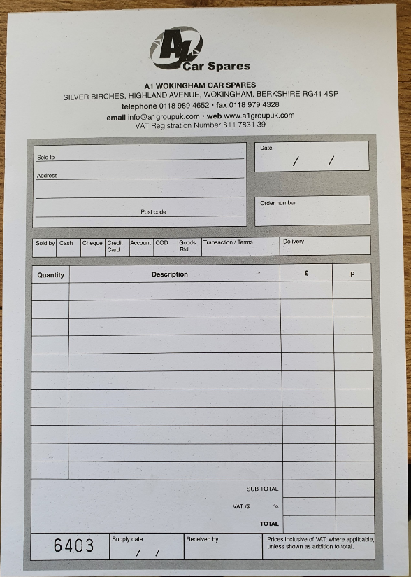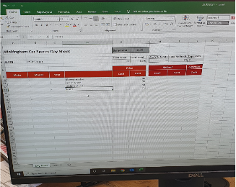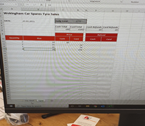
tickets for parts and tyres are still manual raised receipt for goods sold All spreadsheets for payments are kept on a daily spreadsheet

Photos show the new spares offices:

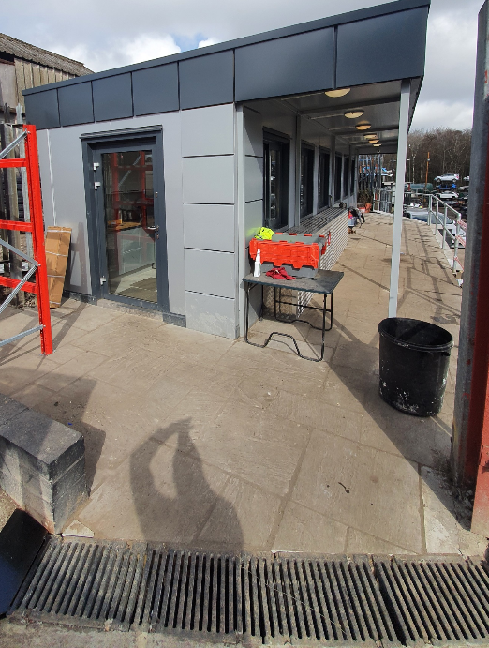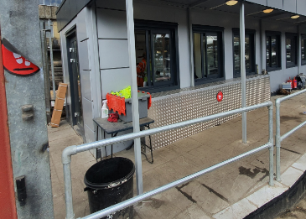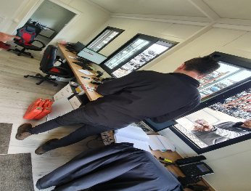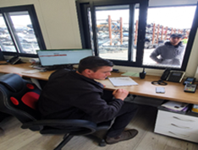

Scrap Metal process: (SS)
The organisation has an operating procedure relating to - Weighing In Bridge Process, last reviewed: Jan 2021, currently on version: 1.0 as seen below:
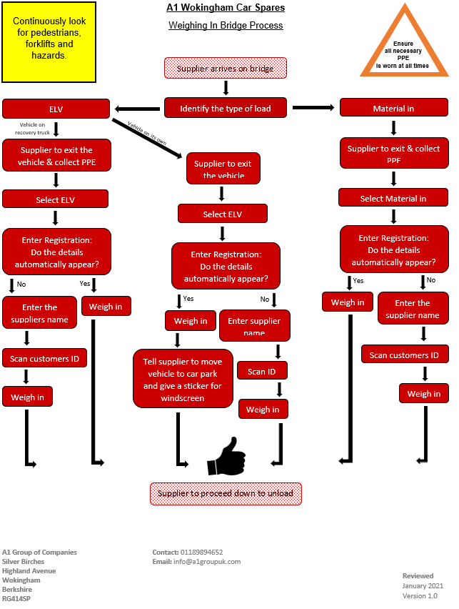
The process was described by CO inline with the current flow process. The following information is logged within the system:
- Registration
- Name of client
- Copy of identification i.e. Driving licence
- Weight of the vehicle loaded
- Weight of vehicle unloaded
- Ticket is then issued
The following tickets were seen and reviewed at the time of the audit:
- Ticket No: 1262771
- ATF No: 83313
- WCL No: CBDU186269
- WM Licence No: EAWML 83313
- Reg No: RO56 BJY
- Date & Time: 15/03/2021 @ 09:52hrs
- Supplier: MS
- Postcode: RG12 0WD
- Weight in: 3800kgs
- Weight out: 2320kgs
- Weight supplied/off loaded: 1480kg
- Payment type: Prepaid card

- Controlled waste transfer Note
- Ticket No: 1262788
- ATF No: 83313
- WCL No: CBDU186269
- WM Licence No: EAWML 83313
- Reg No: YN64UHR
- Date & time: 25/03/2021 @ 10:56hrs
- Customer: Federated Scrap Ltd
- Postcode: HR2 6NS
- Weight in: 18060kgs
- Weight out: 44480kgs
- Weight supplied/off loaded: 24420kg
- Payment type: Account type

The following photographs support the process:
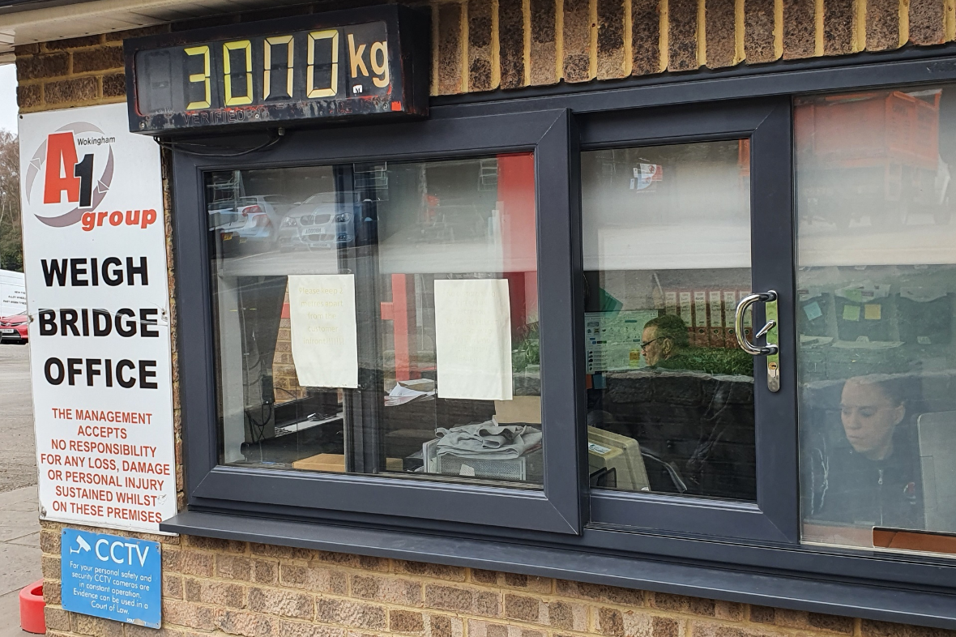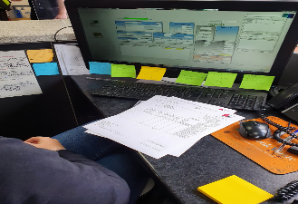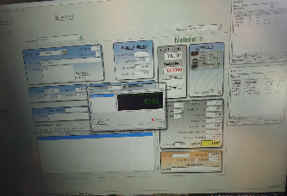

Eliminating hazards and reducing OH&S risks
The organisation has a electronic database containing all the operational risk assessments which contained 105 risk assessments. The risk assessments are rated using the following criteria:

Value | Frequency | Vulnerability | Impact
5 | Certain | Unmanaged | Catastrophic / Death
4 | Likely | Reactive Management | SLA compromised / Permanent Disability
3 | May Happen | Workaround Planned | Workaround possible / Serious injury
2 | Unlikely | Developed Management | Easy Workaround / Minor injury
1 | Very unlikely | Negligible | Negligible

And:
Risk Value | Meaning | Requirement
40+ | Very High Risk | Improvement required
31 to 40 | High Risk | Improvement required
21 to 30 | Medium Risk | Improvement opportunity
11 to 20 | Low Risk | No action required
1 to 10 | Very Low Risk | No action required

The Risk assessment are documented on A1 Group Risk Assessment Form, currently on Version: 1.0. the following information is contained within:
- Activity/task/Equipment
- Controls currently in place
- Threat/Hazard
- Frequency
- Value
- Vulnerability
- Value
- Impact
- Value
- Risk Value
Corrective Actions requirement
The following risk assessments were seen and reviewed at the time of the audit:
- COVID-19 Risk Assessment – Safe Working Procedure: dated: 22/09/2020, completed by: MP, with an overall risk rating of 5 and below: Risk value: Very low no action required.
- Working At Height: dated: 01/01/2021, conducted by: SW H&S Advisor with an overall risk rating of 10 and below, Risk value: very low, no action required.
- Scrap Yard and Spares: dated: 01/01/2021, conducted by: SW H&S Advisor with an overall risk rating of 6, Risk value: very low, no action required.
- High Pressure cutting: dated: 01/01/2021, conducted by: SW H&S Advisor with an overall risk rating of 6, Risk value: very low, no action required.
- Removal of Effluent from Client site: dated: 01/01/2021, conducted by: SW H&S Advisor with an overall risk rating of 10 and below, Risk value: very low, no action required.
Wet Waste – Work Planning and Operational Activities (PG)
Wet waste is also managed via the Big Change database system. The system manages all new jobs being raised and planning and allocation on the system as well as tracking of vehicles and sign off of completed works. The auditor was given a demonstration of how a job is raised including how it tracks the movements etc.. When a job is entered onto the system for a specific driver it automatically sends the details to their mobile phone. New jobs can be added to the system under three main work streams which are; Mobile Mini, Service Works or Emptying Works. When a job is uploaded onto the daily planner the jobs can be allocated to a driver as required. Works are not normally planned further than the next day so as to avoid slippage due to another job over running or a driver being off sick. When the driver or technician receives the works they logon to the job, complete the required works, take pictures after the work is complete and close off the jobs including the times the works was completed, the quantity pumped away and where the waste is being tipped. Screenshot below shows the planned jobs for AA on the Big Change system.

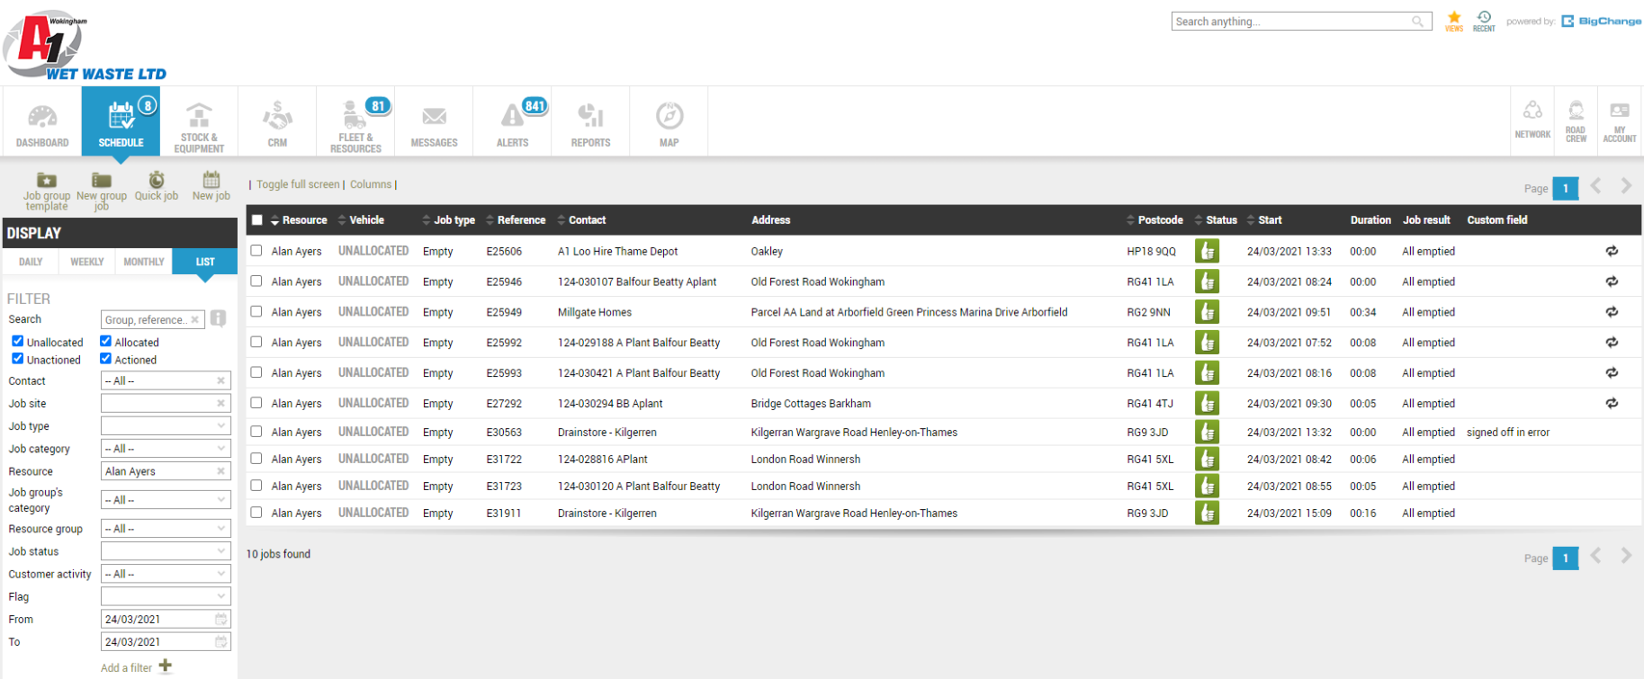

The following jobs where viewed on the Big Change system;

Job No. E31911
Customer – Drainstore – Kilgerren
Date – 24/03/2021 (09.00am)
Scope of Work – Empty 1000 Gallon Sewage Tank
Works Allocated to – AA
----------------------------------------
Job No. E30821
Customer – NHS Testing Site - Rochester
Date – 24/03/2021 (11.41am)
Scope of Work – Emptied waste tanks and filled water bowsers
Works Allocated to – PM
---------------------------------------
Job No. E30894
Customer – Alexander Palace NHS
Date – 23/03/2021 (18.39pm)
Scope of Work – Empty 3 waste tanks 500gl water relief service 3 - bowser 250gl and service toilets
Works Allocated to – SS
---------------------------------------

Vehicle De-Pollution (PG)
Vehicles are taken into the yard area once they are scrapped off by the customer and segregated ready for decontamination. This involves stripping the vehicles of the catalytic converters, axles and engines and fuel tanks which contain the waste fluids. The rest of the vehicles are then considered as dry and are moved to the crushing area for scrapping. If the vehicle is going for spares the engines, fuels and fluids are manually drained and the fuels are filtered out to clean and the fuel is re-used. Oils, Anti Freezes and Waste fluids are put into waste tanks ready to be taken away by the Waste Contractors. Upon completion of this process the vehicle is then transferred to either the crushing area for scrapping or to the spares section where it will be racked up for parts to be sold.

Stripping of Parts (PG)
Where vehicles are required for spares rather than scrap they are de-polluted as per the above process before having the engines and tyres and wheels, tanks removed. Some engines are sent abroad. Tyres are inspected, graded and either sold (re-used) of scrapped off dependent on the condition. Other vehicles are de-contaminated complete and moved to the spare parts storage area where they stored by manufacture type on racking. The vehicles are open to inspection by the public and parts can be removed if required under the supervision of A1 Group Employees. All areas are covered by CCTV.

Car Spare Sales and Provision (PG)
Car spares are managed via the sales/spares team in the office next to the yard area. Most sales are made via the internet portal or through walk in sales. The customer is quoted a price and postage or collection off the vehicle itself either by staff or by the customer themselves. All sales are recorded onto a daily payments sheet which is then sent to Sales Ledger. Sales payments can be made via cards, cash or Paypal. Scrap and spares prices are monitored on a daily basis on the internet to ensure the prices paid are in line with competitors.

Purchasing Incl. supplier evaluation/assessment (PG)
There are purchasing procedures regarding scrap metal, wet waste, loo hire and the review of supplier performance clearly documented. Currently there are three levels of purchase orders raised, the fitter and tyre depot both hold their own purchase order books and a general Wokingham scrap metal purchase order book is also held for suppliers, demonstrated on request.

A current list of approved suppliers was also seen and reviewed.

The purchase process was demonstrated on request. This process and corresponding records confirmed the following:

When a purchase had been made for the scrap metal department, the following had been recorded in the PO book:

- Date
- Order No (order numbers viewed as evidence)
- Name of Supplier
- A description of the goods to be ordered and quantities

Orders are only processed once approval by the Yard Manager. Delivery notes are retained and confirm that when goods had been received. These are cross checked against the purchase order books to confirm the order is correct. Confirmation of this was seen via the initials/signature/date of the inspecting/authorised person on the delivery note. An appropriate process was clearly in place regarding the raising of any discrepancies. When an invoice is received, they are separated into individual piles and checked off once a week, the details are then entered onto Sage.

CoSHH (PG)
The business uses the Sypol system for its CoSHH assessments which are then in turn stored in the back office system.
Assessment checked during the audit were up to date. Sample of Coshh register and assessment records from Sypol system sighted are detailed below;

Product | Provider | Review Date | Reviewed | COSHH Assessment updated
27140 Copper Grease | CHEVRON GLOBAL LUBRICANTS | Sep-22 | Y | N
Air Gun Oil | APASEAL LTD | Sep-22 | Y | Y
Apa038 ruglyde tyre paste | APASEAL LTD | Oct-22 | Y | N
Arco vehilce wash | THR ARCO GROUP | Oct-22 | Y | N
Bacsafe gel | SAFECHEM LTD | Sep-24 | Y | Y
Battery acid | WOBURN CHEMICALS LIMITED | Oct-22 | Y | N
Battery terminal protector | QUEST CONSUMABLES LTD | Oct-22 | Y | N
Channel Cubes | SAFECHEM LTD | Sep-22 | Y | Y
Fixt Copper Anti seize | QUEST CONSUMABLES LTD | Oct-22 | Y | N
Fixt Silicone spray lube | QUEST CONSUMABLES LTD | Oct-22 | Y | N
Graphite penetrating oil | SOLVITOL LTD | Oct-22 | Y | N
Greenox Adblue - Car Spares | TENNANTS DISTRIBUTION LTD | Oct-22 | Y | N
Greenox Adblue - Loo Hire | TENNANTS DISTRIBUTION LTD | Oct-22 | Y | N
Greenox Adblue - Wet Waste | TENNANTS DISTRIBUTION LTD | Oct-22 | Y | N
GT85 Maintenance Spray | WD40 COMPANY LIMITED | Oct-22 | Y | N
Impact | EVODE LTD | Oct-22 | Y | N

Waste Management (PG)
Company Procedure OP14 Waste and the Environment and OP16 Wet Waste Removal.
The procedure and associated risk assessments are available on the Company intranet page. (Back Office).
Waste Licence – Loo Hire – CBDU71782 – Expires – 14/12/21
Waste Licence - A1 Car Spares – CBDU186269 – Expires – 30/07/23
Waste Licence – Wet Waste – CBDU66714 - Expires – 28/11/21

Records for the following jobs were viewed:

Tyre Channel Limited - Consignment Note No. 16259 – Waste Code – 16 01 03 – Car Tyre Waste – Date Removed – 12/03/21 - Waste Carriers Licence No. CBDU336685
Tyre Channel Limited - Consignment Note No. 16334 – Waste Code – 16 01 03 – Car Tyre Waste – Date Removed – 22/03/21 - Waste Carriers Licence No. CBDU336685
Slicker Recycling – Consignment Note No. A1WOKI/56740 – Waste Code – 13 02 05 – Qty-2670kg – Mineral Oils – Date Removed – 13/01/21 Waste Carriers Licence No. CBDU125624
Tyre Channel Limited - Consignment Note No. 16042 – Waste Code – 16 01 03 – Car Tyre Waste – Date Removed – 16/02/21 - Waste Carriers Licence No. CBDU336685

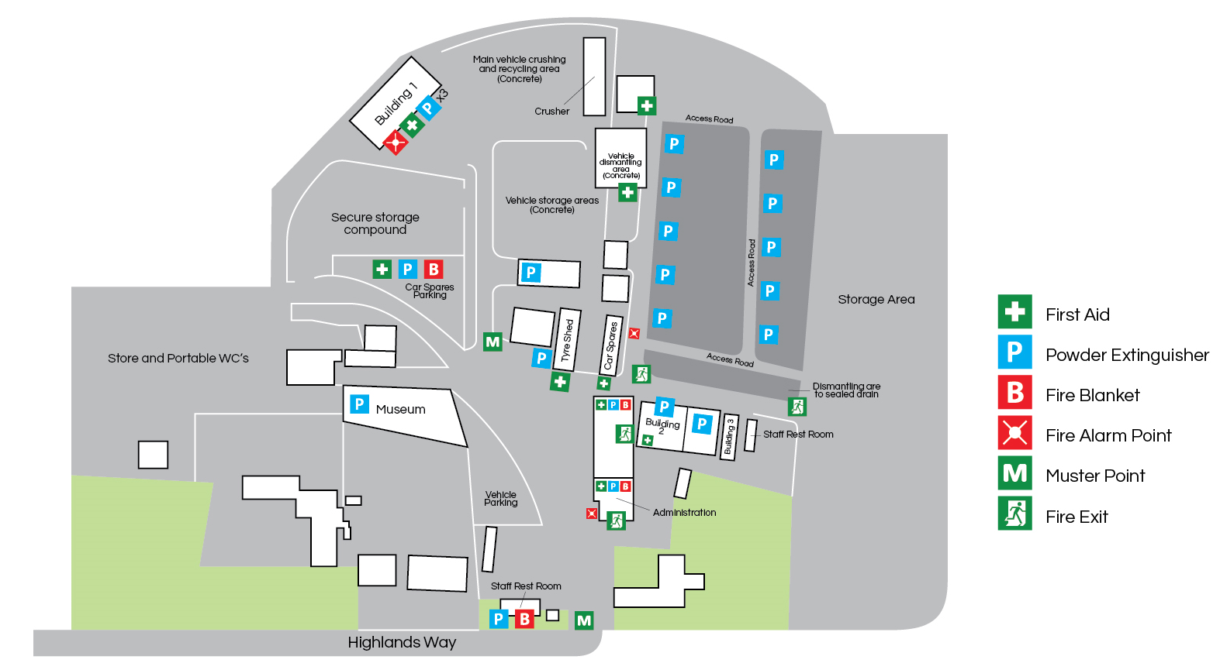

Emergency Preparedness and Response (PG)
The organisation has a procedure in place for Fire, first aid, spillage and other emergency situations, OP9, Issue 1. The following areas were reviewed during the audit;

- Fire Prevention Plan Version 4 – Date January 2021 Plan includes – Purpose, Combustible materials on site, Non-Combustible materials on site, Activities at Site. Managing the common causes of fires, Prevent Self Combustion, Prevent fire Spreading, Appendices, Additional Environmental Considerations, A1 Group Fire Emergency Evacuation Procedure, A1 Group Fire Evacuation strategy, A1 Group Emergency Action Plan
- Fire Alarm System service completed by Berridge Electrical Services Ltd – Report No. 22067150 – 17/09/20
- First Aid kits were all found to be in order across the site.
- First Aid Trained - Wokingham Car Spares - RP and TH
- Spill kits were also in place at various locations
Fire Extinguishers are serviced annually by RES Fire Protection – Last done on in February 2021.
- Fire Risk Assessment was viewed dated 09/12/20. Approved by Sean Whittle, FCIPD H&S Consultants.
- Fire Marshalls and First Aiders are designated for the sites.
- Last emergency evacuation took place on the January 2021
- Alarmed Interceptor at the bottom of the site.
- Fire Alarm weekly checks conducted (19/03/21)
- PAT Testing last conducted in August 2018 by Berridge Electrical
- Evacuation routes – All evacuation routes were clear
- COSHH – (See site walk section of the report)
- Fire prevention plan - Available dated July 2015, Version 1. Plan displayed in the main office
- Drainage Plans are also in place

Summarise Conformity with Requirements and any non-applicable clauses with justification:

Meets the requirements of the standards

- Performance Evaluation

Detail and evidence:

Customer Satisfaction: (SS)
The organisation had continued to gain opportunities from existing clients and relationships. Repeat Business, referrals, verbal feedback, Meetings, Reviews posted on Facebook and Google and Operatives carrying out task on site. As per the management review of IMS objectives/management review minutes, it was evident that this information had been used as an input to the process, in order to assess company performance, client satisfaction levels and any areas for improvement if necessary. The following snapshot was from the client satisfaction page from Facebook at 11:23hrs on the 25/03/2021, with the organisation having a satisfaction score of 4.4 stars out of 5:
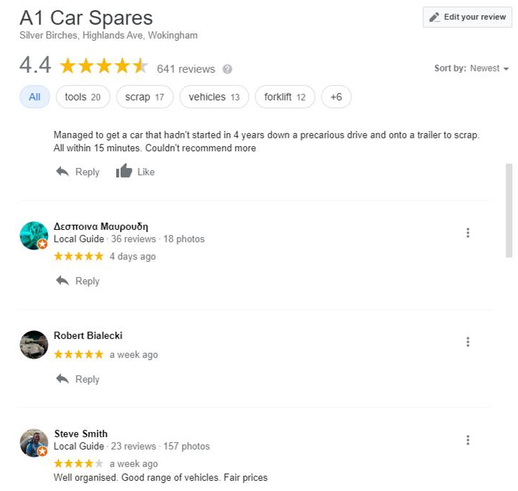

Internal Audit QMS, EMS & OHSMS: (SS)
The organisation has implemented a complete IMS audit program running from Jan to Dec as required within OP11 – Monitoring and Measuring Requirement, currently on issue: 1. The management system is monitored and measured through regular internal audits of this system completed in line with the audit timetable. Records of these audits are maintained and if any areas are identified as in need of improvement then a non-conformity is issued. The following internal audits were seen and reviewed at the time of the remote audit:

The following internal Health and Safety Audit, A1 Car Spares – WOKINGHAM, dated: 10/12/2020 was also seen and reviewed. The audit was conducted by SW (Consultant) on request of CD (Finance Director), NO Nonconformances were raised. Actions noted alongside recommendations for improvement and then followed up during the Health and Safety committee meetings

The following internal audits were seen and reviewed; these were conducted by the IW from (JR consultants) on behalf of the organisation:
- Dated: 07/01/2021
- Areas within the scope of the audit: OP001 Risk assessments and method statements, OP004 Training and competency, OP005 Communication and consultation, OP009 Accident, incident and near miss reporting, Emergency preparedness, Car spares process, including eBay sales, Site walk, ref health, safety and environmental issues.
- Auditees: CO and SW
- Details of Non-Conformances: Observation: The company does not have a structured employee communication process. It will be required for ISO 45001.

- Dated: 30/09/2020
- Areas within the scope of the audit: Business risks, OP003 Compliance obligations, OP006 Document and data storage, OP010 Calibration and maintenance, OP013 Complaints and feedback, De-pollution process and Site walk.
- Auditees: CO and SW
- Details of Non-Conformances: None Found.

- Dated: 24/02/2021
- Areas within the scope of the audit: Loo hire process, Wet waste process, Procurement, suppliers and subcontractors, OP 001 Risk assessments and method statements, OP 002 Environmental aspects, OP 010 Calibration and maintenance, OP 014 waste management and the environment.
- Auditees: CO
- Details of Non-Conformances: None Found
- The following details were contained within the audit report:
- Loo hire process: Requests for Loo Hire are received either: Verbally, Fax, Via Purchase Order, E-mail or Via Tendering Process.
- Order process carried out as per the procedure. When a unit is to be off-hired, a collection note is raised, and when the toilet is returned it is inspected for damage/faults and an off-hire contract is raised, and an invoice for the hire and any damage is sent to the customer.
- Examples: Soiltechnics, High View, Hatfield AL10 8JB. P/o 0536207 on 24th January 2021 for effluent waste from single site toilet delivered the same day. Off hire 3rd February 2021 and collected same day under ref 2696262. Local Toilet Hire ordered a site toilet on 13th February 2021 for delivery to Emmer Green, reading RG4 8QX, their ref 16705/36593. Delivered on 20th February 2021 under contract WOK/322732. Still on hire. Travis Perkins, on 14th June 2021 ordered a toilet for weekly servicing under 3350001258 for delivery to Vidi Construction, Putney, SW15 2NU. Delivered 1st July 2021 Collection note raised 18th February 2021 under contract WOK321522, off-hire note dated same day.
- Wet waste process: Wet waste is not handled here; it is all delivered straight to the STW, see OP 014 below.
- Procurement, suppliers and subcontractors: This part of the company issues purchase orders for local purchases, otherwise anything significant is carried out through head office. The company maintains an approved suppliers list that is periodically reviewed.
- OP 001 Risk assessments, method statements: Risk Assessments and Method Statements are held on the Back Office. Risk Assessments are in place for both the yard and workshop and are reviewed periodically – last review date January 2020. There are currently 104 Risk Assessments in place, including the latest Covid version.
- OP 002 Environmental aspects.
- This process outlines the methodology used by the company to establish the Environmental impacts of the Company activities in order to assess them accordingly and control them.
- The aspect assessment was last reviewed in July 2019. This is reviewed annually, and aspects are documented and recorded on it. Significant aspects are those with a score of 60+, and are as follows: Wastepaper, Tyres, Ferrous metal, Liquids, Engines, Petrol, Fuel storage, Vehicle de-pollution, Storage of vehicles, Tyre storage, Oil and lubricant storage. There have been no amendments to the aspect register since the last review. The file has been saved as Aspect Assessment 2019, dated 23rd July 2019 to confirm a review has been carried out. The register remains current and is unchanged since this date.
- OP 010 Calibration and maintenance: This process is to ensure that all equipment owned and operated by the Company is always maintained and inspected to ensure its adequacy. Other than the forklift daily check sheets filled in by drivers prior to use, all vehicle records are held at the head office. Similarly driving licences and other plant and equipment maintenance records.

Management Review QMS, EMS & OHSMS: (SS)
The last management review meeting was conducted on the 12/11/2020 Attended by: SP (Director), RP (Director), CO (Director), CD ( Finance Director), RJP (Car Spares, Manager), MP (Wet Waste Director), SC (Transport Manager), SW (HR Consultant), GW (Yard Manager), SM (Coventry and Bridgend / Coventry), Loo Hire, LW (Bennetts), MD (Oxford0, DC (Wet Waste), SW (HR consultant) and CE (Group) and ER (Minutes) the following agenda was seen:
- Actions Outstanding
- Overall System Performance
- Policy Review
- Proposed changes / suggestions
- External Communications
- Resources
- Participation and Consultation
- Training
- Emergency Procedures
- Company Objectives
- Suppliers / rejects
- External / Internal Audits
- Corrective and Preventative actions
- Legal Compliance
- New Developments
- Customer Complaints
- Customer feedback
- Risk assessments / COSHH
- Accidents / Incidents

The following key points were discussed within the meeting:
- Company Objectives: Various on-going, see attached schedule. Office expansion completed in 2017. Some training for 2020 has yet to be completed – COVID caused some courses to be postponed. Accident statistics have been reviewed and they have increased but this is because of the increased culture now in place through the committee; Fire marshal training has been completed at al sites 6 personnel. The vehicle fleet has been expanded considerably due to workloads; older vehicles are still being replaced however not until 2021 now. H&S meeting: (SS)
- Participation and Consultation: A health and safety committee established 2013 no issues meet on monthly basis and recorded. The minutes of these were reviewed by and no issues. Accident’s procedure has been re written and communicated to all employees and accidents / incidents are being reported and there is an increased awareness amongst staff and personnel.
- External / Internal Audits - corrective and Preventative actions: Internal audits have recorded no problems. Previous external audit report was reviewed - Fire extinguishers – all serviced regularly. The training matrix has now been completed and is in working process. IOSH training has been considered and is planned for 2021 when it is quieter. An improvement log is in place and actions highlighted are recorded on here and signed off once completed.
- Legal Compliance & New Developments; Company is in legal compliance; there have been no significant issues raised by the EA or highlighted during internal auditing. Environment Agency are always in contact regarding noise, smell complaints etc. and these are investigated as required with a further record created if necessary. The Spray Booth at Bennetts is still under review for its compliance and if it needs inspections required – DC is organising this. New ISO Audit requirements and migration to ISO 45001 were discussed – CO and SW to review the business risks register NH JR Consulting to update the manuals to a new System manual in the next month.
- Accidents / Incidents Accident statistics for 2019 and 2020 to date are as follows:
Maj Min RIDDOR Near Miss
2020 (TD) 0 4 0 0
2019 2 12 2 2

These are discussed and reviewed at the monthly H&S Committee meetings held; with another scheduled for early January – COVID permitting. Accident investigations have also progressed and are being completed where identified as required. Near misses are being reported a lot more; it was all agreed that accidents have increased because more people are reporting them and that going forward this hope this improves as the culture changes.

Health & Safety Meeting: (SS)
The last H&S meeting was conducted on the 09/03/2021, attended by the following personnel: SW (H&S Adviser), SC (Transport Manager), CO (Loo Hire Director), SM (Bridgend /Coventry), RJP (Car Spares Manager), MP/DC (Wet Waste), CD (Finance Director), GW (Yard Manager), LW (Loo Hire Bennetts), ER (Office Administrator), MK (Oxford/Network Rail) and JR (Maintenance), the following areas were covered within the meeting:
- Accidents in previous month
- Incidents / Near Misses in previous month:
- Performance Metrics: Accidents / Incidents in 2021 to date
- Impact of operational infrastructure changes in the last month/next month
- Risk Assessments reviewed last month
- Risk Assessments reviewed next month
- Management programs and legal compliance issues arising: Fire, Fire Evacuation, Noise and Road Safety management.
- Issues in performance of contracted third parties: Contractor’s performance.
- Legislation & HSE Updates
- Ongoing operational or project-based issues: Projects currently being undertaken.
- Any other business: PSE NVQ, DVSA and Environment Agency, COSHH, HSE, FORS Silver/Gold, IAuditor, H&S Notice boards, Employees Appraisals, WAMATAB Course, Future meetings and AOB.
The following key points were taken from the meeting minutes:

- Incidents / Near Misses in previous month:
Ref No | Open Date | Issue | Owner | Comment/Monthly update
4.14 | 09-Mar-21 | 6 vehicle incidents reported since November 2020 | All | Dec 2020 WX15YVO DN from LOO HIRE reversed into parked car  15.1.21 CE61WTR JA from LOO HIRE reversed in to parked car  10.1.21 RP11KES TS from WWW hit lamp post when reversing  FEB 21 RX65AOF DN from LOO HIRE slid on black ice into lamp post  24.2.21 DX18RUH RP from WWW clipped a car when pulling in to let other cars through  2.3.21 DK13JGZ JT from LOO HIRE hit in the rear
4.15 | 09-Mar-21 | Near misses since September | All | Near Miss – no near miss incidents recorded since November 2020

- Performance Metrics:
Ref No | Open Date | Issue | Owner | Comment/Monthly update
5.11 | 09-Mar-21 | Accident/Incidents in 2021 to date | SW | 3 Accidents and 20 vehicle incidents for 2020  2 Accidents and 6 Vehicle incidents for 2021

- Management programs and legal compliance issues arising:
Ref No | Open Date | Issue | Owner | Comment/Monthly update
10.14 | 09-Mar-21 | Fire | SW | FPP still to be approved by the Environment Agency in Spring 2021
10.33 | 09-Mar-21 | Fire Evacuation Process | All | Fire Evacuation process / Weekly Fire Alarm tests– Nothing to report
10.43 | 09-Mar-21 | Noise | All | CE has now completed a noise management programme
10.52 | 09-Mar-21 | Road Safety Management | SC | Drug tests are now still ongoing. Stuart is keeping on top of doing these, so far everything has come back all clear, keep going with them during the months. Still ongoing one was done last month so we are up to date.  Sprinters now need to be looked at getting cameras for all vehicles- Stuart has found a deal so the first step will be getting LH equipped with them all. Well into getting all of this sorted. Once LH is done, looking at WW vehicles.  Road safety – just need to be extra vigilant at making sure we are aware of bridges as this is an ongoing problem for the whole of the UK. Nothing else new has been addressed.  Refresher training and rules about certain yards to be given to all staff. – CLIVE/MICHAEL/GARRY to make sure all employees are following the correct rules of each site in regards to PPE/site rules. This can also be incorporated in the tool box tools.

Next meeting set for the April 2021; the meeting minutes meet the requirements of ISO45001: 2018.

Evaluation of Compliance: (SS)
The evaluation of the organisations legal compliance is conducted on an annual basis through the following methods:
- Legal audit completed of the management system by JR Consultants at least once annually.
- Site inspections – reviewed during this audit.
- Annual management review meeting – where company legal compliance is discussed, and a formal statement issued by the Directors to confirm (recorded at the management meeting).

Summarise Conformity with Requirements:

Meets the requirements of the standards

- Improvement

Detail and evidence:

Accident / Incident/ Near Miss investigation and communication: (SS)
The organisation has OP 009 -Accident, incident and Near Miss reporting process, currently on issue: 3. The organisation maintains an Accident Report folder detailing any accidents which have been reported, also a near miss reporting form. Accidents and near misses are reviewed and discussed on the Monthly Health and Safety meetings. Due to pandemic lockdown and restriction, there have been limited activities on site, and no incident recorded.

Nonconformity and corrective action Continual Improvement: QMS, EMS & OHSMS: (SS)
The organisation had strived to continually improve the IMS Over this period. This has been seen through various areas of this audit, including and captured in MRM meeting minutes. QHSE system is effectively and is constantly reviewed. The company have implementing SAGE HR to replace the training matrix. This will interact with the payroll system and provide staff to monitor training more effectively. There is a new audit quality check system with managers now using tablets to confirm that they have checked the yard. If any issues are identified they can take pictures which can be uploaded, and this allows staff to sign them off. The organisation Action & Improvement log 2021 was seen and reviewed at the time of the audit:

Action No. | Date Raised | Depot | Audit Identification | Process improvement issue | Corrective action (fix at source) | Preventive Action (prevent re-occurrence) | Action to be undertaken by | Date Closed
308 | Dec-20 | Wokingham | H&S | Fire Extinguishers | Ideally be stored off the floor and on a wall with signage to indicate their location and use. | Review on weekly walk rounds | H&S Reps / Yard H&S Monitors | Ongoing
309 | Dec-20 | Wokingham | H&S | Flammable liquids storage | Ideally be stored in lockable area and away from ignition sources | Review on weekly walk rounds | H&S Reps / Yard H&S Monitors | Ongoing
310 | Dec-20 | Wokingham | H&S | Housekeeping | Ensure employees do not leave rubbish in area used for forklift operations / store butane in cages / replace broken signage – use IAuditor to identify issues weekly | Review on weekly walk rounds | H&S Reps / Yard H&S Monitors | Ongoing
311 | Dec-20 | Wokingham | H&S | Ladder storage | Secure ladder to wall when not in use | Review on weekly walk rounds | H&S Reps / Yard H&S Monitors | Ongoing
312 | Dec-20 | Wokingham | H&S | Hoses & Leads | Place back on hooks when not being used | Review on weekly walk rounds | H&S Reps / Yard H&S Monitors | Ongoing
313 | Dec-20 | Wokingham | H&S | Steps | Get grip covers placed on steps – ensure gritted in cold conditions | Review on weekly walk rounds | H&S Reps / Yard H&S Monitors | Ongoing

Once the action is closed it then moved to the closed tab.

Summarise Conformity with Requirements:

Meets the requirements of the standards

The audit methods used in these sections were interviews, observation of activities, review of hard copy documentation, review of documentation retained electronically and a review of records. The conclusion is based upon the evidence obtained during the audit. The auditor(s) used standard sampling techniques to obtain this evidence and no guarantee can be given that a different conclusion may have been reached had different samples been taken.

Post Audit Activities

- Closing Meeting Attendees:
Name | Position
Clive Owen | General Manager
Ian Wilson | JR Consultant
Paul Grainger | Lead Auditor
Shaw Spratt | Lead Auditor
Sean Whittle | HR Consultant

OH Requirement
The organization representative shall be requested to invite the management legally responsible for occupational health and safety, personnel responsible for monitoring employees’ health and the employees' representative(s) with responsibility for occupational health and safety to attend the closing meeting. If any individuals with these responsibilities cannot attend, then justification shall be recorded below:
Justification for any non-attendance

- Activities planned but not covered on this visit and require planning for the next visit.

N/A

- Head Office/Locations/Branch Offices visited during this audit

Date | Location | Auditor(s)
23/05/21 | Head Office | PG & SS
24/05/21 | Head Office | PG & SS
25/05/21 | Head Office | PG & SS

- Client/Contract Sites/Temporary Sites visited during this audit (if applicable).

Date | Location | Auditor(s)
N/A

- Locations/Branch Offices

All permanent Locations/Branch offices for which certificates are required (Check on Business Manager)
are current and correctly identified | Yes: | x | No:

If no correct details are
Location (Town/City) | Address | Standards

- Registration Marks

Use of Registration Marks is in accordance with the Use of Logo Rules (if used) | Yes | x | No |  | May use in the future

Brief details of where the UKAS Accreditation Mark and Alcumus ISOQAR Logo is used.

Use of Registration Marks on website is appropriate to the scope of the certification | Yes | x | No |  | Not Applicable

EXTENSION TO SCOPE (USE THIS SECTION ONLY IF NECESSARY)

Has the wording of the scope changed? | Yes: |  | No:

New Scope Wording if changed:

IF NEW LOCATION(S) ARE ADDED PLEASE COMPLETE FOLLOWING SECTION(S)

(Only complete the scope section if different from the Head Office Scope)

Number of new certificates required i.e. Head Office plus Certificate for each Location: | 1

Address:

Scope:

- Recertification Visits (complete only at a Recertification Visit)

Has the review of activities (in particular complaints against the client) and reports covering the certification cycle revealed any issues?

Yes |  | No | x
If yes please provide details:

AUDIT PLAN NEXT VISIT

Please note that changes to Auditors may be unavoidable due to operational requirements
The objectives of the audit:
- To confirm that the management system conforms with the requirements of the audit standard and also any statutory, regulatory and contractual requirements that are applicable;
- To confirm that the organisation has effectively implemented the planned management system;
- To confirm that the management system is meeting its specified objectives
Audit criteria:
- Documents, procedures and policies relevant to the standard being audited will be required.
- The audit will be performed against the scope of activities agreed at the opening meeting or as agreed at stage 1 or as detailed on the Certificate.
- The audit will be conducted at the locations identified on this audit plan.

Lead Auditor |  |  |  | Paul Grainger |  | Additional Auditors (Expert) |  |  |  | N/A
Standard(s) |  |  |  | ISO 9001:2015, ISO 14001:2015 45001:2018 |  |  |  | Type of Audit (ie Surveillance) |  | Surveillance 1
Audit Dates |  |  |  | 05th & 06th October 2021 |  |  | Location(s) |  | Head office
Audit Start Time |  |  |  | 0900 |  | Does Client need to confirm site visit with ISOQAR Head Office prior to next visit YES/NO |  |  |  |  | No
Audit Language (if not English) |  |  |  | N/A |  | Is Recertification Planning Required YES/NO |  |  |  |  | No
 |  | AM | Opening Meeting / Site Walk (taking into account car spares yard/office, tyres, crane area, loo hire storage area, office, Access and egress from the site, control of the public and visitors) |  |  |  |  |  |  |  |  |  | PG
Day 1 |  | AM | 4. Context & Scope –  4.1 Understanding the organisation and its context  4.2 Understanding the needs and expectations of interested parties  4.3 Determining the scope of the Quality / Environmental Management System  4.4 Quality / Environmental Management system, its processes and their interactions. |  |  |  |  |  |  |  |  |  | PG
 |  | AM | 5. Leadership –  5.1 Leadership & Commitment (interview with top management);  5.2 Quality, Environmental and OHSAS Policies  5.3 Organisational Roles & Responsibilities |  |  |  |  |  |  |  |  |  | PG
 |  | AM | 6. Planning –  6.1 Risks & Opportunities (including H&S risks)  6.3 Planning of Changes)  6.1.3 Compliance Obligations |  |  |  |  |  |  |  |  |  | PG
 |  | AM | 7. Support –  7.1 Resources  Infrastructure – (Lifting equipment maintenance, LOLER, vehicle maintenance, Plant and site maintenance / Equipment maintenance / PUWER)  7.3 Awareness  7.4 Communication  7.5 Documented Information – creating & updating  Consultation and participation |  |  |  |  |  |  |  |  |  | PG
Day 2 |  | PM | 8. Operation –:  Scrap waste process  Procurement/approval of suppliers/contractors  Purchasing  Vehicle de pollution  Control of COSHH |  |  |  |  |  |  |  |  |  | PG
 |  | PM | 9.Performance Evaluation –  9.1.2- Customer Satisfaction  9.1.3 - Analysis and Evaluation  9.2 - Internal Audit;  9.3 - Management Review  9.1.2 Evaluation of Compliance |  |  |  |  |  |  |  |  |  | PG
 |  | PM | 10. Improvement –  10.1 General;  Accident/Incident/Near miss process  10.2 Nonconformity and corrective action;  10.3 Continual Improvement |  |  |  |  |  |  |  |  |  | PG
 |  | PM | Closing Meeting |  |  |  |  |  |  |  |  |  | PG

NOTE TO CLIENT: No further confirmation or reminders will be issued. Failure to honour the date arranged may result in extra charges being incurred by your company as stated in ISOQAR Rules of Registration. Cancellation of audit or surveillance dates within 20 working days of the agreed date will result in ISOQAR claiming an extra levy from the company for each staff day cancelled.
Note to Auditor

AUDIT PLAN COVERING THE 3 YEAR ASSESSMENT CYCLE

Organisation Name | A1 Group

This plan commences:

- On the date of the first surveillance visit following the initial audit (stage 2) or;
- On the date of the Surveillance Audit following the Re Certification Audit;
- At the next surveillance visit if the plan requires amending or to take into account extensions to scope.

 | Visit 1 | Visit 2 | Visit 3 | Visit 4 | Visit 5 | Visit 6
Month and Year | Oct 21 | Apr 22 | Oct 22 | Apr 23 | Oct 23 | Mar 24
Number of Days | 2 | 2 | 2 | 2 | 2 | TBD
Standards | 9001/14001/ 45001 | 9001/14001/ 45001 | 9001/14001/ 45001 | 9001/14001/ 45001 | 9001/14001/ 45001 | 9001/14001/ 45001
Area/Function/Process/Activity/Site Visits (temporary sites)
Site Walk (taking into account car spares yard/office, tyres, crane area, loo hire storage area, office, Access and egress from the site, control of the public and visitors)
4.1 Understanding the organisation and its context
4.2 Understanding the needs and expectations of interested parties
4.3 Determining the scope of the Quality / Environmental / OHS Management System
4.4 Quality / Environmental / OHS Management system, its processes and their interactions.
5.1 Leadership & Commitment (interview with top management);
5.2 Quality, Environmental and OHS Policies
5.3 Organisational Roles & Responsibilities
5.4 Consultation and participation of workers
6.1 IMS Risks & Opportunities (including H&S risks)
6.1.2 Environmental Aspects
6.2 Objectives & Planning to achieve them
6.3 Planning of Changes)
6.1.3 Compliance Obligations
7.1 Resources, Infrastructure – (Lifting equipment maintenance, LOLER, vehicle maintenance, Plant and site maintenance / Equipment maintenance / PUWER)
7.2 Competence
7.3 Awareness;
7.4 Communication;
7.5 Documented Information – creating & updating
Scrap waste process
Wet waste process
Loo Hire
Procurement/approval of suppliers/contractors
Purchasing
Vehicle de pollution
Accident/Incident/Near miss process
Control of COSHH
Emergency Preparedness & Response
Waste Management
9.1.2- Customer Satisfaction;
9.1.3 - Analysis and Evaluation
9.2 - Internal Audit;
9.3 - Management Review
9.1.2 Evaluation of Compliance
10.2 Nonconformity and corrective action
10.3 Continual Improvement
Closing Meeting
SSIP Checklist
Recertification Planning
Recertification

Head Office/Locations/Branch Offices Visit Plan
 | Visit 1 | Visit 2 | Visit 3 | Visit 4 | Visit 5 | Visit 6
Head Office
Main Office- Loo Hire; Swallowfield, Berkshire
Loo Hire Site Visit
Wet Waste Site Visit

Indicate with a ✓ when audit of this function planned or when a visit is planned.

When producing this plan ensure that all clauses of the standard(s) can be attributed to Area/Function/Process/Activity/Site Visits (temporary sites) and are audited over the 3 year Recertification Cycle. The clients Locations/Branch Offices must also be appropriately sampled over the 3 Year Certification Cycle.

Plan Produced By | Paul Grainger | Date | 25/03/21

Plan Amended By |  | Date

