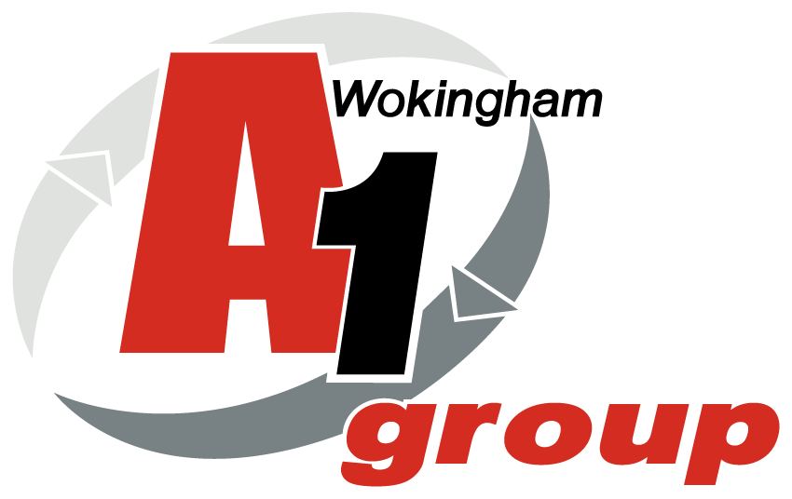

Health and Safety Audit

A1 Car Spares - WOKINGHAM

21st November 2023

Approvals and Amendments

Rev # | Date | Amended by | Approved by | Details
01 | 21/11/23 | Sean Whittle | Clive Owen | Site audit and creation of draft
02 | 18/12/23 | Sean Whittle |  | Report sent to client
03 | Ongoing | Sean Whittle |  | Meeting to review actions
04 | H&S meeting Dec 23 |  |  | Feedback to H&S Reps
05 | 14/12/23 |  |  | Action Plans Devised
06 | At H&S meetings |  |  | Action Plans reviewed

Report completed by:
Sean Whittle FCIPD
HR Advisor
HR & Business Solutions Ltd

Report completed for:
Clive Owen
Director
A1 Group of Companies,
Silver Birches,
Highland Avenue,
Wokingham,
Berkshire
RG41 4SP

This risk assessment is limited to the risks and findings identified on the day of the assessment and the recommendations contained in this report are based upon information provided by others and the assumption that all relevant information has been provided by those bodies from whom it has been requested.

This document is solely for the use and benefit of the Client. This document shall not be distributed, republished, uploaded, referred to, displayed, posted, edited, modified, re-written, copied in whole or part in any form (including but not limited to electronic, mechanical, printing, photocopying), by any other corporate entity, individual persons, or for any other purpose by the Client without the prior written permission of HR & Business Solutions Limited.

Table of Contents

Approvals and Amendments 2
1. Introduction 4
2. Scope 6
3. Aims and Objectives 6
4. Meeting the Objective 6
5. Background Information 6
6. Significant and Moderate Risks 7
Umbrella Risk Assessment Report 9
Substantial Risks 9
2. Bunded tank for fuel / oil storage 10
3. Barrier entry to scrap area 11
Moderate Risks 12
Next Steps 15
Appendix 1 - Prioritised Risk and Hazard Table 16
General Site - Risk Assessment Table 17
Driving at Work - Risk Assessment Table 18
Occupational Health - Risk Assessment Table 19
Manual Handling - Risk Assessment Table 20
Workshop Noise - Risk Assessment Table 21
Training and Induction - Risk Assessment Table 22
Offices and DSE Work Stations - Risk Assessment Table 23
Contractors - Risk Assessment Table 24
Site Electrical Equipment - Risk Assessment Table 25
Drivers Lifting Equipment - Risk Assessment Table 26
Water Systems and Shower - Risk Assessment Table 27
Site Fire - Risk Assessment Table 28
Work at Height - Risk Assessment Table 29
Falling Objects - Risk Assessment Table 30
Pressure Vessels and Gas Supplies - Risk Assessment Table 31
Handling Waste for Disposal - Risk Assessment Table 32
Machinery and Work Equipment - Risk Assessment Table 33
External Area and Site Access - Risk Assessment Table 34
First Aid and Accident Reporting - Risk Assessment Table 35
Hazard and Near Miss Reporting - Risk Assessment Table 36
Health & Safety Communication - Risk Assessment Table 37
Outdoor Work - Risk Assessment Table 38
Asbestos - Risk Assessment Table 39
Kitchen Area / Rest room - Risk Assessment Table 40
Pregnant Workers and Young Persons - Risk Assessment Table 41
Appendix 2 - Risk Assessment Scoring 42
Severity Score Table 43

1. Introduction

Clive Owen, Director commissioned HR & Business Solutions Ltd to

- Audit the health and safety status of their site at Highland Avenue,
Wokingham, Berkshire, RG41 4SP
- HR & Business Solutions used an umbrella risk assessment to achieve this requirement
A1 Group Ltd is a well-established company with three separate Divisions namely: Car Spares / metal recycling / Wet Waste and Loo Hire from its six depots in Wokingham, Bridgend, Coventry, Longacres (Bennett’s Yard), Oxford and Portsmouth.
The Wokingham site is a large open planned working site which is used to dismantle various vehicles and recycling their parts. The yard is constantly in use by both A1 vehicles delivering and removing both scrap vehicles and materials and by members of the public to purchase car spare parts. There is a tyre unit the stores and replaces tyres.
There are two general office units and numerous workshops and storage units around the yard in various locations. All are open planned and have adequate firefighting equipment. There is also a fire engine on site to deal with any fires this is manned by trained fire fighters who work on site.
There is a small office brick building with flat roof at the front of the yard and a steel framed / cladded general office with two floors at the rear of the building. The general office contains a small reception area / small transport office / there I a further office of the main corridor there is a kitchen area / storage room and toilet facility. The corridor leads downstairs to a large open planned general office with small kitchen and 8 desks and toilet facilities at the rear of the unit. There is a staircase leading to a large open planned area with two further Director’s offices, a large meeting room / rest area and 4 hot desks and a further small kitchen area. There are fire exits out of the window onto the roof of the reception area and there is a ladder to exit the roof. There is employee parking at the side of the main office. There are three fire escapes in the main building one through the front door by the reception and one at the side of the main office area. There is adequate emergency lighting in the building and smoke detectors in the office and kitchen areas.
The main yard is in five main sections and there is a small customer parking which has pre-painted designated bays.
- A Metal Recycling area which houses one large Crusher / a depollution area and three separate units – engines / wiring and / scrapped car storage area / toilet storage area.
- There is a tyre bay workshop and a car spares office behind the main office building. There is also a large racking system to store all scrapped cars adjacent to the car spares office and also a workshop unit at the rear of the car storage area.
- The car storage area is accessible to members of the public in certain areas and there is adequate lighting and signage in this area with both employees and members of the public wearing PPE at all times whilst in this area. There are three further car storage areas in the main yard all of which store numerous vehicles at ground level.
- There are two metal recycling units for nonferrous and copper materials adjacent to the main office and a separate workshop area.
- There is a large static 2 story unit at the front of the yard which is used as an employee canteen the 2nd floor is redundant.
- There is a large area to the side of the main yard which is used to store plastic toilets.
There is high use of oxyacetylene on site and there is also fuel (diesel and unleaded) stored on site in suitable secure containers. There are also gas bottles in various locations all of which are stored in lockable cages when not in use. There are also numerous skips located around the site which are used for storage of scrap materials.
The site is well lit with clear H&S signage and numerous defined walkways for employees and members of the public to use. PPE is worn at all times on site by both employees and members of the public.
The site is well protected in terms of fencing and there are numerous CCTV units around the site. The premises are considered to be of HIGH risk given the level of flammable materials and operations conducted on site.
At the time of the visit approximately 155 people (40 based at Wokingham) were employed within the A1 Group business, with around 40 on the Wokingham site at any time serving the operational needs of the business.

Risk assessment is a legal requirement and is the starting point for all Occupational Health and Safety (OH&S); HR & Business Solutions risk assessment approach is an umbrella over the top of A1 Car Spares (Wokingham) ensuring all risks are captured. By assessing the risks of injury and ill health, identifying what is in place to control these risks and then determining further controls necessary, sets the boundaries on OH&S. The resulting risk control measures determine the effort, time and financial commitment that need to be applied to training, writing procedures, on-going support etc. The H&S system can then be proportionate to the risks; because it is derived from A1 Car Spares (Wokingham) relevant risks, it will have value and purpose for your business. The umbrella risk assessment is a functional business tool, which should be used by the Board as part of their commitment to managing and monitoring OH&S risks.

By reviewing its operations and identifying key risks A1 Car Spares (Wokingham) will be able to manage its OH&S issues. By establishing risks, A1 Car Spares (Wokingham) can plan and implement relevant safe working procedures to ensure, so far as is reasonably practicable, the health, safety and welfare of those affected by its undertaking.

2. Scope

Carry out an ‘Umbrella Risk Assessment’ for A1 Car Spares (Wokingham).

3. Aims and Objectives

The aim is to identify and provide A1 Car Spares (Wokingham) with an overview of their key health and safety hazards and risks within their operations.

The main objective is to identify significant hazards and risks for A1 Car Spares (Wokingham) and make recommendations in line with legislative requirements.

4. Meeting the Objective

To meet the objectives the following activities will be undertaken:

Umbrella Risk Assessment of Wokingham Site

- Visit each key area in the Wokingham facility
- Meet and talk to management, H&S representative and employees, as appropriate
- Record relevant risks/hazards, current controls and recommendations
- Include hazard/risk table in appendix 1
- Outline significant and moderate risks in main body
- Make recommendations in line with legislative requirements

5. Background Information

H&S Poster
Displayed and completed around the depot

H&S Policy
Signed copy displayed on notice boards.

Employers Liability Insurance
Current copy displayed in general office.

Accidents and Incidents
Reported, recorded and reviewed. Two significant incidents in the last 12 months.

Current H&S Documentation

- H&S Policy written, signed and displayed
- Risk Assessments for items of work equipment, tasks and areas completed
- Risk Assessments are contained on a shared drive
- Risk Assessments reviewed annually by the responsible person for H&S at the depot

6. Significant and Moderate Risks

Understanding the Hazard and Risk Table (Appendix 1)
The columns in the Umbrella Risk Assessment Table are as follows:

No.
The hazard number.

Hazard
A description of the common hazard identified.

S
This is the severity of the hazard (see Appendix 2 for Severity Scoring).
Person Affected
This column identifies the persons most likely to be affected by the hazard.

Existing Control Measures and Common Theme
These are the existing controls in place to reduce the likelihood of the hazard reaching full potential and any common themes seen at the depots.

L
This is the likelihood, taking account of the persons affected and the existing controls, of the hazard occurring (see Appendix 2 for Likelihood Scoring).

RPN
This is the Risk Priority Number = Severity x Likelihood.

Recommendations
These are recommendations of how to lower the risk.

Relevant Legislation
Applicable legislation for the risk identified.

Risk Priority Number is kept simple, and scoring is summarised in the following table and in Appendix 2 - Risk Assessment Scoring.

Risk Priority Number | Action and Timescale
Intolerable:  RPN = 9 | Stop activity immediately or do not start until action has been taken to reduce the level of risk. (Enforcement risk - possible HSE Prohibition Notice).
Substantial:  RPN = 6 | Take action to reduce the risk level within 1 month. (Enforcement risk - possible HSE Improvement Notice).
Moderate:  RPN = 3 or 4 | Take action to reduce the risk level within 3 - 6 months.
Trivial/Low:  RPN = 1 or 2 | No further action required.

The Risk and Hazard Table is prioritised with the high RPN’s listed first, these are discussed next.

Umbrella Risk Assessment Report

On the day of the risk assessment, and in the opinion of the assessor there was 3 Substantial Risks and 3 Moderate Risks scoring a four; these are outlined below.

Substantial Risks

1. Firefighting equipment

There were numerous fire extinguishers around the site that were out of date and not used anymore. In event of emergency, they could be mistaken for being full / fully serviced and may not work.

There we a number of Fire Extinguishers in Depollution that were stored incorrectly on the floor or were hidden / obstructed
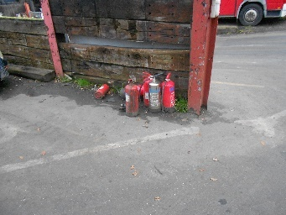
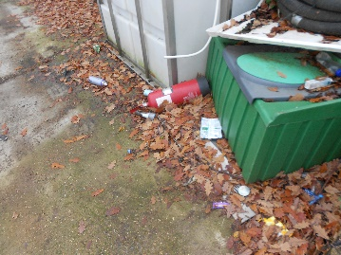
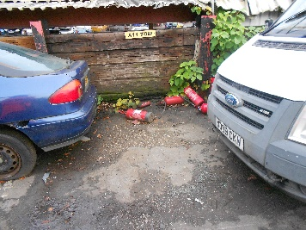

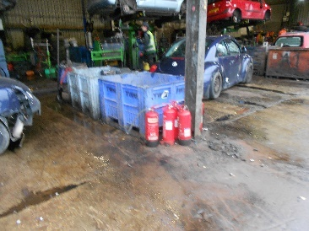

Specific Risks

Fire equipment being hit by moving vehicles. Being knocked over and driven over and possible trip hazard. Could be moved and not available when required in emergency situation.

Relevant Legislation

- Regulatory Reform (Fire Safety) Order 2005
- Management of Health and Safety at Work Regulations 1999

Recommendations

- Store Fire extinguishers on the wall of the unit or in a correct fire extinguisher holder.
- Ensure fire Extinguishers which are not in date are removed from site to avoid confusion in emergency

2. Bunded tank for fuel / oil storage

There were a number of oil drums just stored on pallets.

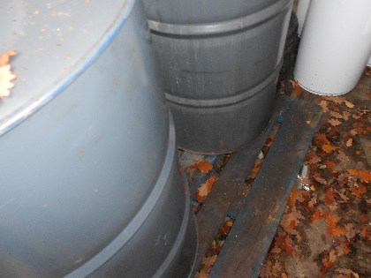

Specific Risks

It they leak then the spillage would not be contained.

Relevant Legislation

- Regulatory Reform (Fire Safety) Order 2005
- Management of Health and Safety at Work Regulations 1999

Recommendations

- Purchase bunded tank for drums to sit on

3. Barrier entry to scrap area

The is a barrier system in operation down bottom of slop in scrap yard. This was installed at the recommendation of the HSE in Jan 23. Whilst conducting the audit a member of public drove van into area without a check and the grab crane was in operation a the time and did not stop.
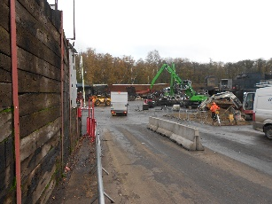

Specific Risks

Members of the public getting hit by the grab crane whilst dropping off scrap metal.

Relevant Legislation

- Regulatory Reform (Fire Safety) Order 2005
- Management of Health and Safety at Work Regulations 1999

Recommendations

- Ensure the barrier is down at all times and only raised when the grab cranes are not in operation and facing away from the main yard

Moderate Risks

1. General housekeeping

General housekeeping around the site was excellent. PPE use was excellent with all employees observed wearing PPE. H&S Notice board in employee canteen neds to be tided up as some documents are out of date

General rubbish around site was minimal and all issues recorded on IAuditor. There were a number of hoses on floor and hooks need to be in place to store after use off floor

Some potholes were deep and could be considered a trip hazard

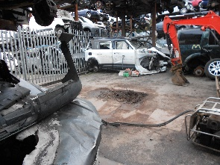
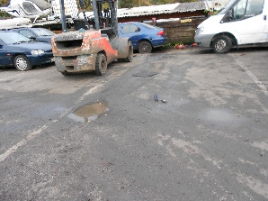
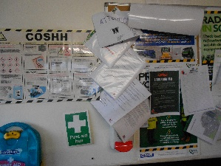
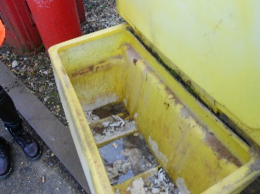
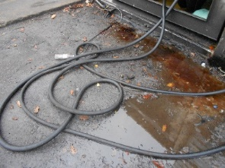
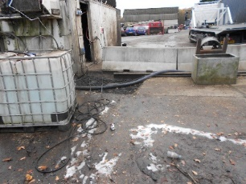

Specific Risks

Water is the root cause of potholes and existing potholes let more water get in under the sub-surface of your pavement, Loose hoses can be considered trip hazard. Ensure enough Salt and grit to cover yard in cold spell.

Relevant Legislation

- Management of Health and Safety at Work Regulations 1999
- Control of Substances Hazardous to Health Regulations 2002

Recommendations

- Potholes on site need to be checked and filled regularly as part of a management plan. Given the traffic on site potholes appear frequently
- Ensure grit an salt bins are full
- Ensure noticeboards are part of the weekly IAuditor checks and all documents are up to date.

2. Ladder storage / Gas bottle storage

There were various ladders on site which were left out and not stored correctly and could fall on employees if left unsecured – need to have fit for use sticker on an also checked weekly prior to use.

There were a number of gas bottles on site not stored correctly – if empty then remove from site
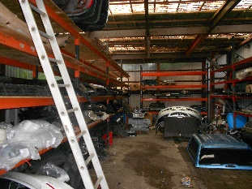
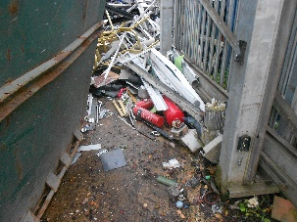
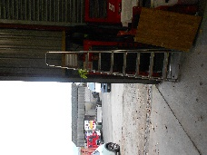
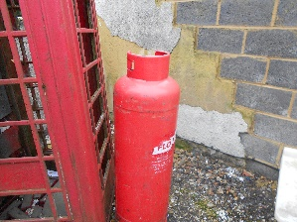

Specific Risks

Storing your ladder properly is important and when a ladder isn't stored safely and securely, it can lead to damage - to the ladder, surrounding objects, and most importantly, people.

Relevant Legislation

- Management of Health and Safety at Work Regulations 1999

Recommendations

- Ensure all ladders are checked and safe to use. Also, when not in use ladders need to be secured and locked securely
- Ensure all loose gas bottles around the site are storage securely

3. Forklift inventory / Service records

There are numerous forklifts on site but no record of how many of when they are required to be serviced.
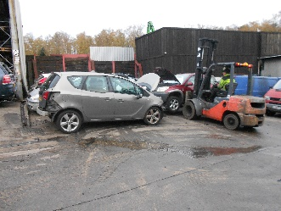
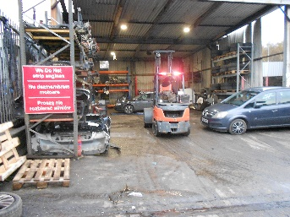
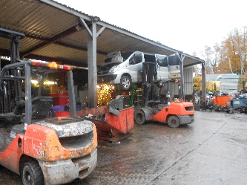
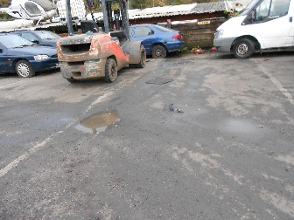
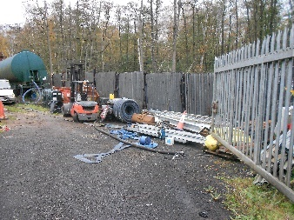

Specific Risks

Forklifts are an integral part of day-to-day operations. It is extremely important that any forklift, whether it’s powered by gas, electric or diesel, receives a regular maintenance check to ensure maximum safety and ensure optimum productivity in the workplace.

Furthermore, forklifts are expensive items of materials handling equipment and if regularly maintained by professionally trained engineers serve to enhance the efficiency and productivity rather than a drain on time and resources.

Relevant Legislation

- Management of Health and Safety at Work Regulations 1999

Recommendations

- Develop a management programme to ensure the forklifts are services every 200 hours or eight days to ensure they run smoothly and as intended.
- Operators to conduct daily checks and ensure all faults are reported immediately and fork lift is quarantined until safe to operate

Next Steps

This risk assessment is a live working document and a tool for the business.

Read the recommendations in point 6 above. These are the top priority recommendations based on the RPN.

Further recommendations are outlined in the risk assessment table (Appendix 1).

Documented Action Plan
Document an Action Plan and assign responsibility with timescales for completing the recommendations in the report.

- Monitor and review the Action Plan on a regular basis, recording when the actions are completed. Note down any relevant evidence against the completed actions i.e. training records, new work instructions etc.
- Some examples of how to record the evidence: on the action plan, hand written notes in this report, or separate documents attached or referenced to the report/Action Plan

Consultation and Training
There is a legal requirement to consult employees on risk control measures that relate to, or affect them and to provide any related training. Where either result from this risk assessment, ensure the communications and training occur. Document when and how consultation was achieved, and document employee training records.

Risk Assessment Review
There is no legally set review period for a risk assessment, but there needs to be a mechanism for reviewing when necessary.

As a framework, a risk assessment should be reviewed:

- At least every 1-5 years; the Health and Safety Executive recommend annual review
- If the business expands, takes on more staff or moves premises
- If there is a significant change to the work activities, process or task
- If the type or no. of persons exposed changes
- If there is a related accident, ill-health or incident reported
- If there is a change in technology or information that could affect the risk
- For any other reason if the assessment is no longer valid

Appendix 1 - Prioritised Risk and Hazard Table

Hazards considered during this Risk Assessment:

Work At Height | X |  | Manual Handling | X |  | Slips, Trips & Housekeeping | X
Lighting, Heating & Ventilation Levels | X |  | Falling Objects | X |  | Display Screen Equipment | X
Layout/Storage/Space/Obstructions | X |  | Workplace Transport / Pedestrians | X |  | Driving At Work | X
Welfare Facilities | X |  | Pregnant Workers / Young Persons | X |  | DDA
Outdoor Work/Extreme Temperature | X |  | Off Site/Home/Peripatetic Working |  |  | Occupational Pressure
Violence To Staff / Verbal Assault |  |  | Contractors | X |  | Visitors / Trespassers | X
Lifting Equipment | X |  | Work Equipment (Fixed / Portable) | X |  | Electrical Equipment | X
Lone Working/Out Of Hours/Security | X |  | Pressure Vessels / Gas Supplies | X |  | Hazardous Substances | X
Noise | X |  | Vibration | X |  | Biological Agents
Legionella or Lead | X |  | Asbestos | X |  | Flammable Substances (F, F+) | X
Dangerous Substances (O, E, DSEAR) | X |  | Radiation Sources I.E. Lasers, UV |  |  | Confined Space/Asphyxiation
Environmental Risks | X |  | Food Preparation |  |  | Fire | X

X = Relevant at the time of the visit, if there is no X the hazard was considered not relevant or insignificant.

General Site - Risk Assessment Table

# | Hazard | S | Persons Affected | Existing Control Measures and Common Theme | Risk |  | Recommendations | Relevant Legislation
 |  |  |  |  | L | RPN
1 | Hazardous/Flammables Substances – liquids | 2 | Employees | Existing controls exist to store flammable liquids / cleaning products etc. when not in use. | 1 | 2 | No further recommendations | Control of Substances Hazardous to Health Regulations 2002

Driving at Work - Risk Assessment Table

# | Hazard | S | Persons Affected | Existing Control Measures and Common Theme | Risk |  | Recommendations | Relevant Legislation
 |  |  |  |  | L | RPN
2 | Driving At Work - Delivery and tanker drivers are the main drivers for A1 Group but other employees may drive on company business.  Hazard: road traffic accident.  Vehicles used are both company and privately owned. | 2 | Employees | A Driving at work procedures manual is in place. | 1 | 2 | No further recommendations | Management of Health and Safety at Work Regulations 1999

Occupational Health - Risk Assessment Table

# | Hazard | S | Persons Affected | Existing Control Measures and Common Theme | Risk |  | Recommendations | Relevant Legislation
 |  |  |  |  | L | RPN
3 | Occupational Health - Work activities can impact on employee’s heath as well as their safety. A proactive occupational health program can assist with the monitoring of adverse health effects and also maintain a healthy and productive workforce.  Specific Risks - Some occupational health is required under certain regulations for managing specific risks: For IOS these include Skin and respirator sensitising chemicals, Noise and Task Repetition.  Additional Considerations  - Sickness absence management  - Fitness for work assessment  - Wellbeing and stress management  - Drugs and alcohol | 2 | Employees | MSD Reporting (musculoskeletal disorder) - Repetitive tasks have ben risk assessed Use of HSE guidance in HSG60 is recommended but not recorded at time of assessment. MSD reporting is currently verbal and too Depot managers. If further medical advice is required the employee is referred to the OH.  Audiometry - No audiometry is carried out currently.  COSHH Heath Surveillance - Currently, nothing is carried out.  Stress/Wellbeing - Employees reporting stress are currently referred to the OH.  Drugs & Alcohol - Zero tolerance, procedure in place. Facility to random test in place. | 2 | 4 | Sickness Absence - There is system that records current absence levels which should be discussed at a monthly H&S committee meeting – Representative from Coventry should attend bi monthly H&S meeting  Audiometry - Introduce audiometry for those exposed to noise above the 1st and 2nd action levels.  MSD Report - Introduce reporting system for MSD. Train employees on what to look out for and report issues to line managers.  Train line managers on completing MSD form, restricting duties and referral procedure to OH. | Management of Health and Safety at Work Regulations 1999  Noise at Work Regulations 2005  Control of Substances Hazardous to Health Regulations 2002  Working Time Regulations 1998

Manual Handling - Risk Assessment Table

# | Hazard | S | Persons Affected | Existing Control Measures and Common Theme | Risk |  | Recommendations | Relevant Legislation
 |  |  |  |  | L | RPN
4 | Manual Handling - Handling of incoming/outgoing equipment. | 2 | Employees | Risk Assessments include manual handling activities; these are housed on the Back Office.  Safety shoes worn by all employees handling equipment.  Manual Handling training recorded in training files soon to be via Human Focus which will be accessible via the HUB. | 1 | 2 | In addition to training on manual handling at induction provide practical manual handling training to all employees who are required to carry out MH operations such as lifting, pulling, pushing, bending and twisting as part of their role. | Manual Handling Operations Regulations 1992  Lifting Operations and Lifting Equipment Regulations 1998  Provision and Use of Work Equipment Regulations 1998

Workshop Noise - Risk Assessment Table

# | Hazard | S | Persons Affected | Existing Control Measures and Common Theme | Risk |  | Recommendations | Relevant Legislation
 |  |  |  |  | L | RPN
5 | Noise: Equipment and vehicles being serviced after hire and before new hire - Exposure to noise above statutory action levels of 80dBA and 85dBA can lead to hearing loss. | 2 | Employees | Existing controls in place | 1 | 2 | Users are trained to fit their hearing protection, and this is documented.  Employees were witnessed wearing appropriate PPE  No further recommendations | Noise at Work Regulations 2005

Training and Induction - Risk Assessment Table

# | Hazard | S | Persons Affected | Existing Control Measures and Common Theme | Risk |  | Recommendations | Relevant Legislation
 |  |  |  |  | L | RPN
6 | Training and Induction - Without a clear and relevant induction and training programme, new starters and employees are more likely to have accidents and/or suffer from work related ill health.  A1 Group Training Includes:  - Manual Handling - Induction and annually  - DSE training online  - Role specific training  - Equipment specific training  - Managers H&S responsibilities | 2 | Employees | Excellent training arrangements in place and recorded on Sage HR  All employees’ are trained against defined skills and subjects, which are recorded in personal file,  H&S training is captured either as a specific role H&S module or as part of other training i.e. equipment operation.  A lot of the H&S related training is managed and delivered in house. | 1 | 2 | Review other specific H&S training delivered internally to ensure the key points of the training are documented.  All employees receive practical manual handling training as well as the on-line training. This is documented and refreshed regularly i.e. 1-2 yearly.  General H&S awareness training is undertaken for all employees yearly.  Introduce training for MSD and issues related to repetitive roles.  Introduce Health Surveillance training in relation to skin issues.  Introduce regular H&S training for members of H&S committee. | Management of Health and Safety at Work Regulations 1999

Offices and DSE Work Stations - Risk Assessment Table

# | Hazard | S | Persons Affected | Existing Control Measures and Common Theme | Risk |  | Recommendations | Relevant Legislation
 |  |  |  |  | L | RPN
7 | Display Screen Equipment - Use of desktop PCs at workstations in various locations at Wokingham Site. | 2 | Employees | Employees made aware of DSE during Induction.  Annual Assessments have been completed | 1 | 2 | VDU operators have annual DSE refresher training this was complete and up to date at time of Audit.  No further recommendations | Display Screen Equipment Regulations 1992

Contractors - Risk Assessment Table

# | Hazard | S | Persons Affected | Existing Control Measures and Common Theme | Risk |  | Recommendations | Relevant Legislation
 |  |  |  |  | L | RPN
8 | Contractors - Uncontrolled contractor activities can lead to incidents both to themselves on company premises or which could affect company employees.  Hazards include: falling objects, electrical damage, fires etc. | 2 | Employees and Contractors | There is mention of contractor management in the H&S Manual.  Contractors supply business with completed questionnaire, RAMS and insurance documentation prior to wok being undertaken. | 1 | 2 | No further recommendations | Management of Health and Safety at Work Regulations 1999

Site Electrical Equipment - Risk Assessment Table

# | Hazard | S | Persons Affected | Existing Control Measures and Common Theme | Risk |  | Recommendations | Relevant Legislation
 |  |  |  |  | L | RPN
9 | Electrical Equipment - Failure of electrical equipment through poor maintenance or damage can lead to electrocutions. | 3 | Employees and Third Parties | PAT Testing completed internally on a rolling basis.  Fixed wiring installation tested and inspected. | 1 | 3 | Ensure all electrical equipment PAT tested every three years  No further recommendations | Electricity at Work Regulations 1989

Drivers Lifting Equipment - Risk Assessment Table

# | Hazard | S | Persons Affected | Existing Control Measures and Common Theme | Risk |  | Recommendations | Relevant Legislation
 |  |  |  |  | L | RPN
10 | Lifting Equipment - Failure of lifting equipment can result in a serious incident and would be a RIDDOR reportable incident.  Lifting equipment identified:  - Workshop hoist equipment  - Roller Shutter Doors  - Tailgates on vehicles | 2 | Employees | Statutory inspections for lifting equipment and accessories are completed.  Maintenance in place for all lifting equipment.  Workshop/delivery drivers wear safety shoes and high visibility clothing.  Risk Assessments are completed and reviewed regularly | 1 | 2 | No further recommendations | Lifting Operations and Lifting Equipment Regulations 1998  Provision and Use of Work Equipment Regulations 1998

Water Systems and Shower - Risk Assessment Table

# | Hazard | S | Persons Affected | Existing Control Measures and Common Theme | Risk |  | Recommendations | Relevant Legislation
 |  |  |  |  | L | RPN
11 | Legionella - Hazards: Legionella bacterial inhalable through water mist from a shower or developing in hot and cold water systems. | 2 | Employees | Legionella risk assessment not available at time of audit. | 1 | 2 | No further recommendations | Control of Substances Hazardous to Health Regulations 2002

Site Fire - Risk Assessment Table

# | Hazard | S | Persons Affected | Existing Control Measures and Common Theme | Risk |  | Recommendations | Relevant Legislation
 |  |  |  |  | L | RPN
12 | Fire - Fire risks from ignition source finding a fuel source. Fuel sources include stock, cardboard/paper/waste materials in outside bins. | 3 | Employees, Third Parties, Vulnerable Persons and Contractors | Fire risk assessment completed by external competent person.  Fire Extinguishers should be stored off the floor and signage for correct use displayed near all extinguishers. | 2 | 6 | Place all extinguishers off floor and in areas that are both visible and easily accessible  No Further recommendations | Regulatory Reform (Fire Safety) Order 2005

Work at Height - Risk Assessment Table

# | Hazard | S | Persons Affected | Existing Control Measures and Common Theme | Risk |  | Recommendations | Relevant Legislation
 |  |  |  |  | L | RPN
13 | Work at Height - Limited work at height for A1 Group employees.  No work at height for Office workers.  Contractors carry out work at height. | 2 | Employees | Limited working at height activity at Depot therefore not risk assessed. | 1 | 2 | No further recommendations | Work at Height Regulations 2005

Falling Objects - Risk Assessment Table

# | Hazard | S | Persons Affected | Existing Control Measures and Common Theme | Risk |  | Recommendations | Relevant Legislation
 |  |  |  |  | L | RPN
14 | Falling Objects - Hazards: items falling on persons around the site. | 3 | Employees | Items over 20kgs were stored above head height in various areas around the depot | 1 | 3 | Car racking currently being assessed  No further recommendations | Management of Health and Safety at Work Regulations 1999

Pressure Vessels and Gas Supplies - Risk Assessment Table

# | Hazard | S | Persons Affected | Existing Control Measures and Common Theme | Risk |  | Recommendations | Relevant Legislation
 |  |  |  |  | L | RPN
15 | Pressure Vessels and Gas Supplies - For A1 Group these are:  - Gas Storage bottles  - Gas boiler  - Compressor for machine air lines  - Pressure Washer  Failure of pressure vessels or poorly maintained gas supplies can lead to serious incidents.  Hazard: uncontrolled release of pressurised material, failure of pressure vessel, release of gas, explosion or fire. | 2 | Employees and Third Parties in the areas | No gas boiler on site | 1 | 2 | No further recommendations. | Gas Safety (Installation and Use) Regulations 1998  Pressure Systems Safety Regulations 2000

Handling Waste for Disposal - Risk Assessment Table

# | Hazard | S | Persons Affected | Existing Control Measures and Common Theme | Risk |  | Recommendations | Relevant Legislation
 |  |  |  |  | L | RPN
16 | Handling Waste for Disposal - Use of bins at the back of the site.  Hazard: manual handling. | 2 | Employees | Waste is stored bins around the site. All materials are disposed of correctly. | 2 | 4 | Ensure general housekeeping from all employees to ensure waste is disposed of correctly  No further recommendations. | Management of Health and Safety at Work Regulations 1999  Manual Handling Operations Regulations 1992

Machinery and Work Equipment - Risk Assessment Table

# | Hazard | S | Persons Affected | Existing Control Measures and Common Theme | Risk |  | Recommendations | Relevant Legislation
 |  |  |  |  | L | RPN
17 | Machinery and Work Equipment - Use of work equipment by untrained persons or work equipment that is poorly guarded and maintained is more likely to lead to incidents.  Work equipment includes:  Lifting equipment  Hire Equipment. | 2 | Employees | Risk Assessment - The use of each item of work equipment is risk assessed.  New equipment is captured when purchased and training on use delivered by supplier.  . | 1 | 2 | No further recommendations | Provision and Use of Work Equipment Regulations 1998

External Area and Site Access - Risk Assessment Table

# | Hazard | S | Persons Affected | Existing Control Measures and Common Theme | Risk |  | Recommendations | Relevant Legislation
 |  |  |  |  | L | RPN
18 | Visitors/Trespassers - Unaccompanied visitors may be more likely to have an accident due to less knowledge about the site layout and operation.  Foreseeable hazards to trespassers should be avoided. | 2 | Employees, Visitors, Contractors and  Trespassers | Signage generally good around site  Site fencing is adequate | 1 | 2 | No further recommendations | Management of Health and Safety at Work Regulations 1999  Occupiers Liability Act 1947/1984

First Aid and Accident Reporting - Risk Assessment Table

# | Hazard | S | Persons Affected | Existing Control Measures and Common Theme | Risk |  | Recommendations | Relevant Legislation
 |  |  |  |  | L | RPN
19 | First Aid and Accident Reporting - If an incident occurs, slow first aid response can increase the severity of the injury. | 2 | Employees and Third Parties | Accident reporting procedure in place although not available at time of audit.  First aiders trained and displayed as pictures around the site on notice boards. | 1 | 2 | No further recommendations | First Aid Regulations 1981

Hazard and Near Miss Reporting - Risk Assessment Table

# | Hazard | S | Persons Affected | Existing Control Measures and Common Theme | Risk |  | Recommendations | Relevant Legislation
 |  |  |  |  | L | RPN
20 | Hazard and Near Miss Reporting - Reported incidents (Hazards and Near Misses) are indicators of potential accidents waiting to happen. | 1 | Employees and Third Parties | System in place for recording near miss occurrences on site or for drivers. This is agenda item on the H&S monthly meeting. Corrective Actions are then discussed. | 1 | 1 | No further recommendations | Management of Health and Safety at Work Regulations 1999

Health & Safety Communication - Risk Assessment Table

# | Hazard | S | Persons Affected | Existing Control Measures and Common Theme | Risk |  | Recommendations | Relevant Legislation
 |  |  |  |  | L | RPN
21 | H&S Communication - Clear methods of H&S communication.  A written H&S policy signed and displayed.  H&S procedures for controlling workplace risks in place and available to employees.  H&S Committee. | 2 | Employees | H&S Committee meet monthly and made up of a chair person and committee reps from all 4 depots. | 1 | 2 | No further recommendations. | Health and Safety at Work Act etc. 1974  Management of Health and Safety at Work Regulations 1999  The Health and Safety (Consultation with Employees) Regulations 1996

Outdoor Work - Risk Assessment Table

# | Hazard | S | Persons Affected | Existing Control Measures and Common Theme | Risk |  | Recommendations | Relevant Legislation
 |  |  |  |  | L | RPN
22 | Outdoor Work - Some employees have a need to work outside during the winter.  Pot holes are visible on site | 2 | Employees | All employees are provided with high visibility jackets/fleeces gloves for wearing in all areas apart from offices on site.  All affected employees can move into the warmth as required.  Heaters provided in rest area and general offices  Gritting products available to prevent slips in winter weather. | 2 | 4 | Fill potholes and ensure all plates are covering large potholes and if they move they are bolted to the floor  No further recommendations. | Management of Health and Safety at Work Regulations 1999

Asbestos - Risk Assessment Table

# | Hazard | S | Persons Affected | Existing Control Measures and Common Theme | Risk |  | Recommendations | Relevant Legislation
 |  |  |  |  | L | RPN
23 | Asbestos - If asbestos is present in the building, disturbance of the fibres can lead to personal exposure. | 1 | Employees and Contractors | Asbestos not present on site. | 1 | 1 | No further recommendations. | Control of Asbestos at Work Regulations 2006

Kitchen Area / Rest room - Risk Assessment Table

# | Hazard | S | Persons Affected | Existing Control Measures and Common Theme | Risk |  | Recommendations | Relevant Legislation
 |  |  |  |  | L | RPN
24 | Food Hygiene - risk of bacterial cross contamination with out of date food.  Slips Trips and falls - bags / clothing and rubbish across floor | 2 | All employees | Fridge provided to place food into to keep at adequate temperature.  Lockers and hooks provided to store personal belongs and work clothing.  Bins provided | 1 | 2 | No further recommendations | Food Hygiene Regulations 2006  Management of Health and Safety at Work Regulations 1999

Pregnant Workers and Young Persons - Risk Assessment Table

# | Hazard | S | Persons Affected | Existing Control Measures and Common Theme | Risk |  | Recommendations | Relevant Legislation
 |  |  |  |  | L | RPN
25 | Pregnant Workers and Young Persons - Higher risk groups more susceptible to workplace risks. | - | Pregnant Employees and Young Persons | Pregnancy Risk Assessment is a HR procedure and is in place.  No young persons employed at the time of the visit. Risk Assessments are completed for any work experience visitors. | - | - | No further recommendations | Management of Health and Safety at Work Regulations 1999

Appendix 2 - Risk Assessment Scoring

Risk Management and Compliance Audit Scoring
Severity Hazard (S) | Severity Hazard (S) |  | Likelihood of Occurrence (L)
 | Compliance | Harm or Ill Health | Low | Medium | High
 | 3 - None | 3 - High | 1 | 2 | 3
 | 2 - Partial | 2 - Medium
 | 1 - Satisfactory | 1 - Low

Risk Priority Number | Action and Timescale
Intolerable:  RPN = 9 | Stop activity immediately or do not start until action has been taken to reduce the level of risk. (Enforcement risk - possible HSE Prohibition Notice).
Substantial:  RPN = 6 | Take action to reduce the risk level within 1 month. (Enforcement risk - possible HSE Improvement Notice).
Moderate:  RPN = 3 or 4 | Take action to reduce the risk level within 3 - 6 months.
Trivial/Low:  RPN = 1 or 2 | No further action required.

See next page for Severity and Likelihood descriptions.

Severity Score Table

# | Description
3 | High Hazard - extremely harmful consequences  Major notifiable RIDDOR injury or fatality. Permanent disability. Severe life threatening RIDDOR Reportable diseases and illnesses i.e. cancer, asbestosis  Extensive loss of plant, or major damage to equipment, property or the environment. RIDDOR Dangerous Occurrence.  Would attract a prohibition notice from the HSE.  None Compliance  Breach of a relevant statutory provision with potential for harm.  No evidence of compliance to the relevant statutory provisions.
2 | Medium Hazard - harmful consequences  7 Day RIDDOR Reportable Lost time incident. Temporary disability, lacerations, serious cuts and bruises, burns, concussion, serious sprains and strains, minor fractures (fingers and toes).  RIDDOR Reportable Diseases i.e. occupational deafness, dermatitis, allergy, repetitive strain injury. Serious damage to equipment, property or the environment disrupting normal activities would attract an improvement notice from the HSE.  Partial Compliance  Minor or technical Breach possible. Some evidence of compliance to the relevant statutory provision i.e. hazards and risks identified some supporting documentation & training records.
1 | Low Hazard Severity - slightly harmful consequences  Minor Injuries & ill health i.e. minor sprains and strains, cuts and bruises, eye irritation, nuisance (e.g. headaches), minor skin irritation.  Minor damage to equipment, property or the environment.  Satisfactory  At the time of the audit or risk assessment and in the opinion of the assessor, compliance to the relevant statutory provisions is considered to be adequate i.e. hazards and risks identified by competent persons, full documentation supporting a system of managing the relevant risk and hazards identified, training in place and recorded, communication of risk control measures to employees in place.  Achieving this standard does not absolve the company of its duty to continuously monitor compliance to the relevant statutory provisions review risk on a regular basis.
Likelihood of Occurrence Table
3 | High (highly likely) | Daily or weekly opportunities for the hazard to be realised.  Continuous or almost continuous presence of the hazard.
2 | Medium (likely) | Opportunities for hazard to be realised are possible i.e. within the next 6-12 month period.
1 | Low (unlikely) | Opportunities for hazard to be realised are Infrequent and possible, but not expected in the next 12 month period.

