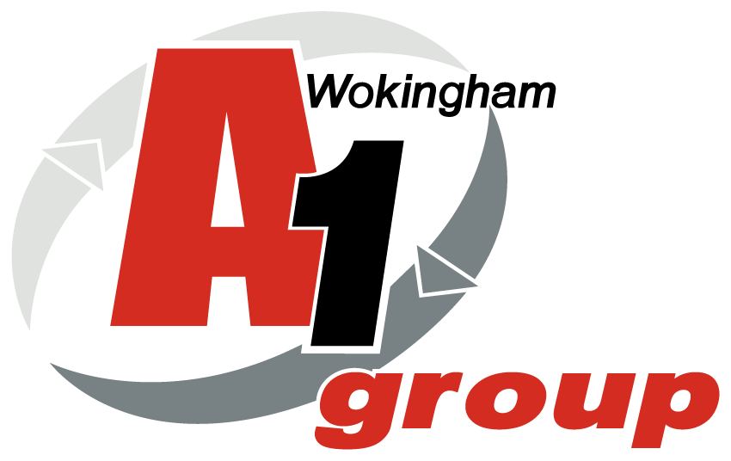

Health and Safety Audit

A1 Loo Hire – OXFORD DEPOT

22nd November 2019

Approvals and Amendments

Rev # | Date | Amended by | Approved by | Details
01 | 22/11/19 | Sean Whittle | Martyn Kirkham | Site audit and creation of draft
02 | 28/11/19 | Sean Whittle | Martyn Kirkham | Report sent to client
03 | Ongoing |  |  | Meeting to review actions
04 | H&S meeting Dec | Sean Whittle | Martyn Kirkham | Feedback to H&S Reps
05 | 28/11/19 | Sean Whittle | Martyn Kirkham | Action Plans Devised
06 | At H&S meetings |  |  | Action Plans reviewed

Report completed by:
Sean Whittle FCIPD
HR Advisor
HR & Business Solutions Ltd

Report completed for:
Clive Owen
General Manager
A1 Group of Companies,
Silver Birches,
Highland Avenue,
Wokingham,
Berkshire
RG41 4SP

This risk assessment is limited to the risks and findings identified on the day of the assessment and the recommendations contained in this report are based upon information provided by others and the assumption that all relevant information has been provided by those bodies from whom it has been requested.

This document is solely for the use and benefit of the Client. This document shall not be distributed, republished, uploaded, referred to, displayed, posted, edited, modified, re-written, copied in whole or part in any form (including but not limited to electronic, mechanical, printing, photocopying), by any other corporate entity, individual persons, or for any other purpose by the Client without the prior written permission of HR & Business Solutions Limited.

Table of Contents

Approvals and Amendments 2
1. Introduction 4
2. Scope 4
3. Aims and Objectives 5
4. Meeting the Objective 5
5. Background Information 5
6. Significant and Moderate Risks 6
Umbrella Risk Assessment Report 8
Substantial Risks 8
Moderate Risks 13
Moderate and Low Priority Risks 16
Next Steps 16
Appendix 1 - Prioritised Risk and Hazard Table 17
General Site - Risk Assessment Table 18
Driving at Work - Risk Assessment Table 19
Occupational Health - Risk Assessment Table 20
Manual Handling - Risk Assessment Table 21
Workshop Noise - Risk Assessment Table 22
Training and Induction - Risk Assessment Table 23
Offices and DSE Work Stations - Risk Assessment Table 24
Contractors - Risk Assessment Table 25
Site Electrical Equipment - Risk Assessment Table 26
Delivery Drivers Lifting Equipment - Risk Assessment Table 27
Water Systems and Shower - Risk Assessment Table 28
Site Fire - Risk Assessment Table 29
Work at Height - Risk Assessment Table 30
Falling Objects - Risk Assessment Table 31
Pressure Vessels and Gas Supplies - Risk Assessment Table 32
Handling Waste for Disposal - Risk Assessment Table 33
Machinery and Work Equipment - Risk Assessment Table 34
External Area and Site Access - Risk Assessment Table 35
First Aid and Accident Reporting - Risk Assessment Table 36
Hazard and Near Miss Reporting - Risk Assessment Table 37
Health & Safety Communication - Risk Assessment Table 38
Outdoor Work - Risk Assessment Table 39
Asbestos - Risk Assessment Table 40
Kitchen Area / Rest room - Risk Assessment Table 41
Pregnant Workers and Young Persons - Risk Assessment Table 42
Appendix 2 - Risk Assessment Scoring 43
Severity Score Table 44

1. Introduction

Ivor Swatton, Events Manager commissioned HR & Business Solutions Ltd to

- Audit the occupational health and safety status of their site at Thame Road, Oxford, HP18 9DQ
- HR & Business Solutions used an umbrella risk assessment to achieve this requirement

A1 Group Ltd is a well-established company with three separate Divisions namely: Car Spares / metal recycling / Wet Waste and Loo Hire from its five depots in Wokingham, Bridgend, Coventry, Longacres (Bennett’s Yard) and Thame (Oxford). The Oxford depot comprises of a large industrial unit housing ground floor general office with separate kitchen/toilet facilities and Workshop / Warehouse. There is also a small mezzanine floor above the office area with access gained through stairs in the Workshop. There is a separate kitchen / rest room and shower / toilet facility to the rear of this unit. The large workshop (which houses spares materials / vehicles in for repair and a spares area for the toilets and welfare units). The large yard area in front of the main unit is used for employee parking / trailer toilet storage and plastic toilet storage there is also a wash down cleaning area. The perimeters of the yard are protected with steel fencing and CCTV and is well lit. At the time of the visit approximately 145 people (4 based at Oxford) were employed within the A1 Group business, with around 5 on the Oxford site at any time serving the operational needs of the business.

Risk assessment is a legal requirement and is the starting point for all Occupational Health and Safety (OH&S); HR & Business Solutions risk assessment approach is an umbrella over the top of A1 Loo Hire (Oxford) ensuring all risks are captured. By assessing the risks of injury and ill health, identifying what is in place to control these risks and then determining further controls necessary, sets the boundaries on OH&S. The resulting risk control measures determine the effort, time and financial commitment that need to be applied to training, writing procedures, on-going support etc. The H&S system can then be proportionate to the risks; because it is derived from A1 Loo Hire (Oxford) relevant risks, it will have value and purpose for your business. The umbrella risk assessment is a functional business tool, which should be used by the Board as part of their commitment to managing and monitoring OH&S risks.

By reviewing its operations and identifying key risks A1 Loo Hire (Oxford) will be able to manage its OH&S issues. By establishing risks, A1 Loo Hire (Oxford) can plan and implement relevant safe working procedures to ensure, so far as is reasonably practicable, the health, safety and welfare of those affected by its undertaking.

2. Scope

Carry out an ‘Umbrella Risk Assessment’ for A1 Loo Hire at its Oxford Depot.

3. Aims and Objectives

The aim is to identify and provide A1 Loo Hire (Oxford) with an overview of their key health and safety hazards and risks within their operations.

The main objective is to identify significant hazards and risks for A1 Loo Hire (Oxford) and make recommendations in line with legislative requirements.

4. Meeting the Objective

To meet the objectives the following activities will be undertaken:

Umbrella Risk Assessment of Oxford Site

- Visit each key area in the Oxford facility
- Meet and talk to management, H&S representative and employees, as appropriate
- Record relevant risks/hazards, current controls and recommendations
- Include hazard/risk table in appendix 1
- Outline significant and moderate risks in main body
- Make recommendations in line with legislative requirements

5. Background Information

HSE Poster
Not displayed around the depot and not completed with contact details

H&S Policy
No signed copy displayed / No specific H&S notice boards.

Employers Liability Insurance
No copy displayed.

Accidents and Incidents
Not reported or reviewed. No record of any significant incidents in the last 12 months.

Current H&S Documentation

- H&S Policy written but not signed or displayed
- Risk Assessments for items of work equipment, tasks and areas completed
- Risk Assessments are contained on a shared drive but are not available in certain relevant areas or specific relevant items of work equipment
- Risk Assessments reviewed annually by the responsible person for H&S at the depot

6. Significant and Moderate Risks

Understanding the Hazard and Risk Table (Appendix 1)
The columns in the Umbrella Risk Assessment Table are as follows:

No.
The hazard number.

Hazard
A description of the common hazard identified.

S
This is the severity of the hazard (see Appendix 2 for Severity Scoring).
Person Affected
This column identifies the persons most likely to be affected by the hazard.

Existing Control Measures and Common Theme
These are the existing controls in place to reduce the likelihood of the hazard reaching full potential and any common themes seen at the depots.

L
This is the likelihood, taking account of the persons affected and the existing controls, of the hazard occurring (see Appendix 2 for Likelihood Scoring).

RPN
This is the Risk Priority Number = Severity x Likelihood.

Recommendations
These are recommendations of how to lower the risk.

Relevant Legislation
Applicable legislation for the risk identified.

Risk Priority Number is kept simple and scoring is summarised in the following table and in Appendix 2 - Risk Assessment Scoring.

Risk Priority Number | Action and Timescale
Intolerable:  RPN = 9 | Stop activity immediately or do not start until action has been taken to reduce the level of risk. (Enforcement risk - possible HSE Prohibition Notice).
Substantial:  RPN = 6 | Take action to reduce the risk level within 1 month. (Enforcement risk - possible HSE Improvement Notice).
Moderate:  RPN = 3 or 4 | Take action to reduce the risk level within 3 - 6 months.
Trivial/Low:  RPN = 1 or 2 | No further action required.

The Risk and Hazard Table is prioritised with the high RPN’s listed first, these are discussed next.

Umbrella Risk Assessment Report

On the day of the risk assessment, and in the opinion of the assessor there were 3 Substantial Risks and 3 Moderate Risks scoring a four; these are outlined below.

Substantial Risks

1. Hazardous/Flammables Substances – Various liquids in the workshop

There was a petrol container and some solvents in various locations around the workshop. There is a lockable cabinet at the back of the workshop.
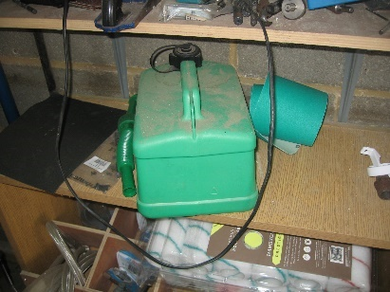
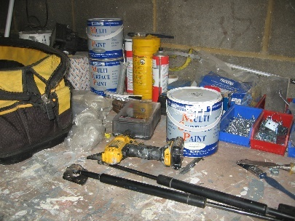
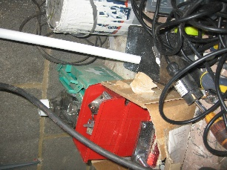

Relevant Legislation

- Control of Substances Hazardous to Health Regulations 2002

Recommendation

- All flammable liquids / solvents/ aerosols should be stored in the lockable cupboard at the back of the workshop when not in use.

2. Compressor / Forklift

There was a compressor at the back of the workshop had no certificate of being tested. There was also a forklift use on site which had also not had a service

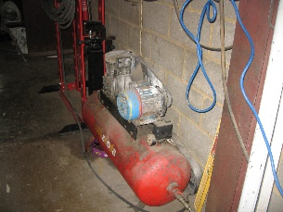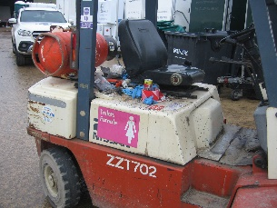

Relevant Legislation

- Regulatory Reform (Fire Safety) Order 2005
- Management of Health and Safety at Work Regulations 1999
Recommendations

- Book compressor in for service with competent engineer
- Book Forklift truck in for service with competent engineer

3. Yard Area

A large pothole in yard area which collected water. Yard in constant use with employees and vehicles – this could freeze in winter months and become slip hazard.
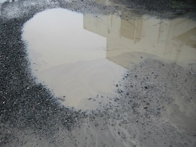

Relevant Legislation

- Management of Health and Safety at Work Regulations 1999

Recommendations

- Fill pothole to prevent puddles

Moderate Risks

1. General housekeeping

General housekeeping around the site was excellent and there had been a significant improvement in last 12 months. however, there were a few minor issues
- 2 ladders were unsecured in workshop and yard area
- Items left on microwave
- Low level beams on mezzanine
- Hose pipe coming across door entrance to prevent locking – this action was moved and completed during the audit
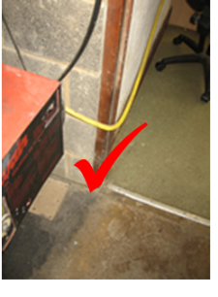
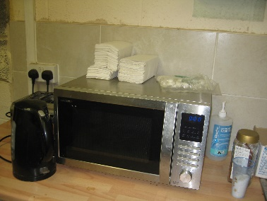
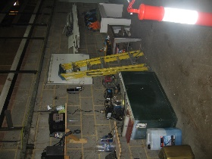
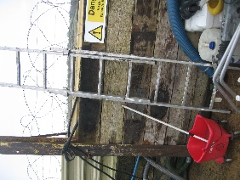
✓

Relevant Legislation

- Management of Health and Safety at Work Regulations 1999
- Control of Substances Hazardous to Health Regulations 2002

Recommendations

- Ensure weekly walkaround completed and employees reminded to clear working areas of general rubbish – IAuditor being introduced before end of 2019
- Place signage to remind employees not to place items on microwave
- Place foam covers around low-level beams on mezzanine and then yellow warning tape
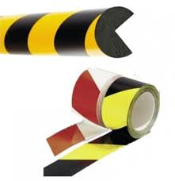

- Ensure all ladders are fit for purpose and secured to wall when not in use

2. Health and Safety Documentation / H&S signage

There was no Health and Safety documentation around the depot. H&S policy should be printed off and signed and displayed on a specific H&S notice board in the Office, employee canteen / workshop.

There are no details of first aiders or fire Evacuation Marshals who are trained on site

There was a first aid station in the office kitchen however the one in the Workshop was hidden on a workbench and this was out of date
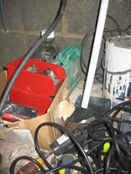
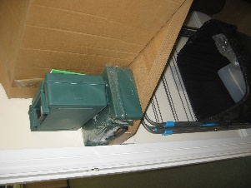

Relevant Legislation

- Management of Health and Safety at Work Regulations 1999

Recommendations

- Conduct a full assessment of the legal documentation required at various locations around the depot. This will include emergency evacuation site plan, H&S Policy, PPE usage etc
- There are two additional first aid kits (in employee canteen on work surface) which have been purchased and should be in the workshop and employee canteen areas

3. Smoking Area

Designated Smoking area is too close to main building and entrance and appeared to take place in other areas.
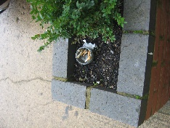

Specific Risks
Cigarettes not disposed of correctly could be blown around site and become fire hazards. Smoking near the main office entrance could be harmful to other employees. HSE suggests a smoking area should be at least 4 meters from working area.

Relevant Legislation

- Management of Health and Safety at Work Regulations 1999

Recommendations

- Purchase smoking ashtray and secure to wall outside away from main office entrance. Remind employees smoking to only take place in designated area as flammable materials in use around site and discarded cigarettes could cause fire hazard.

Moderate and Low Priority Risks

There are a number of remaining Moderate and Low Priority risks that are included in the Hazard and Risk Table but not discussed in this section of the report.

Next Steps

This risk assessment is a live working document and a tool for the business.

Read the recommendations in point 6 above. These are the top priority recommendations based on the RPN.

Further recommendations are outlined in the risk assessment table (Appendix 1).

Documented Action Plan
Document an Action Plan and assign responsibility with timescales for completing the recommendations in the report.

- Monitor and review the Action Plan on a regular basis, recording when the actions are completed. Note down any relevant evidence against the completed actions i.e. training records, new work instructions etc.
- Some examples of how to record the evidence: on the action plan, hand written notes in this report, or separate documents attached or referenced to the report/Action Plan

Consultation and Training
There is a legal requirement to consult employees on risk control measures that relate to, or affect them and to provide any related training. Where either result from this risk assessment, ensure the communications and training occur. Document when and how consultation was achieved, and document employee training records.

Risk Assessment Review
There is no legally set review period for a risk assessment, but there needs to be a mechanism for reviewing when necessary.

As a framework, a risk assessment should be reviewed:

- At least every 1-5 years; the Health and Safety Executive recommend annual review
- If the business expands, takes on more staff or moves premises
- If there is a significant change to the work activities, process or task
- If the type or no. of persons exposed changes
- If there is a related accident, ill-health or incident reported
- If there is a change in technology or information that could affect the risk
- For any other reason if the assessment is no longer valid

Appendix 1 - Prioritised Risk and Hazard Table

Hazards considered during this Risk Assessment:

Work At Height | X |  | Manual Handling | X |  | Slips, Trips & Housekeeping | X
Lighting, Heating & Ventilation Levels | X |  | Falling Objects | X |  | Display Screen Equipment | X
Layout/Storage/Space/Obstructions | X |  | Workplace Transport / Pedestrians | X |  | Driving At Work | X
Welfare Facilities | X |  | Pregnant Workers / Young Persons | X |  | DDA
Outdoor Work/Extreme Temperature | X |  | Off Site/Home/Peripatetic Working |  |  | Occupational Pressure
Violence To Staff / Verbal Assault |  |  | Contractors | X |  | Visitors / Trespassers | X
Lifting Equipment | X |  | Work Equipment (Fixed / Portable) | X |  | Electrical Equipment | X
Lone Working/Out Of Hours/Security | X |  | Pressure Vessels / Gas Supplies | X |  | Hazardous Substances | X
Noise | X |  | Vibration | X |  | Biological Agents
Legionella or Lead | X |  | Asbestos | X |  | Flammable Substances (F, F+) | X
Dangerous Substances (O, E, DSEAR) | X |  | Radiation Sources I.E. Lasers, UV |  |  | Confined Space/Asphyxiation
Environmental Risks | X |  | Food Preparation |  |  | Fire | X

X = Relevant at the time of the visit, if there is no X the hazard was considered not relevant or insignificant.

General Site - Risk Assessment Table

# | Hazard | S | Persons Affected | Existing Control Measures and Common Theme | Risk |  | Recommendations | Relevant Legislation
 |  |  |  |  | L | RPN
1 | Hazardous/Flammables Substances – gas bottles  Gas bottles are stored around the site in various locations. There is no lockable cage in which to store them. | 3 | Employees | Existing controls exist to store flammable liquids / cleaning products etc. when not in use. | 2 | 6 | Ensure that the flammable liquids / cleaning products are stored correctly in the lockable cupboard.  Mezzanine floor in workshop needs impact protection on beams and stairs to mezzanine need some grip as could become slippery when wet  No further recommendations | Control of Substances Hazardous to Health Regulations 2002

Driving at Work - Risk Assessment Table

# | Hazard | S | Persons Affected | Existing Control Measures and Common Theme | Risk |  | Recommendations | Relevant Legislation
 |  |  |  |  | L | RPN
2 | Driving At Work - Delivery and tanker drivers are the main drivers for A1 Group but other employees may drive on company business.  Hazard: road traffic accident.  Vehicles used are both company and privately owned. | 2 | Employees | A Driving at work procedures manual is in place. | 1 | 2 | Ensure copies of MOT, business class insurance and driving license are taken annually for ALL employees who drive at work.  No further recommendations | Management of Health and Safety at Work Regulations 1999

Occupational Health - Risk Assessment Table

# | Hazard | S | Persons Affected | Existing Control Measures and Common Theme | Risk |  | Recommendations | Relevant Legislation
 |  |  |  |  | L | RPN
3 | Occupational Health - Work activities can impact on employee’s heath as well as their safety. A proactive occupational health program can assist with the monitoring of adverse health effects and also maintain a healthy and productive workforce.  Specific Risks - Some occupational health is required under certain regulations for managing specific risks: For IOS these include Skin and respirator sensitising chemicals, Noise and Task Repetition.  Additional Considerations  - Sickness absence management  - Fitness for work assessment  - Wellbeing and stress management  - Drugs and alcohol | 2 | Employees | MSD Reporting (musculoskeletal disorder) - Repetitive tasks have ben risk assessed Use of HSE guidance in HSG60 is recommended but not recorded at time of assessment. MSD reporting is currently verbal and too Depot managers. If further medical advice is required the employee is referred to the OH.  Audiometry - No audiometry is carried out currently.  COSHH Heath Surveillance - Currently, nothing is carried out.  Stress/Wellbeing - Employees reporting stress are currently referred to the OH.  Drugs & Alcohol - Zero tolerance, procedure in place. Facility to random test in place. | 2 | 4 | Sickness Absence - There is system that records current absence levels which should be discussed at a monthly H&S committee meeting – Representative from Coventry should attend bi monthly H&S meeting  Audiometry - Introduce audiometry for those exposed to noise above the 1st and 2nd action levels.  MSD Report - Introduce reporting system for MSD. Train employees on what to look out for and report issues to line managers.  Train line managers on completing MSD form, restricting duties and referral procedure to OH. | Management of Health and Safety at Work Regulations 1999  Noise at Work Regulations 2005  Control of Substances Hazardous to Health Regulations 2002  Working Time Regulations 1998

Manual Handling - Risk Assessment Table

# | Hazard | S | Persons Affected | Existing Control Measures and Common Theme | Risk |  | Recommendations | Relevant Legislation
 |  |  |  |  | L | RPN
4 | Manual Handling - Handling of incoming/outgoing equipment. | 2 | Employees | Risk Assessments include manual handling activities; these are housed on the Back Office.  Safety shoes worn by all employees handling equipment.  Manual Handling training recorded in training files soon to be via Human Focus which will be accessible via the HUB. | 1 | 2 | No further recommendations | Manual Handling Operations Regulations 1992  Lifting Operations and Lifting Equipment Regulations 1998  Provision and Use of Work Equipment Regulations 1998

Workshop Noise - Risk Assessment Table

# | Hazard | S | Persons Affected | Existing Control Measures and Common Theme | Risk |  | Recommendations | Relevant Legislation
 |  |  |  |  | L | RPN
5 | Noise: Equipment and vehicles being serviced after hire and before new hire - Exposure to noise above statutory action levels of 80dBA and 85dBA can lead to hearing loss. | 2 | Employees | No existing controls in place | 1 | 2 | All employees were witnessed wearing appropriate PPE  No further recommendations | Noise at Work Regulations 2005

Training and Induction - Risk Assessment Table

# | Hazard | S | Persons Affected | Existing Control Measures and Common Theme | Risk |  | Recommendations | Relevant Legislation
 |  |  |  |  | L | RPN
6 | Training and Induction - Without a clear and relevant induction and training programme, new starters and employees are more likely to have accidents and/or suffer from work related ill health.  A1 Group Training Includes:  - Manual Handling - Induction and annually  - DSE training online  - Role specific training  - Equipment specific training  - Managers H&S responsibilities | 2 | Employees | Sporadic training arrangements in place.  All employees’ are trained against defined skills and subjects, which are recorded in personal file,  H&S training is captured either as a specific role H&S module or as part of other training i.e. equipment operation.  A lot of the H&S related training is managed and delivered in house. | 1 | 2 | Review other specific H&S training delivered internally to ensure the key points of the training are documented.  All employees receive practical manual handling training as well as the on-line training. This is documented and refreshed regularly i.e. 1-2 yearly.  General H&S awareness training is undertaken for all employees yearly.  No further recommendations | Management of Health and Safety at Work Regulations 1999

Offices and DSE Work Stations - Risk Assessment Table

# | Hazard | S | Persons Affected | Existing Control Measures and Common Theme | Risk |  | Recommendations | Relevant Legislation
 |  |  |  |  | L | RPN
7 | Display Screen Equipment - Use of desktop PCs at workstations in various locations at Oxford Depot. | 2 | Employees | Employees made aware of DSE during Induction but no annual refreshers  Annual Assessments have been completed | 2 | 4 | All employees have recently undertaken DSE training  No further recommendations | Display Screen Equipment Regulations 1992

Contractors - Risk Assessment Table

# | Hazard | S | Persons Affected | Existing Control Measures and Common Theme | Risk |  | Recommendations | Relevant Legislation
 |  |  |  |  | L | RPN
8 | Contractors - Uncontrolled contractor activities can lead to incidents both to themselves on company premises or which could affect company employees.  Hazards include: falling objects, electrical damage, fires etc. | 2 | Employees and Contractors | There is mention of contractor management in the H&S Manual.  Contractors supply business with completed questionnaire, RAMS and insurance documentation prior to wok being undertaken. | 1 | 2 | H&S procedures required to manage risks while working at an A1 Group depot, including preparation of risk assessments, method statements and assessing competence.  No further recommendations | Management of Health and Safety at Work Regulations 1999

Site Electrical Equipment - Risk Assessment Table

# | Hazard | S | Persons Affected | Existing Control Measures and Common Theme | Risk |  | Recommendations | Relevant Legislation
 |  |  |  |  | L | RPN
9 | Electrical Equipment - Failure of electrical equipment through poor maintenance or damage can lead to electrocutions. | 2 | Employees and Third Parties | PAT Testing completed internally on a rolling basis.  Fixed wiring installation tested and inspected. | 1 | 2 | No further recommendations | Electricity at Work Regulations 1989

Delivery Drivers Lifting Equipment - Risk Assessment Table

# | Hazard | S | Persons Affected | Existing Control Measures and Common Theme | Risk |  | Recommendations | Relevant Legislation
 |  |  |  |  | L | RPN
10 | Lifting Equipment - Failure of lifting equipment can result in a serious incident and would be a RIDDOR reportable incident.  Lifting equipment identified:  - Workshop hoist equipment  - Roller Shutter Doors  - Tailgates on vehicles | 2 | Employees | Statutory inspections for lifting equipment and accessories are completed.  Maintenance in place for all lifting equipment.  Workshop/delivery drivers wear safety shoes and high visibility clothing.  Risk Assessments are completed and reviewed regularly | 1 | 2 | No further recommendations | Lifting Operations and Lifting Equipment Regulations 1998  Provision and Use of Work Equipment Regulations 1998

Water Systems and Shower - Risk Assessment Table

# | Hazard | S | Persons Affected | Existing Control Measures and Common Theme | Risk |  | Recommendations | Relevant Legislation
 |  |  |  |  | L | RPN
11 | Legionella - Hazards: Legionella bacterial inhalable through water mist from a shower or developing in hot and cold water systems. | 3 | Employees | Legionella risk assessment not available at time of audit. | 1 | 3 | Shower should be tested and descaled monthly. | Control of Substances Hazardous to Health Regulations 2002

Site Fire - Risk Assessment Table

# | Hazard | S | Persons Affected | Existing Control Measures and Common Theme | Risk |  | Recommendations | Relevant Legislation
 |  |  |  |  | L | RPN
12 | Fire - Fire risks from ignition source finding a fuel source. Fuel sources include stock, cardboard/paper/waste materials in outside bins. | 3 | Employees, Third Parties, Vulnerable Persons and Contractors | Fire risk assessment completed by external competent person.  Fire Extinguishers are stored off the floor and signage for correct use displayed near all extinguishers. | 2 | 6 | Ensure a trained Fire Marshals on site and name displayed around site with contact number and Fire Evacuation procedure visible in all areas  No Further recommendations | Regulatory Reform (Fire Safety) Order 2005

Work at Height - Risk Assessment Table

# | Hazard | S | Persons Affected | Existing Control Measures and Common Theme | Risk |  | Recommendations | Relevant Legislation
 |  |  |  |  | L | RPN
13 | Work at Height - Limited work at height for A1 Group employees.  No work at height for Office workers.  Contractors carry out work at height. | 2 | Employees | Limited working at height activity at Depot therefore not risk assessed. | 2 | 4 | Steps and ladders should be locked away when not in use – one at side of workshop and one in yard near wash down area.  No further recommendations | Work at Height Regulations 2005

Falling Objects - Risk Assessment Table

# | Hazard | S | Persons Affected | Existing Control Measures and Common Theme | Risk |  | Recommendations | Relevant Legislation
 |  |  |  |  | L | RPN
14 | Falling Objects - Hazards: items falling on persons around the site. | 2 | Employees | Items over 20kgs were stored above head height in various areas around the depot | 2 | 4 | IAuditor being introduced in Dec 2019 | Management of Health and Safety at Work Regulations 1999

Pressure Vessels and Gas Supplies - Risk Assessment Table

# | Hazard | S | Persons Affected | Existing Control Measures and Common Theme | Risk |  | Recommendations | Relevant Legislation
 |  |  |  |  | L | RPN
15 | Pressure Vessels and Gas Supplies - For A1 Group these are:  - Gas Storage bottles  - Gas boiler  - Compressor for machine air lines  - Pressure Washer  Failure of pressure vessels or poorly maintained gas supplies can lead to serious incidents.  Hazard: uncontrolled release of pressurised material, failure of pressure vessel, release of gas, explosion or fire. | 3 | Employees and Third Parties in the areas | Gas boiler inspected annually by a gas safe registered company - viable maintenance ticket visible at time of visit.  Salt / grit available for period of cold weather to prevent water freezing and creating serious slip hazard Safety | 2 | 6 | Competent person to carry out statutory Pressure systems inspections 6 monthly  Any flammable products to be stored in lockable cupboard  No further recommendations. | Gas Safety (Installation and Use) Regulations 1998  Pressure Systems Safety Regulations 2000

Handling Waste for Disposal - Risk Assessment Table

# | Hazard | S | Persons Affected | Existing Control Measures and Common Theme | Risk |  | Recommendations | Relevant Legislation
 |  |  |  |  | L | RPN
16 | Handling Waste for Disposal - Use of bins at the back of the site.  Hazard: manual handling. | 2 | Employees | Waste is stored bins around the site. All materials are disposed of correctly. | 1 | 2 | No further recommendations. | Management of Health and Safety at Work Regulations 1999  Manual Handling Operations Regulations 1992

Machinery and Work Equipment - Risk Assessment Table

# | Hazard | S | Persons Affected | Existing Control Measures and Common Theme | Risk |  | Recommendations | Relevant Legislation
 |  |  |  |  | L | RPN
17 | Machinery and Work Equipment - Use of work equipment by untrained persons or work equipment that is poorly guarded and maintained is more likely to lead to incidents.  Work equipment includes:  Lifting equipment  Hire Equipment. | 2 | Employees | Risk Assessment - The use of each item of work equipment is risk assessed. on hooks on walls on hooks on walls on hooks on walls  New equipment is captured when purchased and training on use delivered by supplier.  . | 1 | 2 | No further recommendations | Provision and Use of Work Equipment Regulations 1998

External Area and Site Access - Risk Assessment Table

# | Hazard | S | Persons Affected | Existing Control Measures and Common Theme | Risk |  | Recommendations | Relevant Legislation
 |  |  |  |  | L | RPN
18 | Visitors/Trespassers - Unaccompanied visitors may be more likely to have an accident due to less knowledge about the site layout and operation.  Foreseeable hazards to trespassers should be avoided. | 2 | Employees, Visitors, Contractors and  Trespassers | Signage generally good around site  Site fencing is adequate  No clear smoking signs  . | 2 | 4 | Visitors/Contractors should be made aware of fire evacuation procedures upon arrival  Devise smoking area away from building and ensure proper cigarette disposal  Fill large pothole in yard area  No further recommendations | Management of Health and Safety at Work Regulations 1999  Occupiers Liability Act 1947/1984

First Aid and Accident Reporting - Risk Assessment Table

# | Hazard | S | Persons Affected | Existing Control Measures and Common Theme | Risk |  | Recommendations | Relevant Legislation
 |  |  |  |  | L | RPN
19 | First Aid and Accident Reporting - If an incident occurs, slow first aid response can increase the severity of the injury. | 2 | Employees and Third Parties | None | 2 | 4 | Ensure at least one trained First aiders on site and name displayed as pictures around the site on notice boards.  No further recommendations. | First Aid Regulations 1981

Hazard and Near Miss Reporting - Risk Assessment Table

# | Hazard | S | Persons Affected | Existing Control Measures and Common Theme | Risk |  | Recommendations | Relevant Legislation
 |  |  |  |  | L | RPN
20 | Hazard and Near Miss Reporting - Reported incidents (Hazards and Near Misses) are indicators of potential accidents waiting to happen. | 3 | Employees and Third Parties | None | 1 | 3 | No further recommendations | Management of Health and Safety at Work Regulations 1999

Health & Safety Communication - Risk Assessment Table

# | Hazard | S | Persons Affected | Existing Control Measures and Common Theme | Risk |  | Recommendations | Relevant Legislation
 |  |  |  |  | L | RPN
21 | H&S Communication - Clear methods of H&S communication.  A written H&S policy signed and displayed.  H&S procedures for controlling workplace risks in place and available to employees.  H&S Committee. | 3 | Employees | H&S Committee meet monthly and made up of a chairperson and committee reps from all 4 depots. - ensure Oxford Depot is represented at future meetings | 2 | 6 | H&S Policy to be signed, and displayed on notice boards around site i.e. office, canteen and workshop.  H&S poster to be completed with contact details.  Weekly H&S inspections to be carried out by the reps and issues discussed at H&S committee meeting. Corrective actions are implemented immediately.  When trained ensure picture of all trained first aiders and Fire Marshals  Site evacuation procedure and site map to be displayed in Offices / Canteen / Workshop and meeting rooms  No further recommendations. | Health and Safety at Work Act etc. 1974  Management of Health and Safety at Work Regulations 1999  The Health and Safety (Consultation with Employees) Regulations 1996

Outdoor Work - Risk Assessment Table

# | Hazard | S | Persons Affected | Existing Control Measures and Common Theme | Risk |  | Recommendations | Relevant Legislation
 |  |  |  |  | L | RPN
22 | Outdoor Work - Some employees have a need to work outside during the winter but they are not based outside continuously. | 2 | Employees | All employees are provided with high visibility jackets/fleeces gloves for wearing in all areas apart from offices on site.  All affected employees can move into the warmth as required.  Heaters provided in rest area and general offices  Gritting products available to prevent slips in winter weather. | 2 | 4 | Repair pothole in yard area and ensure yard area gritted in winter months once work completed.  Purchase correct smoking ashtray and place away from office entrance.  No further recommendations. | Management of Health and Safety at Work Regulations 1999

Asbestos - Risk Assessment Table

# | Hazard | S | Persons Affected | Existing Control Measures and Common Theme | Risk |  | Recommendations | Relevant Legislation
 |  |  |  |  | L | RPN
23 | Asbestos - If asbestos is present in the building, disturbance of the fibres can lead to personal exposure. | 1 | Employees and Contractors | Asbestos not present on site. | 1 | 1 | Asbestos inspection required | Control of Asbestos at Work Regulations 2006

Kitchen Area / Rest room - Risk Assessment Table

# | Hazard | S | Persons Affected | Existing Control Measures and Common Theme | Risk |  | Recommendations | Relevant Legislation
 |  |  |  |  | L | RPN
24 | Food Hygiene - risk of bacterial cross contamination with out of date food.  Slips Trips and falls - bags / clothing and rubbish across floor | 2 | All employees | Fridge provided to place food into to keep at adequate temperature.  Hooks provided to store personal belongs and work clothing.  Bins provided | 2 | 4 | Remove items from top of Microwave and place sign asking employees not to store anything on top  No further recommendations. | Food Hygiene Regulations 2006  Management of Health and Safety at Work Regulations 1999

Pregnant Workers and Young Persons - Risk Assessment Table

# | Hazard | S | Persons Affected | Existing Control Measures and Common Theme | Risk |  | Recommendations | Relevant Legislation
 |  |  |  |  | L | RPN
25 | Pregnant Workers and Young Persons - Higher risk groups more susceptible to workplace risks. | - | Pregnant Employees and Young Persons | Pregnancy Risk Assessment is a HR procedure and is in place.  No young persons employed at the time of the visit. Risk Assessments are completed for any work experience visitors. | - | - | No further recommendations at this time. | Management of Health and Safety at Work Regulations 1999

Appendix 2 - Risk Assessment Scoring

Risk Management and Compliance Audit Scoring
Severity Hazard (S) | Severity Hazard (S) |  | Likelihood of Occurrence (L)
 | Compliance | Harm or Ill Health | Low | Medium | High
 | 3 - None | 3 - High | 1 | 2 | 3
 | 2 - Partial | 2 - Medium
 | 1 - Satisfactory | 1 - Low

Risk Priority Number | Action and Timescale
Intolerable:  RPN = 9 | Stop activity immediately or do not start until action has been taken to reduce the level of risk. (Enforcement risk - possible HSE Prohibition Notice).
Substantial:  RPN = 6 | Take action to reduce the risk level within 1 month. (Enforcement risk - possible HSE Improvement Notice).
Moderate:  RPN = 3 or 4 | Take action to reduce the risk level within 3 - 6 months.
Trivial/Low:  RPN = 1 or 2 | No further action required.

See next page for Severity and Likelihood descriptions.

Severity Score Table

# | Description
3 | High Hazard - extremely harmful consequences  Major notifiable RIDDOR injury or fatality. Permanent disability. Severe life threatening RIDDOR Reportable diseases and illnesses i.e. cancer, asbestosis  Extensive loss of plant, or major damage to equipment, property or the environment. RIDDOR Dangerous Occurrence.  Would attract a prohibition notice from the HSE.  None Compliance  Breach of a relevant statutory provision with potential for harm.  No evidence of compliance to the relevant statutory provisions.
2 | Medium Hazard - harmful consequences  7 Day RIDDOR Reportable Lost time incident. Temporary disability, lacerations, serious cuts and bruises, burns, concussion, serious sprains and strains, minor fractures (fingers and toes).  RIDDOR Reportable Diseases i.e. occupational deafness, dermatitis, allergy, repetitive strain injury. Serious damage to equipment, property or the environment disrupting normal activities would attract an improvement notice from the HSE.  Partial Compliance  Minor or technical Breach possible. Some evidence of compliance to the relevant statutory provision i.e. hazards and risks identified some supporting documentation & training records.
1 | Low Hazard Severity - slightly harmful consequences  Minor Injuries & ill health i.e. minor sprains and strains, cuts and bruises, eye irritation, nuisance (e.g. headaches), minor skin irritation.  Minor damage to equipment, property or the environment.  Satisfactory  At the time of the audit or risk assessment and in the opinion of the assessor, compliance to the relevant statutory provisions is considered to be adequate i.e. hazards and risks identified by competent persons, full documentation supporting a system of managing the relevant risk and hazards identified, training in place and recorded, communication of risk control measures to employees in place.  Achieving this standard does not absolve the company of its duty to continuously monitor compliance to the relevant statutory provisions review risk on a regular basis.
Likelihood of Occurrence Table
3 | High (highly likely) | Daily or weekly opportunities for the hazard to be realised.  Continuous or almost continuous presence of the hazard.
2 | Medium (likely) | Opportunities for hazard to be realised are possible i.e. within the next 6-12 month period.
1 | Low (unlikely) | Opportunities for hazard to be realised are Infrequent and possible, but not expected in the next 12 month period.

