Fire Risk Assessment

1. | Premises Particulars

PREMISES NAME: |  | USE OF PREMISES:
A1 Group Wokingham Site |  | Scrap Metal/Metal Recycling/Toilet storage
ADDRESS: |  | OWNER/EMPLOYER/PERSON IN CONTROL OF WORKPLACE:
Highland Avenue |  | Clive Owen
Silver Birches |  | TELEPHONE NUMBER:
Wokingham RG41 4SP |  | 0118 989 4652

DATE OF RISK ASSESSMENT: |  | DATE OF REVIEW:
28th November 2017 |  | November 2018

NAME AND RELEVANT DETAILS OF THE PERSON WHO CARRIED OUT THE FIRE RISK ASSESSMENT:
Sean Whittle, FCIPD H&S Consultant
HR & Business Solutions Limited
6 Tamar Drive, Keynsham, Bristol, BS31 1PP

2. | General Statement of Policy

STATEMENT:
It is the policy of the A1 Group to protect all persons including employees, customers, contractors and members of the public from potential injury and damage to their health which might arise from work activities.

The company will provide and maintain a safe and healthy working environment, equipment, and systems of work for all employees, and to provide such information, training and supervision as they need for this purpose. The company will give a high level of commitment to health and safety and will comply with all statutory requirements.

3. | Management Systems

COMMENTARY:
The Fire Safety Management plan is contained within the Health & Safety file and is kept in the General Office on the Wokingham site and copies are also held by the General Manager and the Health & Safety Representative. The H&S consultant also retains a copy.

It confirms that a fire risk assessment will be completed and reviewed periodically every 6 months to ensure adequate fire safety. The fire risk assessment will follow the 5- step narrative method as advocated by the Employers Guide. The significant findings will be recorded and any deficiencies identified by the fire risk assessment process will be prioritised and rectified accordingly.

Although having overall responsibility for fire safety matters the A1 Group has made the Health & Safety Representative responsible for fire safety matters at the Wokingham site and is supported by the H&S Consultant for the Group which includes the fire risk assessment and all matters appertaining to it.

This person will be responsible for:-

• Deciding the fire safety protective and preventative measures
• Informing other responsible persons what they are
• Ensuring they are implemented and communicated to other employees
• Ensuring co-ordination between other responsible persons

Fire Safety will be an agenda item for the monthly H&S meeting.

The other responsible persons are shown on the schematic (attached). They will be responsible for the fire safety measures as shown. The Health & Safety Consultant will be responsible for monitoring the effectiveness of the fire risk assessment process and its implementation.

4. | General Description of Premises

DESCRIPTION:
The Wokingham site is a large open planned working site which is used to dismantle various vehicles and recycling the parts. The yard is constantly in use by both A1 vehicles delivering and removing both scrap vehicles and materials and by members of the public to purchase car spare parts.
There are two general office units and numerous workshops and storage units around the yard in various locations.
There is a small office brick building with flat roof at the front of the yard and a steel framed / cladded general office with two floors at the rear of the building. The general office contains a small reception area / small transport office / kitchen area / open planned general office and storage office. The main office is down a small flight of stairs into a large open planned area containing a number of desk spaces an open kitchen and toilet facilities at the rear of the unit. There is employee parking at the side of the main office. There are two fire escapes in the main building one through the front door to the reception and one at the side of the main office area. There is adequate emergency lighting in the building and smoke detectors in the office and kitchen areas.
The main yard is in five main sections and there is a small customer parking which has pre-painted designated bays.
- A Metal Recycling area which houses one large Crusher / a depollution area and three separate units – engines / wiring and / scrapped car storage area / toilet storage area.
- There is a tyre bay workshop and a car spares office behind the main office building. There is also a large racking system to store all scrapped cars adjacent to the car spares office and also a workshop unit at the rear of the car storage area. The car storage area is accessible to members of the public in certain areas and there is adequate lighting and signage in this area with both employees and members of the public wearing PPE at all times whilst in this area. There are three further car storage areas in the main yard all of which store numerous vehicles at ground level.
- There are two metal recycling units for nonferrous and copper materials adjacent to the main office and a separate workshop area.
- There is a large static 2 story unit at the front of the yard which is used as an employee canteen and on the 2nd floor there is a small training facility. in the yard area for staff accommodation with three exits routes in case of emergency.
- There is a large area to the side of the main yard which is used to store plastic toilets.
There is high use of oxyacetylene on site and there is also fuel (diesel and unleaded) stored on site in suitable secure containers. There are also gas bottles in various locations all of which are stored in lockable cages when not in use. There are also numerous skips located around the site which are used for storage of scrap materials.
The site is well lit with clear H&S signage and numerous defined walkways for employees and members of the public to use. PPE is worn at all times on site by both employees and members of the public.
The site is well protected in terms of fencing and there are numerous CCTV units around the site.
The premises are considered to be of high risk given the level of flammable materials on site

OCCUPANCY |  | SIZE
TIMES THE PREMISES ARE IN USE: |  | BUILDING FOOTPRINT (METERS X METERS):
7am – 6pm |  | Total Site Meterage = 34233 m²  Main Office = 400.52 m²  Tyre Bay = 242 m²  Spares Office = 94 m²
TOTAL NUMBER OF PERSONS EMPLOYED WITHIN THE PREMISES AT ANY ONE TIME: |  | NUMBER OF FLOORS:
30 |  | 2 in main office and also employee canteen and training unit
TOTAL NUMBER OF PERSONS WHO MAY RESORT TO THE PREMISES AT ANY ONE TIME: |  | NUMBER OF STAIRS:
30 |  | 2 – main office and canteen / training unit

5. | Fire Safety Systems within the Premises

FIRE WARNING SYSTEM: (i.e. AUTOMATIC FIRE DETECTION, BREAK-GLASS SYSTEM TO BS 5839, OTHER)
Manual Alarm system located on outside of Main office / outside Spares Office / outside depollution workshop complying with British safety standards BS5839. Smoke detectors fitted in main office

EMERGENCY LIGHTING: (i.e. MAINTAINED/NON-MAINTAINED, 1HR/3HR DURATION TO BS 5266)
Emergency exits visible – emergency lighting in all offices. Yard area well lit with manual lighting on all building and on perimeter fencing in various locations

OTHER: (i.e. SPRINKLER SYSTEM TO LPC RULES BS 5306)
No sprinkler system present on site. There is a hose system in yard area if required

6. | Plan Drawing

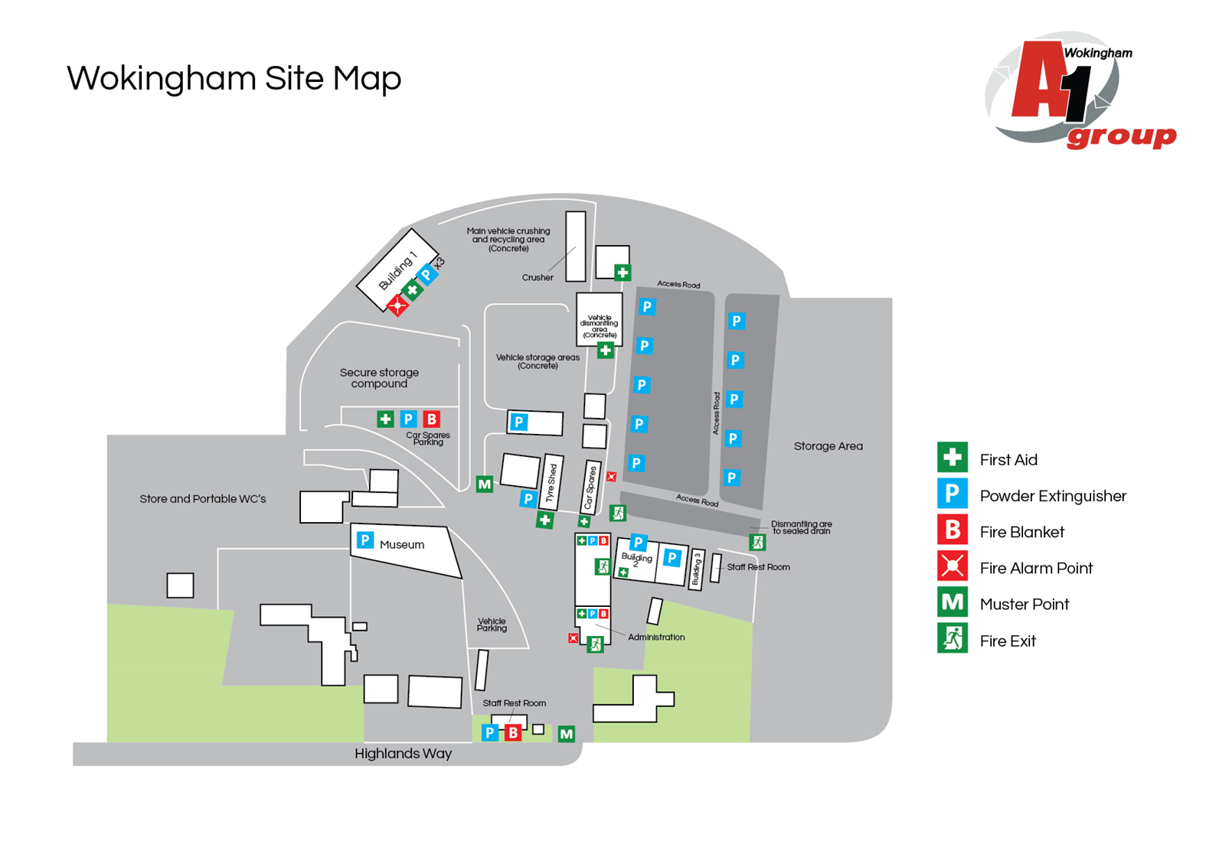

7. | Indentify Fire Hazards

SOURCES OF IGNITION:
The following ignition sources are those commensurate with office premises. Kitchen area in general office – microwave/kettle/toaster
- Paper is stored in cupboards in office area
- Smoking is not allowed in the building
- Waste bins – emptied weekly

The following ignition sources are those commensurate with workshop
- Combustible materials in workshops – limited to grinding and oxyacetylene

Canteen area – kitchen with microwave/kettle/toaster

Yard area – there are combustible materials and ignition sources in the yard and therefore should be considered high risk

SOURCES OF FUEL:
The sources of fuel commensurate with office premises are as follows:
- The majority of the work is completed on computers so there are not vast amounts of paper. Paper for printers etc. is stored away in stationary cupboard which is kept locked. Waste paper bins are emptied weekly and the waste is removed from site.

The sources of fuel commensurate with workshop / yard are as follows:
- Oxyacetylene
- Butane Gas
- Oil for vehicles
- Petrol stored on site in depollution area

WORK PROCESSES:
The work processes are commensurate with office and workshop/yard premises. There are no processes
that pose a significant fire hazard in the office. In the various workshops grinding and use of Oxyacetylene is regularly conducted.

A competent electrician maintains all the electrical equipment. There is a service level agreement with an outside contractor to service all IT equipment. The company policy is the close down all electrical equipment at night.

STRUCTURAL FEATURES THAT COULD PROMOTE THE SPREAD OF FIRE:
The office premises is a building built around 1950. All services and compartments are adequately fire stopped and there are no voids or false ceilings.

8. | Fire Safety Signs and Notices

COMMENTARY:
There are adequate fire safety signs and notices on the premise. All exit routes and fire safety equipment are adequately signposted.

9. | Fire Warning System

COMMENTARY:
There are three manual fire warning systems on site comprising of a switch system to activate alarm. They will warn persons on site including visitors to evacuate the building / area and locate in the fire evacuation point at either outside the tyre bay or outside the main entrance to the site.

10. | Emergency Lighting System

COMMENTARY:
There is emergency lighting system in the general office. There are two fire exits in the general office and two in the spares office and tyre bay. The yard area has adequate emergency lighting which can be activated manually if required.

11. | Fire Fighting Equipment

COMMENTARY:
There is sufficient number of correct type of extinguishers located throughout the general office /canteen/yard area/workshop and storage area. These are serviced annually and staff are trained in their use.

12. | Management - Maintenance

IS THERE A MAINTENANCE PROGRAMME FOR THE FIRE SAFETY PROVISIONS IN THE PREMISES? | YES | NO
COMMENTARY:
All firefighting equipment is serviced annually by RES Group of 14 Cremyll Road, Reading, RG1 8NQ / Fire Alarm is serviced by Berridge Electrical | 

ARE REGULAR CHECKS OF FIRE RESISTING DOORS, WALLS AND PARTIONS CARRIED OUT? | YES | NO
COMMENTARY:
Carried out by H&S Representative | 

ARE REGULAR CHECKS OF ESCAPE ROUTES AND EXIT DOORS CARRIED OUT? | YES | NO
COMMENTARY:
Yes a weekly check is conducted by the H&S Representative | 

ARE REGULAR CHECKS OF FIRE SAFETY SIGNS CARRIED OUT? | YES | NO
COMMENTARY:
Yes a weekly check is conducted by the H&S Representative | 

IS THERE A MAINTENANCE REGIME FOR THE FIRE WARNING SYSTEM? |  | YES | NO
COMMENTARY:
Yes a weekly check is conducted by the H&S Representative | WEEKLY: | 
 | ANNUALLY: | 

IS THERE A MAINTENANCE REGIME FOR THE EMERGENCY LIGHTING SYSTEM? |  | YES | NO
COMMENTARY:
The lighting in the yard area is tested weekly | WEEKLY: |  | 
 | MONTHLY: |  | 
 | ANNULALLY: |  | 

IS THERE MAINTENANCE OF THE FIREFIGHTING EQUIPMENT (BY COMPETENT PERSON?) |  | YES | NO
COMMENTARY:
 | WEEKLY: |  | 
All firefighting equipment is serviced annually by RES Group of 14 Cremyll Road, Reading, RG1 8NQ / Fire Alarm is serviced by Berridge Electrical | ANNUALLY: | 
ARE RECORDS KEPT AND THEIR LOCATION IDENTIFIED? |  | YES | NO
COMMENTARY:
The records for all aspects relating to maintenance issues are kept in general office by the H&S Representative |  | 

13. | Method for calling the Fire Service

SPECIFY:
Dial 999 from any telephone

14. | Emergency Action Plan (EAP)

COMMENTARY:
There is a sufficient Emergency Action Plan attached to this record.

15. | Training

COMMENTARY:
Training is provided by the H&S Representative. An annual refresher training is conducted to remind staff of what to do in the event of fire. Also included – How to call the Fire Service, and How to operate the fire alarm system. All personnel including the Managing Director undertake this Training.

16. | Fire Safety Deficiencies to be rectified

DEFICIENCY/RECTIFICATION: | PRIORTY: | DATE TO BE RECTIFIED: | DATE RECTIFIED:
There were a number of fuel containers which were not locked away when not in use | 1 | ASAP | Immediate

17. | Significant findings

SIGNIFICANT FINDING: | CONTROL MEASURE/ACTION:

18. | Additional Hazards

SPECIFY:
None present at time of assessment
NEED TO CONSULT FIRE SERVICE? (Please circle) | YES | NO

A1 GROUP FIRE SAFETY MANAGEMENT PLAN

FIRE SAFETY PLAN: |  | RESPONSIBLE PERSON:
Person with overall responsibility for Fire Safety. |  | Clive Owen
 |  | POSITION:
 |  | General Manager

FIRE RISK ASSESSMENT: |  | RESPONSIBLE PERSON:
Person responsible for carrying out and review. |  | Sean Whittle, FCIPD
 |  | POSITION:
 |  | H&S Consultant

MAINTENANCE PROGRAMME: |  | RESPONSIBLE PERSON:
Person responsible for:  - Maintenance of Fire Safety provisions  - Fire Alarm  - Emergency Lighting  - Fire Fighting Equipment  - Escape routes  - Fire Safety signs and notices |  | Alan McGregor / Garry Webb
 |  | POSITION:
 |  | H&S Representatives and Transport Manager and Metal Recycling Manager

EMERGENY ACTION PLAN: |  | RESPONSIBLE PERSON:
Person responsible for production and review |  | Clive Owen
 |  | POSITION:
 |  | General Manager

STAFF TRAINING: |  | RESPONSIBLE PERSON:
Person responsible:  - Fire Safety Training of all staff  - Implementing Fire Drills |  | Alan McGregor
 |  | POSITION:
 |  | Transport Manager

A1 GROUP EMERGENCY ACTION PLAN

ASSEMBLY POINT:
There are two muster stations on site
- If fire in bottom yard (metal crushing and recycling area) then muster station at top of the slope next to tyre bay

- Total site / office evacuation is outside main gates to the site

ACTION ON DISCOVERY OF FIRE:
- Sound the alarm using the nearest fire alarm call point
- Leave the building by the nearest fire exit
- Do not re-enter the building
- Report to the assembly point
- Call the fire brigade by mobile phone (after leaving the building)
- Liaise with the fire brigade on their arrival
- Only attempt to tackle small fires if confident to do so
- Do not put yourself at risk

ACTION ON HEARING ALARM:
- Leave the building by the nearest fire exit
- Do not re-enter the building
- Report to the assembly point
- Call the fire brigade by mobile phone (after leaving the building)
- Liaise with the fire brigade on their arrival

VISITORS:
- Ensure all visitors and contractors are taken to the assembly point
- Assist any disabled persons with their evacuation as necessary

