Fire Risk Assessment – Bennett’s Yard

1. | Premises Particulars

PREMISES NAME: |  | USE OF PREMISES:
A1 Loo Hire/Wet Waste Bennetts Yard |  | Tanker vehicles/Toilet/Welfare Unit storage, garage workshop/ Storage and offices
ADDRESS: |  | OWNER/EMPLOYER/PERSON IN CONTROL OF WORKPLACE:
Waterloo Road |  | Laura White (Loo Hire) / Paul James (Wet Waste)
Wokingham |  | TELEPHONE NUMBER:
Reading RG40 3DA |  | 0118 989 4652

DATE OF RISK ASSESSMENT: |  | DATE OF REVIEW:
15th October 2019 |  | November 2020

NAME AND RELEVANT DETAILS OF THE PERSON WHO CARRIED OUT THE FIRE RISK ASSESSMENT:
Sean Whittle, FCIPD H&S Advisor
HR & Business Solutions Limited
6 Tamar Drive, Keynsham, Bristol, BS31 1PP

2. | General Statement of Policy

STATEMENT:
It is the policy of the A1 Group to protect all persons including employees, customers, contractors and members of the public from potential injury and damage to their health which might arise from work activities.

The company will provide and maintain a safe and healthy working environment, equipment, and systems of work for all employees, and to provide such information, training and supervision as they need for this purpose. The company will give a high level of commitment to health and safety and will comply with all statutory requirements.

3. | Management Systems

COMMENTARY:
The Fire Safety Management plan is contained within the Health & Safety file and is kept in the both the Loo Hire and Wet Waste offices at the Bennett’s Yard site and copies are also held by the Office Manager (Loo Hire) and Wet Waste Manager and the Health & Safety Representative. The H&S consultant also retains a copy.

It confirms that a fire risk assessment will be completed and reviewed periodically every 6 months to ensure adequate fire safety. The fire risk assessment will follow the 5- step narrative method as advocated by the Employers Guide. The significant findings will be recorded, and any deficiencies identified by the fire risk assessment process will be prioritised and rectified accordingly.

Although having overall responsibility for fire safety matters the A1 Group has made the Health & Safety Representative responsible for fire safety matters at the Lambs Lane site and is supported by the H&S Consultant for the Group which includes the fire risk assessment and all matters appertaining to it.

This person will be responsible for: -

• Deciding the fire safety protective and preventative measures
• Informing other responsible persons what they are
• Ensuring they are implemented and communicated to other employees
• Ensuring co-ordination between other responsible persons

Fire Safety will be an agenda item for the monthly H&S meeting.

The other responsible persons are shown on the schematic (attached). They will be responsible for the fire safety measures as shown. The Health & Safety Consultant will be responsible for monitoring the effectiveness of the fire risk assessment process and its implementation.

4. | General Description of Premises

DESCRIPTION:
The Bennett’s Yard depot comprises of two offices 1) Wet Waste - a two story brick building which comprises of a ground floor reception area, general office which has a separate toilet facility. 2) A single story Portacabin adjacent to this building which houses a large open plan office / separate single office separate kitchen and toilet facilities. There is a large external workshop building which comprises of 6 individual units - storage / Spray booth for vehicles / garage to service vehicles sw3ith large open pit. The large yard area is used for equipment and vehicle storage, toilet and Welfare storage a hard-standing cleaning area. At the time of the visit approximately 145 people were employed within the A1 Group business, with around 12 on the Bennett’s Yard site at any time serving the operational needs of the business.

The Wet waste building has one internal stairway which is protected by fire resisting walls, partitions and doors with Fire escape back into general office or out of window. The Loo Hire building has three fire escapes via main office, entrance hall or Kitchen. There is a large standalone unit in the yard area (workshop and material storage) with roller shutter doors which have door access and are interlinked with the end storage unit being always open whilst site is occupied between 7am and 6pm.

The yard area is open planned and is used to store plastic toilets, welfare units and Wet waste tankers and other service vehicles and vehicles awaiting repair in the garage workshop

OCCUPANCY |  | SIZE
TIMES THE PREMISES ARE IN USE: |  | BUILDING FOOTPRINT (METERS X METERS):
7am – 6pm |  | Whole Yard = 12823 m²  Wet Waste Office / Canteen = 80.51 m²  Loo Hire Office = 112.13 m²  Workshop = 176.86 m²
TOTAL NUMBER OF PERSONS EMPLOYED AITHIN THE PREMISES AT ANY ONE TIME: |  | NUMBER OF FLOORS:
10 |  | 2 in Wet Waste general office
TOTAL NUMBER OF PERSONS WHO MAY RESORT TO THE PREMISES AT ANY ONE TIME: |  | NUMBER OF STAIRS:
45 |  | 2 – Wet Waste Office

5. | Fire Safety Systems within the Premises

FIRE WARNING SYSTEM: (i.e. AUTOMATIC FIRE DETECTION, BREAK-GLASS SYSTEM TO BS 5839, OTHER)
There is a manual alarm system present on the outside of the Wet Waste Office – last Fire Drill was June

EMERGENCY LIGHTING: (i.e. MAINTAINED/NON-MAINTAINED, 1HR/3HR DURATION TO BS 5266)
Emergency exits visible – emergency lighting in Loo Hire Office and Garage Workshop. The Yard area well-lit at the top but no lighting at bottom area which is Loo Hire storage area. Adequate manual lighting on all buildings and on perimeter fencing in various locations.

OTHER: (i.e. SPRINKLER SYSTEM TO LPC RULES BS 5306)
No sprinkler system present on site. There is a hose system in yard area if required

6. | Plan Drawing

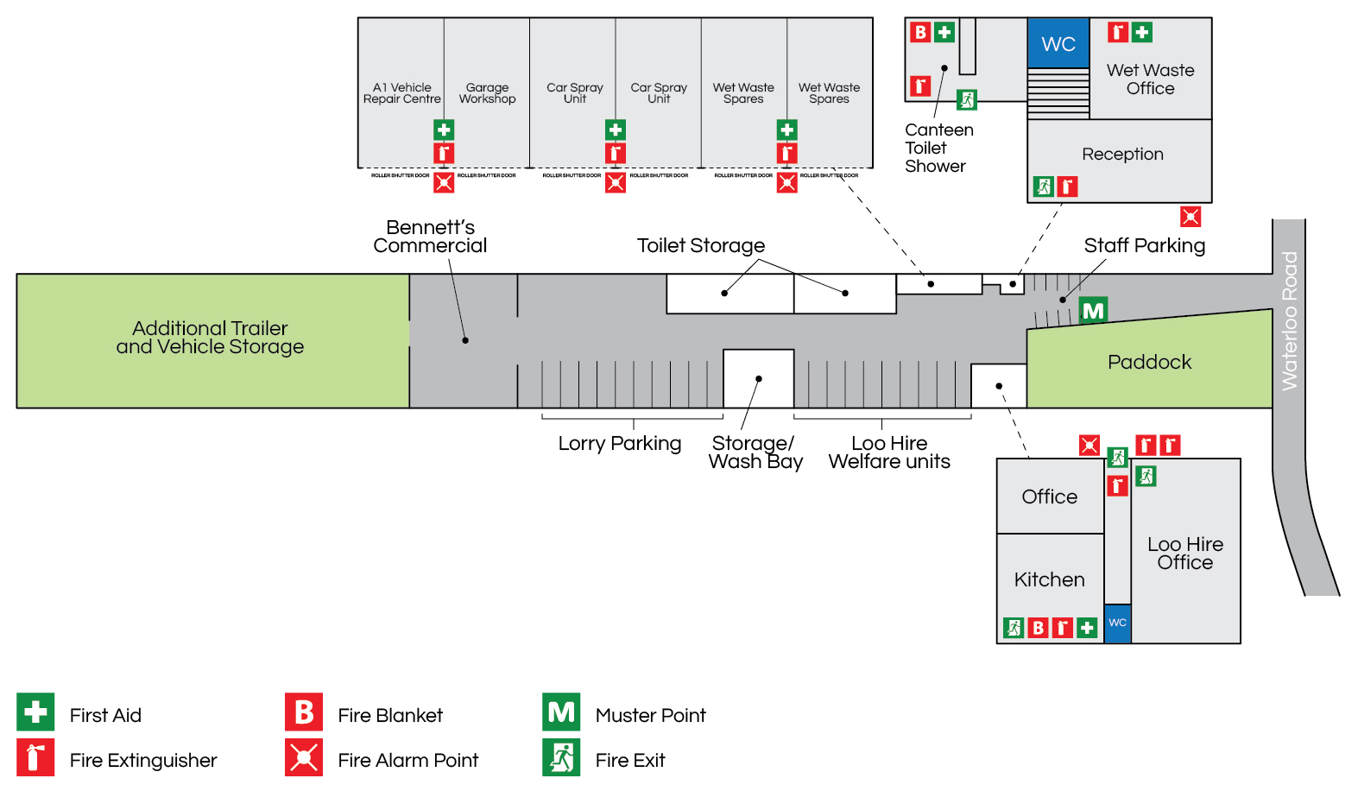

7. | Indentify Fire Hazards

SOURCES OF IGNITION:
The following ignition sources are those commensurate with office premises.

Wet Waste - kitchen area – microwave/kettle/toaster/Washing Machine.

Loo Hire - kitchen area – microwave/kettle/toaster/Washing Machine

General
- Paper is stored in cupboards in office area
- Smoking is not allowed in the building
- Waste bins – emptied weekly

The following ignition sources are those commensurate with workshop
- Combustible materials in workshop – limited to welding and grinding

Yard area – there are no combustible materials or ignition sources in the yard and therefore should be considered low risk

SOURCES OF FUEL:
The sources of fuel commensurate with office premises are as follows:
- The majority of the work is completed on computers so there are not vast amounts of paper. Paper for printers etc. is stored away in stationary cupboard which is kept locked. Wastepaper bins are emptied weekly and the waste is removed from site.
- The Loo Hire Offices are heated with electric heaters which are on timers
- The Wet Waste Office is heated by radiators via a boiler which is oil fuelled

The sources of fuel commensurate with office premises are as follows:
- Butane Gas for heaters in workshop
- Oil for vehicles
- No petrol stored on site

WORK PROCESSES:
The work processes are commensurate with office and workshop premises. There are no processes
that pose a significant fire hazard in the office. In the workshop grinding is limited to workbench which is clear of combustible material.

A competent electrician maintains all the electrical equipment. There is a service level agreement with an outside contractor to service all IT equipment. The company policy is the close down all electrical equipment at night.

STRUCTURAL FEATURES THAT COULD PROMOTE THE SPREAD OF FIRE:
The Wet Waste office premises is an old building built around 1930. All services and compartments are adequately fire stopped and there are no voids or false ceilings.
The Loo Hire office premises is an portacabin building built around 2000. All services and compartments are adequately fire stopped and there are no voids or false ceilings.

8. | Fire Safety Signs and Notices

COMMENTARY:
There are adequate fire safety signs and notices on the premise. All exit routes and fire safety equipment are adequately signposted.

9. | Fire Warning System

COMMENTARY:
The is an Alarm system operational and is used by both A1 Wet Waste and A1 Loo Hire. There are three trained Fire Marshals on site and all have been trained to deal with a site evacuation.

10. | Emergency Lighting System

COMMENTARY:
Wet Waste - There is emergency lighting system in the general office. There are two fire exits in the general office and storage space above. The yard area has adequate emergency lighting which can be activated manually if required.

Loo Hire - There is emergency lighting system in the general office. There are two fire exits in the general office and flat above. The yard area has adequate emergency lighting which can be activated manually if required.

11. | Fire Fighting Equipment

COMMENTARY:
There is sufficient number of correct type of extinguishers located throughout the general office /canteen/yard area/workshop and storage area. These are serviced annually and staff are trained in their use.

12. | Management - Mantenance

IS THERE A MAINTENANCE PROGRAMME FOR THE FIRE SAFETY PROVISIONS IN THE PREMISES? | YES | NO
COMMENTARY:
All fire equipment is serviced annually by RES Group based in Reading (last check 2/19) | 

ARE REGULAR CHECKS OF FIRE RESISTING DOORS, WALLS AND PARTIONS CARRIED OUT? | YES | NO
COMMENTARY:
Carried out by H&S Representative | 

ARE REGULAR CHECKS OF ESCAPE ROUTES AND EXIT DOORS CARRIED OUT? | YES | NO
COMMENTARY:
Yes a weekly check is conducted by the H&S Representative | 

ARE REGULAR CHECKS OF FIRE SAFETY SIGNS CARRIED OUT? | YES | NO
COMMENTARY:
Yes a weekly check is conducted by the H&S Representative | 

IS THERE A MAINTENANCE REGIME FOR THE FIRE WARNING SYSTEM? |  | YES | NO
COMMENTARY:
Yes a weekly check is conducted by the H&S Representative | WEEKLY: | 
 | ANNUALLY: | 

IS THERE A MAINTENANCE REGIME FOR THE EMERGENCY LIGHTING SYSTEM? |  | YES | NO
COMMENTARY:
The lighting in the yard area is tested weekly | WEEKLY: | 
 | MONTHLY: |  | 
 | ANNULALLY: |  | 

IS THERE MAINTENANCE OF THE FIREFIGHTING EQUIPMENT (BY COMPETENT PERSON?) |  | YES | NO
COMMENTARY:
 | WEEKLY: |  | 
All fire equipment is serviced by RES Group based in Reading | ANNUALLY: | 

ARE RECORDS KEPT AND THEIR LOCATION IDENTIFIED? | YES | NO
COMMENTARY:
The records for all aspects relating to maintenance issues are kept in general office by the H&S Representative | 

13. | Method for calling the Fire Service

SPECIFY:
Dial 999 from any telephone

14. | Emergency Action Plan (EAP)

COMMENTARY:
There is a sufficient Emergency Action Plan attached to this record.

15. | Training

COMMENTARY:
Training is provided by the H&S Representative. An annual refresher training is conducted to remind staff of what to do in the event of fire. Also included – How to call the Fire Service, and How to operate the fire alarm system. All personnel including the Managing Director undertake this Training.

16. | Fire Safety Deficiencies to be rectified

DEFICIENCY/RECTIFICATION: | PRIORTY: | DATE TO BE RECTIFIED: | DATE RECTIFIED:
No Fire Extinguishers present n Workshop area – need to purchase | 1 | Immediate
Gas bottles storage – there are various loose bottles in numerous locations in yard and workshops that need to be locked in the Gas cage outside Wet Waste Office – suggest full and empty signs on cage | 1 | Immediate
Smoking area needs to relocate away from Gas Cage | 1 | Immediate
Gas Bottle propping vehicle in bottom of the Yard needs to be moved | 1 | Immediate
Flammable liquids in various locations around the site need to be either dispose of or locked in flame proof cabinet | 1 | Immediate
No emergency lighting test has been conducted – contact supplier and arrange for check and certificate | 1 | Immediate
Flammable liquids in both Spray area and Garage workshop need to have flame proof cabinet purchased and all products stored inside when not in use | 1 | Immediate
Warning signage erected to warn employees of electricity pylons in bottom yard area | 1 | Immediate

17. | Other Significant findings

SIGNIFICANT FINDING: | CONTROL MEASURE/ACTION:
No Smoking signs need to be placed in Garage Workshop area and enforced | H&S Representative
Lighting in Loo Hire yard at the bottom of the site | H&S Representative

18. | Additional Hazards

SPECIFY:
None present at time of assessment
NEED TO CONSULT FIRE SERVICE? (Please circle) | YES | NO

A1 GROUP FIRE SAFETY MANAGEMENT PLAN

FIRE SAFETY PLAN: |  | RESPONSIBLE PERSON:
Person with overall responsibility for Fire Safety. |  | Clive Owen
 |  | POSITION:
 |  | Director

FIRE RISK ASSESSMENT: |  | RESPONSIBLE PERSON:
Person responsible for carrying out and review. |  | Sean Whittle, FCIPD
 |  | POSITION:
 |  | H&S Advisor

MAINTENANCE PROGRAMME: |  | RESPONSIBLE PERSON:
Person responsible for:  - Maintenance of Fire Safety provisions  - Fire Alarm  - Emergency Lighting  - Fire Fighting Equipment  - Escape routes  - Fire Safety signs and notices |  | Laura White (Loo Hire) Paul James (Wet Waste)
 |  | POSITION:
 |  | H&S Representative and Office Manager

EMERGENY ACTION PLAN: |  | RESPONSIBLE PERSON:
Person responsible for production and review |  | Clive Owen
 |  | POSITION:
 |  | Director

STAFF TRAINING: |  | RESPONSIBLE PERSON:
Person responsible:  - Fire Safety Training of all staff  - Implementing Fire Drills |  | Laura White (Loo Hire) Paul James (Wet Waste)
 |  | POSITION:
 |  | H&S Representative and Office Manager

A1 GROUP EMERGENCY ACTION PLAN

ASSEMBLY POINT:
Inside main gate to site on left hand side in front of security fencing.

ACTION ON DISCOVERY OF FIRE:
- Sound the alarm using the nearest fire alarm call point outside Wet Waste Office
- Leave the building by the nearest fire exit
- Do not re-enter the building
- Report to the assembly point by the main gates in Staff Car Park area
- Call the fire brigade by mobile phone (after leaving the building)
- Liaise with the fire brigade on their arrival
- Only attempt to tackle small fires if confident to do so
- Do not put yourself at risk

ACTION ON HEARING ALARM:
- Leave the building by the nearest fire exit
- Do not re-enter the building
- Report to the assembly point
- Call the fire brigade by mobile phone (after leaving the building)
- Liaise with the fire brigade on their arrival

VISITORS:
- Ensure all visitors and contractors are taken to the assembly point
- Assist any disabled persons with their evacuation as necessary

