Fire Risk Assessment

1. | Premises Particulars

PREMISES NAME: |  | USE OF PREMISES:
A1 Loo Hire Coventry Depot |  | Toilet / Welfare Unit storage, workshop and offices
ADDRESS: |  | OWNER/EMPLOYER/PERSON IN CONTROL OF WORKPLACE:
Unit 2B & 2C |  | Casey Owen
Springhill Industrial Estate, |  | TELEPHONE NUMBER:
Coventry, CV7 8HN |  | 01575 54 11 99

DATE OF RISK ASSESSMENT: |  | DATE OF REVIEW:
30th October 2018 |  | October 2019

NAME AND RELEVANT DETAILS OF THE PERSON WHO CARRIED OUT THE FIRE RISK ASSESSMENT:
Sean Whittle, FCIPD H&S Consultant
HR & Business Solutions Limited
6 Tamar Drive, Keynsham, Bristol, BS31 1PP

2. | General Statement of Policy

STATEMENT:
It is the policy of the A1 Group to protect all persons including employees, customers, contractors and members of the public from potential injury and damage to their health which might arise from work activities.

The company will provide and maintain a safe and healthy working environment, equipment, and systems of work for all employees, and to provide such information, training and supervision as they need for this purpose. The company will give a high level of commitment to health and safety and will comply with all statutory requirements.

3. | Management Systems

COMMENTARY:
The Fire Safety Management plan is contained within the Health & Safety file and is kept in the General Office on the Coventry Depot and copies are also held by the Office Manager, the Health & Safety Representative and H&S Consultant as well as the Staff and Client Back Office system.

It confirms that a fire risk assessment will be completed and reviewed periodically every 6 months to ensure adequate fire safety. The fire risk assessment will follow the 5- step narrative method as advocated by the Employers Guide. The significant findings will be recorded and any deficiencies identified by the fire risk assessment process will be prioritised and rectified accordingly.

Although having overall responsibility for fire safety matters the A1 Group has made the Health & Safety Representative responsible for fire safety matters at the Coventry Depot and is supported by the H&S Consultant for the Group which includes the fire risk assessment and all matters appertaining to it.

This person will be responsible for:-

• Deciding the fire safety protective and preventative measures
• Informing other responsible persons what they are
• Ensuring they are implemented and communicated to other employees
• Ensuring co-ordination between other responsible persons

Fire Safety will be an agenda item for the monthly H&S meeting.

The other responsible persons are shown on the schematic (attached). They will be responsible for the fire safety measures as shown. The Health & Safety Consultant will be responsible for monitoring the effectiveness of the fire risk assessment process and its implementation.

4. | General Description of Premises

DESCRIPTION:
The Coventry depot comprises of two separate buildings one housing ground floor general office with separate kitchen/toilet/accommodation facilities and Warehouse. The other building is adjacent to the main office building and comprises of two large units one is a Workshop the other is Warehouse. There is also a small mezzanine floor above the kitchen area in the workshop and a separate office to the rear of this unit. There is a large workshop (which houses spares materials / vehicles in for repair and a spares area for the toilets and welfare units) the other unit is for spare equipment and materials. There are also toilet facilities to the front of the Warehouse area.

The small yard area to the back of the two units which is used for toilet storage and a wash down cleaning area. There is additional space in between the two buildings for vehicle parking and a small yard area which is opposite the main yard which also houses addition toilets. The perimeters to both yards are protected with steel fencing and CCTV and both yards are well lit.

At the time of the visit approximately 145 people (9 based at Coventry) were employed within the A1 Group business, with around 4 on the Coventry site at any time serving the operational needs of the business.

OCCUPANCY |  | SIZE
TIMES THE PREMISES ARE IN USE: |  | BUILDING FOOTPRINT (METERS X METERS):
8am – 5pm Monday to Friday |  | Yard 1 between two buildings = 620 m²  Yard 2 rear of workshop = 410 m²  Yard 3 = 220 m²  Offices/canteen =237 m²  workshop/warehouse = 237 m²  Total Site = 1504 m²
TOTAL NUMBER OF PERSONS EMPLOYED AITHIN THE PREMISES AT ANY ONE TIME: |  | NUMBER OF FLOORS:
4 |  | 2 one in workshop above workshop/warehouse
TOTAL NUMBER OF PERSONS WHO MAY RESORT TO THE PREMISES AT ANY ONE TIME: |  | NUMBER OF STAIRS:
10 |  | 1 - in workshop/warehouse leading to mezzanine floor area which contains storage and office

5. | Fire Safety Systems within the Premises

FIRE WARNING SYSTEM: (i.e. AUTOMATIC FIRE DETECTION, BREAK-GLASS SYSTEM TO BS 5839, OTHER)
Manual Alarm system located in General Office / Canteen and also in workshop complying with British safety standards BS5839. Smoke detector fitted in general office / canteen and living accommodation

EMERGENCY LIGHTING: (i.e. MAINTAINED/NON-MAINTAINED, 1HR/3HR DURATION TO BS 5266)
Emergency exits visible – with emergency lighting. Yard area well lit with manual lighting on all building and on perimeter fencing in various locations

OTHER: (i.e. SPRINKLER SYSTEM TO LPC RULES BS 5306)
No sprinkler system present on site. There is a hose system in yard area if required

6. | Plan Drawing

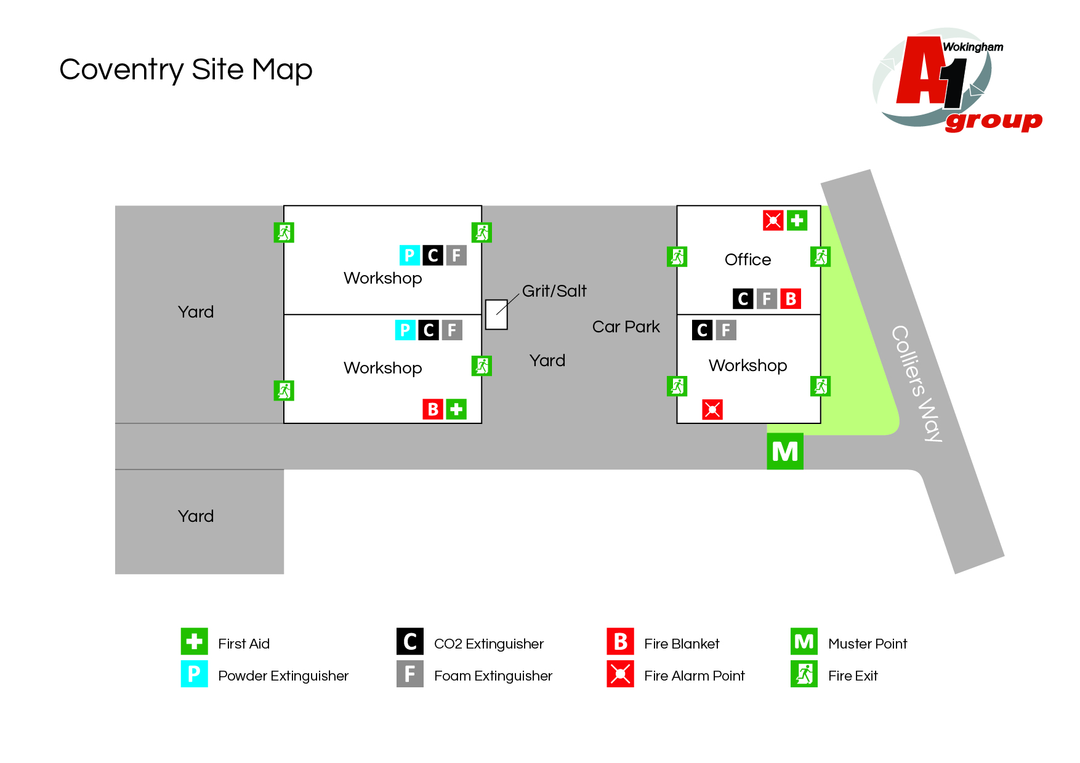

7. | Indentify Fire Hazards

SOURCES OF IGNITION:
The following ignition sources are those commensurate with office premises. Kitchen area in general office – microwave/kettle/toaster
- Paper is stored in cupboards in office area
- Smoking is not allowed in the building but should be 4mtrs away from entrance
- Waste bins – emptied weekly

The following ignition sources are those commensurate with workshop
- Combustible materials in workshop – solvents / fuel / cleaning materials

Canteen area – kitchen with microwave/kettle/toaster/fryer

Yard area – there are no combustible materials or ignition sources in the yard and therefore should be considered low risk

SOURCES OF FUEL:
The sources of fuel commensurate with office premises are as follows:
- Office - the majority of the work is completed on computers so there are not vast amounts of paper. Paper for printers etc. is stored away in stationary cupboard which is kept locked. Waste paper bins are emptied weekly and the waste is removed from site. There are files stored on shelves

The sources of fuel commensurate with workshop premises are as follows:
- Oil for vehicles
- No petrol stored on site

WORK PROCESSES:
The work processes are commensurate with office and workshop premises. There are no processes
that pose a significant fire hazard in the office. In the workshop grinding and use of Oxyacetylene
are limited to workbenches which are clear of combustible material.

A competent electrician maintains all the electrical equipment. There is a service level agreement with an outside contractor to service all IT equipment. The company policy is the close down all electrical equipment at night.

STRUCTURAL FEATURES THAT COULD PROMOTE THE SPREAD OF FIRE:
The office premises were built around 90’s. All services and compartments are adequately fire stopped and there are no voids or false ceilings. The workshop and Warehouse are large open spaces with numerous fire exits

8. | Fire Safety Signs and Notices

COMMENTARY:
There are adequate fire safety signs and notices on the premise. All exit routes and fire safety equipment are adequately signposted.

9. | Fire Warning System

COMMENTARY:
There are a number of manual fire warning systems on site comprising of a switch system to activate alarm. They will warn persons on site including visitors to evacuate the building and locate in the fire evacuation point at the front of the building

10. | Emergency Lighting System

COMMENTARY:
There is emergency lighting system in the general office / canteen. The Workshop/Warehouse as a number of fire exits with warning signs above the appropriate fire doors – which do not have emergency lightening. There are two fire exits in the general office. The yard area has adequate emergency lighting which can be activated manually if required.

11. | Fire Fighting Equipment

COMMENTARY:
There is sufficient number of correct type of extinguishers located throughout the general office /canteen/yard area/workshop and warehouse area. These are serviced annually and staff are trained in their use.

12. | Management - Mantenance
IS THERE A MAINTENANCE PROGRAMME FOR THE FIRE SAFETY PROVISIONS IN THE PREMISES? |  | YES | NO
COMMENTARY:
All firefighting equipment is serviced annually by TVF, 59/69 Queens Road  High Wycombe, HP13 6AH, ENGLAND / Fire Alarms serviced annually by TVF, 59/69 Queens Road High Wycombe, HP13 6AH, ENGLAND |  | 

ARE REGULAR CHECKS OF FIRE RESISTING DOORS, WALLS AND PARTIONS CARRIED OUT? | YES | NO
COMMENTARY:
Carried out by Depot Manager | 

ARE REGULAR CHECKS OF ESCAPE ROUTES AND EXIT DOORS CARRIED OUT? | YES | NO
COMMENTARY:
Yes a weekly check is conducted by the Depot Manager | 

ARE REGULAR CHECKS OF FIRE SAFETY SIGNS CARRIED OUT? |  | YES | NO
COMMENTARY:
Yes a weekly check is conducted by the Depot Manager |  | 
IS THERE A MAINTENANCE REGIME FOR THE FIRE WARNING SYSTEM? |  | YES | NO
COMMENTARY:
Yes a weekly check is conducted by the H&S Representative | WEEKLY: | 
 | ANNUALLY: | 
IS THERE A MAINTENANCE REGIME FOR THE EMERGENCY LIGHTING SYSTEM? |  | YES | NO
COMMENTARY:
The lighting in the yard area is tested weekly | WEEKLY: |  | 
 | MONTHLY: |  | 
 | ANNULALLY: |  | 

IS THERE MAINTENANCE OF THE FIREFIGHTING EQUIPMENT (BY COMPETENT PERSON?) |  |  | YES | NO
COMMENTARY:
 |  | WEEKLY: |  | 
All firefighting equipment is serviced annually by TVF, 59/69 Queens Road, High Wycombe, HP13 6AH, ENGLAND / Fire Alarms serviced annually by TVF, 59/69 Queens Road High Wycombe, HP13 6AH |  | ANNUALLY: | 
ARE RECORDS KEPT AND THEIR LOCATION IDENTIFIED? |  |  | YES | NO
COMMENTARY:
The records for all aspects relating to maintenance issues are kept in general office by the Depot Manager |  |  | 
13. | Method for calling the Fire Service

SPECIFY:
Dial 999 from any telephone

14. | Emergency Action Plan (EAP)

COMMENTARY:
There is a sufficient Emergency Action Plan attached to this record.

15. | Training

COMMENTARY:
Training is provided by the Depot Manager. An annual refresher training is conducted to remind staff of what to do in the event of fire. Also included – How to call the Fire Service, and How to operate the fire alarm system. All personnel including the Managing Director undertake this Training.

16. | Fire Safety Deficiencies to be rectified

DEFICIENCY/RECTIFICATION: | PRIORTY: | DATE TO BE RECTIFIED: | DATE RECTIFIED:
Lockable cabinet for flammable materials / aerosols and cleaning products which are used on site. | 1 | Immediate
Smoking area is current at front of office needs to be moved at least 4mtres away from the building | 1 | immediate
Two fire extinguishers on site had no indication they were in date and usable | 1 | immediate

17. | Significant findings

SIGNIFICANT FINDING: | CONTROL MEASURE/ACTION:
No record of last fire drill conducted | Action by H&S Representative
Flammable materials / aerosols and cleaning products which are used on site to be stored in lockable cabinet when not in use | Action by H&S Representative
Create a smoking area which requires a closed ashtray 4 mts from building | Action by H&S Representative
Remove two fire extinguishers from site that are not usable | Action by H&S Representative

18. | Additional Hazards

SPECIFY:
None present at time of assessment
NEED TO CONSULT FIRE SERVICE? (Please circle) | YES | NO

A1 GROUP FIRE SAFETY MANAGEMENT PLAN

FIRE SAFETY PLAN: |  | RESPONSIBLE PERSON:
Person with overall responsibility for Fire Safety. |  | Casey Owen
 |  | POSITION:
 |  | Depot Manager

FIRE RISK ASSESSMENT: |  | RESPONSIBLE PERSON:
Person responsible for carrying out and review. |  | Sean Whittle, FCIPD
 |  | POSITION:
 |  | H&S Consultant

MAINTENANCE PROGRAMME: |  | RESPONSIBLE PERSON:
Person responsible for:  - Maintenance of Fire Safety provisions  - Fire Alarm  - Emergency Lighting  - Fire Fighting Equipment  - Escape routes  - Fire Safety signs and notices |  | Casey Owen
 |  | POSITION:
 |  | Depot Manager

EMERGENY ACTION PLAN: |  | RESPONSIBLE PERSON:
Person responsible for production and review |  | Clive Owen
 |  | POSITION:
 |  | General Manager

STAFF TRAINING: |  | RESPONSIBLE PERSON:
Person responsible:  - Fire Safety Training of all staff  - Implementing Fire Drills |  | Casey Owen
 |  | POSITION:
 |  | Depot Manager

A1 GROUP EMERGENCY ACTION PLAN

ASSEMBLY POINT:
In front of main office building

ACTION ON DISCOVERY OF FIRE:
- Sound the alarm using the nearest fire alarm call point
- Leave the building by the nearest fire exit
- Do not re-enter the building
- Report to the assembly point
- Call the fire brigade by mobile phone (after leaving the building)
- Liaise with the fire brigade on their arrival
- Only attempt to tackle small fires if confident to do so using the correct firefighting equipment
- Do not put yourself at risk

ACTION ON HEARING ALARM:
- Leave the building by the nearest fire exit
- Do not re-enter the building
- Report to the assembly point
- Call the fire brigade by mobile phone (after leaving the building)
- Liaise with the fire brigade on their arrival

VISITORS:
- Ensure all visitors and contractors are taken to the assembly point
- Assist any disabled persons with their evacuation as necessary

