Fire Risk Assessment

1. | Premises Particulars

PREMISES NAME: |  | USE OF PREMISES:
A1 Loo Hire Meakins Depot |  | Welfare Unit storage, workshop and offices
ADDRESS: |  | OWNER/EMPLOYER/PERSON IN CONTROL OF WORKPLACE:
Lambs Lane |  | Laura White
Spencerswood |  | TELEPHONE NUMBER:
Reading RG7 1JB |  | 0118 989 4652

DATE OF RISK ASSESSMENT: |  | DATE OF REVIEW:
12th October 2017 |  | October 2018

NAME AND RELEVANT DETAILS OF THE PERSON WHO CARRIED OUT THE FIRE RISK ASSESSMENT:
Sean Whittle, FCIPD H&S Consultant
HR & Business Solutions Limited
6 Tamar Drive, Keynsham, Bristol, BS31 1PP

2. | General Statement of Policy

STATEMENT:
It is the policy of the A1 Group to protect all persons including employees, customers, contractors and members of the public from potential injury and damage to their health which might arise from work activities.

The company will provide and maintain a safe and healthy working environment, equipment, and systems of work for all employees, and to provide such information, training and supervision as they need for this purpose. The company will give a high level of commitment to health and safety and will comply with all statutory requirements.

3. | Management Systems

COMMENTARY:
The Fire Safety Management plan is contained within the Health & Safety file and is kept in the General Office on the Lambs Lane site and copies are also held by the Office Manager and the Health & Safety Representative. The H&S consultant also retains a copy.

It confirms that a fire risk assessment will be completed and reviewed periodically every 6 months to ensure adequate fire safety. The fire risk assessment will follow the 5- step narrative method as advocated by the Employers Guide. The significant findings will be recorded and any deficiencies identified by the fire risk assessment process will be prioritised and rectified accordingly.

Although having overall responsibility for fire safety matters the A1 Group has made the Health & Safety Representative responsible for fire safety matters at the Lambs Lane site and is supported by the H&S Consultant for the Group which includes the fire risk assessment and all matters appertaining to it.

This person will be responsible for:-

• Deciding the fire safety protective and preventative measures
• Informing other responsible persons what they are
• Ensuring they are implemented and communicated to other employees
• Ensuring co-ordination between other responsible persons

Fire Safety will be an agenda item for the monthly H&S meeting.

The other responsible persons are shown on the schematic (attached). They will be responsible for the fire safety measures as shown. The Health & Safety Consultant will be responsible for monitoring the effectiveness of the fire risk assessment process and its implementation.

4. | General Description of Premises

DESCRIPTION:
Large open site with a medium size open plan brick built general office with tiled roof. Internally there is a kitchen area and two small offices and toilet facilities. Adjacent is a small canteen with kitchen facilities for employees the building is brick built with flat roof. The site including buildings have a fire certificate. The premises are considered to be of low risk (in the event of fire there is little chance of anyone being placed at risk due to the fire safety measures in place).

The building has one internal stairway which is protected by fire resisting walls, partitions and doors.
It has one external escape staircase leading from the second floor via the outside to ground floor.
There are two large standalone units in the yard area (workshop and material storage) both have roller shutter doors which are always open whilst site is occupied between 7am and 6pm. Both are of steel construction with metal sides and roofs and have fire exits. There in an internal office in the workshop with two fire exits.

There is a large static mobile home caravan in the yard area for staff accommodation with three exits routes in case of emergency.

The yard area is open planned and is used to stored welfare units and other vehicles. There are two steel container units in the yard area which are locked.

OCCUPANCY |  | SIZE
TIMES THE PREMISES ARE IN USE: |  | BUILDING FOOTPRINT (METERS X METERS):
7am – 6pm |  | Yard 1 = 56m x 87m = 4872 metres squared  Yard 2 = 29m x 43m = 1247 metres squared  Office = 12m x 5m = 60 metres squared
TOTAL NUMBER OF PERSONS EMPLOYED AITHIN THE PREMISES AT ANY ONE TIME: |  | NUMBER OF FLOORS:
8 |  | 2 in general office and workshop
TOTAL NUMBER OF PERSONS WHO MAY RESORT TO THE PREMISES AT ANY ONE TIME: |  | NUMBER OF STAIRS:
12 |  | 2 - General Office and workshop

5. | Fire Safety Systems within the Premises

FIRE WARNING SYSTEM: (i.e. AUTOMATIC FIRE DETECTION, BREAK-GLASS SYSTEM TO BS 5839, OTHER)
Manual Alarm system located on outside of General office and also in workshop complying with British safety standards BS5839. Smoke detector fitted in general office

EMERGENCY LIGHTING: (i.e. MAINTAINED/NON-MAINTAINED, 1HR/3HR DURATION TO BS 5266)
Emergency exits visible – no emergency lighting. Yard area well lit with manual lighting on all building and on perimeter fencing in various locations

OTHER: (i.e. SPRINKLER SYSTEM TO LPC RULES BS 5306)
No sprinkler system present on site. There is a hose system in yard area if required

6. | Plan Drawing

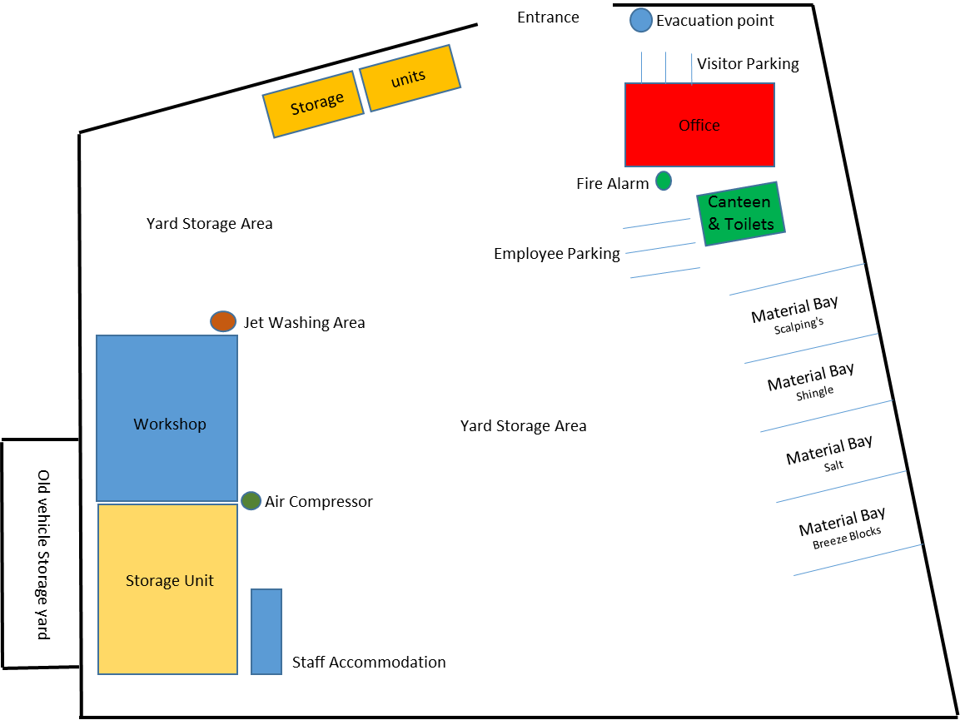

7. | Indentify Fire Hazards

SOURCES OF IGNITION:
The following ignition sources are those commensurate with office premises. Kitchen area in general office – microwave/kettle/toaster
- Paper is stored in cupboards in office area
- Smoking is not allowed in the building
- Waste bins – emptied weekly

The following ignition sources are those commensurate with workshop
- Combustible materials in workshop – limited to grinding and oxyacetylene

Canteen area – kitchen with microwave/kettle/toaster

Yard area – there are no combustible materials or ignition sources in the yard and therefore should be considered low risk

SOURCES OF FUEL:
The sources of fuel commensurate with office premises are as follows:
- The majority of the work is completed on computers so there are not vast amounts of paper. Paper for printers etc. is stored away in stationary cupboard which is kept locked. Waste paper bins are emptied weekly and the waste is removed from site.

The sources of fuel commensurate with office premises are as follows:
- Oxyacetylene
- Butane Gas for heaters in workshop
- Oil for vehicles
- No petrol stored on site

WORK PROCESSES:
The work processes are commensurate with office and workshop premises. There are no processes
that pose a significant fire hazard in the office. In the workshop grinding and use of Oxyacetylene
are limited to workbenches which are clear of combustible material.

A competent electrician maintains all the electrical equipment. There is a service level agreement with an outside contractor to service all IT equipment. The company policy is the close down all electrical equipment at night.

STRUCTURAL FEATURES THAT COULD PROMOTE THE SPREAD OF FIRE:
The office premises is an old building built around 1930. All services and compartments are adequately fire stopped and there are no voids or false ceilings.

8. | Fire Safety Signs and Notices

COMMENTARY:
There are adequate fire safety signs and notices on the premise. All exit routes and fire safety equipment are adequately signposted.

9. | Fire Warning System

COMMENTARY:
There are two manual fire warning systems on site comprising of a switch system to activate alarm. They will warn persons on site including visitors to evacuate the building and locate in the fire evacuation point at the front of the building

10. | Emergency Lighting System

COMMENTARY:
There is no emergency lighting system in the general office. There are two fire exits in the general office and flat above. The yard area has adequate emergency lighting which can be activated manually if required.

11. | Fire Fighting Equipment

COMMENTARY:
There is sufficient number of correct type of extinguishers located throughout the general office /canteen/yard area/workshop and storage area. These are serviced annually and staff are trained in their use.

12. | Management - Mantenance

IS THERE A MAINTENANCE PROGRAMME FOR THE FIRE SAFETY PROVISIONS IN THE PREMISES? | YES | NO
COMMENTARY:
All fire equipment is serviced annually by RES Group based in Reading | 

ARE REGULAR CHECKS OF FIRE RESISTING DOORS, WALLS AND PARTIONS CARRIED OUT? | YES | NO
COMMENTARY:
Carried out by H&S Representative | 

ARE REGULAR CHECKS OF ESCAPE ROUTES AND EXIT DOORS CARRIED OUT? | YES | NO
COMMENTARY:
Yes a weekly check is conducted by the H&S Representative | 

ARE REGULAR CHECKS OF FIRE SAFETY SIGNS CARRIED OUT? | YES | NO
COMMENTARY:
Yes a weekly check is conducted by the H&S Representative | 

IS THERE A MAINTENANCE REGIME FOR THE FIRE WARNING SYSTEM? |  | YES | NO
COMMENTARY:
Yes a weekly check is conducted by the H&S Representative | WEEKLY: | 
 | ANNUALLY: | 

IS THERE A MAINTENANCE REGIME FOR THE EMERGENCY LIGHTING SYSTEM? |  | YES | NO
COMMENTARY:
The lighting in the yard area is tested weekly | WEEKLY: |  | 
 | MONTHLY: |  | 
 | ANNULALLY: |  | 

IS THERE MAINTENANCE OF THE FIREFIGHTING EQUIPMENT (BY COMPETENT PERSON?) |  | YES | NO
COMMENTARY:
 | WEEKLY: |  | 
All fire equipment is serviced by RES Group based in Reading | ANNUALLY: | 

ARE RECORDS KEPT AND THEIR LOCATION IDENTIFIED? | YES | NO
COMMENTARY:
The records for all aspects relating to maintenance issues are kept in general office by the H&S Representative | 

13. | Method for calling the Fire Service

SPECIFY:
Dial 999 from any telephone

14. | Emergency Action Plan (EAP)

COMMENTARY:
There is a sufficient Emergency Action Plan attached to this record.

15. | Training

COMMENTARY:
Training is provided by the H&S Representative. An annual refresher training is conducted to remind staff of what to do in the event of fire. Also included – How to call the Fire Service, and How to operate the fire alarm system. All personnel including the Managing Director undertake this Training.

16. | Fire Safety Deficiencies to be rectified

DEFICIENCY/RECTIFICATION: | PRIORTY: | DATE TO BE RECTIFIED: | DATE RECTIFIED:
Fire Exit in general office – blocked and locked | 1 | Immediate
No emergency lighting | 1 | Ongoing
Site maps need to be displayed | 2 | Immediate
General housekeeping in Office needs to be improved | 1 | Immediate

17. | Significant findings

SIGNIFICANT FINDING: | CONTROL MEASURE/ACTION:
Waste Bins were full and not emptied | Action by H&S Representative
No record of last fire drill conducted | Action by H&S Representative
Fire Procedure missing from notice boards in general office/canteen/workshop | Action by H&S Representative
No emergency lighting | Action by qualified electrician
Gas Bottled need to be stored in lockable cage when not in use | Action by H&S Representative
Stairwell in canteen area blocked | Action by H&S Representative
Smoking area requires a closed ashtray securing on wall by canteen and smoking to take place 4 meters from office | Action by H&S Representative

18. | Additional Hazards

SPECIFY:
None present at time of assessment
NEED TO CONSULT FIRE SERVICE? (Please circle) | YES | NO

A1 GROUP FIRE SAFETY MANAGEMENT PLAN

FIRE SAFETY PLAN: |  | RESPONSIBLE PERSON:
Person with overall responsibility for Fire Safety. |  | Clive Owen
 |  | POSITION:
 |  | General Manager

FIRE RISK ASSESSMENT: |  | RESPONSIBLE PERSON:
Person responsible for carrying out and review. |  | Sean Whittle, FCIPD
 |  | POSITION:
 |  | H&S Consultant

MAINTENANCE PROGRAMME: |  | RESPONSIBLE PERSON:
Person responsible for:  - Maintenance of Fire Safety provisions  - Fire Alarm  - Emergency Lighting  - Fire Fighting Equipment  - Escape routes  - Fire Safety signs and notices |  | Laura White
 |  | POSITION:
 |  | H&S Representative and Office Manager

EMERGENY ACTION PLAN: |  | RESPONSIBLE PERSON:
Person responsible for production and review |  | Clive Owen
 |  | POSITION:
 |  | General Manager

STAFF TRAINING: |  | RESPONSIBLE PERSON:
Person responsible:  - Fire Safety Training of all staff  - Implementing Fire Drills |  | Alan McGregor
 |  | POSITION:
 |  | Transport Manager

A1 GROUP EMERGENCY ACTION PLAN

ASSEMBLY POINT:
In front of main office building

ACTION ON DISCOVERY OF FIRE:
- Sound the alarm using the nearest fire alarm call point
- Leave the building by the nearest fire exit
- Do not re-enter the building
- Report to the assembly point
- Call the fire brigade by mobile phone (after leaving the building)
- Liaise with the fire brigade on their arrival
- Only attempt to tackle small fires if confident to do so
- Do not put yourself at risk

ACTION ON HEARING ALARM:
- Leave the building by the nearest fire exit
- Do not re-enter the building
- Report to the assembly point
- Call the fire brigade by mobile phone (after leaving the building)
- Liaise with the fire brigade on their arrival

VISITORS:
- Ensure all visitors and contractors are taken to the assembly point
- Assist any disabled persons with their evacuation as necessary

