A1 Group H&S Method Statement

This Health and Safety Method Statement has been prepared by A1 Group and concerns disposal of cardboard, plastic and MDR in cages and bales for Helistrat on behalf of Marks & Spencer stores at the DHL site in South Marston on various specified dates.

Please find below details of the work to be carried out and any perceived hazards associated to the work involved and should be read in conjunction with quotation provided.

Nature of Work
Disposal of cardboard, plastic and MDR in cages and bales from various M&S Stores at a recycling centre.

Safe system of work for A1 Employee whilst at the DHL site in Swindon

- Arrive at Swindon facility in A1 vehicle wearing PPE and notify security in the gate house of arrival
- Security will inform a representative from Servest of arrival
- Servest Representative will allocate a free bay or inform A1 employees to park vehicle in a designated waiting area
- A1 vehicle will travel around the site with hazards warning lights flashing at all times and in a controlled and safe manner and adhere to strict site speed limits
- A1 vehicle will move into allocated bay leaving approx. 20 foot behind the vehicle in order to position ramps required to increase the height of the vehicle so tailgate will be flush to the warehouse floor
- A1 employee will exit vehicle in safe and controlled manner and ensure ignition off, keys removed, handbrake applied and vehicle in gear
- A1 employee will use dolly’s to manoeuvre ramps from designated area back to the bay
- A1 employee will position ramps behind the A1 vehicle and ensure they are tight to the bay wall
- A1 employee will drop the tailgate on the A1 vehicle and apply both side bars on tailgate
- A1 employee will reverse the A1 vehicle onto the ramps in a controlled manner only if the traffic light system in operation is green
- A1 employee in vehicle will be guided by other A1 employee (banks person) who will remain in full vision at all times whilst assisting vehicle to move into position
- A1 employee will stop the A1 vehicle once it reaches the wall of the bay and is level with the surface of the warehouse
- A1 employee will exit vehicle in safe and controlled manner and ensure ignition off, keys removed, handbrake applied and vehicle in gear
- A1 employees will safely climb onto the tailgate and the Servest representative will open the loading bay door
- Servest representative will then ensure traffic light system is red whilst unloading takes place
- A1 employees will remove all bales and cages from A1 vehicle into designated area in Warehouse
- Once ALL material has been emptied from A1 vehicle A1 employees will inform Servest representative who will close loading bay door
- A1 Employees will climb off tailgate in controlled manner
- A1 employees will manoeuvre A1 vehicle forward off the ramps
- A1 employee will exit vehicle in a safe and controlled manner and ensure ignition off, keys removed, handbrake applied and vehicle in gear
- A1 employee will use dolly’s to return ramps to designated area
- A1 employees will remove side bars from tailgate
- A1 employees will raise tailgate back to its original position and ensure safely secured
- A1 vehicle will exit loading bay area in a safe manner and be mindful of other traffic at all times
- A1 vehicle stops at security who will sign them off site after checking the vehicle is empty
- A1 employees will exit site in a safe and controlled manner and turn off hazard warning lights

Labour force

Each cleaning team will consist of:

- 1 A1 Operatives who will be responsible for unloading waste materials on site in safe manner, wearing correct PPE and adhering to any H&S requirements at all times

Training

The team will be trained in:

- Driving A1 vehicle
- Operating tailgate
- Manual handling
- Emergency first aid

Protection of assets

The client’s assets will be protected during the course of all work.

Work permits and licences

A1 employees will obtain and provide the required licences as requested.

First aid

All A1 company vehicles are equipped with a suitable first aid kit.

The Health and Safety manager for the A1 Group is Mr Clive Owen 24hr contact number: 07712556825.

Fire

All the client’s fire evacuation procedures will be carried out as per site instructions. All operators will be trained in Fire awareness.

All Working operations will have present on site for use: 1 no.6 litre foam fire extinguishers

Personal protective equipment

All operators will be issued with, and trained in the use of the following PPE:

General- Overalls, gloves, safety boots, hi visibility jackets

Detailed records of monitoring of all equipment are available for inspection, along with issue and use of PPE.

Accidents, incidents and reporting of injuries, diseases and dangerous occurrences (RIDDOR 1995).

All accidents will be recorded in the accident book and reported to client. Incidents that are reportable, under RIDDOR 95 will be reported to the HSE using forms F2506, F2508A etc. Copies will be sent to client.

The company’s safety manager, Mr Clive Owen will investigate all reportable incidents.

The site safety file will contain a site specific accident book, although all information entered will be recorded in the depot accident book.

Housekeeping

All working areas on site will be left clean, tidy, clear of any obstruction and safe on completion of works.

Access and egress to authorised personnel

Via approved exits and entrances and other safe areas, this will be determined by a site specific risk assessment.

Emergency Procedures

A1 Wokingham Wet Waste 24 hour emergency service number is:
Tel: 07831507920 Fax: 0118 9894652 Safety officer: 07712556825

Transportation

All operators use A1 vehicles to and from the work site.

Statutory records

All accidents will be recorded in the accident book and client notified immediately. A1 Group head office will handle all reportable incidents in association with the Head office of other contractors, so that the HSE can be notified.

The site will have an individual accident book, and all information held will be recorded in the A1 head office accident book.

Noise and vibration

N/A

Air quality and dust

N/A

Waste management

Any waste materials disposed of following safe working procedures and all such activities are carried out in accordance with the requirements of the Code of Practice “A duty of care” under the provisions of the Environment Protection Act 1990. A1 Wet Waste is a licensed waste carrier and its registration no. is CB/BE5104ZY.

Records and documentation

All consents, environmental check lists and audit results are kept at our head office at each appropriate depot. These are the responsibility of the Operations Manager at each depot who can be contacted.

Potential Hazards to A1 Group employees

The potential hazards and risks to which the teams may be exposed are:

- Working in a busy access area

Control Measure: A1 employees to wear Hi visibility jackets and steel toe capped boots at all times whilst undertaking all work at site. Possible other delivery vehicles in area and possible pedestrians. Ensure high awareness when moving and parking A1 vehicle and ensure A1 employee exits vehicle in controlled manner wearing appropriate PPE
- Lifting cages and bales from vehicle

Control Measure: Use correct manual handling techniques to move and remove material to and from vehicle. Do not stack materials weighing over 20kgs above waist height.

- Use of tailgate

Control Measure: ensure pedestrians and not in the area when in operation and the area is free of potential obstacles to allow safe and controlled use of tailgate. Do not use designated bay tailgates these must remain down when conducting operation and not placed on top of vehicle tailgate at ANY time

- Trip Hazards

Control Measure: Ensure that all material is disposed at site as per instructions. A1 employee to be vigilant of other possible material which may be a trip hazard in site disposal area. A1 employees to collect and return ramps to be used in the operation from the designated areas using a dolly.

Other:

- There will be no hazardous materials used
- No chemicals
- No silicone
- No burners
- No oils
- No lubricants
- No gas or naked flames
- No water
- No mains voltage tooling

DHL Site Rules

All A1 employees MUST adhere to the following site rules at all times

- The site speed limit is 10mph
- Please ensure you hand all paperwork to security. They will then check the seal of your load
- Security will then give paperwork back and you will be asked to proceed to a loading bay or asked to park up in the yard
- Proceed to the yard a supervisor will come to ask for your paperwork and direct you to a loading bay
- Parking brakes and where applicable trailer brakes must be applied when parked and when dropping trailer
- Once on bay you should take note of the traffic light system on the loading bay. While the traffic light is RED you must not take you vehicle off of the loading bay. When the traffic light is GREEN you may drive off of the bay
- While on site please stay with your vehicle at all times. If you require to use the sites facilities please agree this with a Warehouse Supervisor when you first arrive
- Due to site rules you will not be permitted help to unload your vehicle
- Once you have finished unloading your vehicle, a Supervisor will return your signed paperwork to you.
- You are now permitted to leave. Drive back in a controlled manner to the gatehouse, security will check your vehicle is empty

Site Rules

All A1 employees MUST adhere to the following site rules at all times

- All persons entering and exiting the site must do so via the gatehouse, using the pedestrian crossing provided. All visitors must sign in at the gatehouse
- All staff who are on the KRONOS system must carry their Kronos ID card with them at all times. You may be asked to show this to the security personnel before entering site. If you are unable to produce your ID card you will be refused access to the site until a member of the management team confirms your identity. Persistent failure to produce your Kronos card will result in action being taken by the management team
- All persons and vehicles entering or leaving the site are liable to be searched
- Be aware of moving vehicles and machinery in the yard and warehouse
- Personal Protective Clothing/ Equipment (PPE) to be worn in designated areas
- Designated walkway routes must always be adhered to
- Practice good housekeeping at all times, report spillages and keep emergency exits clear
- No smoking anywhere on site except in the smoke shelter. Never take smoking materials (including matches, lighters etc.) into the warehouse, these must be kept in lockers provided. Staff may smoke in the car park or in their cars however, smoking is NOT permitted at any entrance or exits this includes in or around pedestrian access gates, the gatehouse and bike shed
- Report all safety hazards, damaged equipment and near misses to a safety representative or a member of management immediately
- In case of injury/accident inform your section manager and a First Aider immediately. Enter injury/accident in the accident record book and complete accident form
- All work must be carried out as directed in the relevant Work Instruction/Safe System of Work.
- Running and playing around with equipment etc. is forbidden on site
- Staff must not climb in and out of the warehouse via the loading bay doors except under management instruction and formal procedure
- The wearing of hats and hoodies is not permitted in the warehouse unless authorised by management. Coats that are determined as incorrect attire will be at the discretion of the management team.
- Food and drink must only be consumed in the canteen, tea room, P.I room or patio area. All crockery/cutlery used outside the canteen area must be returned to the canteen after use. NOTE Only food and drink from the vending machines in Phase 3 room may be consumed in that room
- Mobile phones, personal stereos and bags must not be taken into or used in the warehouse except under authorisation

Health and Safety Rules

All A1 employees MUST adhere to the following the following Health and Safety rules at all times

- Hard toe capped safety boots and high visibility jacket must be worn at ALL times whilst on site
- In the event of a fire alarm please leave your vehicle and report to Car Park 1 (leaving via the security gatehouse)
- When on foot please keep to pedestrian walkways at all times
- No children allowed on site
- No smoking on site except for in the designated smoking area (see map)
- Intoxicating liquor or drugs must not be brought onto site
- If you are considered unfit through drink or drugs you will be reported to the police
- The use of personal cooking equipment whilst on site is not allowed
- While on site please be aware of all moving vehicles, machinery and pedestrians
- Practice good hygiene at all times report spillages and keep emergency exits clear
- Repot all safety hazards or anything suspicious to a Warehouse Manager immediately
- In case of an accident or injury please inform a Warehouse Manager immediately
- You are not allowed access inside the Warehouse or any other areas other than those stated above (toilets and canteen) without supervision from a member of Management. Drivers must not climb in and out of the loading bay doors

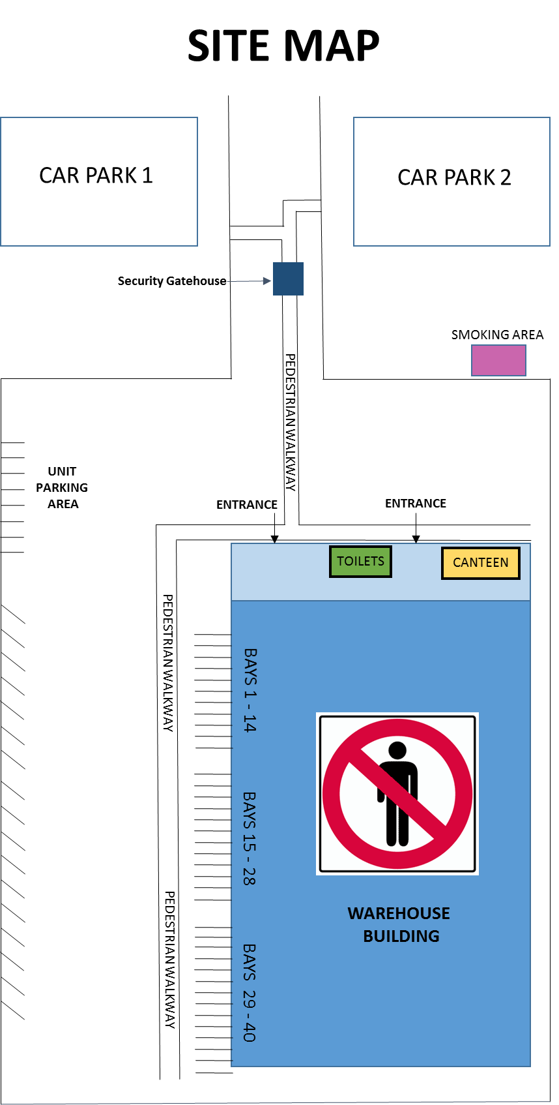

Site Signage

SPEED LIMIT

PARKING AREA

TRAFFIC LIGHTS (RED & GREEN)

HIGH VISABILITY VESTS MUST BE WORN

NO SMOKING

NO ENTRY

Site Traffic Light information

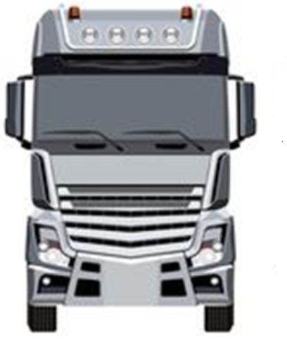

ALWAYS LOOK
TO YOUR RIGHT

DO NOT APPROACH THE BAY
DO NOT LEAVE THE BAY

APPROACH WHEN AUTHORISED
OK TO LEAVE BAY

NO LIGHTS ILLUMIINATED
DO NOT APPROACH BAY
DO NOT LEAVE BAY
REPORT IMMEDIATELY TO THE SHUNTER

I have read and acknowledge the safe working procedures, DHL site instructions and map and all Health & Safety rules including a full risk assessment. I understand that failure to adhere to these could result in me being removed from site and could result in disciplinary action.

Confirmation

Print Name:

Signature: |  | Date:

