Method Statement - CCTV Survey – Non-Man Entry

- Intent and Introduction
This method statement is for proposed works. This is purely a method Statement for works and is not a risk assessment, please see attached Risk Assessment for related hazards and controls. Please note it is the responsibility of the proprietor / person responsible for works to ensure that there are no other hazards introduced from their own acts or omissions, or from others instructed by them. It is the responsibility of the supervisor to ensure that this method statement is adhered to and works must be halted if any hazards or risks occur that have not been suitably controlled.

2 Location:
Interserve – House of Parliament / Palace of Westminster

3. Description of Work
To undertake a visual inspection and a CCTV survey inspection (if required) of an existing soil vent pipe which is to be partly replaced. The pipe runs the full hight of the Vent shaft within Elizabeth Tower. The section of the pipe to be replaced is partly within the Vent shaft and partly in the Belfry above. Access will only be provided from the Belfry for this survey. Once the damage and repairs are known a further method statement for further work will be obtained.

- On arrival to site all A1 Wet Waste Ltd employees must report to the prearranged meeting point.
- Where required all A1 Wet Waste Ltd employees will undergo a site induction. All site rules will be understood and adhered to.
- A1 Wet Waste Ltd employees are reminded on the dangers of working on site. See generic risk assessment “Working on Site”.
- Site will be under the control of the appointed site supervisor whose instructions will be obeyed at all times.
- An on-site risk assessment will be carried out by the site supervisor. Any changes from the site risk assessment will be noted and appropriate measures taken to control the risks identified. If site safe with all control measures in place work may commence. If site unsafe with all control measures in place work must be abandoned until risks assessed and additional control measures put in place.
- Work will not commence until procedure 5 is completed. If risks cannot be controlled works must be abandoned until appropriate control measures in place and works safe to continue.
- Safe access will be made to the point of works. All site safety rules will be followed throughout the operations including access and egress to point of works.
- The pipe has been adequately ventilated prior to all work being undertake
- The atmosphere test has been passed previously and the operations can commence
- The A1 Wet Waste Ltd employees carry the survey box upstairs and then in the elevator and place it in the suspended pipework and manually push the camera rod down the pipe.
- CCTV equipment will be set up and lowered into entry point, the CCTV survey will then take place.
- All equipment used for operations will be lowered into the pipe not carried down.
- On completion of the works all equipment is checked, cleaned and stowed away the work area cleaned and disinfected and the site is left in a safe condition
- Report any defects, faults or operational problems immediately to the A1 Wet Waste Ltd Supervisor.

4. Plant and Equipment

- Gas detectors.
- CCTV operations equipment.
- A1 Wet Waste vehicle.

- Equipment winch/Hand line for lowering equipment.
- All tools and equipment to be tethered throughout the operation to prevent it from falling
- First aid kit
- Portable exterior lighting (if required).
- Appropriate lighting (intrinsically safe head/hand lamps.)
- PPE. A hard hat, light eye protection, Hi vis jacket, gloves and steel toe capped boots to be worn at all times whilst on site.

5. Related Documentation and Assessments

- Site specific Risk Assessment to be submitted prior to work being undertaken
- On site visual Risk Assessment to be conducted on the day by the A1 Wet Waste Ltd Supervisor
- COVID 19 Risk Assessment to be submitted prior to work being undertaken
- Health and Safety and Environmental Policy.

6. Location and Protection of any Services/Facilities Affected by Works

- No other services or persons affected by the work detailed in this RAMS as only A1 Wet Waste Ltd employees working in area

7. Foreseeable Adverse Effects and their Control

- None as the work is to be conducted inside the Belfry

8. Safety Precautions

- First aid kit.
- Constant atmosphere testing throughout operations is not required as the pipe has been ventilated prior to the commencement of the work

9. Monitoring Systems

Supervisor or Team Leader (TBC) to oversee complete operations.

Gas monitoring to constantly monitor atmosphere not required

10. Further Information/Observations

A1 Wet Waste Ltd supervisors or managers take over all responsibility of operations and retain the right to cancel or halt any operations as they deem necessary.

Works may need to be rescheduled if initial assessment of site deems this method statement as unviable. Please see attached site specific risk assessment.

11. Emergencies

First aid equipment is provided on each vehicle and carried to the work area
Emergency services: 999
- Call 999 in the event of an emergency and state the incident location as [site address]
- Follow the instructions of the 999 call handler/emergency medical dispatcher until help arrives.
- Care must be taken to ensure that access for emergency vehicles is maintained throughout the site operations.
Nearest Hospital: St Thomas’s Westminster Bridge Road, Lambeth, London SE1 7EH
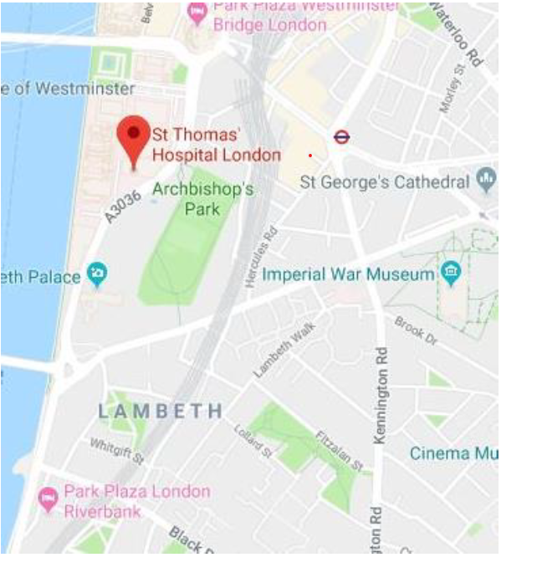

Method statement prepared by: |  | Paul James
Signed |  |  | Date | 22nd June 2020

Engineers Signature:
When on site to confirm you have read and understood the content of this method statement.

……………………………………………………………………………

……………………………………………………………………………

……………………………………………………………………………

