Method Statement - CCTV Survey – Non Man Entry

- Intent and Introduction
This method statement is for proposed works. This is purely a method Statement for works and is not a risk assessment, please see attached Risk Assessment for related hazards and controls. Please note it is the responsibility of the proprietor / person responsible for works to ensure that there are no other hazards introduced from their own acts or omissions, or from others instructed by them. It is the responsibility of the supervisor to ensure that this method statement is adhered to and works must be halted if any hazards or risks occur that have not been suitably controlled.

2 Location:

Aggreko Unit 14 Kimpton Ind Est Sandiford road Sutton Surrey SM3 9RD

3. Description of Work
To undertake CCTV survey on existing public/private sewer. All works are weather reliant. Forecast reports shall be obtained and no works shall commence if weather causes uncontrollable hazards. These works can only commence in the hours of daylight.

- On arrival to site all A1 Wet Waste Ltd employees must report to the pre arranged meeting point.
- Where required all A1 Wet Waste Ltd employees will undergo a site induction. All site rules will be understood and adhered to.
- A1 Wet Waste Ltd employees are reminded on the dangers of working on site. See generic risk assessment “Working on Site”.
- Site will be under the control of the appointed site supervisor whose instructions will be obeyed at all times.
- An on site risk assessment will be carried out by the site supervisor. Any changes from the site risk assessment will be noted and appropriate measures taken to control the risks identified. If site safe with all control measures in place work may commence. If site unsafe with all control measures in place work must be abandoned until risks assessed and additional control measures put in place.
- Work will not commence until procedure 5 is completed. If risks cannot be controlled works must be abandoned until appropriate control measures in place and works safe to continue.
- Safe access will be made to the point of works. All site safety rules will be followed throughout the operations including access and egress to point of works.
- Safe positioning of all company vehicles around work site ensuring our Safety at Street Works and Road Works code of practice is adhered to.
- When all safety barriers are in place around required manholes then manhole covers can be raised. See manual handling assessment on lifting manholes.
- Once the chamber has been adequately ventilated an atmosphere test using a gas monitor must be obtained. The outcome of this test will determine whether works will be permitted. If the test is a pass operations are permitted following the instructions below. If the test is a fail no works will commence. All chamber access covers will be replaced and all A1 Wet Waste Ltd employees will leave the site ensuring it is left in a safe condition. Again following all site safety rules and regulations.
- If the atmosphere test has passed.
- Operations may now start.
- CCTV equipment will be set up and lowered in to entry point, the CCTV survey will then take place. Works will only be attempted with out the need for a confined space entry. If this is not possible then the work will be discontinued and the customer notified that a confined space entry crew will be will be required to carry out the survey.
- All equipment used for operations will be lowered or raised, not carried down.
- On completion of the works.
- Ensure all equipment is checked, cleaned and stowed away.
- When safe to do so ensure covers are replaced, barriers removed, the work area cleaned and disinfected and the site is left in a safe condition
- Report any defects, faults or operational problems immediately to your supervisor.

4. Plant and Equipment

- Gas detectors.
- CCTV operations equipment.
- A1 Wet Waste vehicle.
- Equipment winch/Hand line for lowering equipment.
- First aid kit
- Portable exterior lighting ( if required ).
- Appropriate lighting (intrinsically safe head/hand lamps.)
- PPE.

5. Related Documentation and Assessments

- Site specific Risk Assessment.
- All generic Risk Assessments.
- Safety at street works and road works Code of Practice.
- Health and Safety and Environmental Policy.

6. Location and Protection of any Services/Facilities Affected by Works

  - Customer to advise prior to work commencing.
  - Priority: Manhole cover safety.

7. Foreseeable Adverse Effects and their Control

- Member of the public, shop and office staff, other works personnel. Barriers and cones to be erected to cordon off safe work area.
- Weather conditions: control weather forecast must be obtained before any works commences.
- Charged and surcharging chambers. Action: extra care to be taken in the location of channel and out-falling pipe. The use of drain rods must be used to locate these.
- Damaged cables. Action: maintenance and inspection programme. Defect reporting process.
- Flow conditions to be assessed on site.

8. Safety Precautions

- Gas detectors.
- First aid kit.
- Constant atmosphere testing throughout operations.
- Safety Barrier

9. Monitoring Systems

Supervisor or Team Leader ( Insert Name ) to oversee complete operations.

Gas monitoring to constantly monitor atmosphere.

10. Further Information/Observations

A1 Wet Waste Ltd supervisors or managers take over all responsibility of operations and retain the right to cancel or halt any operations as they deem necessary.
Works may need to be re scheduled if initial assessment of site deems this method statement as unviable. Please see attached site specific risk assessment.

11. Emergencies

First aid equipment is provided on each vehicle
Emergency services: 999
- Call 999 in the event of an emergency and state the incident location as [site address]
- Follow the instructions of the 999 call handler/emergency medical dispatcher until help arrives.
- Care must be taken to ensure that access for emergency vehicles is maintained throughout the site operations.
Nearest Hospital:

St Helier Hospital - Tel: 020 8296 2000 Fax: 020 8641 4546
Address: Wrythe Lane, Carshalton, Surrey, SM5 1AA
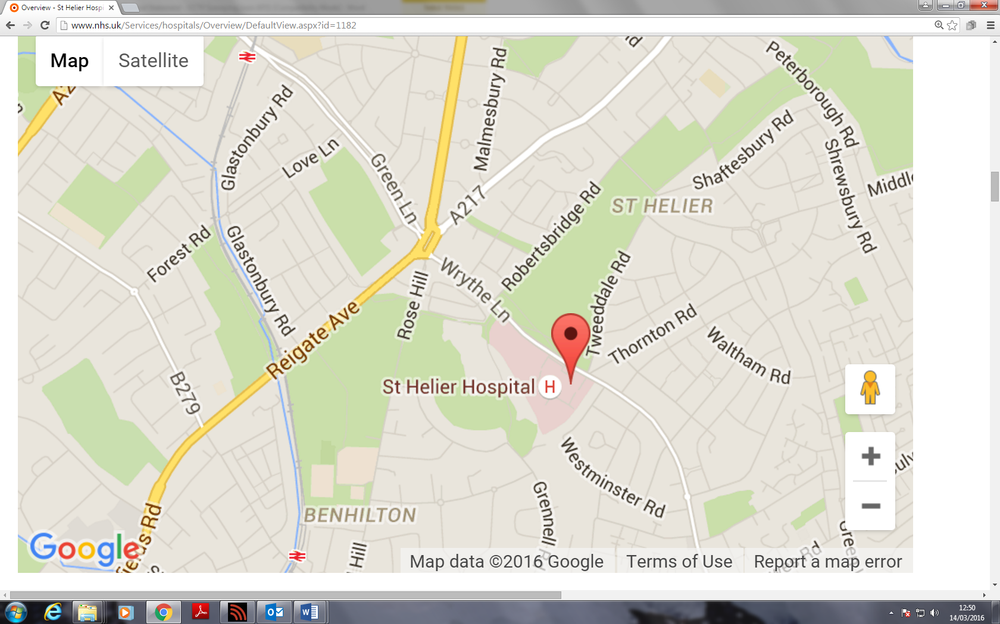

Method statement prepared by: |  | Steven Cummings
Signed |  |  | Date | 14th March 2016

Engineers Signature:
When on site to confirm you have read and understood the content of this method statement.

……………………………………………………………………………

……………………………………………………………………………

……………………………………………………………………………

