**RAMS for**

**Drain cleaning and CCTV Survey**

**British Airways - LHR**

Vanguard House, Vanguard Way,

Eastchurch Road, Hatton Cross. TW6 2PL

Prepared by: A1 Group

Date: 6th November 2015

Table of Contents

Summary 1

Nature of Work 1

Traffic Management Area 1 (TM1) (Section Map Appendices 3) 1

Time of work to be conducted 1

Traffic Management System – TM1 1

Type of Work to be conducted in Area 1

Traffic Management Area 2 (TM2) (Section Map Appendices 4) 2

Time of work to be conducted 2

Traffic Management System – TM2 2

Type of Work to be conducted in Area 2

Traffic Management Area 3 (TM3) (Section Map Appendices 5) 3

Time of work to be conducted 3

Traffic Management System – TM3 3

Type of Work to be conducted in Area 3

Traffic Management Area 4 (TM4) (Section Map Appendices 6) 4

Time of work to be conducted 4

Traffic Management System – TM4 4

Type of Work to be conducted in Area 4

Traffic Management Area 5 (TM5) (Section Map Appendices 7) 5

Time of work to be conducted 5

Traffic Management System – TM5 5

Type of Work to be conducted in Area 5

Specific Work Method Statements 6

Confined Space/Manhole traverse (man entry) – Risk Assessment Appendices 8 6

CCTV Survey - Risk Assessment Appendices 9 8

Jet Blasting/Vacuum Pumping - Risk Assessment Appendices 10 9

Site specific scope of work for A1 Employee 10

Housekeeping 10

Access and egress to authorised personnel 10

Work permits and licences 10

Labour force 10

Training 11

Personal protective equipment 11

Transportation 11

Lifting equipment 11

Portable tools 11

Mechanical plant 11

Track mounted vehicles and plant 11

Temporary lighting and power 11

Signs and notices 12

Safety Barriers 12

Traffic management 12

Temporary structures/ false work 12

Working at heights 12

Emergency Procedures 12

First aid 13

Accidents, incidents and reporting of injuries, diseases and dangerous occurrences (RIDDOR 1995). 13

Statutory records 13

Fire 13

Excavation 13

Materials 13

Control of work with Hazardous substances and processes 14

Storage and handling of hazardous substances and materials 14

System/codes of practice 14

Inspection and Environmental auditing 14

Noise and vibration 14

Air quality and dust 14

Waste management 14

Protection of assets 14

Protection of water quality 15

Management of pest and weeds 15

Nature protection 15

Contaminated Land 15

Archaeology 15

Records and documentation 15

Names and copies of qualifications and certification of A1 Employees completing this work. 16

APPENDICES 1-10 17

Appendices 1 - TM1/TM4 (Full Map) 18

Appendices 2 - TM5 (Full Map) 19

Appendices 3 - TM1 (Section Map) 20

Appendices 4 - TM2 (Section Map) 21

Appendices 5 - TM3 (Section Map) 22

Appendices 6 - TM4 (Section Map) 23

Appendices 7 - TM5 (Section Map) 24

Appendices 8 – Confined Space/Traverse Entry Risk Assessment 25

Appendices 9 – CCTV Survey/Traverse Entry Risk Assessment 27

Appendices 10 – Drain Jetting/Emptying drain or Gully Risk Assessment 29

# Summary

This Health and Safety Method Statement has been prepared by A1 Group and concerns cleaning / jetting and CCTV Surveys of the drainage and their associated assets as requested by the client BA.

Please find below details of the work to be carried out and any perceived hazards associated to the work involved.

Nature of Work

Cleaning / jetting and CCTV Surveys of the drainage at British Airways, Vanguard House Car Parks, Vanguard Way, Eastchurch Road, Hatton Cross, TW6 2PL between **<DATE> and <DATE>.**

# Traffic Management Area 1 (TM1) (Section Map Appendices 3)

Please refer to the detailed map in ***Appendices 3*** for location of work to be completed.

Time of work to be conducted

The work in this area will be undertaken by the A1 Group at **NIGHT** after BA employees have left area. This will mean less traffic in work area therefore limiting the risks. BA Staff and suppliers who work night shift will have access to the works area but the number of vehicles will be greatly reduced after 6pm.

Traffic Management System – TM1

Chapter 8 barriers to be erected around each marked location. Barriers will conform to BSI standards and locked together.

A portable lighting tower will be erected to provide adequate lighting to the area in order that work can be conducted safely.

Appropriate road signage will be placed approx. 50 metres away from the work area in both directions warning possible oncoming vehicles of work being undertaken head.

6 volt flashing road lights will be placed by the barriers as additional warning of work being undertaken.

Type of Work to be conducted in Area



**Manhole**

**Confined Space Assessment and Procedure**. Please refer to method statement for working in confined space on page 6/7.

**Jet Blasting**. Please refer to the method Statement for Jet Blasting on page 9.

**CCTV Survey**. Please refer to the method statement for CCTV on page 8.



**Gully / ACO**

**Jet Blasting**. Please refer to the method Statement for Jet Blasting on page 9.

**CCTV Survey**. Please refer to the method statement for CCTV on page 8.

# Traffic Management Area 2 (TM2) (Section Map Appendices 4)

Please refer to the detailed map in ***Appendices 4*** for location of work to be completed.

Time of work to be conducted

The work in this area will be undertaken by the A1 Group at **NIGHT** after BA employees have left area. This will mean less traffic in work area therefore limiting the risks. BA Staff and suppliers who work night shift will have access to the works area but the number of vehicles will be greatly reduced after 6pm.

Traffic Management System – TM2

Chapter 8 barriers to be erected around each marked location. Barriers will conform to BSI standards and locked together.

A portable lighting tower will be erected to provide adequate lighting to the area in order that work can be conducted safely.

Appropriate road signage will be placed approx. 50 metres away from the work area in both directions warning possible oncoming vehicles of work being undertaken head.

6 volt flashing road lights will be placed by the barriers as additional warning of work being undertaken.

Type of Work to be conducted in Area



**Manhole**

**Confined Space Assessment and Procedure**. Please refer to method statement for working in confined space on page 6/7.

**Jet Blasting**. Please refer to the method Statement for Jet Blasting on page 9.

**CCTV Survey** Please refer to the method statement for CCTV on page 8.



**Gully / ACO**

**Jet Blasting**. Please refer to the method Statement for Jet Blasting on page 9.

**CCTV Survey**. Please refer to the method statement for CCTV on page 8.

# Traffic Management Area 3 (TM3) (Section Map Appendices 5)

Please refer to the detailed map in ***Appendices 5*** for location of work to be completed.

Time of work to be conducted

The work in this area will be undertaken by the A1 Group at **NIGHT** after BA employees have left area. This will mean less traffic in work area therefore limiting the risks. BA Staff and suppliers who work night shift will have access to the works area but the number of vehicles will be greatly reduced after 6pm.

Traffic Management System – TM3

Chapter 8 barriers to be erected around each marked location. Barriers will conform to BSI standards and locked together.

A portable lighting tower will be erected to provide adequate lighting to the area in order that work can be conducted safely.

Appropriate road signage will be placed approx. 50 metres away from the work area in both directions warning possible oncoming vehicles of work being undertaken head.

6 volt flashing road lights will be placed by the barriers as additional warning of work being undertaken.

Type of Work to be conducted in Area



**Manhole**

**Confined Space Assessment and Procedure**. Please refer to method statement for working in confined space on page 6/7.

**Jet Blasting**. Please refer to the method Statement for Jet Blasting on page 9.

**CCTV Survey**. Please refer to the method statement for CCTV on page 8.

**Gully /ACO**

**Jet Blasting.** Please refer to the method Statement for Jet Blasting on page 9.

**CCTV Survey**. Please refer to the method statement for CCTV on page 8.

# Traffic Management Area 4 (TM4) (Section Map Appendices 6)

Please refer to the detailed map in ***Appendices 5*** for location of work to be completed.

Time of work to be conducted

The work in this area will be undertaken by the A1 Group during the **NIGHT.** There is also a 24-hour employee bus service in operation in this area. Pedestrian traffic is reduced after 6pm but there will still be staff walking from the bus stop to the turnstile at gate E11.

Traffic Management System – TM4

Chapter 8 barriers to be erected around each marked location. Barriers will conform to BSI standards and locked together.

A portable lighting tower will be erected to provide adequate lighting to the area in order that work can be conducted safely.

Appropriate road signage will be placed approx. 50 metres away from the work area on the approach road warning employee bus services of work being undertaken head.

6 volt flashing road lights will be placed by the barriers as additional warning of work being undertaken.

Type of Work to be conducted in Area



**Manhole**

**Confined Space Assessment and Procedure.** Please refer to method statement for working in confined space on page 6/7.

**Jet Blasting**. Please refer to the method Statement for Jet Blasting on page 9.

**CCTV Survey**. Please refer to the method statement for CCTV on page 8.

**Gully / ACO**

**Jet Blasting**. Please refer to the method Statement for Jet Blasting on page 10.

**CCTV Survey**. Please refer to the method statement for CCTV on page 9.

# Traffic Management Area 5 (TM5) (Section Map Appendices 7)

Please refer to the detailed map in ***Appendices 6*** for location of work to be conducted.

Time of work to be conducted

The work in this area will be undertaken by the A1 Group during the **NIGHT** as there are a high number of pedestrians using this area during the day. There will still be some staff walking through this area after 6pm.

Traffic Management System – TM5

Chapter 8 barriers to be erected around each marked location. Barriers will conform to BSI standards and locked together.

A portable lighting tower will be erected to provide adequate lighting to the area in order that work can be conducted safely.

Appropriate road signage will be placed approx. 50 metres away from the work area in both directions warning possible oncoming vehicles of work being undertaken head.

6 volt flashing road lights will be placed by the barriers as additional warning of work being undertaken.

Type of Work to be conducted in Area



**Manhole**

**Confined Space Assessment and Procedure**. Please refer to method statement for working in confined space on page 6/7.

**Jet Blasting.** Please refer to the method Statement for Jet Blasting on page 9.

**CCTV Survey**. Please refer to the method statement for CCTV on page 8.

**Gully / ACO**

**Jet Blasting**. Please refer to the method Statement for Jet Blasting on page 9.

**CCTV Survey**. Please refer to the method statement for CCTV on page 8.

# Specific Work Method Statements

Confined Space/Manhole traverse (man entry) – Risk Assessment Appendices 8

1. Obtain permit to work from Norland Managed Services.
2. The team leader (top man 1) shall assign the members of his team to specific duties during man entry operations.
3. Ensure all Traffic Management in in place and all personnel have the required PPE equipment which includes
   1. **Top Man 1** – Overalls, gloves, hard hats, safety boots. Hi visibility jackets, safety glasses.
   2. **Top Man 2** – Full face visor, ear defender, safety boots, 10-minute positive pressure escape B.A, safety harness and a 12m safety rope, approved gas monitor and an intrinsically safe torch.
   3. **Bottom Man** - Full face visor, ear defender, safety boots, 10-minute positive pressure escape B.A, safety harness and a 12m safety rope, approved gas monitor and an intrinsically safe torch.
4. Lift manhole cover in accordance with manual handling procedures and ventilate for 15 minutes.
5. Lower gas monitor into manhole chamber to invert and leave for 5 minutes. If no alarm is sounded work may proceed. If gas monitor indicates hazardous gases the client’s responsible person will be notified and work will not proceed.
6. The gas monitor will be used to provide constant monitoring of the working environment. Two engineers will be the designated top men 1 and 2, who will control the equipment on the surface (one of these men Top Man 1 will be the Team Leader).
7. Set up tri pod and winch system on the surface above the drain
8. The Jet Blasting and Vacuum pumping will then be carried out in accordance with the specific method statement included in this document on ***page 9***.
9. The CCTV surveying work will then be carried out in accordance with the specific method statement on **page 8** of this document.
10. If there is a problem with the jetting or the CCTV equipment and an Operative is required to enter the drain, then the following process is to be followed.

**Top Man 1&2**

1. Top Man 1 shall test the atmosphere at the base of the access manhole with the gas detector. Five minutes must be allowed to ensure the monitor the monitor has carried out a complete sensing cycle. If when the monitor is withdrawn, no audible or visual alarm operating the indication is that the manhole is safe to enter. The detector is then replaced into the manhole for continuous monitoring.
2. Should alarm indication occur the manhole should not be entered under any circumstances/immediate evacuation must take place.
3. Once the top men 1 and 2 are convinced that the access is safe the survey engineer (bottom man) may descend following the bottom man procedure.
4. Communication between the top men and the bottom man must be maintained at all times.
5. Should the prevailing surface conditions give cause for concern (i.e. rainfall), the top man 1 shall call for full confined space evacuation. It is the responsibility of the top man 1 to alert the rescue services in the event of an emergency.

**Bottom Man**

1. The bottom man must ensure that prior to entering the drain a full PPE check is conducted and that all s PPE is functioning correctly. They must also ensure they are clipped onto the winch system. The bottom man will also have a 10mm B.A. escape set. (If the gas monitor signals an alarm, the engineer working in the confined space will don their escape set and immediately leave the confined space)
2. The Bottom Man shall be positioned at the bottom of the manhole and he shall have direct visual and verbal contact with Top Man 1 and 2 at all times.
3. Bottom man shall carry his own personal gas monitor, escape breathing apparatus along with safety lines.
4. On hearing his gas alarm, the bottom man must alert top man 1 and 2 to effect an evacuation of the manhole.

[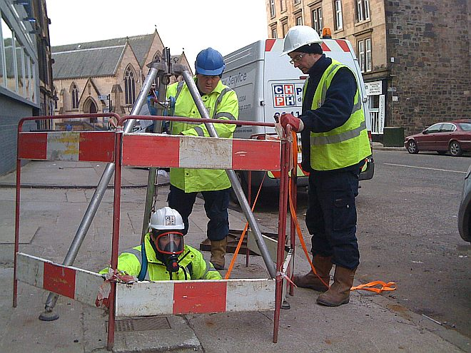](https://www.google.co.uk/url?sa=i&rct=j&q=&esrc=s&source=images&cd=&cad=rja&uact=8&ved=&url=http://www.chanlon.com/case-studies/drainage-division/&psig=AFQjCNHRedKcUkPn0wsG9bIshfIsNppVFg&ust=1446918534240314)

Top man 1

Top man 2

Bottom man 1

Manhole

Tripod/Winch



CCTV Survey - Risk Assessment Appendices 9

1. Confirm Permit to work is in place from Norland Managed Services.
2. Ensure all Traffic Management in in place
3. Ensure all personnel have the required PPE equipment
4. Check jetting has been completed
5. Undertake a confined space assessment as detailed on page 7 & 8 of this document
6. A1 use a flexible CCTV camera, which allow us to perform close and thorough inspections of every drain encountered.
7. An A1 technician will have a mobile CCTV camera which they insert into the pipework either manually by lying down and placing in the pipe if it is less than 500mm below ground.
8. A1 Operators are also trained if necessary to insert the CCTV camera using two ropes and lowering into the drain.
9. If necessary, the A1 Operator can enter the drain and place into the pipe following the confined spaces requirements as in the Confined Space Method statement on page 7 & 8.
10. Once inside, the camera's operator will investigate and highlight any structural faults or defects, both on the footage and in their notes.
11. Every CCTV camera comes with its own power unit and either a mini-cam rover pan or tilt colour tractor, so the camera can be remotely navigated through a drain of any size.
12. On completion of the survey the operative will remove the camera from the pipe using the same method that it was lowered in to the pipe. This will either be via hand for pipes less than 500mm below ground level and using ropes for pipes more than 500mm below ground level. If it is necessary for the Operator to enter the manhole the confined space method statement on page 7 & 8 is to be followed.

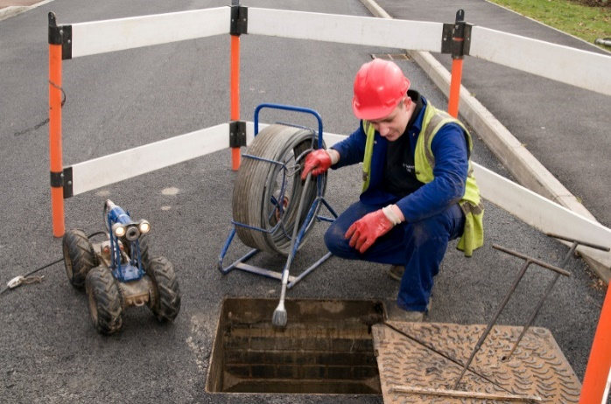

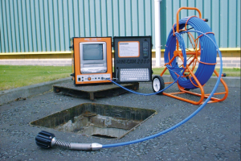

Jet Blasting/Vacuum Pumping - Risk Assessment Appendices 10

1. Confirm Permit to work is in place from Norland Managed Services.
2. Ensure all Traffic Management in in place.
3. Ensure all personnel have the required PPE equipment.
4. Undertake a confined space assessment as detailed on page 7 & 8 of this document.
5. Assess depth of drain and distance from tank opening to vehicle to determine hose requirements.
6. Unload required length or quantity of hoses.
7. Connect hoses together and connect one end to inlet valve on vacuum tanker vehicle.
8. Place lose end of hose into manhole.
9. Engage jetter or vacuum pump.
10. Open inlet valve on pump.
11. Proceed to jet or empty contents of drain making any necessary adjustments to the positioning of the hose at the bottom of the drain to ensure that it is totally clean or empty.
12. When the task is complete, close the pump valve.
13. Switch off the pump.
14. Remove the hose from the drain.
15. Replace the cover to the drain.
16. Disconnect the hoses and place them back in or on the vehicle.

[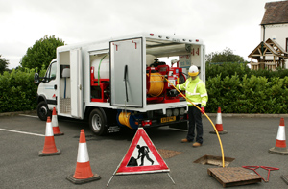](https://www.google.co.uk/url?sa=i&rct=j&q=&esrc=s&source=images&cd=&cad=rja&uact=8&ved=0CAcQjRxqFQoTCLi8r72y_MgCFcgEGgodXmULtg&url=http://whale.co.uk/sp-holding-invests-in-more-whales/&psig=AFQjCNHtcnedzjKrdONsUyORsSz9VcHe3Q&ust=1446919718862722)

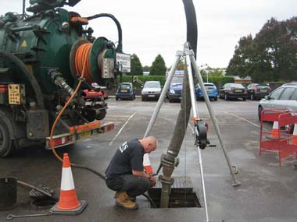

# Site specific scope of work for A1 Employee

* On arrival at site, contact the Norland Managed Services responsible person and obtain necessary permits and note any special precautions required. All staff employed by A1 Wokingham Wet Waste Limited carrying out protection duties will have been through approved training.
* A Team leader will control the teams for the duration of the job.
* Teams of trained staff under the supervision of a Team leader will carry out all works.
* Team Leader to ensure that all operators are wearing issued PPE. All engineers must wear PPE provided.
* Carry out protection procedures as required by site and location in accordance with client’s procedures.
* Provide signing, lighting and guarding to isolate working areas, taking into consideration the protection of any adjacent properties.

Housekeeping

* All working area on all sites will be left clean, tidy, clear of any obstruction and safe on completion of works.
* All waste will be removed from site and disposed of to a licensed waste transfer station.
* A1 will set up a Welfare unit on site for employees to use kitchen and toilet facilities. This will be stored on site in designated area for the duration on the work.

Access and egress to authorised personnel

* Via approved exits and entrances and other safe areas, this is in site specific Traffic Management plans.

Work permits and licences

* All tools, equipment and materials will be removed from site at the end of a shift.
* As the work to be completed may involve A1 employees entering a confined space working which is considered to be sufficiently hazardous as to give rise to specific risks a permit to work system will be used and a site specific risk and method statement has been completed in this document.
* A1 will obtain a permit to work and a permit to work in a confined space from British Airways Facilities Management Company – Norland Managed Services.
* All employees will book in as appropriate on arrival and when leaving the client’s property, to comply with the client’s regulations.

Labour force

Each Drain cleaning/CCTV surveying team will consist of:

* 1 x Team Leader
* 2 x Suitably qualified and experienced person

Training

The teams will be trained in:

* CITB working safely
* OS20 x pipe condition surveying
* High pressure water jetting techniques
* Emergency first aid
* NRASWA- signing, lighting and guarding
* Working in confined spaces
* Tool box talks as appropriate at the start of each shift

Personal protective equipment

All operators will be issued with, and trained in the use of the following PPE:

* General - Overalls, gloves, hard hats, safety boots. Hi visibility jackets, safety glasses.
* Specific- Full face visor, ear defender, wetsuit, safety Wellington boots, 10-minute positive pressure escape B.A, safety harness and a 12m safety rope, approved gas monitor and an intrinsically safe torch.
* Detailed records of monitoring, servicing and calibration of all equipment are available for inspection, along with issue and use of PPE.

Transportation

* All operators use vans or lorries for transport to and from the work site.

Lifting equipment

* All manhole covers where required will be lifted using mechanical manhole lifting equipment.
* Hydraulic manhole lifting equipment will be used if the mechanical lifting is not successful.

Portable tools

* Portable tools used will be hand tools such as shovels, drain scoops and buckets. Special items will be detailed on the list of equipment to be used for each job in the method statements.

Mechanical plant

* All plant brought onto site will be regularly maintained and tagged for identification purposes. The CCTV surveying unit will be located as close as possible to the work area as is permitted.

Track mounted vehicles and plant

N/A

Temporary lighting and power

Temporary lighting will be provided by:

* Portable electric lighting rigs.
* Hand held intrinsically safe battery powered torches.
* Power will be obtained via approved portable diesel generators.

Signs and notices

* The working will be isolated using signing, lighting and guarding in accordance with chapter 8 of the NRASWA 1991.
* Notices of warning of HPWJ and CCTV survey activities are erected in prominent positions for the protection of employees and general public.

[](https://www.google.co.uk/url?sa=i&rct=j&q=&esrc=s&source=images&cd=&cad=rja&uact=8&ved=0CAcQjRxqFQoTCJyt8bnL_MgCFcbsFAodWPcHuA&url=http://www.protectsigns.uk/750mm-traffic-lights-ahead.html&psig=AFQjCNFDoEDknlwSEE0A4RauSd95jxV-5A&ust=1446926513953910)[](https://www.google.co.uk/url?sa=i&rct=j&q=&esrc=s&source=images&cd=&cad=rja&uact=8&ved=0CAcQjRxqFQoTCKnkhp_L_MgCFcJGFAodfNUEcg&url=http://www.sabre-roads.org.uk/wiki/index.php?title%3DGallery:Warning_Sign/Road_Narrows&psig=AFQjCNETkIY6L-UPbUbqJP0ju6lYZFWa2w&ust=1446926458020360)

**Road narrows Work Ahead**

[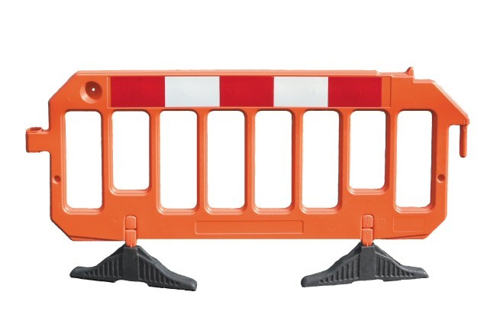](https://www.google.co.uk/url?sa=i&rct=j&q=&esrc=s&source=images&cd=&cad=rja&uact=8&ved=&url=http://www.grade1online.com/fencing/4544487958&psig=AFQjCNE9re6MqSLcMwDiTBwsam5ml5AzmA&ust=1446920048340842)Safety Barriers

* Compliant with BS 7818 for pedestrian restraint systems and Chapter 8 Street works A1 Group use Avalon plastic barriers with locking system which creates secure joints on uneven ground, up slopes, over kerbs and across rough terrain. Either unlocked or in locked mode, configurations are made to prevent unauthorised dismantling.

Traffic management

* Only operators trained in the signing, lighting and guarding of road works in accordance with the requirements of NRASWA 1991 will be employed.

Temporary structures/ false work

N/A

Working at heights

N/A

Emergency Procedures

A1 Wokingham Wet Waste Limited 24-hour emergency service number is:

**Tel: 07831 507 920**

**Fax: 0118 989 4652**

**Safety Officer: 07712 556 825**

First aid

* All vehicles will carry an accident book and are equipped with a suitable first aid kit.
* A nominated first aider is available at each depot together with the necessary first aid equipment.
* All operators will carry Weils disease and HPWJ cards at all times.

The Health and Safety manager for A1 Wokingham Wet Waste Limited is Mr Clive Owen.

**24-hour contact numbers: 07712 556 825 / 07831 507 920.**

Accidents, incidents and reporting of injuries, diseases and dangerous occurrences (RIDDOR 1995).

* All accidents will be recorded in the accident book and reported to the client. Incidents that are reportable, under RIDDOR 95 will be reported to the HSE using forms F2506, F2508A etc. Copies will be sent to the DER.
* The company’s safety manager, Mr Clive Owen will investigate all reportable incidents.
* The site safety file will contain a site specific accident book, although all information entered will be recorded in the depot accident book.

Statutory records

* All accidents will be recorded in the site accident book and the client notified immediately. A1 Wokingham Wet Waste Limited head office will handle all reportable incidents in association with the Head office of other contractors, so that the HSE can be notified.
* The site safety file will have an individual accident book, and all information held will be recorded in the head office accident book. This office safety file will be the responsibility of the Operations manager at each depot.

Fire

All the client’s fire evacuation procedures will be carried out as per site instructions. All operators will be trained in Fire awareness.

All Working operations will have present on site for use:

* 1 no.9 litre Triple F aqueous foam extinguishers
* 1 no.2.5 kg CO2 extinguisher

Excavation

N/A

Materials

* There are no hazardous substances being used on this job and therefor no data sheets will be supplied.

Control of work with Hazardous substances and processes

* As there are no hazardous materials being used on this particular job then there will be no requirement for COSHH assessments to be included within this document.
* If asbestos is found to be present in any working area, the client will be notified and further instructions obtained.
* All team members will be trained in the use of the HPWJ equipment.

Storage and handling of hazardous substances and materials

* Care will be taken to ensure that all hazardous substances will be stored and handled in accordance with the manufactures safety data sheets and COSHH assessments.

System/codes of practice

* A schedule of documents and references will be provided by the A1 Group. This list is not exhaustive and check should be made for any revisions. If in doubt refer to quality/safety department at head office.

Inspection and Environmental auditing

* The Operations manager at each depot is the person responsible for environmental surveillance on a client site.
* The Team Leader on each job is the person responsible for environmental surveillance on site, as work progresses.

Noise and vibration

* The system of dealing with noise and vibration assessments and preventative action is contained within the project plan.
* If the Team Leader is concerned regarding noise and vibration levels of an activity or an item of plant he will refer back to A1 Management, who will plan the necessary course of action.
* If noise or vibration assessments and specialized prevention measures are required, a specific risk assessment and method statement will be prepared.

Air quality and dust

* All equipment will be regularly maintained with specific attention being given to the control of exhaust emissions.
* Inspect area of work before work starts to establish if dust may be a problem and be prepared to damp down, especially in windy conditions.

Waste management

* Any materials or debris arising from the CCTV operations will be placed in double bags, removed from site and taken to a licensed waste transfer station.
* All such activities are carried out in accordance with the requirements of the “Code of practice. A duty of care” under the provisions of the Environment Protection Act 1990.
* A1 Wokingham Wet Waste Limited is a licensed waste carrier and its registration no. is TSE/388156.

Protection of assets

* The client’s assets will be protected during the course of all work.

Protection of water quality

* The teams carrying out the CCTV surveying work will ensure that no materials or debris are allowed to enter any watercourse or drainage outlets or channels.

Management of pest and weeds

* Should any special measures be required these will be the subject of a separate instruction from the client and a specific method statement raised by A1 Wokingham Wet Waste Limited and agreed with the client, before work commences.

Nature protection

* Should any special measures be required these will be the subject of a separate instruction from the client and a specific method statement raised by A1 Wokingham Wet Waste Limited and agreed with the client, before work commences.

Contaminated Land

* Should any special measures be required these will be the subject of a separate instruction from the client and a specific method statement raised by A1 Wokingham Wet Waste Limited and agreed with the client, before work commences.

Archaeology

* Where it is suspected that archaeology finds may be made a separate method statement will be raised for the works involved.
* Should any archaeological finds be made during the works the charge hand will cease working in the areas affected and alert the client and A1 Wokingham Wet Waste Limited head office immediately.
* The area (s) affected will be left in a safe condition and as undisturbed as that will allow. A1 Wokingham Wet Waste Limited will agree and obtain written instructions from the client as what works are to proceed. A new programme/method statement for the works will be raised by A1 Wokingham Wet Waste Limited and accepted by the client, in writing, prior to works recommencing.

Records and documentation

* All consents, environmental check lists and audit results are kept at our head office at each appropriate depot. These are the responsibility of the operations manager at each depot who can be contacted.

# Names and copies of qualifications and certification of A1 Employees completing this work.

|  |
| --- |
| **Confirmation** |

I confirm that I have read, acknowledge and will adhere to the contents of this document at all times whilst working at a client’s premises on behalf of the A1 Group.

|  |  |  |
| --- | --- | --- |
| **EMPLOYEE NAME** | **QUALIFICATIONS** | **CERTIFICATION**  ***(attached)*** |
|  |  |  |
| **SIGNATURE** |
|  |  |  |
| **SIGNATURE** |
|  |  |  |
| **SIGNATURE** |
|  |  |  |
| **SIGNATURE** |
|  |  |  |
| **SIGNATURE** |

# APPENDICES 1-10

Appendices 1 - TM1/TM4 (Full Map)

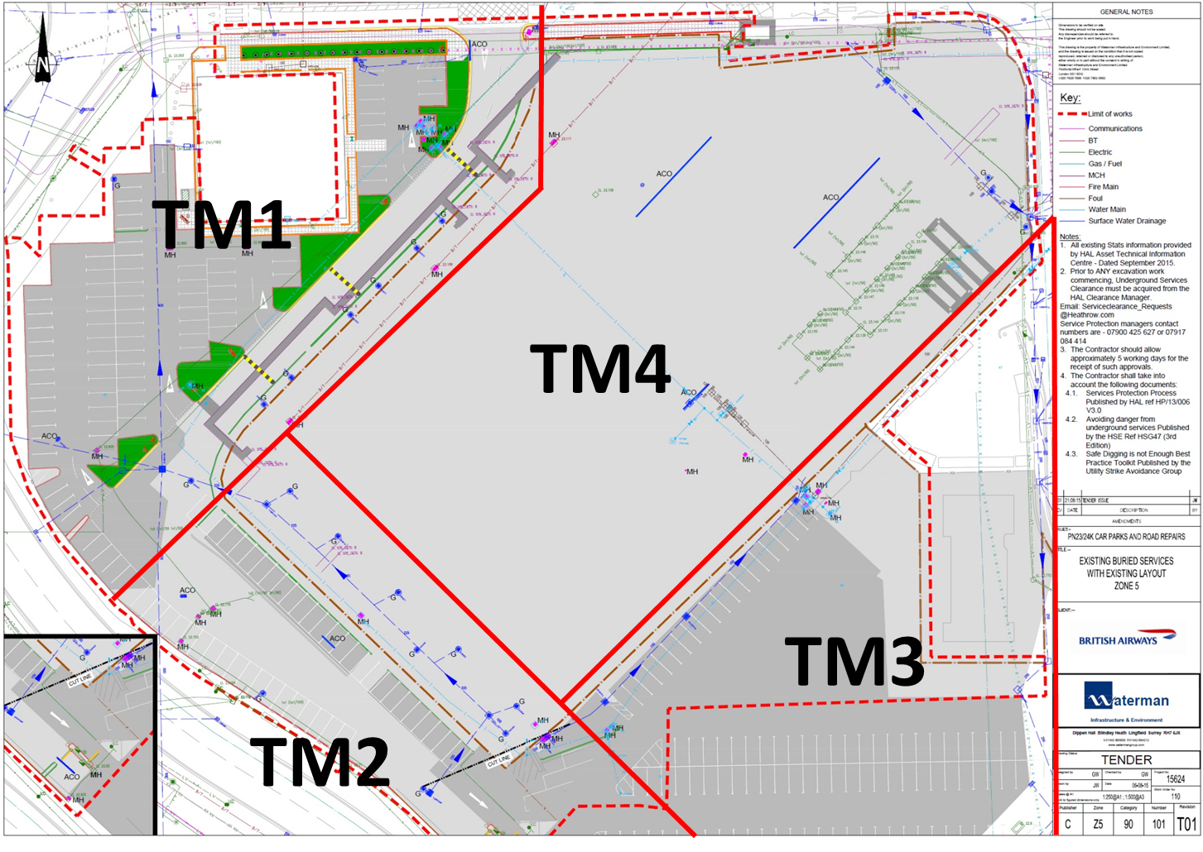

Appendices 2 - TM5 (Full Map)

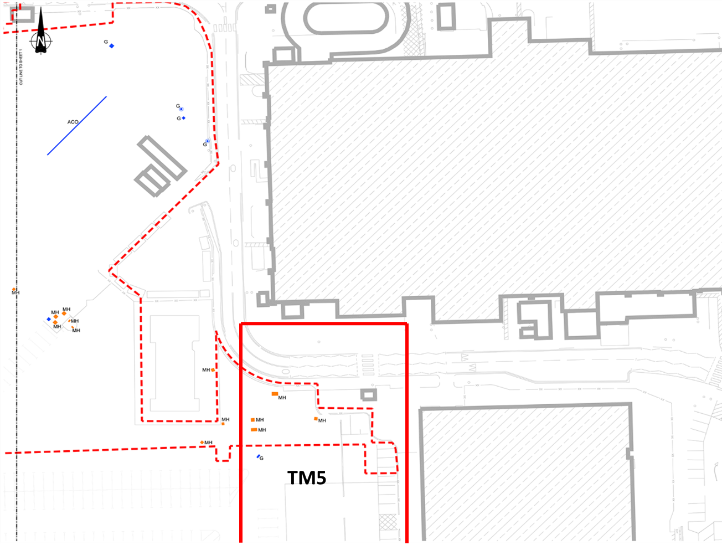

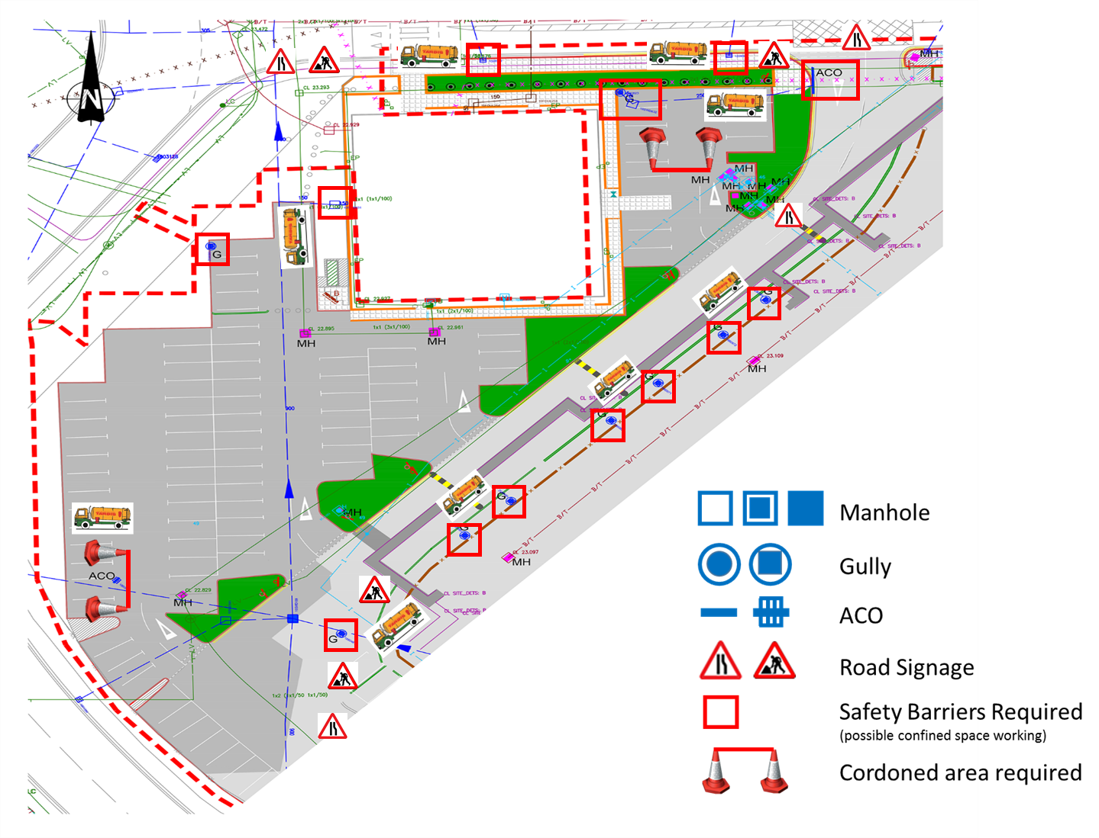Appendices 3 - TM1 (Section Map)

Appendices 4 - TM2 (Section Map)

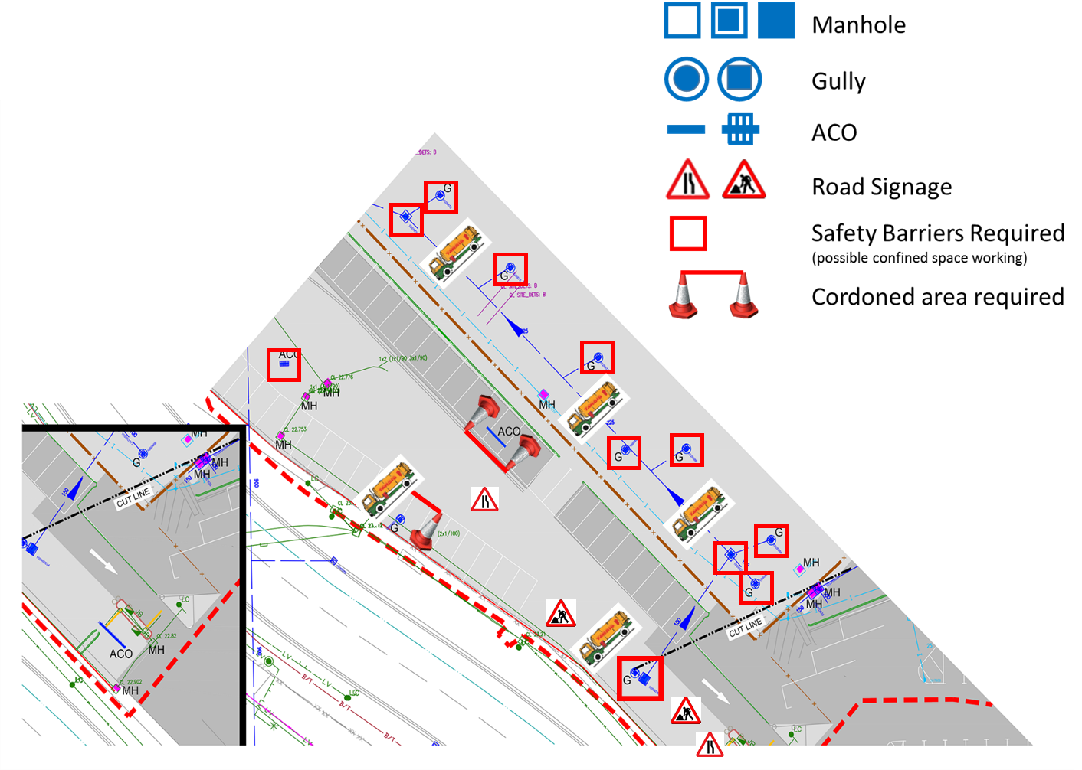

Appendices 5 - TM3 (Section Map)

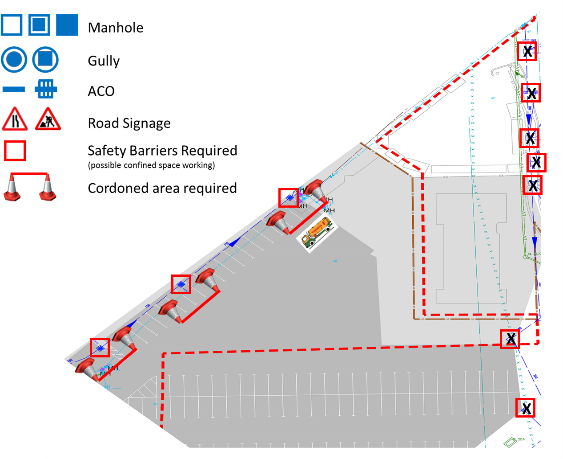

Appendices 6 - TM4 (Section Map)

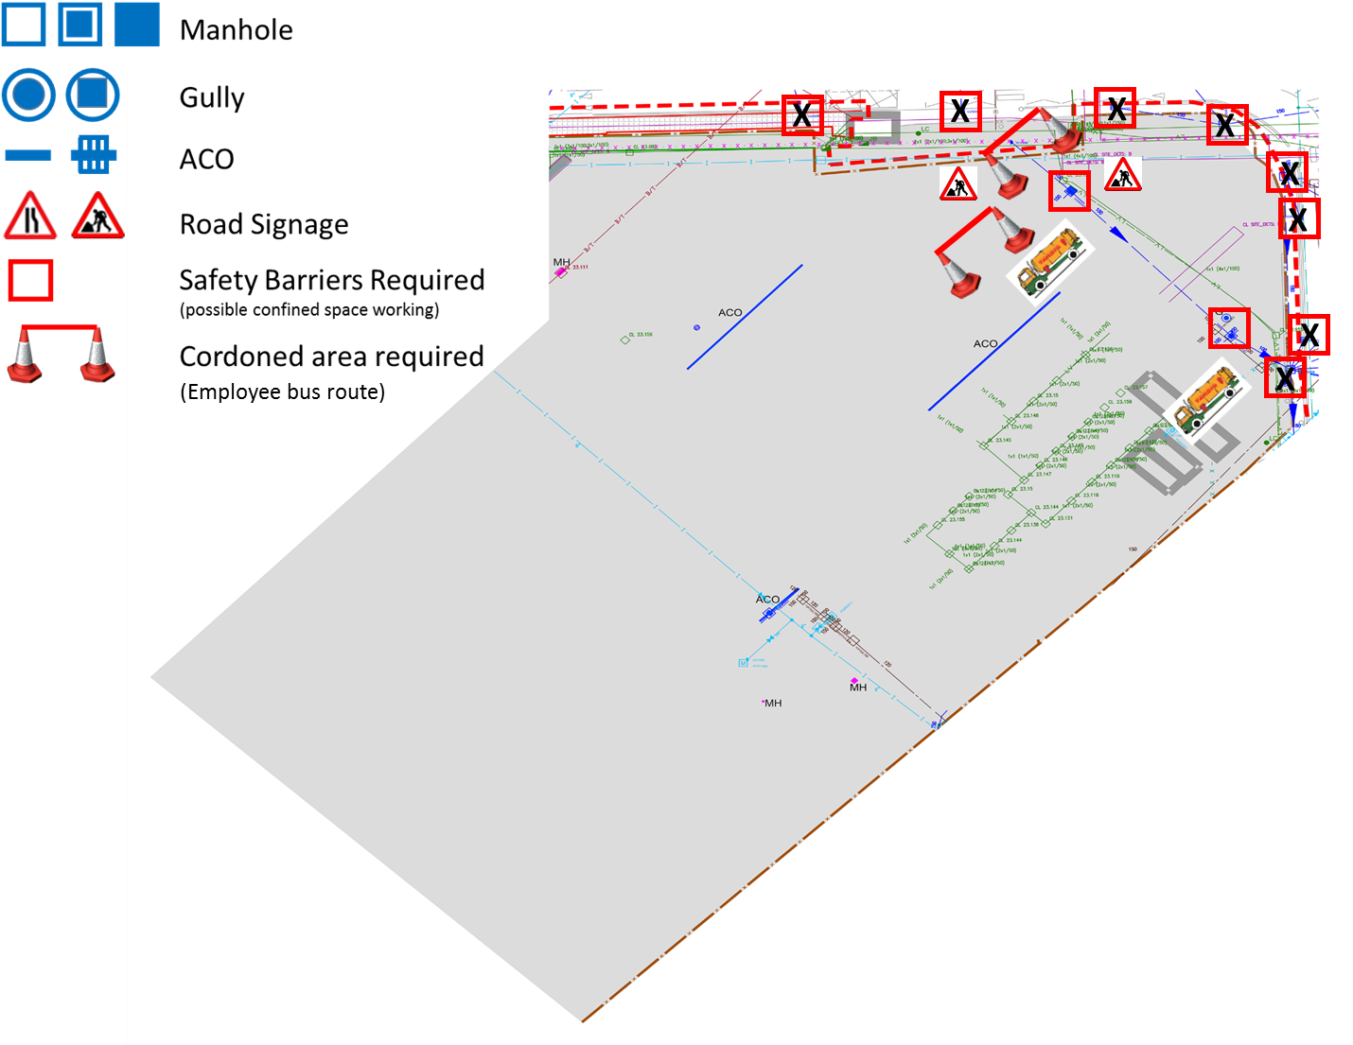

Appendices 7 - TM5 (Section Map)

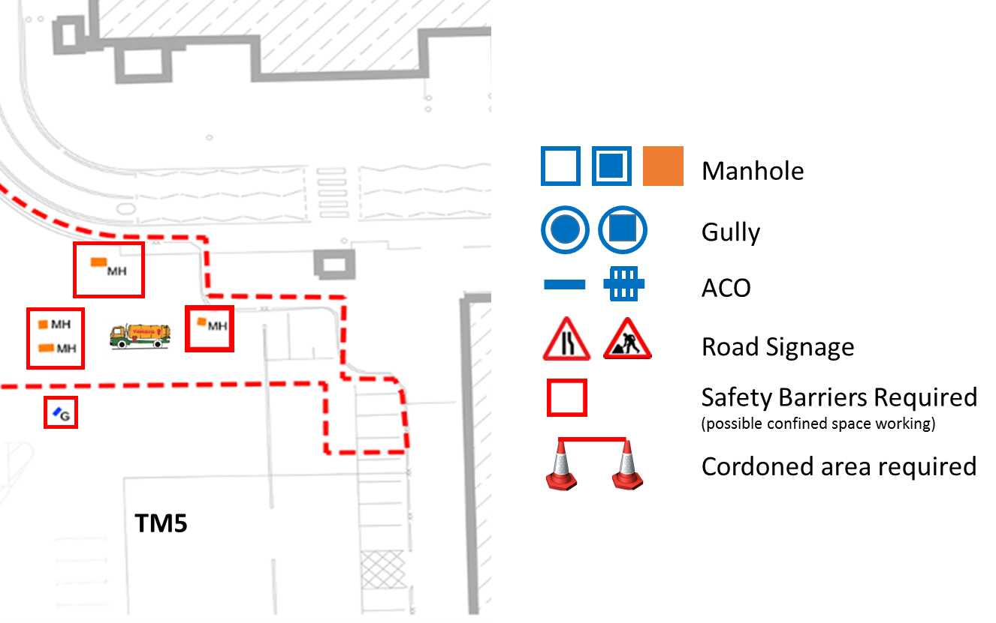

Appendices 8 – Confined Space/Traverse Entry Risk Assessment



Appendices 9 – CCTV Survey/Traverse Entry Risk Assessment



Appendices 10 – Drain Jetting/Emptying drain or Gully Risk Assessment

